The Americans succeed in constructing a canal across Panama

J. David Rogers, P.E., P.G., M.ASCE¹
¹ K.F. Hasselmann Chair in Geological Engineering, Missouri University of Science and Technology, Rolla, MO 65409, rogersda@mst.edu

ABSTRACT

When the United States took over title of the French canal franchise in Panama in 1903 they approached the project with vigor and confidence, treating it as an enormous railroad engineering project. By 1907 the various excavation problems led American engineer John Stevens to redesign the project, using a series of three locks at either end to lift ships 85 feet and transit across man-made Gatun Lake. In 1908 control of the project passed to the Army Corps of Engineers, who completed the project in August 1914, excavating 225 million cubic yards of material at a cost about 260% beyond that originally envisioned, which required an additional 2-1/2 years to complete. Despite all the setbacks and cost-overruns, the project was the jewel of an emerging American empire, and its contributions to world health and sea-born commerce were without precedent.

THIRD PARTY OVERSIGHT

A large part of the eventual success of the United States in building a canal at Panama came from avoiding the mistakes of the French, whose leadership had proven too inflexible. The American success came in large measure from their ability to employ third party oversight and a knack for innovate solutions on a broad number of challenges which, like the French, they did not foresee.

When the Americans took over in late 1903 they augmented the Isthmian Canal Commission (ICC) that Congress had established in 1899 to examine which route the Americans might pursue across the Central American Isthmus. President Roosevelt appointed a new slate of commissioners: Rear Admiral John G. Walker, Chairman; Major General George W. Davis, Governor of the new Canal Zone; William Barclay Parsons, C.E.; William H. Burr, C.E.; Benjamin M. Harrod, C.E.; Carl E. Grunsky, C.E.; and Frank J. Hecker. Admiral Walker had recently supervised the feasibility studies of various Isthmian Canal routes, which included detailed surveys of the French works. Davis had just completed a term as military Governor of Cuba. Parsons, Burr, Harrod, and Grunsky were all practicing civil engineers, who had published widely and owned considerable expertise with the design and construction of waterworks and heavy construction.

Railroad civil engineer John F. Wallace (Figure 1), who had served as ASCE President in 1900, was named as Engineer-in-Chief of the project, while Surgeon Colonel William C. Gorgas as Chief of the Sanitary Department. The chief engineer and surgeon would reside in Panama during the project and the commission was subject to the supervision of the War Department Secretary William Howard Taft.

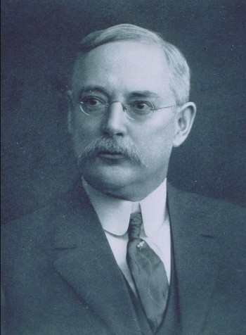 | 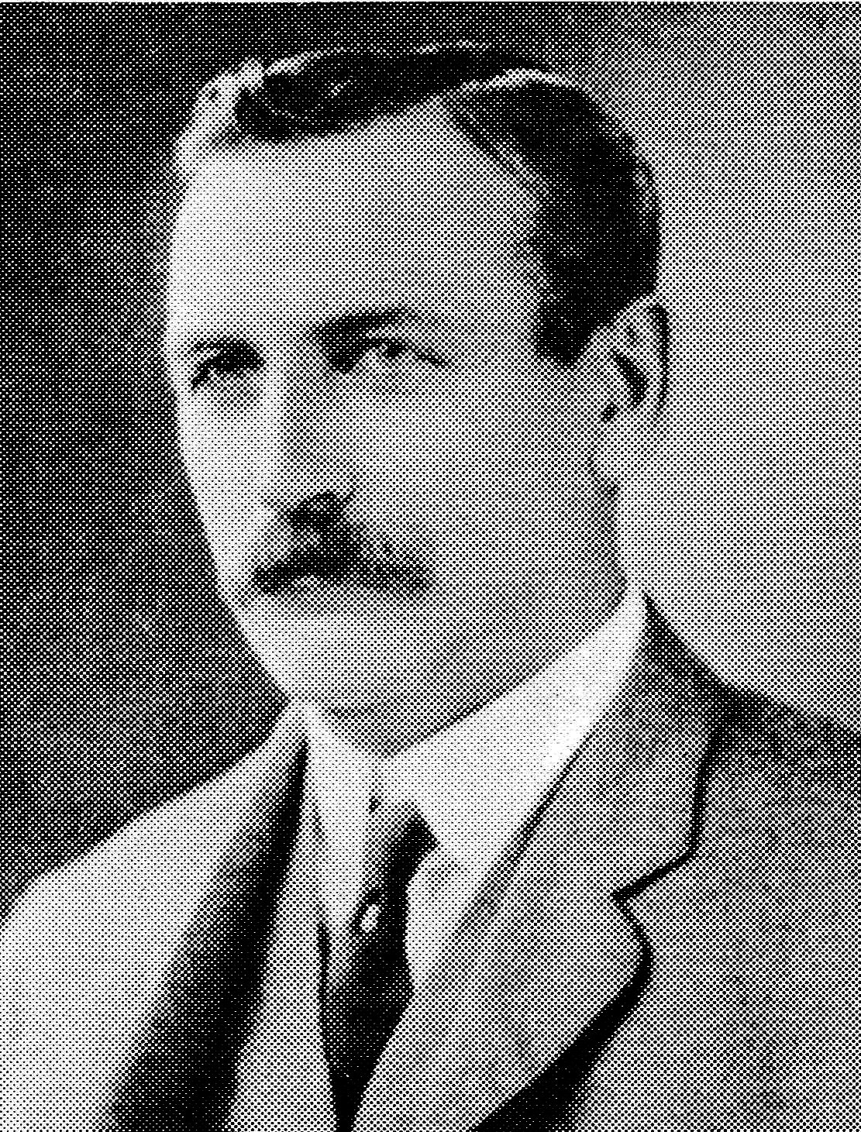 | 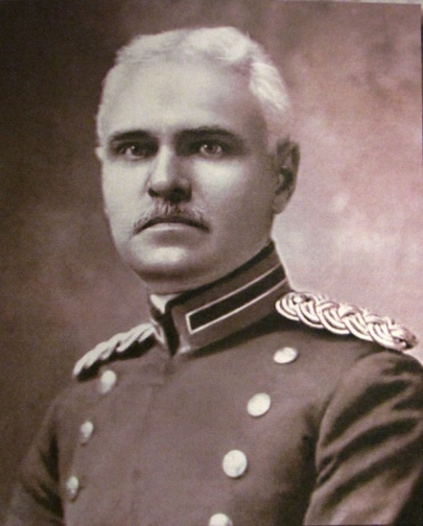
Figure 1. Left John F. Wallace served as ASCE President in 1900 and was the first Engineer-in-Chief of the Panama Canal (from Jackson, 1911). Middle: John F. Stevens succeeded Wallace in 1905, and served as ASCE President in 1927 (from Jackson, 1911). Right: Colonel George Washington Goethals, who took charge of the project in March 1907, seeing it through to completion in August 1914 (National Archives).

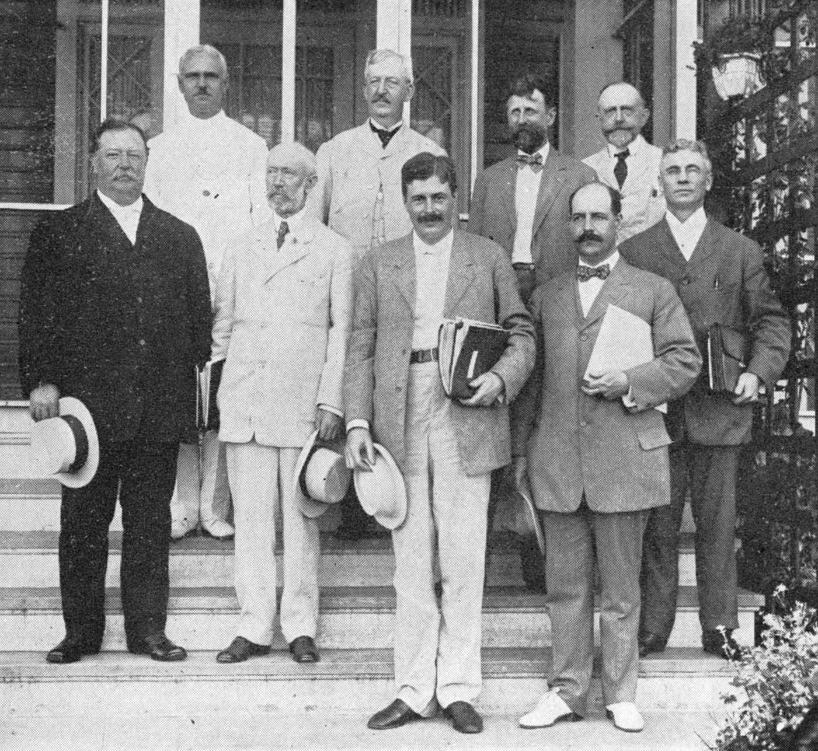
Figure 2. The Special Board of Consulting Engineers visiting the Gatun Dam and Locks in 1909. From left: War Secretary William H. Taft, Colonel George W. Goethals, Frederick P. Stearns, Henry A. Allen, Arthur Powell Davis, James D. Schuyler, Isham Randolph, John R. Freeman, and Allen Hazen (National Archives).

The engineers comprising the technical advisory arm of the ICC became the Special Board of Consulting Engineers (SBCE), shown in Figure 2. Its members would shift and change over the succeeding decade, during construction of the mammoth project. Some of these luminaries included engineers: Alfred Noble, John R. Freeman, Allen Hazen, Frederick P. Stearns, Arthur Powell Davis, James D. Schuyler, Isham Randolph, and Joseph Ripley, among others.

From the outset the engineers on the ICC and the SBCE were able to discuss and jointly solve all the various challenges that had nagged the French, who were handicapped by Ferdinand de Lesseps’ refusal to consider any deviation from his original plans, regardless of the unforeseen situations encountered.

“It’s just a big railroad job”

On May 10, 1904 Wooster University trained civil engineer John F. Wallace was named Chairman and Chief Engineer of the Isthmian Canal Commission, after serving as Chief Engineer and General Manager of the Illinois Central Railroad. He doubted the scientific efforts of Army physicians to combat malaria and yellow fever, and abruptly resigned 13 months later, in June 1905, after witnessing the deaths of some many associates around him in Panama.

Self-taught railroad engineer John F. Stevens succeeded Wallace in June 1905 and he lent full support to William Gorgas’s efforts to combat disease. He views the project as “just a big railroad job,” and doesn’t anticipate any grave problems, so long as he receives adequate logistical support. He wrestled with the overall design concepts and was ably assisted by 27 year old Ralph Budd, who had worked for him on the Rock Island Railroad in Kansas City (Budd went onto a distinguished career in railroading).

During his brief tenure Stevens conceived the “minority plan” to construct a locked canal, using water from the Chagres River to create a vast inland lake. This reduced the required depth of excavations by 70 feet (Sibert and Stevens, 1915). This plan was favored by Teddy Roosevelt and approved by Congress on June 29, 1906. It became the blueprint for all subsequent work, which was gradually completed between 1906-1934 (when Madden Dam was completed on the Chagres River). The basic layout of the canal, which runs more or less north-south, is shown in Figure 3.

Stevens said the canal job was all about “logistics, logistics, and logistics.” He told his laborers and foremen “don’t talk, dig.” He fought considerable ‘red tape’ to get the workers and their families fed and transported to and from their works stations without undue delays. This included such novel innovations as the construction of temporary suspension bridge across the canal excavations to convey workers to the opposite side in a minimal amount of time. Stevens also helped implement the hiring of Caribbean natives as the project laborers, because he believed they were capable of working harder in the oppressive heat and humidity.

In the first three years the Americans only managed to excavate 7 million cubic yards. Stevens stepped up the pace, removing half a million cubic yards of material from the Culebra Cut in January 1907, more than doubling the record set by the French. In February it increased to 600,000 cubic yards. On January 22, Theodore P. Shonts, an Iowa lawyer turned railroad executive, resigned his position as chairman of the ICC, to become head of the Interbourough Rapid Transit Co. in New York. This resignation seems to have rattled Stevens, who viewed himself in a power struggle with William Crawford Gorgas, the Army surgeon appointed to oversee sanitation, who had considerable influence with the War Department in Washington, DC. With nary a warning to anyone, Stevens resigned on February 26, 1907, much to the disgust of President Roosevelt.

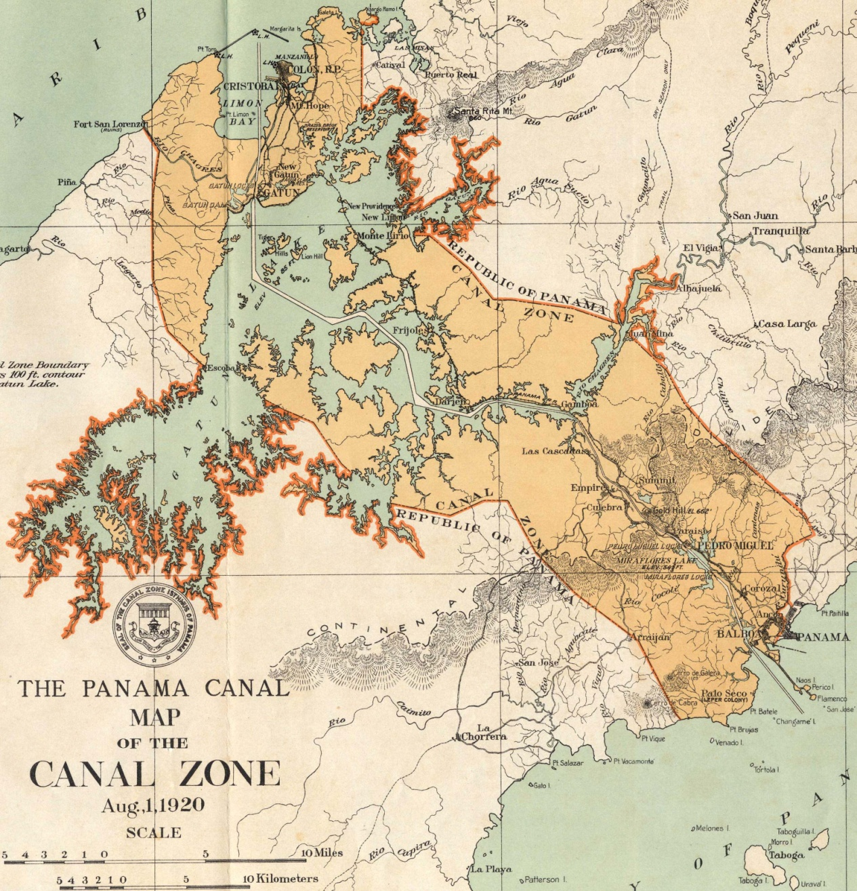
Figure 3. Map of the Canal Zone, as it was originally completed, around 1920. The canal is 47.9 miles long. The Canal Zone was agreed to be six miles wide, but the subsequent creation of Gatun Lake extended the zone to the spillway level of Gatun Dam, about 85 feet above sea level (from National Academy of Sciences, 1924).

Those closest to Stevens felt that, as a railroad engineer, he had little expertise in building locks and dams. They also voiced the opinion that he seemed to have been ground down by the enormity of his responsibilities and his evident desire to look after too many details himself. Despite any ignominy associated with his departure, Stevens flourished as a consulting engineer to railroads and served as ASCE President in 1927.

The Corps of Engineers takes charge of the project

Wary of appointing a third civilian engineer who might also resign, President Roosevelt decided to turn the work over to the Army Corps of Engineers, who assumed control on March 4, 1907. George Washington Goethals was promoted to Lieutenant Colonel and named Chairman and Chief Engineer of the ICC, a position that would consume him for the next 7-1/2 years. Goethals was ably assisted by fellow officers Majors David D. Gaillard and William A. Sibert, and he soon brought in Lt. Colonel Harry F. Hodges from the Corps headquarters in Washington, DC as his chief design engineer (Figure 4). All four were West Pointers who had graduated from near the tops of their respective classes (Goethals in 1880, Hodges in 1881, and Sibert and Gaillard in 1884). Goethals, Gorgas, Hodges, and Sibert were promoted to major general rank within a few years of the canal’s completion, but Gaillard died of a brain tumor in December 1913.

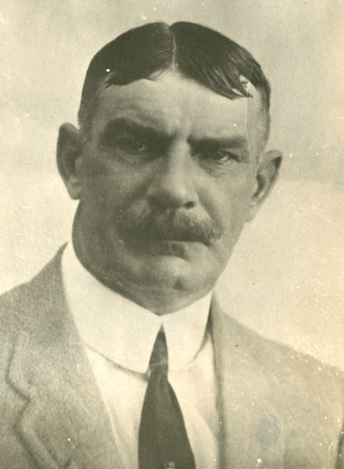 | 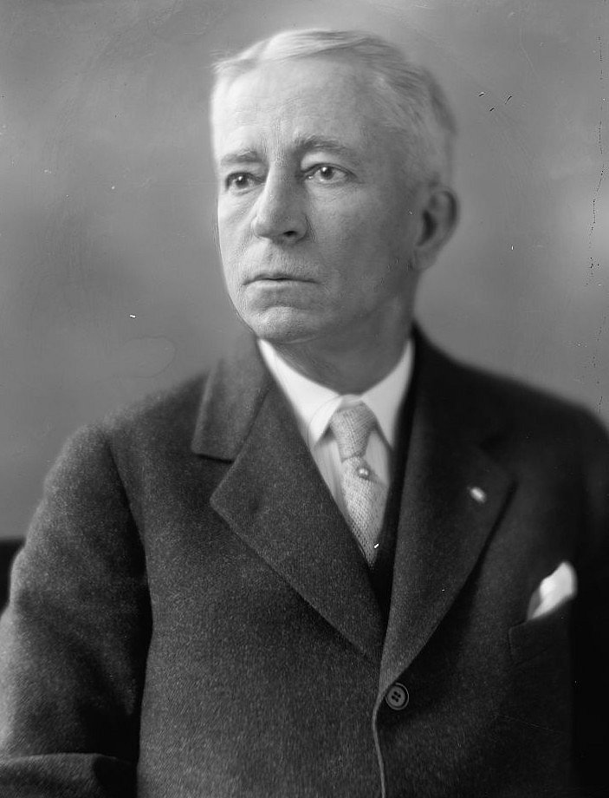 | 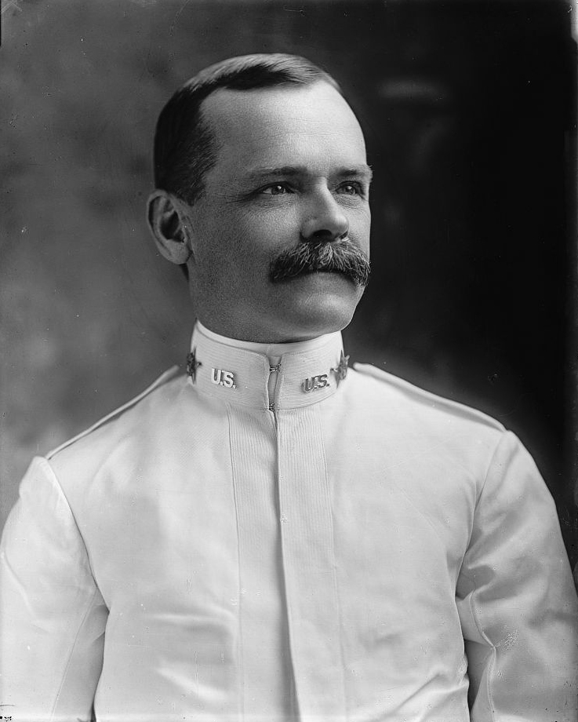 | 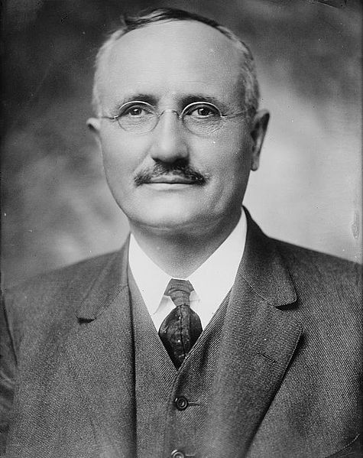
Figure 4. The four principal engineers who had oversight of the Panama Canal’s construction between 1907-14; from left: Civilian engineer Sydney B. Williamson, Lt Colonel Harry F. Hodges, Lt Colonel David D. Gaillard, and Lt Colonel William A. Sibert (Virginia Military Institute, Library of Congress, and National Archives).

Goethals inherited Stevens’ design for three locks on either end of the canal, with a massive lake 85 feet above sea level, created by damming the Chagres River near Gatun, on the Atlantic side. In typical military fashion, Goethals split the project into divisions of responsibility, shown in Figure 5. The Atlantic Division, under Sibert, was responsible for constructing the approach channels and three massive locks at Gatun, on the Atlantic side, as well as Gatun Dam (a hydraulic fill embankment) and the gravity concrete spillway structure for Gatun Lake. Gaillard oversaw the expansive Central Division from Culebra Heights. This encompassed 40 miles of work, which included all the landslides that made the project so problematic, extending its completion by more than two years.

When the Army took over the project, they retained the Isthmian Canal Commission, which provided third party review of the transportation, sanitation, and administrative issues involving the canal’s construction. In 1910 this group was comprised of Lt Colonels Goethals and Gorgas, Majors David D. Gaillard and William L. Sibert, Rear Admiral Harry H. Rousseau, Joseph C.S. Blackburn, and Jackson Smith (Figure 6).

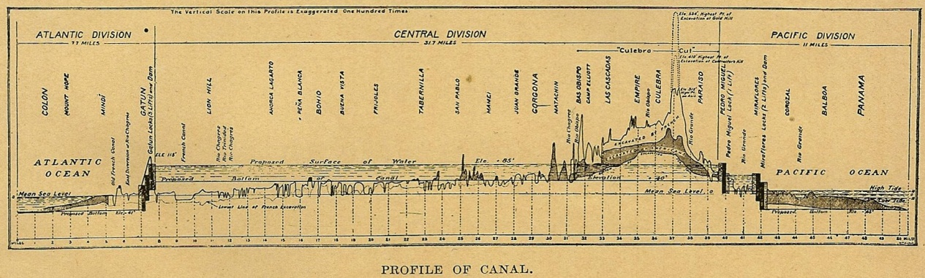
Figure 5. Cross section of the proposed canal in 1910, showing how the project was divided into the Atlantic, Central, and Pacific Divisions (from Lindsay, 1910).

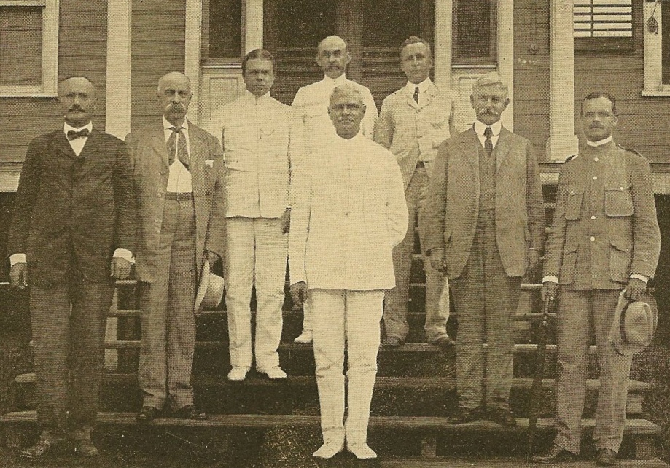
Figure 6. Members of the Isthmian Canal Commission in 1910, from left: LTC William L. Sibert, Senator J. C. S. Blackburn, RADM Harry Rousseau, publisher Joseph Bucklin Bishop, COL George W. Goethals, LTC Harry F. Hodges, COL William C. Gorgas, and LTC David D. Gaillard (National Archives).

Civilian engineer Sydney B. Williamson was an 1884 graduate of the Virginia Military Institute. He was given charge of the Pacific Division, which included nine miles of canal and approach channels, the Pedro Miguel and Miraflores Locks, and a three mile long breakwater. Williamson and Goethals had met while working on the Muscle Shoals Canal along the Tennessee River, in the early 1890s. He was the only civilian engineer on Goethal’s managemnet team and all of Williamson’s subordinate engineers were also civilian.

Responsibility for design of the massive concrete lock structures fell to Lt Colonel Harry Foote Hodges. He succeeded civilian engineer Joseph Ripley, who had been Stevens’ choice for supervising the design of the locks. Prior to Hodges’s arrival the design work had been undertaken in Washington, DC. Like Sibert, Hodges had worked previously on the Soo St. Marie Locks between Lakes Huron and Erie, which had been re-designed and rebuilt following the collison of a ship with the lock gates in 1885. This had been one of the great engineering disasters of the 19th Century, which had required considerable innovation to solve.

Sanitation and public health

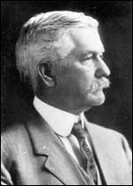 | America’s greatest contribution to come out of the Panama Canal was in the arena of sanitation, through the Army Medical Corps. Surgeon Colonel William C. Gorgas (shown at left) was the only Army officer who remained in the Canal Zone from the onset of the project in 1905 to its conclusion in 1914. Gorgas was the son of General Josiah Gorgas, Confederate Chief of Ordnance during the Civil War. Educated at the University of the South in Sewanee, Tennessee (Class of 1875), he went onto Bellevue Medical College in New York City, receiving his M.D. in 1879. He was commissioned as a First Lieutenant and Army Physician in 1880. While stationed at Fort Brown, Texas in 1882-84, he contracted yellow fever and almost died.

When Gorgas arrived in Panama he was already known for his pioneering research in Florida and Cuba, working under fellow Army physician Walter Reed, who led the team that postulated and confirmed the theory that yellow fever is transmitted by the female anopheles mosquito in 1900 (Reed died of an appendicitis in 1902).

The challenges being faced by Gorgas in Panama were without precedent, and Gorgas accepted his new responsibilities with zeal and determination. His #1 goal was to abate the widespread transmission of yellow fever and malaria by controlling the mosquitoes that conveyed those diseases, at a time when there was considerable skepticism and opposition to such measures, which many did not believe. Gorgas zealously fought the mosquitoes, with his own corps of sanitation workers improvising their mitigation techniques to rid the isthmus of the deadly insects (they also had to battle ants, cockroaches, and rats).

Gorgas fought many battles with his fellow engineering officers, beginning with the first Canal Zone Governor, General George W. Davis, who refused to release the funds Gorgas requested for his sanitation work, feeling it would be better spent on excavation (Gibson, 1950). Similar battles continued with Davis’ successors, especially John Stevens and Commissioner Carl E. Grunsky. In February 1905 the American Medical Association (AMA) sent Dr. Charles A.L. Reed of Cincinnati, one of the country’s eminent surgeons, down to Panama to make an independent investigation, which was submitted to Secretary of War William Howard Taft on March 1st.and published a 6-page letter in the AMA Journal, critical of engineers without proper medical training having oversight on Gorgas’ activities, which were meant to save lives. These conflicts led to the eventual departure of Grunsky (in mid 1906) and Stevens (in early 1907).

A few years later, Goethals came to Gorgas and asked him if he really felt he could justify the enormous cost of his mosquito abatement program, which was costing the government about $10 for each mosquito they killed. This seemed excessive to Goethals. Gorgas smilingly replied that one of those $10 expenditures might well have saved Goethals’ life, and that his value to the successful completion of the project was worth many millions of dollars! Goethals never bothered Gorgas again. Gorgas’ efforts in Panama would save countless millions in the coming century, and he was named the 22nd Surgeon General of the U.S. Army right after the canal was completed, in 1914, and served in this capacity through the First World War.

BATTLING LANDSLIDES

In July 1909 and again, in May 1910, one of the 56 degree (3 vertical to 2 horizontal) cut slopes in the Obispo Section of the canal slid into the excavation, without any hint of rainfall or other obvious means of triggering. Army Engineers tried to evaluate the stability of the slope, but were unable to explain why it occurred. In early July 1911 the first slides began to occur at Cucaracha, on the south side of Gold Hill, near the Continental Divide. This slide buried steam shovels, and 46 muck cars, and destroyed 1,700 feet of track.

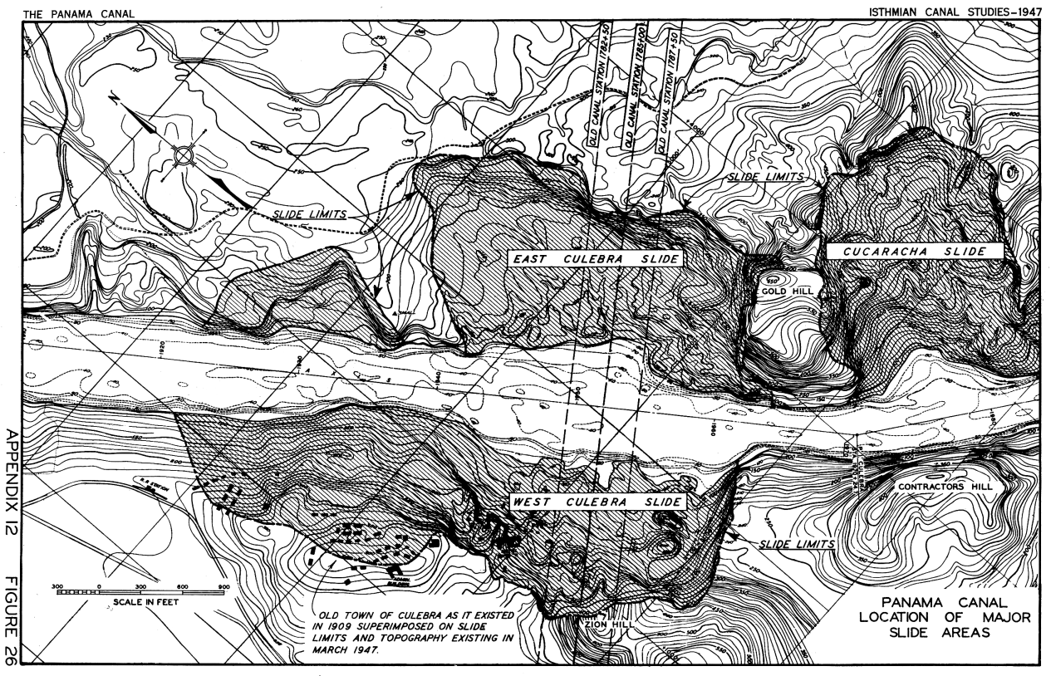
Figure 7. Map showing the principal slides along the Panama Canal near the Continental Divide (from Canal Zone, 1947).

In August 1912 another bank failure occurred in the Obispo Division, preventing drainage from passing along the main canal excavation. By September 1912 the head scarp of the East Culebra Slide was beginning to enlarge itself, threatening to sever the main cross-isthmus road along the east side of the canal, the major vehicular artery across the isthmus. The West Culebra slide began to threaten Culebra, where the Army maintained its principal base of operations for the Continental Divide Division. Throughout the latter half of 1912 through August 1913 Colonel Gaillard supervised emergency operations aimed at stemming the headward advance of these mammoth slides. When he collapsed that summer, everyone believed it to be a nervous breakdown (and it was reported as such), but it turned out to be a brain tumor, hastening his untimely death on December 5th, 1913. The Culebra Cut was re-named Gaillard Cut by Executive Order on April 27, 1915, in honor of Colonel Gaillard, who died of a brain tumor in December 1913 (before the Canal was completed).

As the excavation deepened, the side slopes started caving in on the main excavation. Between 1912 and 1916 three massive landslide complexes developed along the Continental Divide, where cut slopes up to 500 feet high were located. These were the East and West Culebra Slides, and the Cucaracha Slide, shown in Figure 7. By 1916 the headscarp of the West Culebra Landslide had swallowed up part of the town of Culebra (Figure 8). No less than 26 rail-mounted steam shovels and 96 gondola cars were lost in the slides. This lost equipment was salvaged whenever possible. The French excavated 19 million cubic yards in the Culebra Cut, while the Americans ended up removing 96 million yards. The original plans envisioned a cut with a maximum width of 670 feet, which ended up being 1,800 feet wide, because of all the slides.

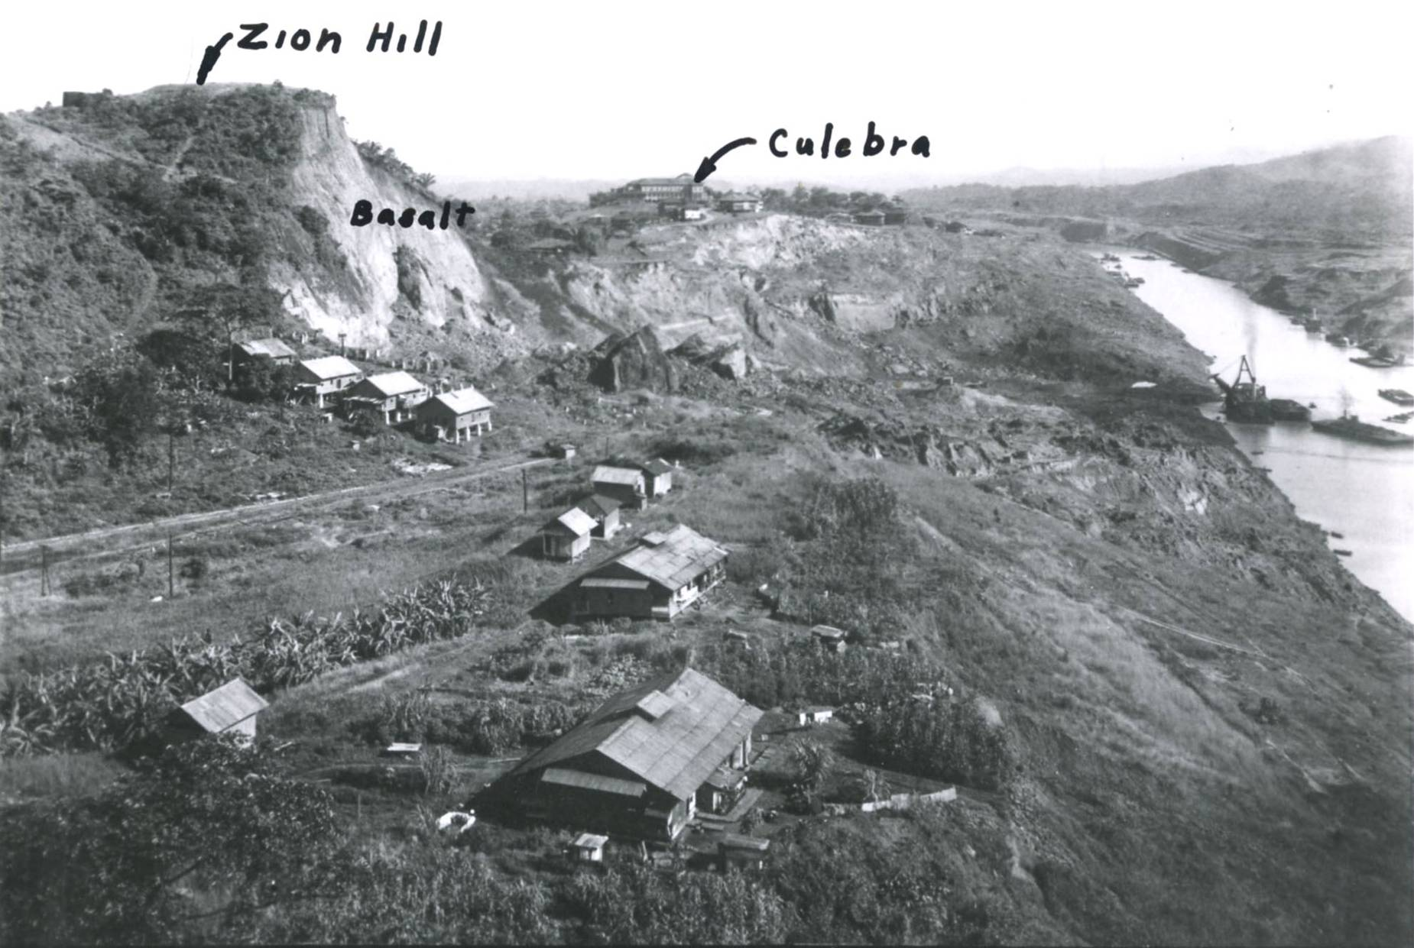
Figure 8. Zion Hill, formed by headscarp of the enormous West Culebra Slide, as seen in July 1916 from Contractor’s Hill, looking north (National Archives).

The Cucaracha landslide

The most vexing nemesis of the American engineers was the Cucaracha landslide, which began just south of the Continental Divide, in February 1913. Figure 9 shows the massive cut at Gold Hill and Cucaracha, just before the first big slide, in September 1913, shown in Figure 10. Between November 1913 and February 1914 Goethals increased the number of suction dredges working the toe of the Cucaracha Slide by five-fold. Almost half of the 232 million cubic yards excavated between 1907-1914 was removed using floating dredges like that shown in Figure 11.

In late October 1913 Colonel Goethals decided that further attempts to excavate the Cucaracha Shale would prove fruitless, and ordered that the canal excavation be flooded so water could provide lateral support of the failing slopes and floating dredges could be positioned to excavate the slide debris as it filled in the channel. Goethals also flooded the canal excavation north of the Continental Divide, to facilitate dredging and subaqueous excavation by shovels where the slopes were highest.

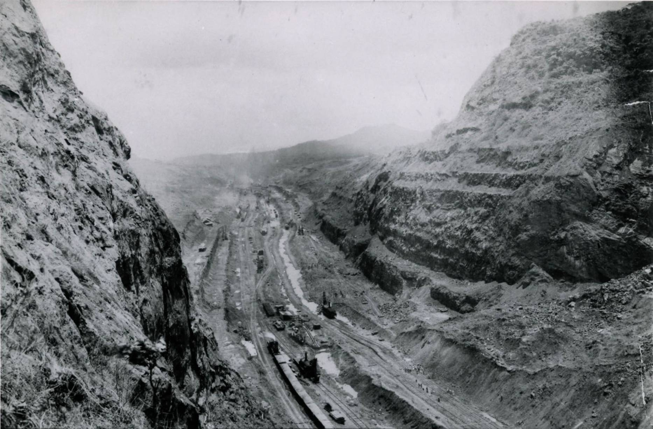
Figure 9. Looking into the gaping hole at Gold Hill on the Continental Divide, viewed on May 17, 1913. Note the 3:2 (vertical to horizontal) (56º) side slopes, before the first Cucaracha slide, shown next (National Archives).

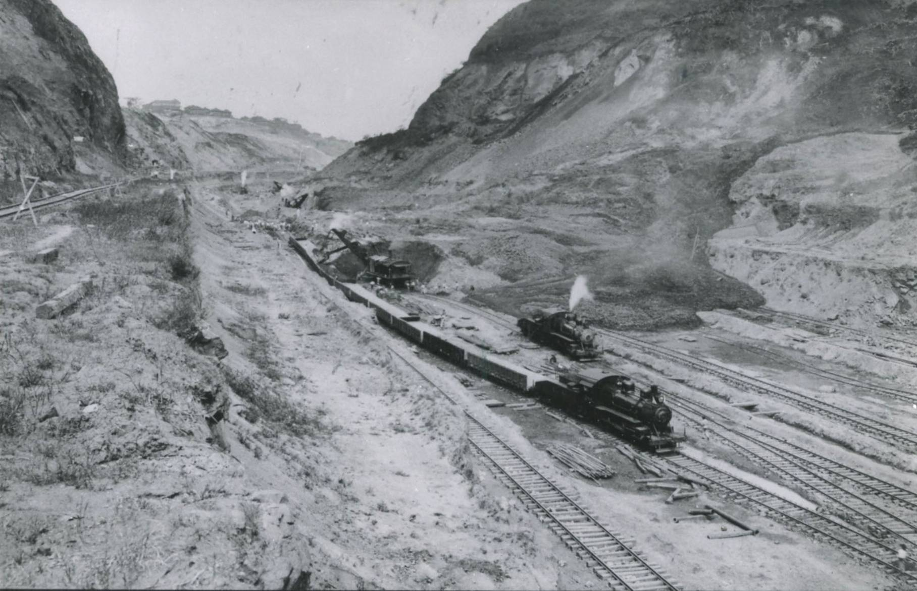
Figure 10. Flowage off the Cucaracha Landslide on February 2, 1913 (National Archives).

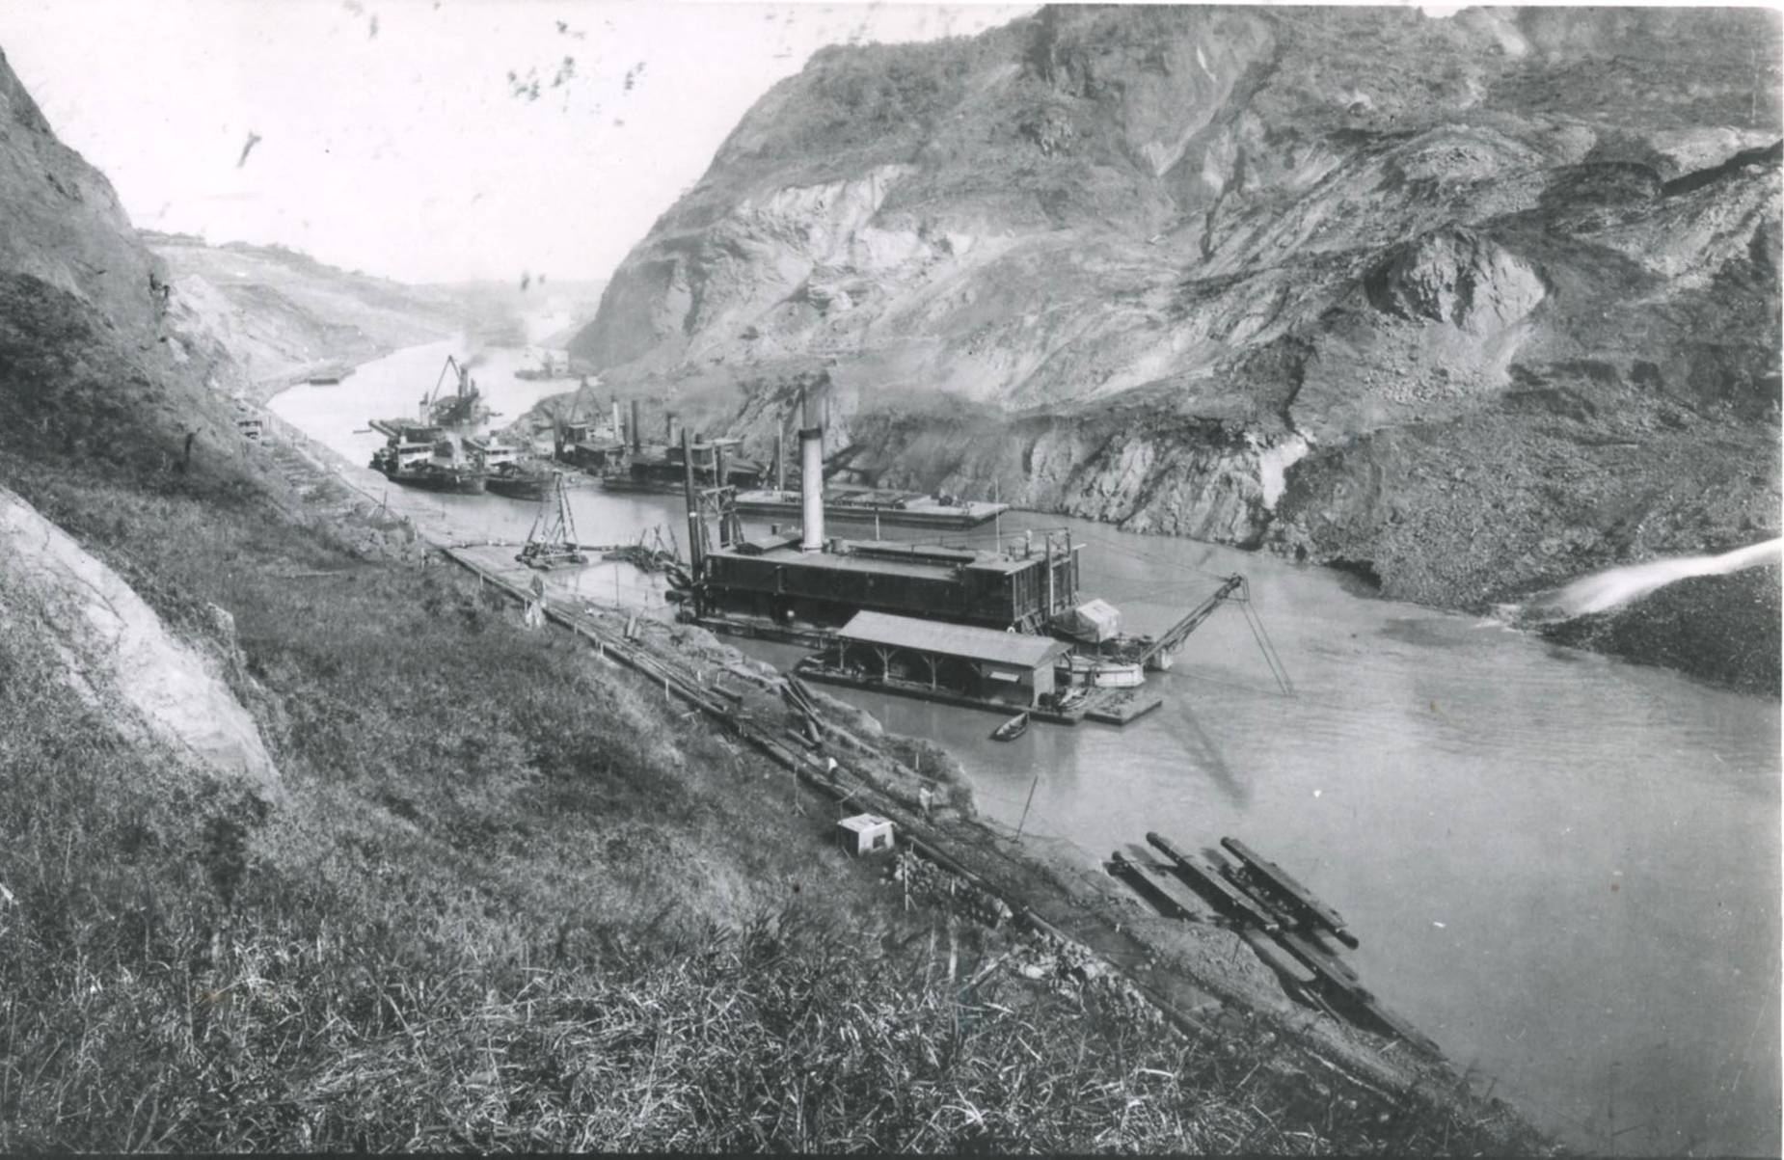
Figure 11. Fleet of suction dredges working the toe of the Cucaracha Slide - February 8, 1914 (National Archives).

CONCLUSIONS

The biggest challenge of all the dredging was conveying the dredge spoils more than a dozen miles to the outfall tailings near the coast, where more than three square miles of fill was laid in Balboa Bay. The dredge tailings were dumped into rock-lined dikes, covering an area of several square miles. The waste muck was conveyed by rail cars and dumped into enormous fill piles at the coasts. In the end the project required 310 million cubic yards of excavation, of which, 78 million yards had been moved by the French in the 1880s. The Americans ended up spending $366.65 million on the 10-year project; about 10 times what de Lesseps came into the project with in 1883.

REFERENCES

Canal Zone, Governor (1947). Report of the Governor of the Panama Canal, Isthmian Canal Studies, and Appendix 12: Slopes & Foundations.
Gibson, John M. (1950). Physician to the World: The Life of General William C. Gorgas. Duke University Press.
Jackson, F.E., ed. (1911). The Makers of the Panama Canal. F.E. Jackson & Sons, New York, 410 p.
Lindsay, Forbes (1910). Panama and the canal today. L.C. Page & Co., Boston, 433 p.
Sibert, W.L., and Stevens, J.F. (1915). The Construction of the Panama Canal. S. Appleton & Co., New York.

