FLOOD DAMAGE:
Evolving laws and policies for an ever-present risk

J. DAVID ROGERS, Ph.D., P.E., R.G., C.E.G., C.H.G.
Karl F. Hasselmann Chair in Geological Engineering
DEPARTMENT OF GEOLOGICAL & PETROLEUM ENGINEERING
129 McNutt Hall, 1870 Miner Circle, University of Missouri, Rolla, MO 65409-0230

INTRODUCTION

Flooding is a natural geologic hazard that will always be with us. In fact, virtually all the sediment deposited upon the continent are deposited on well-defined flood plains, which also enabled our agricultural development. Those areas have since become prime real estate and support a large percentage of the population. This article provides a brief introduction to the reasons for floods, their periodicity, the National Flood Insurance Program, and the problems associated with estimating areas of likely inundation and relative risk; revealed by the repeat occurrences of so-called “100-year” floods with seemingly increasing frequency. The balance of the article contains examples of the various theories of liability presently applied to litigation in the United States associated with common flood hazards, drawing in large part from legal cases in California.

HISTORICAL CONTEXT

The nation’s first locally-controlled flood control agency was the Miami Conservation District, formulated in 1913 in the wake of the disastrous Dayton, Ohio flood of that same year, which killed 600. The city fathers asked renowned civil engineer Arthur E. Morgan to come to Dayton and have a free hand in devising such engineering schemes necessary to prevent such a tragedy from ever occurring again. Morgan was a man with purpose and drive, who went on to become the first director of the Tennessee Valley Authority (TVA) in 1934. Morgan astounded everyone by removing those portions of downtown Dayton which had encroached on the historic channel of the Miami River. He enlarged the river channel and built enormous levees. Then he then built three “flood control dams”, or retention basins, on the Miami River upstream of Dayton. Morgan also issued an edict which prevented the reservoirs from ever being filled, to prevent hydropower and recreation interests from becoming tempted to lessen flood storage and thereby, negate the dam’s fundamental purpose (Morgan, 1952).

Morgan’s stringent flood control measures have proven themselves to be prophetic time and again, as flood control infrastructure in the United States has repeatedly failed because of political and economic compromises to create “multi-purpose reservoir projects”, to gain a broader base of support for funding of dams. In the 1997 New Year’s floods in northern California the unprecedented number of dams and flood control infrastructure was unable to protect the lower Sacramento Valley because operators had gradually lessened the flood storage capacity of each reservoir in order to promote enhanced power generation, greater summer storage and recreation capacity. Morgan’s 1913 warnings about the dangers of multiple-use reservoirs were fulfilled, and California suffered more than $4 billion in flood damages, despite having some of the world’s largest flood control dams in place.

A fundamental problem in forecasting flooding has been the absence of adequate flow records. In his last article for the American Society of Civil Engineers, Professor Ven Te Chow of the University of Illinois reminded fellow engineers that in order to adequately predict a 100-year recurrence interval flow event, one would need 1000 years of hydrograph records (Chow and Takase, 1977). In most instances, project floods are based upon inadequate flow data, extrapolated well beyond the range of scientific certainty and subject to all kinds of flow adjustments, as discussed later.

Perhaps the best appreciation of how poorly we predict so-called “maximum flood events” are some of the flow records in California. The lower Sacramento River recorded nine “100-year floods” during the 20th Century, in 1907, 1909, 1936, 1955, 1964, 1982, 1986, and 1997. Southern California purported to have received seven such events, in 1914, 1916, 1938, 1969, 1993, 1995/97 (depending on location). At the time these extreme flow events occurred each appeared “unprecedented”. Some of the increase in peak flow was likely due to channelization and man-induced activities associated with agricultural development and urbanization. It is obvious that the estimates of 100-year recurrence frequency will continue to evolve as more flow data is collected.

Following the disastrous 1927 and 1937 floods of the lower Mississippi and Ohio Valleys the U.S. Army Corps of Engineers began to develop methods by which levees could be evaluated, engineered and strengthened. This pioneering work culminated in a better understanding of the limitations of man-induced flood control and river training than had previously been appreciated. By the late 1950s flood inundation models began to evolve which were computerized in the 1970s and 80s to calculate inundation areas for the probable maximum flood, as well as 100-year (1 chance in 100 of occurrence) and 500-year (1 chance of 500 of occurrence) frequency floods, commonly used on government-sponsored flood maps. But, because parcels are developed in a piecemeal fashion, each one only a small part of an immense watershed, the so-called “project flood” evolved. A “project flood” is that frequency of occurrence felt to be within economic reasonableness for the size and value of development contemplated. For government infrastructure, the “project flood” value most commonly selected is half of the probable maximum flood, and is usually something between a 50-year and 100-year recurrence frequency event. Developers of small parcels oftentimes attempted to install drainage infrastructure with between 10-year and 25-year recurrence frequency, leading to a heterogeneous mix of drainage improvements which are seldom, if ever, compatible.

In 1969 the Federal Emergency Management Agency (FEMA) began to administer a Federally-mandated National Flood Insurance Program (NFIP) Act of 1968 (42 U.S.C. 4001-4128, and Supp. III 1985). This program sought to socialize the burden for flood damage between those individuals who actually live in flood-prone areas, and sets rates according to relative risk of occurrence, based on computer simulations of flooding. For example, people living within the 100-year frequency inundation area are charged at a higher premium than those above the 100-year line, but within the 500-year recurrence frequency level.

Damaging floods occurred in the San Francisco Bay Area in 1955/56, 1962, 1963, 1964, 1967, 1969, 1973, 1982, 1983, 1986, 1993, 1995 and 1996/97. Five of these events were espoused to be 100-year recurrence frequency events. This is doubtful. A 100-year recurrence frequency suggests that the river or stream flow has one-chance-in-100 storm events of occurring at any given time. But, it’s not that easy. Other factors play a large role in determining how high flood flows get against the bank at any given location. Some of these factors are listed in Table 1.

Table 1

Common factors affecting accuracy of flood predictions

Factor | Description
Antecedent moisture | How much rain has already been absorbed by the ground, season-to-date. The more saturated the ground surface, the greater the runoff from any given storm. Landscape watering can also lead to increased levels of antecedent moisture.
Localized cells of intense precipitation | Very intense bursts of moisture in upland areas can cause localized flooding and destructive debris flows which clog drainage inlets, culverts, etc, which then leads to flooding
Duration of storm events | The longer storms stall over any given area, the greater the flooding
Changes in vegetation within the watershed | Changes in land use (such as grazing) and vegetation will lead to changes in the time-to-concentration of runoff to local creeks and rivers.
Development of the watershed | The more hardened surfaces, such as roofs, walkways, pavements and lined storm drainage channels, the greater the peak runoff. A 400% increase is not unusual, commonly leading to down cutting of unimproved channels
Unnatural constriction of flow | The placement of hardened improvements in channels, such as culverts, rip rap, retaining walls, or; natural impediments to flow, such as landslides, eroded soil, trees, organic debris and natural storm-laden debris, invariably cause localized hydraulic chocking of channels, leading to tail water inundation of previously un-flooded areas
Changes in weather patterns | Frequency and probability-based flood flow assessments are based upon the assumption that weather patterns are essentially unchanging. Data collected since 1849 would suggest otherwise, weather patterns are always changing.
Mistakes in flood plain management | Whatever can go wrong in routing floods via use of planned releases from flood control reservoirs, eventually will.
Failure of flood control infrastructure | Despite the best intentions, infrastructure elements, such as levees, dam spillways and conduits, can fail, most often during peak usage. Levees are particularly sensitive to duration of flood flow
Accuracy of topographic information | The accuracy of topographic information within the watershed being studied will exert keen influence on the areas predicted for inundation
Accuracy of channel roughness estimates | Channel hydraulics assessments are dependent upon estimates of channel roughness, which are highly variable in unimproved channels, and subject to change, depending on frequency and depth of flows
Accuracy of input hydrology | Flow assessments are only as good as the estimates of precipitation upon which they are based. An array of antecedent moisture levels needs to be evaluated in order to make conservative predictions of flow.
Accuracy of the computational methodology chosen | A wide array of computational models exists, the most commonly employed being HEC-2, developed by the Army Corps of Engineers. However, flow predictions are built upon the detail and accuracy of input information, such as the number of channel cross sections.

A careful study of the factors listed in Table 1 should present the reader with sufficient reason to suspect that most of these factors affect every stream in developed watersheds of the United States. Massive changes in vegetation, land use and weather patterns have led to increased downcutting of channels in coastal California, with the largest watersheds responding first, followed by their own tributaries (Bull, 1991). Examples of recently entrenched channels can be seen all over Contra Costa, Alameda and Sonoma Counties. 25 years ago most hydrogeologists believed that the downcutting was associated with increased development, but careful measurements have shown the downcutting appears to be of similar magnitude within non-developed watersheds as well; leading to the conclusion that other factors, such as vegetation, land use and weather patterns are the real culprits (Rogers, 1988).

Some of the most common forms of flood damage are presented in Figures 1, 2 and 3. For public agencies, plugged culverts are by far the most onerous, giving rise to inverse condemnation suits by adjoining property owners whose properties are damaged (van Alstyne, 1969).

THEORIES OF LIABILITY APPLIED TO FLOOD DAMAGE

Damage Ascribable to Unchanneled Surface Waters

California case law has generally stated that liability may follow from damage by naturally-occurring run-off, or surface waters only if the upper landowner causes the damaging flooding by his unreasonable or arbitrary acts. The most cited case is the area of surface run-off is Keys versus Romley (1966) Cal. 2d. 396. In this case, the owner of an electronics store in Walnut Creek (Keys) was happily minding his own business until an adjacent, uphill property was developed into an ice rink by Romley. The run-off from Romley's roof and parking areas was subsequently concentrated on the newly-filled slope above and behind Keys' store. When severe rains came, soil slumped on the newly-filled slope and Romley's run-off was preferentially directed into Keys' store, causing him damage (see Figure 4).

Keys sued and eventually prevailed, therein making this case the pre-eminent example of the so-called "Law of Reasonable Use" wherein all owners of improvements must act in a reasonable and competent manner to combat rainfall-induced run-off.

"Common Enemy Doctrine"

The common enemy doctrine evolved from the same sort of flood cases which gave rise to the Natural Watercourse Rule (discussed later). The difference lay in surface or near channel "improvements", such as protective barriers, dikes, and levees which offer protection from flood water damage. The common enemy doctrine held that such barriers could be constructed with immunity, even if the barrier subsequently caused the diversion of flood waters onto the land of others.

The early California courts felt this exclusion necessary so as not to punish the "good faith improver" who installed his flood control works or barriers. After all, why should an adjacent neighbor, who fails to spend the money necessary to protect his property, be able to punish those who do? The common enemy doctrine was a way of encouraging adjacent landowners to make like improvements. The landmark plaintiff cases were generally made against reclamation districts and railroads.

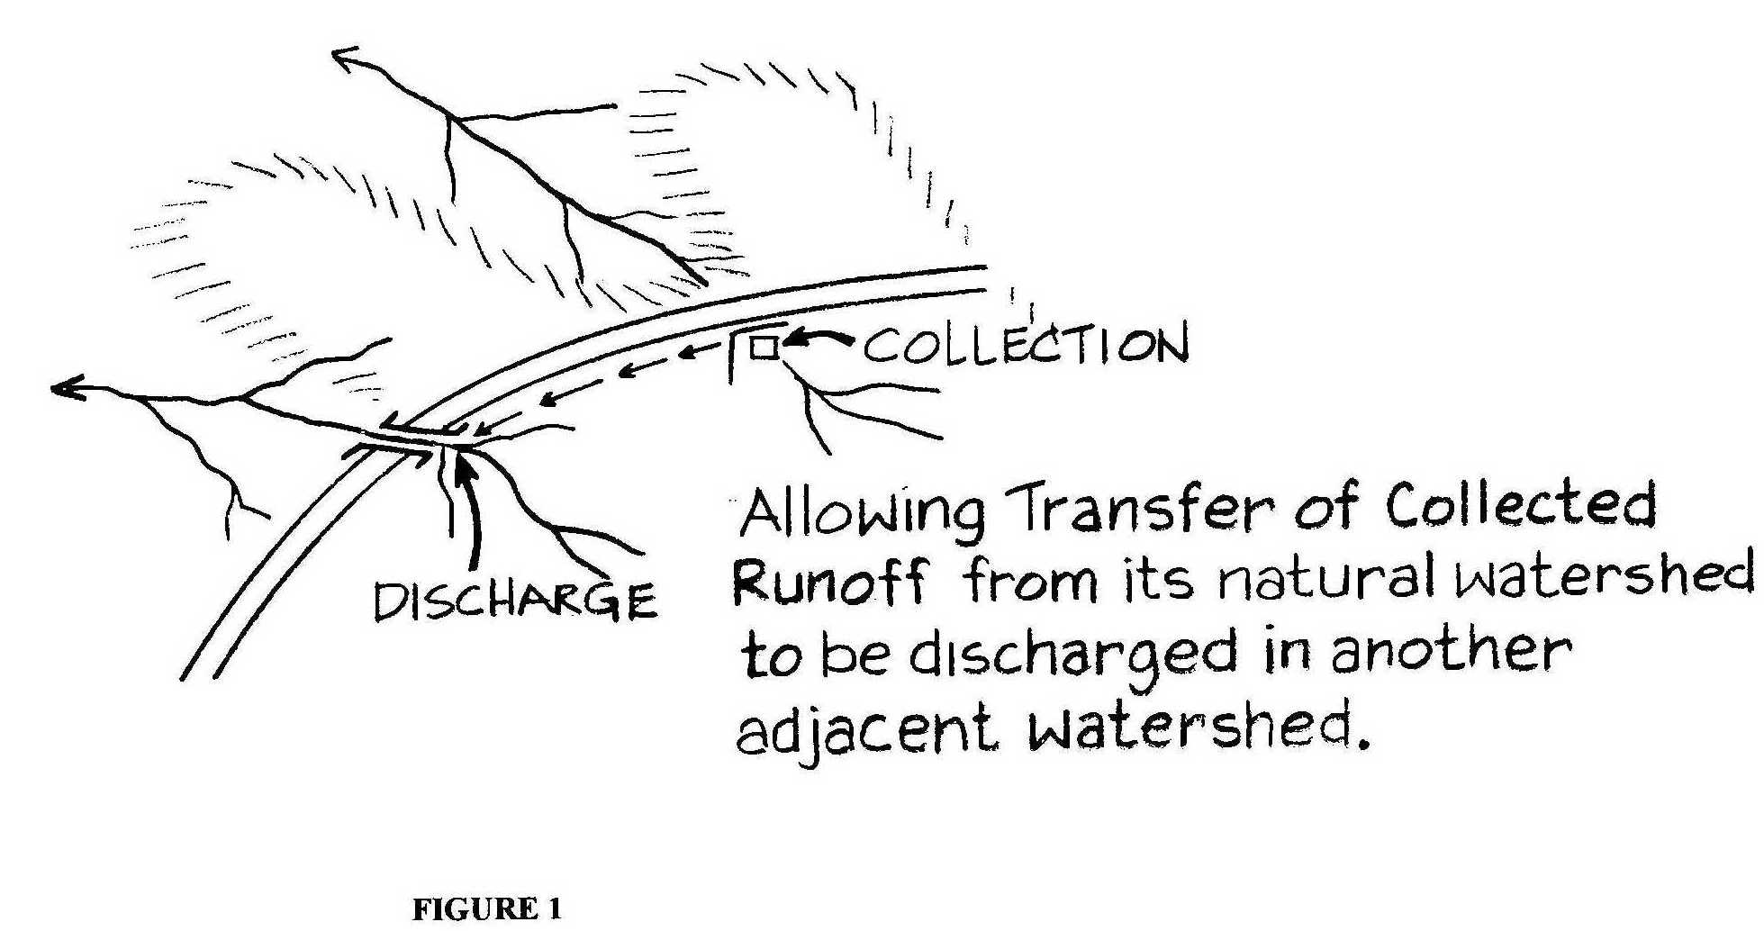

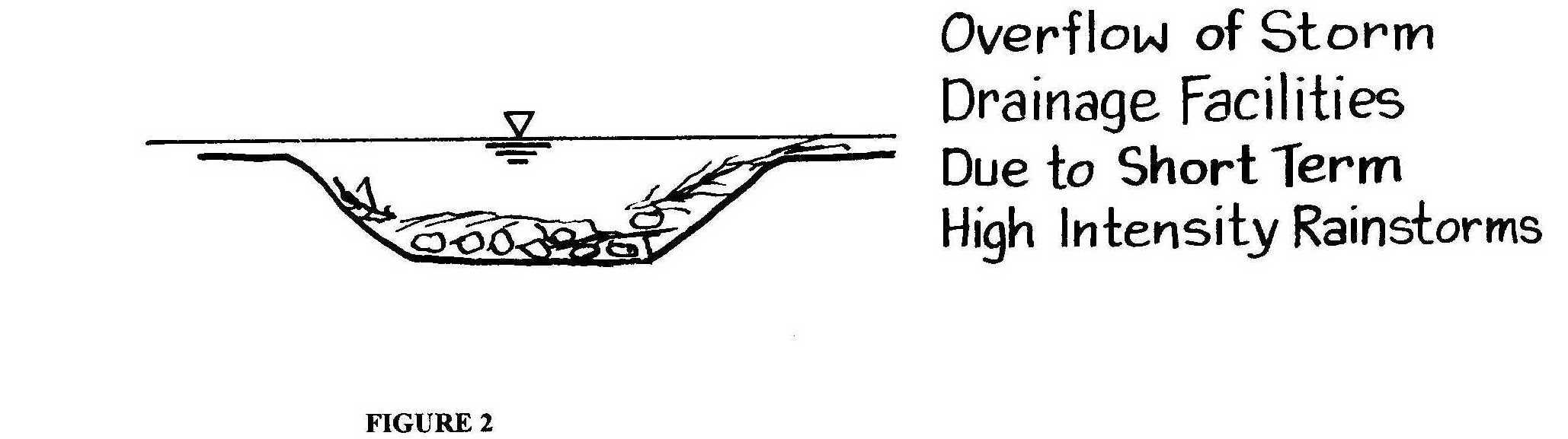

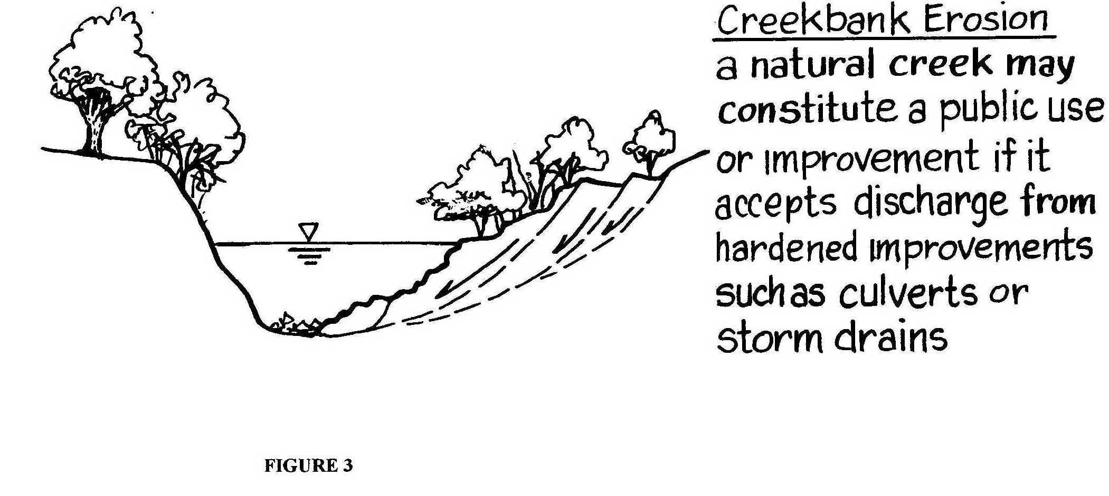

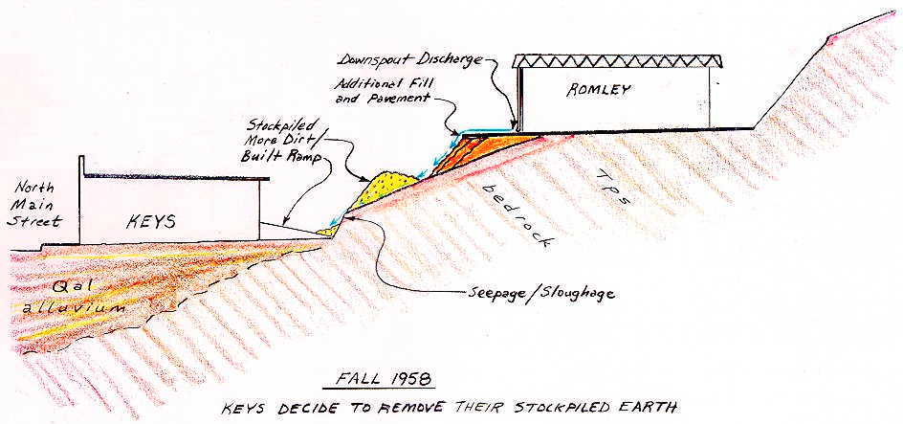

Figure4: In the case of Keys vs Romley (1966), the Doctrine of Reasonable Use was adopted to pertain to collection and conveyance of surface waters on improved parcels. The uphill owner, Romley had constructed his improvements in a manner which is served to unnaturally concentrate run-off onto a cut/fill slope above and behind Keys’ store. Asphalt curbs, drop inlet catch basins, and piped outflow were required to mitigate the problem.

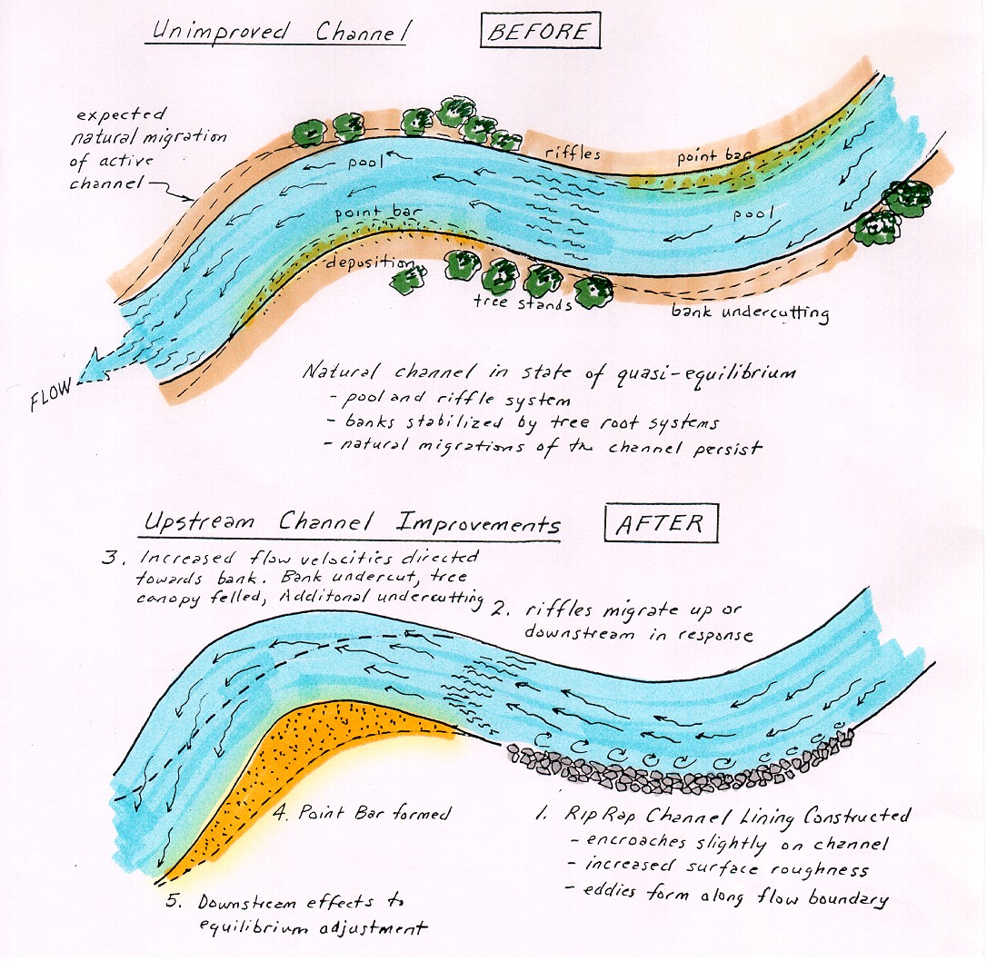

Figure 5

The “common enemy doctrine” reduces the potential liability of a “good faith improves” who takes reasonable action to prevent or retard future flood damage, even if said improvements promote future damages downstream.
However, the "common enemy doctrine" does not relieve landowners of liability for negligence when his diversion of surface water damages another's property. In 1987, the California Court of Appeals reversed a lower court decision that had upheld the common enemy doctrine. The CEB Real Property Reporter (1987) summarized this important case as follows:

Linvill v Perello (1987) 189 CA3d 195

Both parties' lands were adjacent to a natural watercourse which periodically breached its banks during times of flood and caused waters to flow across the properties without significant damage. Defendants then built a levee on their land which directed all the water across plaintiffs' property, causing personal injury and property damage. Plaintiffs sued for negligence. The trial court granted defendants' motion for summary judgment based on the common enemy doctrine, which allows a landowner to build protective barriers against flood waters on his property, even if the barrier then diverts water onto the land of others (see Figure 5).

The court of appeal reversed. Under CC 1714, one is responsible for injuries caused by want of ordinary care in the management of one's property. This principle also applies to natural conditions on land. Sprecher v Adamson Cos.(1980) 30 C3d 358. Under Rowland v Christian (1968) 69 C2d 108, an exception to this rule should not be made unless there is a clear public policy reason to do so.

The court concluded that there is no policy reason to create an exception to the rule for surface waters, as the common enemy doctrine does. Imposing this rule will not necessarily prohibit the development and improvement of land along rivers. The California Supreme Court has declared that the utility of the possessor's use of land is a relevant consideration in determining the propriety of his alteration of the flow of surface waters, see Keys v Romley (1966) 64 C2d 396. The court also noted that the previous supreme court case upholding the common enemy doctrine with regard to flood waters, Clement v State Reclamation Bd. (1950) 35 C2d 628, was decided 18 years before Rowland and, therefore, is probably no longer applicable.

Old Civil Law and the Natural Watercourse Rule

In basic terms, the “civil law rule” developed within California sought to recognize the servitude of natural drainage courses: the lower owner must accept drainage onto his land, and the upper owner has no right to alter drainage so as to increase the downstream burden. But, courts quickly appreciated the Pandora’s Box allowed by such a theorem if every inhabitant of a given watershed normally and naturally subject to flooding is allowed to file a cause of action against upstream parcel owners who they allege have altered the flow.

Beginning with San Gabriel Valley Country Club vs. County of Los Angeles (1907) 182 Cal. 392, courts granted immunity to upstream landowners who make drainage improvements as long as those improvements conform to three basic premises:

1. They have not diverted run-off out of its pre-development, or natural watershed (see Figure 6);
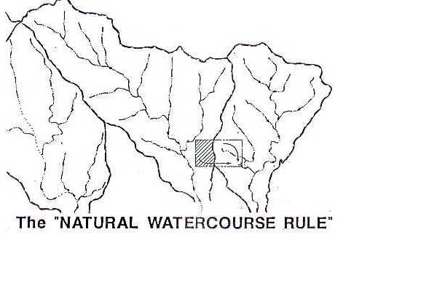
Figure 6: Protection under the legal theorem of the “Natural Watercourse Rule” is violated when surface waters within a natural within a natural watershed are collected and unnaturally discharged in another watershed.

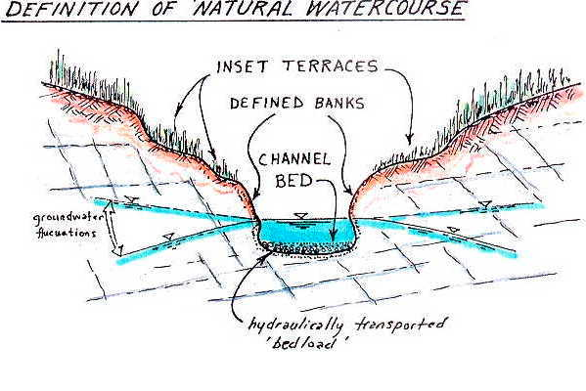
Figure 7: A natural watercourse is defined as a naturally-occurring stream, river, creek, runs, or rivulet. The stream need not flow continuously, it may sometimes be dry. It must be something more than mere surface run-off over the face of the land.

2. Run-off is conveyed to the natural stream course (with bed and bank) that the run-off would have naturally flowed to (see Figure 7; and

3. The upstream improver has not created unnatural diversions, obstructions, or trespassed into the high-flow channel cross section which could be construed as unreasonable, negligent, or worthy of trespass (see Table 2).

The liability relief once spelled by the old Natural Watercourse Rule cannot be understated. Countless flood cases are caused by increases in peak stream flow ascribable to upstream development. As shown in Figure 8, upstream improvements such as impermeable surfaces (pavement, roofs, gutters, culverts, etc.) bring the run-off to a natural stream course much more quickly than in an unimproved or "agrarian" state.

The Natural Watercourse Rule had been challenged unsuccessfully in a large number of cases (see San Gabriel Valley Country Club {1920} and Archer {1941}), but was eventually overturned in the Locklin vs Lafayette, et al case in 1993. Synopses of these cases follow:

San Gabriel Valley Country Club vs County of Los Angeles (1920) 182 C.392.

"The improvements must follow the natural drainage of the country. If the water is diverted out of its natural channel and discharged into a different channel or upon neighboring land, the diverter is liable to the owner whose land is injured."

Archer vs City of Los Angeles (1941), 19 c. 2d 19

Archer lived by a lagoon near the ocean. Tributary watershed to the lagoon area was urbanized, thereby decreasing run-off infiltration and time to concentration and increased peak flow thereby ensued. A non suit judgment was granted in favor of the City. Judgment Statement said "...a lower owner has no right of redress for injury to his land caused by improvements made in a stream for the purpose of draining or protecting the land above, even though the channel may be inadequate to accommodate the increased flow of water resulting from the improvements."

In light of the older, established court decisions, it appears clear that an upper landowner may act with relative impunity in collecting and discharging water from his property into a natural watercourse - even though the additional water may exceed the capacity of the downstream channel.

In addition, it is equally clear that an upstream owner may improve the watercourse to facilitate drainage flow from his property, and the fact that said improvements artificially increase the quantity or accelerate the velocity of the stream flow within the channel is an insufficient basis of which to impose liability.

Locklin vs City of Lafayette (1992) 11 CA4th 1, 13 CR2nd 889

A group of property owners living along lower Reliez Creek, an unimproved channel, alleged in an inverse condemnation action that the City, County, Walnut Creek, BART and Caltrans benefited from the channel’s use as a quasi storm runoff channel, and that because of increased flow due to public improvements, their channel had been unnaturally eroded. In 1988 the trail court granted motions for a nonsuit for 4 of the 5 defendants, citing the Natural Watercourse Rule, which then allowed the establishment of drainage improvements within a natural watercourse, even if said improvements cause increased runoff downstream. This decision was affirmed by the appellate court. The lower courts felt that the plaintiffs had not demonstrated that the public agencies had exercised the kind of control necessary to convert the creek into a public improvement, despite accepting flows from hardened improvements located upstream.

In February 1994 the case then came before the California Supreme Court (7Cal 4th 327, 1994), who partially overturned the decision, there by rescinding the natural watercourse rule. The Supreme Court eliminated the immunity afforded by the Natural Watercourse Rule and instead held that anyone or any agency can be held liable if they act unreasonably in the collection, conveyance and discharge of surface waters. The Court also imposed an obligation on the part of individual property owners to take reasonable actions/precautions to protect their banks from threats of erosion and flooding; and that, if said individuals act unreasonably, they cannot recover for damages which then occur (similar reasoning to the common enemy doctrine, discussed elsewhere). The Locklin decision means that public agencies, in particular, will no longer be granted summary judgements in flood cases involving natural channels, as had been the case for the previous 85 years.

Negligent Diversion or Disturbance of a Natural Watercourse

Even with the recent overturning of the natural watercourse rule, flood water damages have always resulted in liability if there is a diversion of the waters onto property which would otherwise have been unaffected (see Van Alstyne 1969, p. 454). In inverse condemnation liability, the proximate cause of damage is a major consideration. In other words, was a diversion or a negligent act a substantial cause of the alleged loss? In legal terms, the burden of "proof" often times lies in proving that the flood-induced damage was over and above that which would have occurred in the absence of a structure or activity that gave rise to an unnatural diversion or protuberance of the natural flow regimen. Those factors most often cited as being unreasonable behavior inexpert testimony are summarized in Table 2.

TABLE 2

Activities Undertaken Within Channels Commonly Deemed “Unreasonable”

Collecting surface waters from one natural watershed and concentrating into another
Concentrating discharge in any manner of hardened improvement, such as lined channel, culvert or pipe, in such a manner as to cause unnatural increase in runoff velocities and/or concentration of runoff quantity that actually leads to unnatural or accelerated erosion, which occurs as a direct consequence of said improvement
Causing unnatural concentrations of surface flow due to physical encroachment on an unimproved (natural) channel within the FEMA 100-year recurrence interval flow area
Causing unnatural bank erosion through excavation or dredging of the channel substantially outside the centerline (thalweg) of flow
Creating obstructions to flow by blockage, dumping or inadequate diversion of any natural channel or swale, or of an improved channel (common in construction related activities)
Failure to maintain hardened drainage improvements within a reasonable time interval of learning that flow capacity has been hindered or impaired by any manner of hazard, such as catchment of organic debris, siltation, accidental mechanical damage or weathering
Negligent design of channel improvements

Two principal cases pertaining to activities within channels are most often cited. Flooding ascribable to inadequate runoff collection system is not negligence per se, as described in the Tri-Chem decision. The Ektelon and Linvill cases involved alleged negligent activities within channels, and thereby came to be judged under doctrines of reasonableness now commonly associated with surface water collection, conveyance and discharge.

Tri-Chem vs Los Angeles Flood Control District (1973) 60 Cal. App. 3d 309

The plaintiff owned a parcel of naturally low-lying ground in an industrial tract in Torrence. Run-off from natural slopes to the south caused run-off to collect on the property. One cross street culvert served to drain the plaintiff's property (see Figure 8). The capacity of the drainage trunk line into which the plaintiff's culvert entered was only that expected from a 2 or 3-year frequency storm, the mouth of such line having been built in 1940. In January 1969, during a 17-year recurrence frequency storm, the capacity of the trunk drain line was exceeded by a factor in excess of 200%. This increased factor resulted in the breaching of a sandbag dike, which resulted in the flooding of the plaintiff's property. The Court upheld the Flood Control District's assertion that it was not liable for flood damage on the basis that its conduct, in and of itself, was not a proximate cause of the plaintiff's damage. The City and Flood Control District were further able to contend that they were not negligent in maintaining their portion of the flood control system. The Court found that, although the flood control improvements were aged and undersized, they still constituted an improvement which provided benefit to the plaintiff, without which flooding would have been worse.

Ektelon v City of San Diego (1988) 200 CA3d 804

A downstream riparian owner sued the City of San Diego and others for flood damages caused by the City's construction of upstream flood control facilities. The trial court granted defendants' motion for nonsuit, but the court of appeal reversed.

The trial court had relied on Archer v City of Los Angeles (1941) 19 C2d 19. The court in that case held that an upstream owner is not liable for injuries resulting from improvements made to protect the upstream land even if the channel is inadequate to accommodate the subsequent increased flow of water. In a later case, however, the California Supreme Court held that an upper landowner must act reasonably with regard to the discharge of surface waters from his land. Keys v Romley (1966) 64 C2d 396. This principle of reasonableness applies to stream waters as well as surface waters. Linvill v Perello (1987) 189 CA3d 195, 234 CR 392 (10 CEB RPLR 94 (June 1987)). As a consequence of Linvill, upstream flood control improvements are now subject to principles of ordinary negligence. As noted in Linvill, application of negligence principles will not hinder the development and improvement of land along river bottoms; a rule of reasonable conduct, which weighs the utility of upstream diversion of flood waters against the gravity of harm caused to downstream lands, is not inconsistent with development concerns.

Typical Hydrograph
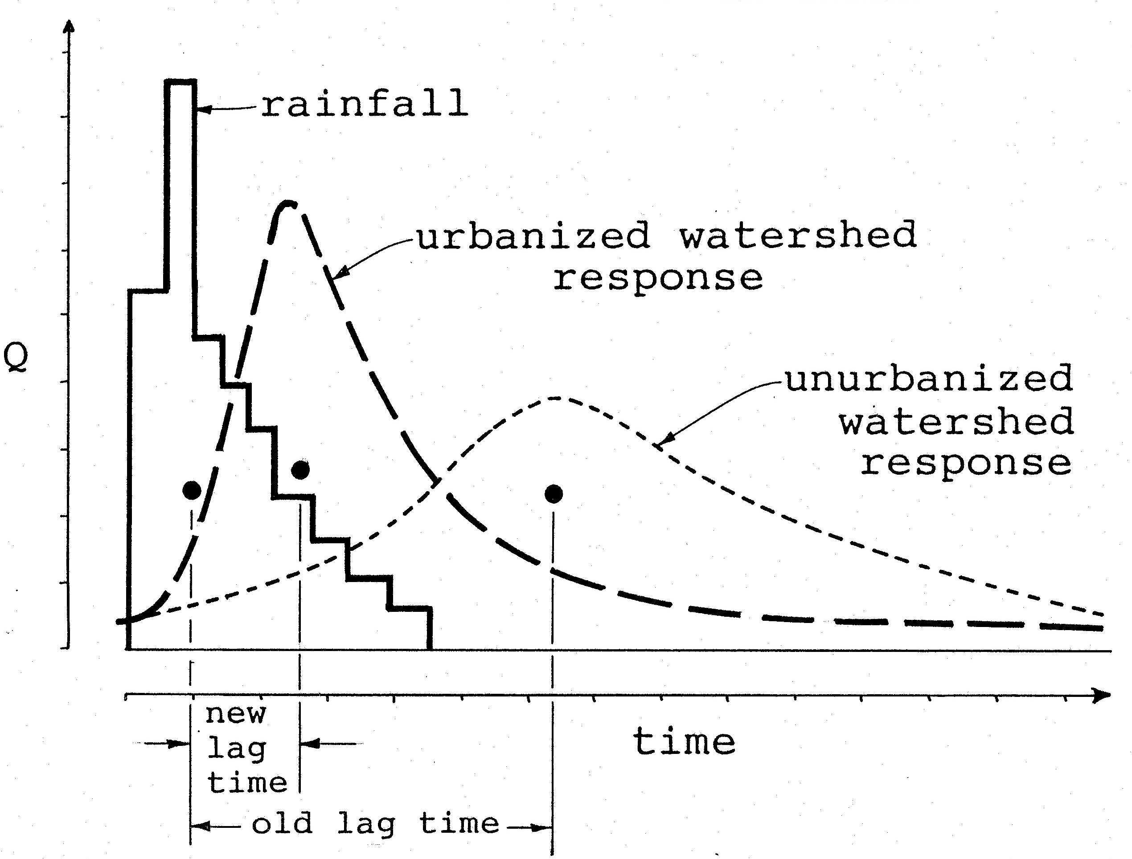

Figure8: Schematic representation of changes in peak stream flow due to adjustment of a perturbed watershed. The lag time is the interval between the mean rainfall occurrence and the mean run-off in response to such rainfall. The lag time can be significantly reduced as the watershed run-off characteristics are changed by paving and urbanization, vegetation change, over grazing, or weather pattern change. Most California streams have made marked adjustments over the past century, due, in part, to all of the above-cited factors. The creeks with the greatest flows adjust first, with successively smaller tributaries adjusting more slowly, due to their lower stream power. Arid areas generally take longer to adjust than do areas of greater precipitation and run-off. Many inverse condemnation suits seek damages from public agencies on the basis of drainage improvements reducing lag time, and therein increasing peak flows which are more destructive and erosive.

Common Sources of “fault” in Flood Cases Involving Public Entities

In order to trigger inverse condemnation liability a plaintiff must demonstrate some manner of preventable fault on the part of the public entity. The burden of proof for the plaintiff in a flood control/levee failure case normally focuses on the demonstration of:

a. failure to properly maintain the levee structure in such a manner that such neglect was a direct or significant factor in the levee's subsequent failure; or

b. that the levee or its appurtenant structures were originally constructed in a negligent manner which significantly contributed to the levee's failure.

Allegations of negligence in design or maintenance are usually "necessary" because they are the only tried and true avenues of "levee liability". In order to trigger maintenance liability, some demonstration of the levee owner's (respondent) legally imposed duty to maintain the levee will first have to be made. Such allegations have failed on several occasions with actions involving the L.A. County Flood Control District, having been formed by referendum in 1916 (see citations, bottom p. 587, in Hayashi vs Alameda F.C.D., (1959) 167 Cal App 2d p. 584) (shown in Figure 9). Districts formed at later dates may have somewhat more explicit mandates with respect to maintenance. In the Hayashi case, Alameda F.C.D. had been formed in 1949 with a more explicit mandate for maintenance responsibility. In that case, the court asked:

"after the public improvement is constructed, is the District, after notice, under an obligation to maintain it (the levee) in such a manner so as not to injure the adjoining property as the result of negligent maintenance?"

In the Hayashi case, the plaintiff had notified the District 10 and 21 days prior to the subject losses. This prior notice sealed the case, and most subsequent cases of proven prior notice, in the plaintiff's favor.

The Hayashi case also went on to explore some of the "common enemy" flood control doctrines normally brought out by public agencies in their defense. These include:

a. "Under the general common law, there can be no doubt that a landowner is responsible for damages caused by the negligent disrepair of an artificial structure." (taken from Hayashi)

But, it would appear that liability is only incurred if it can be shown that reasonable maintenance would have disclosed the problem and that the problem could have been made reasonably safe through quick and judicious repair; or that the owner/maintainer were put on notice that a repair might be needed and failed to heed such notice (thereby possibly being negligent).

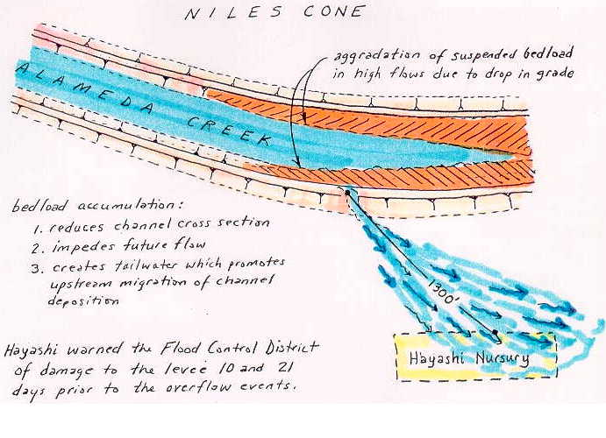
Figure 9: In the case of Hayshi vs. Alameda County Flood Control (1959), the plaintiff prevailed in his flood damage suit because the District’s mandate specifically includes flood control maintenance responsibility. Hayashi had warned the District of a weakened levee area 10 and 21 days prior to the actual breach and the Court found the District liable for not providing reasonable maintenance in light of the prior notice of the problem.

The Hayashi Decision (p 590) went on to state:

b. "If a structure suddenly and without the fault of the processor becomes dangerously dilapidated, the possessor is not subject to liability for any harm done thereby to persons outside the land until he has had an opportunity, by the exercise of reasonable care, to make the structures safe."

In conclusion then, it would appear that a levee owner in California is only liable for flood damage caused by the negligent maintenance, construction, or permitting hazardous activities in proximity to the levee.

Belair vs Riverside County Flood Control District (1988) 47 Cal 3d 550

The most severe challenge to the doctrine of proving unreasonable conduct was the recent case of Belair vs Riverside County Flood Control District. In 1980, a flood control levee on the San Jacinto River failed at a flow volume only 29% of that which the channel had been originally designed to function by the U.S. Corps of Engineers in 1960. Parts of San Jacinto were flooded. Various property owners sued the flood control district and State for damages under inverse condemnation theory. Unable to show fault on the part of the State or the District, the plaintiffs' attempted to establish inverse condemnation tort without fault. But, the trial court entered judgment for defendants and the court of appeal affirmed. The California Supreme Court also affirmed in December 1988, but on different grounds.

The levee was designed and constructed to contain a flood discharge of 86,000 cubic feet per second (cfs), and the discharge at the time of breach was only 25,000 cfs (see Figure 10). Plaintiffs contended that this fact established that the levee had failed to function within its design capacity, which was all that they were required to prove. As in the case of Tri-Chem, the trial court had also found, however, that plaintiffs' properties had been subject to periodic flooding before construction and that the levee had not increased the risk of flooding. On the basis of this finding, the court of appeal had held that the levee was not the proximate cause of plaintiffs' damages (the rain was).

The supreme court rejected the court of appeal's proximate cause analysis, concluding that the levee was a substantial concurring cause because it was designed to contain 86,000 cfs and it failed to function as intended. The prior flooding was not significant because owners had been induced to improve their property in reliance on the protective ability of the levee. The court also held that plaintiffs were not required to prove that the levee had increased the risk of flooding; a public improvement need not worsen a pre-existing hazard to give rise to liability for inverse condemnation.

Nevertheless, in a flood control case, plaintiffs cannot rely on a simple strict liability theory. The rule of Albers v County of Los Angeles (1965) 62 C2d 250, 263 - i.e., imposing liability for any actual physical injury to real property proximately caused by the improvement as deliberately designed and constructed - is subject to the exception established by Archer v City of Los Angeles (1941) 19 C2d 19, 24, which recognized that, in some situations, the state has a right to inflict damage, based on the common law right of landowners to erect barriers to ward off flood waters (known as the common enemy doctrine). However, a public agency engaged in the activity of flood protection must at least act reasonably and non-negligently. "[The fact that a dam bursts or a levee fails is not sufficient, standing alone, to impose liability. However, where the public

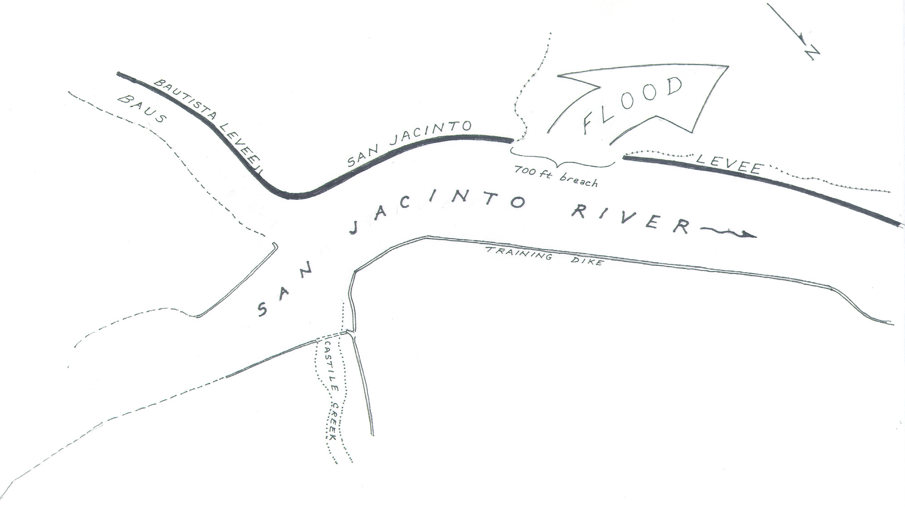

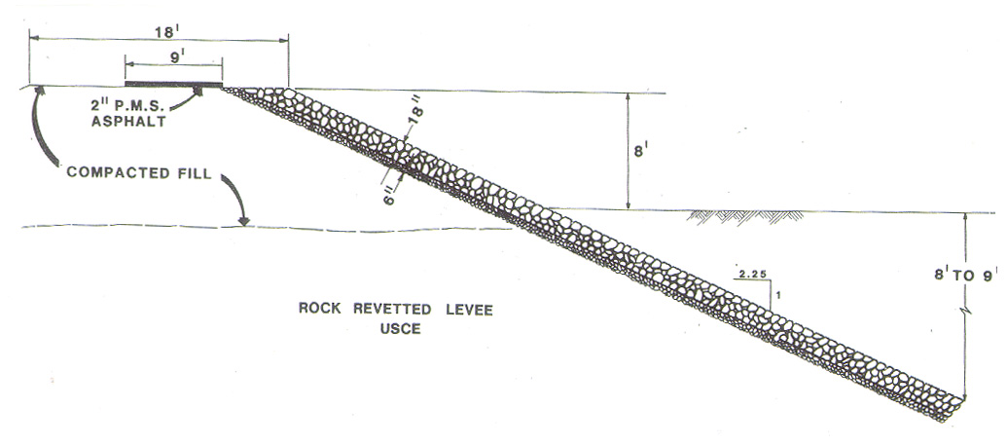

Fig. 10 - The San Jacinto Levee was designed and built in Riverside County under the auspices of the Los Angeles District of the U.S. Corps of Engineers in 1960-61. The levee failed in 1980, while experiencing a flow of only 29% of design-channel capacity. A protective rip-rap apron was designed for the river side of the levee extending 10 feet below the channel bed, shown in the lower inset above (Edwards, 1982). Unfortunately, the on-site materials were not adequate to provide the proper percolation filter between the rip-rap and the sandy loam soils comprising the dike embankment (Sciandrone, et al, 1982). It is likely that a helical underflow current developed against the inside face of the levee just downstream of the turn shown above. This downward current likely undercut the levee well below the dry channel bed and succeeded in causing hydraulic piping of the levee materials through the rip-rap. The plaintiffs tried to establish inverse condemnation sort without showing fault on the part of the defendant.

agency's design, construction, or maintenance of a flood control project is shown to have posted an unreasonable risk of harm to the plaintiffs, and such unreasonable design, construction, or maintenance constituted a substantial cause of the damages, plaintiffs may recover regardless of the fact that the project's purpose is to contain the 'common enemy' of flood waters" 47 C3d at 565.

In this case, plaintiffs failed to establish that the flood damage was the result of any unreasonable act or omission by the defendants. Therefore, the Supreme Court affirmed the judgment in defendants' favor.

Although Belair stands as a landmark decision affirming the torts protecting flood control districts, the Supreme Courts' recognition that the levee's failure at something less than its design capacity opens a tort liability door for future plaintiffs, especially those other than flood control districts (i.e. reclamation districts, municipal water agencies, etc.).

DRAINAGE EASEMENTS

The expressed purpose of most drainage easements is for storm water drainage, including construction access or maintenance of work, improvements, and structures, and also for the clearing of obstructions and vegetation.

If evidence establishes that there has never been any construction or maintenance of any works, it can be shown that the Public Agency never exercised any dominion, or control, over the channel - thereby negating an implied acceptance cause of action.

Formal acceptance of easements requires an ordinance or resolution of the governing legislative body which has jurisdiction, expressly accepting the offer of dedications. See County of Inyo vs Given (1920), 183 C. 415, 191, p. 688 and Santa Clara vs Ivancovich (1941) 47 C.A. 2d 502, 188, p. 2d 303.

Generally speaking, there are two ways that easements can be accepted via the Subdivision Map Act:

a. Public entity expressly accepts the offer of dedication on the final map (becomes effective when map is filed) Government Code 66477.3.

b. Official Resolution of the Public Entity accepting an offer of dedication Government Code 66477.3.

Once there is an offer of dedication, the offer remains open and cannot be revoked, except as provided by statute. Government Code 66475 and 66477.2.

Even if an offer is rejected, the offer remains open in perpetuity and governing body may later rescind its actions and accept the offer by appropriate resolution. Government Code 66477.2.

An agency should be careful to check and see if the easements drawn up on improvement plans were ever accepted and recorded. These are termed statutory dedications, governed by the Statutory Map Act and are exclusive of the Common Law Rules for dedication.

In many instances, an agency such as a water district will utilize approved development plans for purposes of planning adjacent improvements or maintenance activity. Although approved plans usually show proffered easements, this doesn't mean that the easements have actually been accepted. Many lawsuits are erroneously filed on the part of plaintiffs who assume easement boundaries are in effect when, in fact, they are not.

IMPLIED EASEMENTS OR IMPLIED DEDICATIONS

In the California Government Code section directly following the provision for formal easement acceptance (GC 66477.4), a governmental agency is prevented from disregarding an offer of dedication if it then moves forward and uses the improvement for the public good and welfare. The public use can theoretically be substantiated as "constructive acceptance".

Plaintiff attorneys probing this area of law maintain that public entities make a calculated risk decision when they take no action or measures on the basis of "no easement - no liability exposure for loss". Any facility or activity that is clearly tinged with public use or benefit can be theoretically construed to be a form of constructive easement acceptance in lieu of a formal acceptance of dedication. The legal theory supporting this is basically constitutional, emanating from an individual's 5th Amendment Rights to be justly compensated for governmental usage, taking, or in the case of California, simple damage. In this manner, an individual is not singled out to bear the environmental or financial burden of public agencies' decisions.

Some examples of the more interesting implied dedication cases are presented below.

Marin vs City of San Rafael (1980) 111 Cal App. 3d 591

Some time prior to 1942, the City of San Rafael required that a 12-inch-diameter culvert be installed along and under the surface of newly-constructed Jewell Street to a point where it turned westward and continued for 12 feet onto what was to become Marin's lot. There the culvert discharged into the natural watercourse (gully). Around 1949, the City began issuing building permits for another development, uphill and to the northeast. This development increased the demands on Jewell Street's 12-inch culvert, so it was replaced by the City with another, 21 inches in diameter, again extended onto Marin's yet-to-be-developed lot. The parcel owners permission for the successive placement of the pipes had not been sought by the City, nor was such placement objected to by the owner.

Around 1950, the parcel's owner extended the 21-inch pipe downhill and beyond the lot's lower and western boundary, backfilling with fill over the pipe to create a more level development pad. This placement had been accomplished with the knowledge and even advice of a City employee, the City even providing the fill.

In 1952, a home was constructed on the lot over the buried 23-inch drainage pipe (see Figure 11). A building permit had been issued by the City. The plaintiffs (Marins) purchased the home 21 years later, in 1973. They had not been informed of any storm drain line or culvert beneath the property. Twenty-one months later, water gushed up into the basement due to the pipe being filled to over capacity. The plaintiffs asked the City to take care of the problem and were told that "it was a private problem, and, as far as they were concerned, the pipe didn't exist, it was up to the homeowner to take care of it".

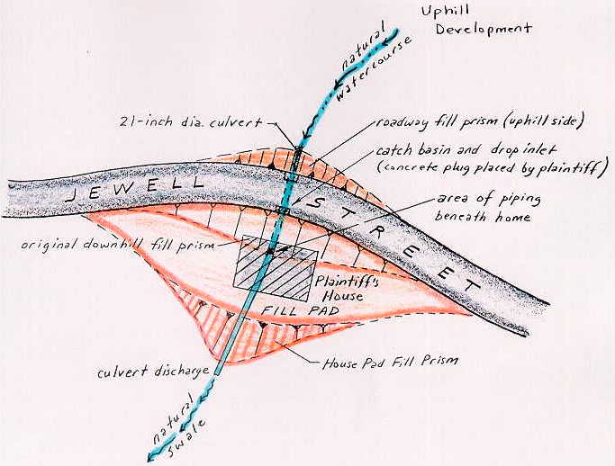

Figure 11: In Marin vs. San Rafael, a road fill (1942), culvert (1949), fill pad (1950), and home (1952) were constructed upon and across a topographic swale containing a natural watercourse. The City’s cross-road culvert had been extended across the lot to accommodate fill for the house pad with the City’s knowledge in 1950. In 1975, the homeowner (Marin) began to notice foundation soils collapsing over the culvert extension during peak run-off events. The City denied responsibility for maintenance or repair, saying “as far as they are concerned, the pipe doesn’t exist”. Marin then blocked the pipe with concrete, therein causing a back-up of run-off behind the roadway fill prism, which flooded onto Jewell Street! Marin prevailed in Court in an inverse condemnation action against the City under the doctrine of easement implied by usage.

The plaintiffs responded by placing a "concrete obstruction" in and above the rupture to the pipe "in order to prevent further damage to their property". The City then sought an injunction compelling plaintiffs "to remove the concrete plug from this storm drain and to restore the storm drainage system to a condition that is operational ....."

Although the court supported the City's defense, the Appeal Court reversed, ruling that the plaintiff's property had suffered physical damage proximately caused by a public improvement or public use maintained as deliberately planned and designed by the City. The Appeal Court further found that none of the plaintiff's damages were caused by their own act, or fault, or negligence.

Chatman vs Alameda County Flood Control District (1986) 183 CA 3d 424

A similar series of events were tested in the case of Chatman vs Oakland (1988) and Chatman vs Alameda County Flood Control and Water Conservation District (1986) 183 Cal App 3d 424. In this case, a hillside area was subdivided in east Oakland between 1912 and 1916. At that time, a culvert was placed across Lyon Creek and backfilled with fill to allow a road crossing. The culvert was then extended and backfilled to create a buildable lot which was subsequently developed in 1923. Chatman moved into the house in 1965 and began to notice settlement beneath her home during a peak run-off period in January, 1982. An inspection of the old culvert beneath her property revealed that it had become cracked and that soil backfill was piping into the culvert during periods of high flow. The resulting soil cavities were then collapsing, undermining the Chatman home (see Figure 12).

As in the case of Marin, both the City and the local flood control district disputed responsibility on the basis of ownership versus use. The culvert section beneath Chatman did not lie within an accepted easement and the line was considered to be privately owned, and therefore, privately maintained. The Flood Control District eventually prevailed in their defense because the plaintiff had allegedly implied dedication through annual inspections begun by the District in 1963. The Court held that, although the District knew of the dangerous condition of the culvert through its inspections, it could not be held liable for damage caused by the culvert unless it had owned, controlled, constructed, repaired, or maintained the culvert. There was no discussion by the Court as to whether the District had a responsibility to inform the affected property owners of the damaged culvert as soon as the District learned of its condition. However, in the remaining suit against the City of Oakland, Chatman eventually prevailed (see Cal Jury Verdicts, V. 32, n. 32, Aug. 5, 1988). The Court ruled that the public benefited from the culvert section within the Chatman property. After all, had Chatman blocked the culvert or filled it in (as Marin did) grievous flood damage would have resulted to the surrounding neighborhood. The City had also exerted control in the letting of building permits, allowing for the construction of a home over the culvert. Oakland countered by maintaining that the creek was not a natural watercourse, but a man-made channel constructed for the homeowners' benefit and convenience. This would appear to have been an incompetent defense as Lyon Creek is one of the earliest mapped landmarks in the East Bay, having formed the land-grant boundary between Ignacio and Antonio Maria Peralta in 1820 (one of the four original land grants in the San Francisco East Bay). The Court ruled in favor of the plaintiff.

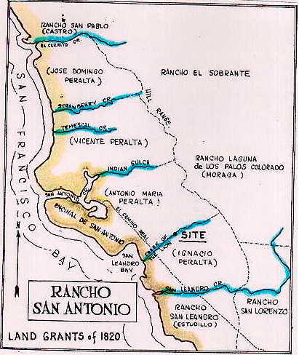
Figure 12

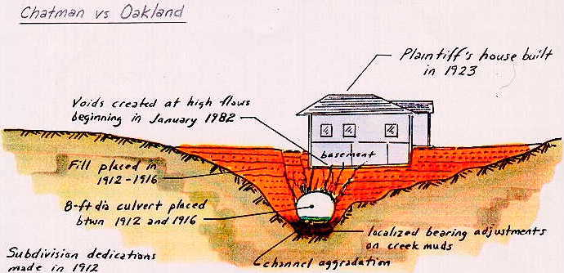

Figure13: In the case of Chatman vs. Oakland (1988), a plaintiff in the inverse condemnation action alleged implied dedication of their own 8-foot-diameter culvert on the basis of its continual usage, benefiting the public welfare. Although the plaintiff prevailed again the City, it lost and earlier inverse suit against the County Flood Control District on the basis of inspections being grounds for inverse tort. The city’s assertion that Lyon Creek was not a natural watercourse was unfounded based upon early maps of the region (above).

BURDEN OF PROOF OF "PUBLIC USE”

In many other cases, plaintiffs have been less successful in alleging that there was sufficient public use or benefit of improvements made on private property. In the case of Cantu vs PG&E (1987) 189 Cal App 3d 160, plaintiffs purchased a lot in a 16-unit subdivision with private drives for access. Before any of the lots were sold, PG&E had installed an 18-inch-wide, 6-foot deep utility trench for gas, electricity, and telephone.

The plaintiff's property experienced a landslide during the winter of 1980-81 that their expert alleged was due, in part, to the collection of water in the PG&E utility trench. Plaintiff sued PG&E under theories of inverse condemnation, trespass, and nuisance. The trial court found defendant inversely liable and rejected PG&E's defense of comparative negligence. The jury upheld PG&E's defense on the trespass and nuisance actions and returned a verdict of no damages for plaintiff.

The court found that utility districts have the legal right to:

a. Condemn lands to furnish utilities for customers; or
b. Operate and maintain lines along private property without condemning property.

In the Cantu's case, PG&E did not condemn the property nor did they condemn the land in an eminent domain proceeding.

The Court concluded by stating that "the law of inverse condemnation, viewed broadly and in perspective, seeks to identify the extent to which otherwise uncompensated private losses attributable to governmental activity should be socialized and distributed over the taxpayers at large rather than borne by the injured individual" (quoted from Val Alstyne, 1969.) The court, after citing this language, held that the trench did not benefit the public at large and that the running of line extensions to plaintiffs' residence was not the type of quasi-public activity where the risk of injury should be spread over society.

CONCLUSIONS

Inverse condemnation proceedings are supported in theory by individual rights of government compensation for the taking or damaging of property. In most instances, the public agency has caused unintentional physical damage to property. Liability in inverse condemnation for unintended physical damage is proper when the damage resulted from a public entity's ownership, maintenance and/or use of a public improvement. When a public agency fails to construct or maintain its improvement properly, it takes a calculated risk that damage to private property may occur. If damage to private property results, it is proper to require the entity that took this risk to bear the loss when damage occurs.

The "Reasonable Use" rule that has applied to surface waters since the Keys/Romley Case of 1966 was recently upheld in the California Supreme Court decision in the Locklin case. As a consequence, the "Common Enemy Doctrine" only affords protection insofar as the actions taken by someone to protect their property can be deemed “reasonable”, as constructed and as maintained.

There is little question about liability in the case of buried improvements, such as culverts or pipes -- whoever owns these is strictly liable for the damage they cause. However, recent decisions have served to extend such liability to those sections of buried conduit that are privately owned, but through which "public agency waters" may flow or be diverted to. We can expect the area of "Implied Dedication" suits to enlarge over the coming decade because private insurance carriers have extensively modified their policies to exempt all manner and form of flood or earth movement losses. If the damaged property is aged enough to be beyond applicable statutes of limitations for patent or latent defects, the public agency becomes the only entity with which to file suit.

According to many recent cases in California, public entities may be liable under inverse condemnation for any damages to property caused by a public improvement as deliberately designed and constructed, regardless of any fault or negligence by the Agency (see Olshansky, 1989, p. 110).

As the cost of litigation continues its skyward acceleration in California, the burden will have to be spread back to the consumer via the embattled agencies. Flood peril is the only nationally adjudicated program which provides protection and relief from this type of natural disaster. But, NFIP proceeds only pay for a single occurrence of flooding, after this the parcel owner must raise their floors to be above the 100-year or 500-year inundation levels. No other systematic system of insurance exists to accommodate the potentially prodigious losses that will be posed by massive infrastructure aging/corrosion, earth movement, environmental pollution (such as selenium), or earthquakes. Each of these could easily spawn losses in the billions of dollars, the likes of which are probably not yet well appreciated by decision makers.

REFERENCES

Bull, W.B., 1991, Geomorphic Response to Climatic Change: Oxford University Press, New York, 326 p.

California Council of Civil Engineers and Land Surveyors, 1981, Drainage Law Syllabus, prepared by Turner and Sullivan, Sacramento, Short Course Notes, 82 p.

Edwards, K. L., 1982, Failure of the San Jacinto River Levees Near San Jacinto, California, From the Floods of February 1980: in Storms, Floods and Debris Flows in Southern California and Arizona in 1978 and 1980: National Research Council, National Academy Press, Washington, D.C., pp. 347-356.

McGuire, J.F., and Noziska, C.B., 1988, Landslide and Subsidence Liability Supplement, March 1988; Calif Continuing Education of the Bar, Supplement to California Practice Book No. 65, Berkeley, 182 p.

Morgan, A. E., 1952, The Miami Conservancy District: McGraw-Hill Book Co., New York, 502 p.

Olshansky, R.B. and Rogers, J.D., 1987, Unstable Ground: Landslide Policy in the United States: Ecology Law Quarterly, V. 13, n. 4, pp. 939-1006.

Olshansky, R.B., 1989, Landslide Hazard Reduction: A Need for Greater Government Involvement: Zoning and Planning Law Report, V. 12, n. 3 (March) pp. 105-112.

Olshansky, R.B., and Rogers, J.D., 1992, The concept of reasonable care on unstable hillsides: in Slosson, J.E., Keene, A.G., and Johnson, J.A., eds., Landslides/landslide Mitigation: Boulder, Colorado, Geological Society of America Reviews in Engineering Geology, v. IX, pp. 23-27.

Rogers, J.D., Pleistocene to Holocene Transition in Contra Costa County, California: in Geology of San Ramon and Environs, Northern California Geological Society Field Trip Guidebook, ed. R. Crane, pp. 29-52.

Shuirman, G., and Slosson, J.E., 1993, Forensic Engineering: Academic Press, San Diego, 256 p.

Sutter, J.H. and Hecht, M.L., 1974, Landslide and Subsidence Liability: California Continuing Education of the Bar California Practice Book No. 65, Berkeley, 240 p.

Slossen, J.E., McArthur, R.C., and Shuirman, G., 1987, Legal Misuse of Urban Hydrology Concepts and Regulations for Rural Areas; Engineering and Hydrology Proceedings, Hydrology Division, Am. Soc. Civil Engineers, Williamsburg, VA, Aug. 3-7, 1987, pp. 714-719.

Sciandrone, J., Albrecht, T., Davidson, R., Douma, J., Hammer, D., Hooppaw, C. and Robles, A., 1982, Levee Failures and Distress, San Jacinto River and Bautista Creek Channel, Riverside County, Santa Ana River Basin, California: in Storms, Floods and Debris Flows in Southern California and Arizona in 1978 and 1980: National Research Council, National Academy Press, Washington, D.C., pp. 357-385.

Van Alstyne, Arlo, 1969, Inverse Condemnation: Unintended Physical Damage: Hastings Law Journal, V. 20, n. 1 (January), pp. 431-516.

V.T. Chow and N. Takase, 1977, Design Criteria for Hydrologic Extremes: Journal of the Hydraulics Division, Am. Soc. Civil Eng’rs, v. 103, n. HY4 (April), pp. 425-36.

? presented at the San Francisco Insurance Claims Forum in San Francisco, April 16, 1997

