Aerospace Laboratory Shock Tube Diaphragm Mount

Development of a diagram retaining/mounting system for a 2.5 x 2.5 compressed air shock tube.
Background:
The S&T Aerospace program has a number of laboratory experiments for instruction of students on various facets of Aerospace Engineering. One of these systems is a compressed air shock tube. Its purpose is to generate a pressure wave traveling down a closed tube, which is then measured for both pressure and velocity. This pressure is developed by charging a fixed volume to a desired pressure (typically under 200 PSI) and then rupturing a diaphragm to allow the pressurized air to expand down the tube. An overview of this system is shown in Figure 1. This diaphragm is expendable and must be replaced after each “shot” of the tube.

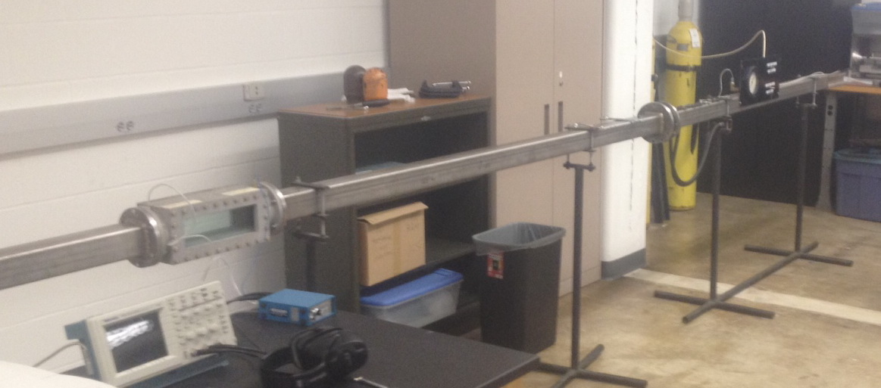
Figure 1 Overview of shock tube system
Diaphragms are currently cut from plastic material, inserted between two o-ring sealed flange faces and clamped in place with either bolts or c-clamps. This process has been and continues to be tedious and inconsistent. Figure 2 shows one of these diaphragms after rupture.

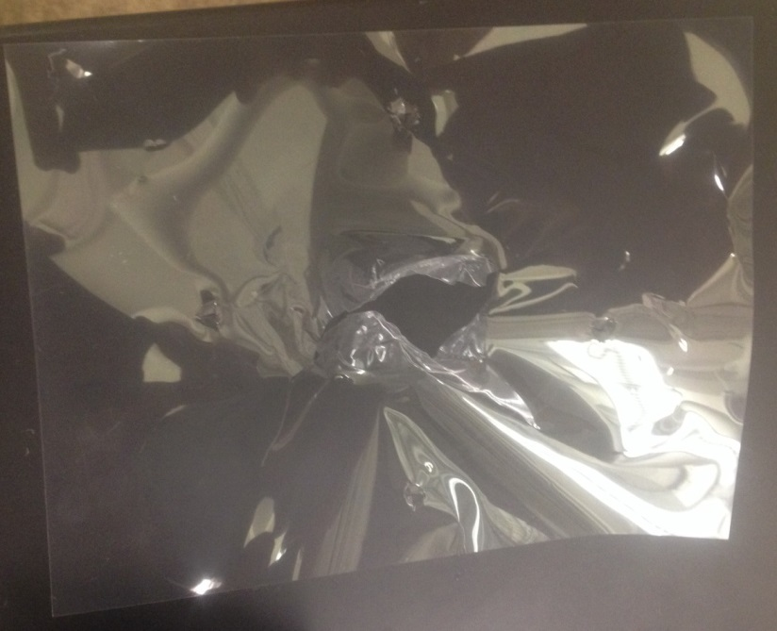
Figure 2 Ruptured diaphram
Problem Description:
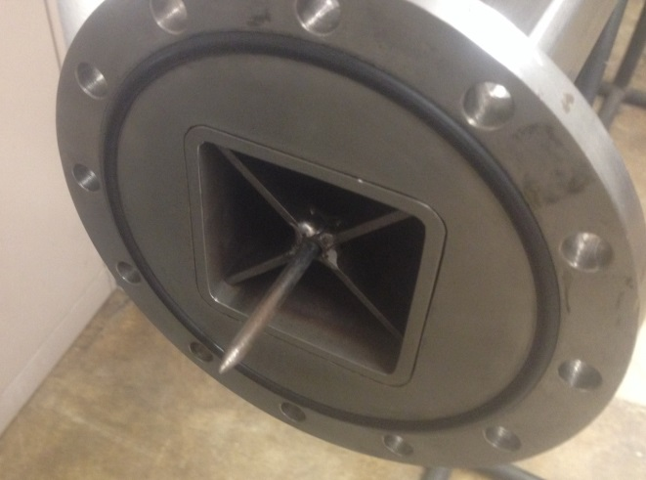
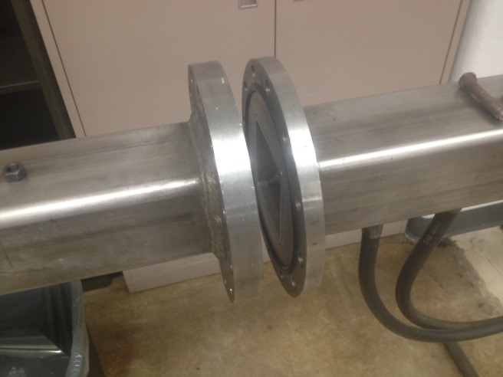
Provided the existing tube and chamber, develop a new method to replicate the pressure release without the use of a disposable diaphragm. This system should fit to the downstream flange and replace the upper flange and chamber assembly seen in figure 4.
Figure 3 Pressure end with poker extended
Figure 4 Flange interface

The new system designed must be able to be installed on the existing flange without modification to the existing system The system must not make any permanent changes to the downstream sections or flange.
Design Requirements and considerations:
- The system must be capable of installation on the existing experimental system without permanent modification of the system.
- The system must be capable of functioning up to 300 PSI of air.
- The system should be simple and quick to operate. A typical experiment run would optimally allow ten or more firing sequences in the course of the hour lab section.
- The system should open within 100 microseconds from fully closed to fully open.
- The system should have a compressed air volume capacity of not less than 560 cubic inches.
- The system must be safe and capable of withstanding pressures of up to 300 PSI. The actual charge pressure will vary based on the intended shot intensity.
- The system should operate at a pressure as low as 50 PSI.
- System design considerations should include modes of potential failure and safety of personnel in the area if such a failure should occur.
Outcome expected:
It is expected that at the completion of the project a new firing system will have been designed, and all documentation required for machining and fabrication of the system will be included in the final deliverable. Functional prototyping (at low pressures) is a plus, but not a requirement. Full shop drawings for machining are required.

