FINITE ELEMENT ANALYSIS AND FATIGUE TEST ON THE BICUSPIDS TO SUPPORT THEORY OF ABFRACTION

by

MADHUCHANDARA MAHADEVASWAMY

A THESIS

Presented to the Faculty of the Graduate School of the

MISSOURI UNIVERSITY OF SCIENCE AND TECHNOLOGY

In Partial Fulfillment of the Requirements for the Degree

MASTER OF SCIENCE IN MECHANICAL ENGINEERING

2010

Approved by

Lokeswarappa R. Dharani, Advisor
William B. Moorkamp
Douglas R. Carroll

ABSTRACT
Abfraction is a small crack or notch found at the cervical area of teeth due to the loss of enamel tissues in the teeth. Proposed explanations for abfraction are that it is caused by toothbrush abrasion, acid erosion, and the mechanical forces applied on the teeth due to chewing, biting, tongue activity. There is disagreement among dentists as to the primary causes of abfraction. Some dentists believe that abfraction is caused by toothbrush abrasion and erosion due to acidic food and drinks. Other dentists believe that tensile and compressive forces acting on the teeth from non-axial, cyclical loading over an individual’s lifetime cause the breakdown of the microstructure of the teeth, which can lead to the non-carious cervical lesions (NCCLs) called abfractions.
In the present study, 2D and 3D teeth structures were modeled and studied by simulating the biomechanical forces acting on the teeth using the ABAQUS finite element code. 3D teeth were modeled on MIMICS, 3D image processing software from scanned images of the premolar teeth using the I-CAT 3-D Imaging System. Experiments were conducted using a non-axial eccentric cyclic loading system applied to teeth samples extracted from the patients.
The objective of this research is to provide evidence to support the theory of abfraction by simulating the behavior of the teeth at the buccal and lingual cervical regions when the mechanical forces are applied on them and by showing the wear of the enamel structure at the microscopic level by applying a non axial cyclic load on the teeth samples.
ACKNOWLEDGEMENTS
I would like to express my deepest gratitude towards my academic advisor, Dr. L. R. Dharani, for his continued support and guidance during the course of this study, and for financially supporting me for the work.
Also would like to thank Dr. Douglas R. Carroll for suggesting that this topic be studied and for being on my advisory committee.
Very Special thanks to Dr. William B. Moorkamp for his support and guidance, who not only spent a good deal of his time working with me but also for his knowledge and dental advice on this research. I would like to extend the appreciation towards his friends who let me use their machine and helped in collecting the teeth samples for the experiment.
I would like to thank Dr. Jeff Thomas from the Interdisciplinary Engineering Department for teaching me how to use the Instron machine and for letting me use equipments for my work. Also I would like to thank Bob Hribar from the Mechanical Department machine shop for his help in many aspects of this research.
Finally I would like to express my deepest gratitude to my parents for their encouragement and support during the course of my graduate studies.

TABLE OF CONTENTS

ABSTRACT…………………………………………………………………………...…iii
ACKNOWLEDGMENTS ……………………………………………………….………iv
LIST OF ILLUSTRATIONS …………………………………………………………...viii
LIST OF TABLES ……………………………………………………………………….xi
SECTION
- INTRODUCTION ……………………………………………………………...……1
- DENTAL ANATOMY ………………………………………………..……………..9
  - Groups of teeth ……………………………………………..……………9
    - Maxillary or Mandibular teeth ……………………………………...……9
    - Right or Left …………………………………………...…………………9
    - Anteriors and Posteriors ……………………….…………………………9
  - Tooth surfaces …………………………………………………….……11
    - Labial or Bucal Surface ………………………………………..……….11
    - Lingual Surface …………………………………………………………11
    - Mesial Surface …………………………………………………….……11
    - Distal Surface ……………………………………………………...……11
    - Occlusal Surface …………………………………………………..……11
  - NAMES OF TEETH ……………………………………………………..……12
    - Incisors ……………………………………………………………….…13
      - Central Incisors …………………………………………..……13
      - Lateral Incisors ……………………………………………...…14
    - Canines ………………………………………………………………….15
    - Premolars …………………………………………………………….…16
      - First Premolar …………………………………………….……17
      - Second premolar …………………...........................................18
    - Molars ……………………………………………………………….….19
      - 1st Molar ………………………………………………….……20
      - 2nd Molar …………………………………………………...…21
      - 3rd Molar ………………………………………………….……22
  - Internal Tooth Structure …………………………………….……23
    - Enamel ……………………………………………………………….…24
      - Enamel Structure ………………………………………...……25
    - Dentine ……………………………………………………….…………26
      - Dentine Structure ………………………………………………27
    - Cementum ………………………………………………………………28
      - Cementum Structure ………………………………………...…29
    - Pulp …………………………………………………………………..…30
  - Periodontal Tissues ………………………………………………...…31
    - Gingiva ………………………………………………………………....32
    - Alveolar Bone ………………………………………………………..…32
    - Periodental Ligament ………………………………………………...…32
- BIOMECHANICS OF ABFRACTION ……………………………………………33
  - Biomechanical Studies ………………………………………….……33
  - Forces on the teeth ……………………………………………………36
  - Mechanical Properties of teeth structure ………….………37
- Finite element study ……………………………………………………….38
  - 3D TEETH SCANNING ………………………………………………………38
  - 3D teeth modeling and meshing ………………………………….40
  - Finite element model ………………………………………………...44
- Fatigue test on the teeth ………………………………………………..48
  - Fixture Design …………………………………………………………...48
  - Maintaining the moisture of Tooth ……………………………..50
  - Selection of tooth……………………………………………………..51
  - Experimental Procedure ……………………………………………51
- RESULTS AND DISCUSSSION ………………………………………………….56
  - Finite Element Analysis ……………………………………………..56
  - Fatigue test on tooth ………………………………………….……..70
- CONCLUSIONS …………………………………………………………….……..79
APPENDICES …………………………………………………………………………..80
REFERENCES ………………………………………………………………………….81
VITA ………………………………………………………………………………….…85

LIST OF ILLUSTRATIONS
Figure
1.1. Abfraction on premolar tooth ……………………...……………………..................2
1.2. Abfraction on some of tooth samples ……………………...…………………….......3
1.3. Abfraction showing breakdown of enamel structures ……………………................3
2.1. Groups of teeth ……………………...……………………...………………..……...10
2.2. Tooth surfaces ……………………...……………………...…………………...…...11
2.3. Teeth names and their development ……………………...………………………...12
2.4. Central Incisors ……………………...……………………...………………….…...13
2.5. Maxillary Right Permanent Lateral Incisor ……………………..............................14
2.6. Mandibular Right Permanent Lateral Incisor ……………………...…………….…15
2.7. Maxillary right Permanent canine ……………………...……..……………….........16
2.8. Mandibular right Permanent canine ……………………...……………………........16
2.9. Maxillary Right First Premolar ……………………...…………………….......……17
2.10. Mandibular Right First Premolar …………………...………………………..........18
2.11. Maxillary Right Second Premolar ……………………...……………………........19
2.12. Mandibular Right Second Premolar ……………………...……………………......19
2.14. Maxillary Right First Permanent Molar ……………………...……………………20
2.15. Mandibular Right First Permanent Molar ……………………...…………….……21
2.16. Maxillary Right Second Permanent Molar ……………………...…………...……21
2.17. Mandibular Right Second Permanent Molar ……………………...………………22
2.18. Maxillary Right Third Molar ……………………...……………………...............22
2.19. Mandibular Right Third Molar ……………………...……………………............23
2.20 Tooth Structure ……………………...……………………...……………………...24
2.21 Enamel Structure ……………………...……………………...……………….……26
2.22. Dentine ……………………...……………………...……………………...………28
2.23. Dentine Structure ……………………...……………………...……………...……28
2.24. Cementum Structure ……………………...……………………...........................29
2.25 Pulp ……………………...……………………...……………………...……..……31
2.26. Periodontal Tissues ……………………...……………………...…………………32
3.1. Axial loading ……………………...……………………...………………….…......34
3.2. Eccentric loading ……………………...……………………...……………….……34
4.1. Bicuspid tooth scanning in i-CAT 3-D imaging system ……………………..........39
4.2. Scanned images showing 3 different views …………………….............................41
4.3. Tetrahedral meshing of 3D mandibular tooth model ……………………...............42
4.4. Cross section of 3D mandibular tooth model ……………………..........................42
4.5. Tetrahedral meshing of 3D maaxillary tooth model ……………………................43
4.6. Cross section of 3D maxillary tooth model ……………………...…………………43
4.7. All degrees of freedom fixed at the root in a mandibular bicuspid …………..……45
4.8. All degrees of freedom fixed at the root in a maxillary bicuspid …………….……45
4.9. Various loading points on a mandibular bicuspid ……………………...................46
4.10. Various loading points on a maxillary bicuspid ……………………....................47
5.1. Fixture 1 for setup of tooth ……………………...……………………...................49
5.2. Fixture 2 for setup of tooth ……………………...……………………...................49
5.3. Tooth covered by saline solution during experiment ……………………...............50
5.4. Experimental tooth setting ……………………...……………………....................51
5.5. Tooth in Epoxy – Post Experiment ……………………...……………………........52
5.6. Tooth setup for fatigue test in Instron 4469 ……………………...…………………53
5.7. Fixture clamped on to the machine table and the tooth is aligned with the steel rod to contact at the cusp ……………………...................................................................54
6.1. Plot of cervical maximum principle stress on the section plane ……………..……57
6.2. Stress at cervical regions for load point A on mandibular tooth ……………………58
6.3. Stress at cervical regions for load point B on mandibular tooth ……………………59
6.4. Stress at cervical regions for load point C on mandibular tooth ……………………60
6.5. Stress at cervical regions for load point D on mandibular tooth ……………………61
6.6. Stress at cervical regions for load point E on mandibular tooth ……………………62
6.7. Stress at cervical regions for load point F on mandibular tooth ……………………63
6.8. Stress at cervical regions for load point A on maxillary tooth ……………………..64
6.9. Stress at cervical regions for load point B on maxillary tooth ……………………...65
6.10. Stress at cervical regions for load point C on maxillary tooth …………….………66
6.11. Stress at cervical regions for load point D on maxillary tooth ……………………67
6.12. Stress at cervical regions for load point E on maxillary tooth ……………………68
6.13. Stress at cervical regions for load point F on maxillary tooth ……………………69
6.14. SEM image of enamel of healthy tooth (x500, 10μm) ……………………………70
6.15. CEJ of the tooth ……………………….……………………….………….………71
6.16. SEM image of enamel just above CEJ (x500, 100μm) ……………………...……72
6.17 Loss of enamel with the formation of cracks ……………………….………..……72
6.18. Surface of sample 3 ……………………….……………………….………………74
6.19. Surface of sample 4 ……………………….……………………….………………75
6.20. Surface of sample 5 ……………………….……………………….………………75
6.21. Surface of sample 6 ……………………….……………………….………………76
6.22. Surface of sample 7 ……………………….……………………….………………76
6.23. Surface of sample 8 ……………………….……………………….………………77
LIST OF TABLES

Table
3.1. Physical properties of dental tissues ……………………...…………………….......37
3.2. Mechanical properties of dental tissues ……………………...……………………..37
6.1. Magnitude of Maximum principle stress for load positions on mandibular bicuspid and maxillary bicuspid ……………………...……………………………………...56
- INTRODUCTION

Some of the most common dental problems are bad breath, tooth decay, loss of tooth structure, tooth sensitivity, and gum disease[1]. Bacteria developed over a period of time on the tongue, cavities formed on the teeth, oral cancer, irregular cleaning, smoking, alcohol consumption are some of the reasons for bad breath, also called as Halitosis. Tooth decay are the cavities on the teeth which are caused by the plague, the bacterial film which sticks to the teeth. The plague, combined with sugar and starch from the food and drinks we consume gives off lactic acid, which dissolves the minerals in thetooth enamel, which leads to tooth destruction. Tooth sensitivity is also one of the common problems where a person feels pain when teeth are exposed to various environments. Gum disease is the infection caused on the gums which surround the teeth, which is one of the main causes for loss of tooth among adults. The most common dental problem is the loss of tooth structure [6]. This can be classified into following types :
Attrition Abrasion Erosion (Corrosion) Abfraction Caries
Attrition is the loss of the tooth structure mainly because of the mechanical forces and friction from opposing teeth [2][3]. The tooth enamel grinds on the edge of the teeth at the contact point because of friction and if it is not taken care of it might as well extend to the dentine of the tooth. Usually these occur due to the high amount of force when clicking and grinding opposing teeth[2][3].
Abrasion is the permanent loss of tooth structure due to rubbing of the teeth with foreign substances such as a toothbrush or toothpaste or using teeth to chew hard substances. This affects the lower end of the enamel along the gum lines forming a V-shaped notch [3].
Erosion (Corrosion) is the loss of tooth structure by the action of the acids from the food, soft drinks, alcohol. This forms a scooped surface on the teeth exposing the affected region [3][4].
Caries is the tooth decay or cavities formed by the bacterial attack on the tooth structure [5]. The dental tissues (enamel, dentine and cementum) break down when the acid producing bacteria along with fermentable carbohydrates react on them. This removes the surface layers of the tooth and may progress to the roots if not treated.
The final type of loss of tooth structure is by Abfraction, loss of dental tissue in cervical areas generated by micro structural loss of tooth in areas of stress concentration, often appearing as a sharp wedge-shaped or v-shaped defect on the buccal surface of a tooth [3]. Figure1.1, figure1.2 and figure1.3 shows a typical abfraction

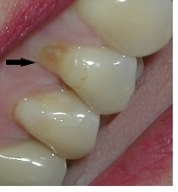
Figure 1.1 Abfraction on premolar tooth
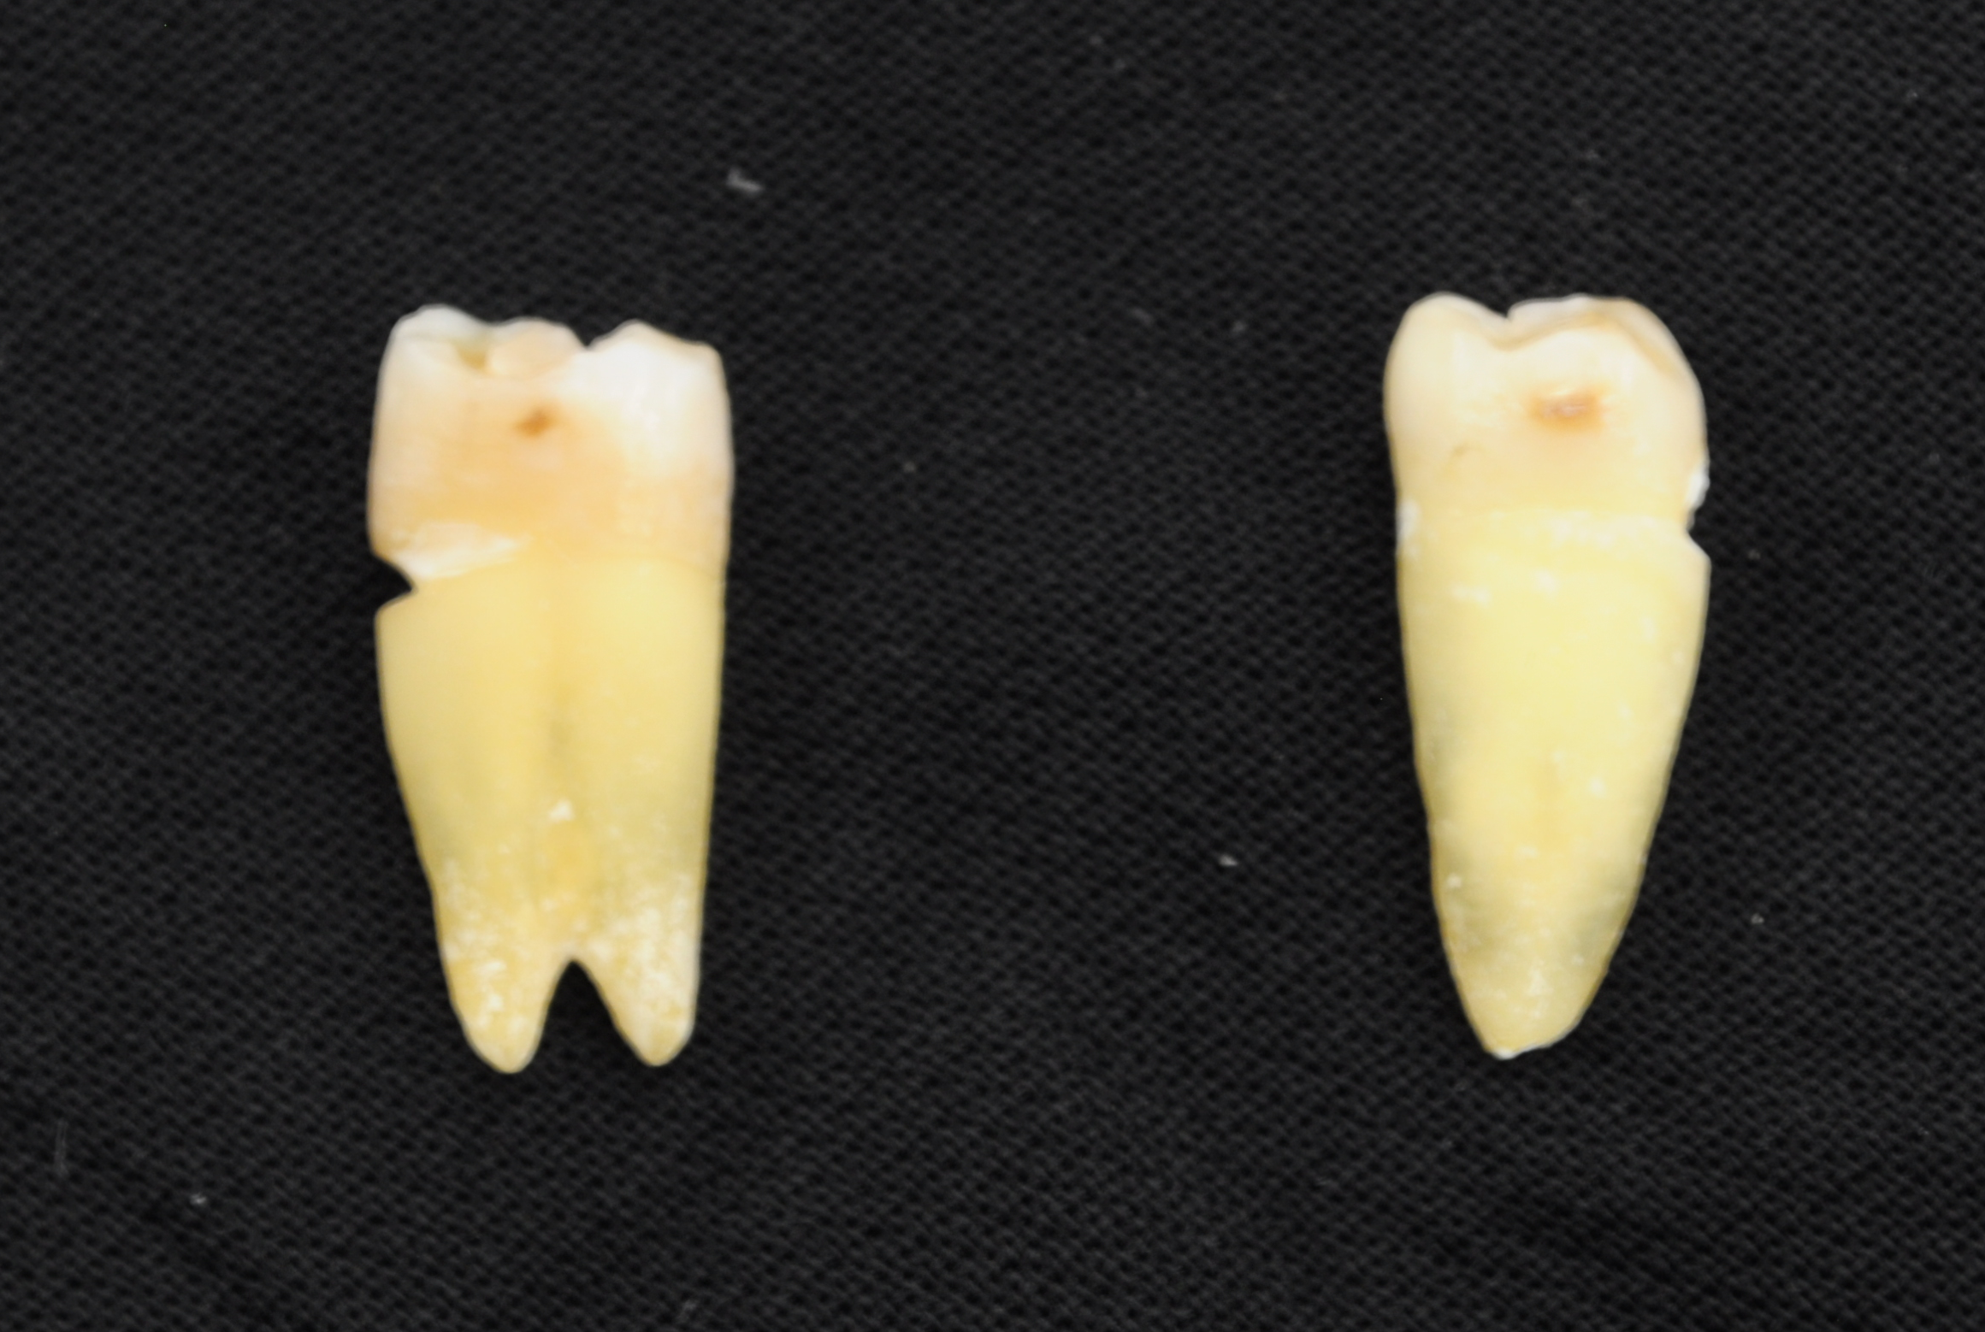
Figure 1.2 Abfraction on some of tooth samples
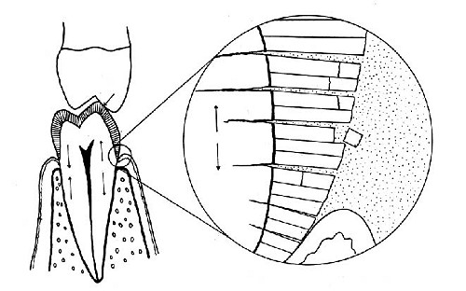
Enamel rods breaking away
Figure 1.3 Abfraction showing breakdown of enamel structures [6]
Previously the reason for this loss of cervical region tooth substance was considered to be the effect of toothbrush on the tooth. But most recently a theory has been postulated in the field of biomechanics which indicates that mechanical forces acting on the tooth causes non carious cervical tooth loss. Due to these mechanical forces, tensile and compressive stresses are induced on the tooth. When a cyclic load of this kind is induced on the tooth it loosens the bond between hydroxyapatite crystals in enamel [14] which eventually leads to crack formation and loss of material in enamel and the adjacent dentine.
Abfraction is a relatively new theory in dentistry, and the debate is still going on whether or not it even exists. What is known and accepted is that lesions are known to develop near the cervical areas of some teeth, and these lesions are broadly defined as non-carious cervical lesions (NCCLs) [11]. There are two major, opposing theories widely accepted to explain this type of lesion. The first theory is that the loss of tooth structure near the cervical areas of the teeth is caused by either toothbrush abrasion or toothpaste abuse. The abrasion theory was initially studied by W.D. Miller [19] in late 1800’s and early 1900’s who concluded that the lesions are due to weak acids or gritty tooth powders or by both. But in 1914 Black [20] was not convinced with Miller’s belief that toothbrush abrasion alone could wear out enamel tissues of teeth since he had observed lesion in cases where toothbrushes were not used. Later research, however, has shown that “toothpaste abuse,” because of the coarse toothpaste used as the exact reason for NCCLs. In 1960 Mannerberg [21] conducted an experiment by brushing freshly extracted teeth for 10hrs under standard condition. In one set of tests he useddistilled water and in the other set of tests he used toothpaste. With distilled water he found no scratches on the surface of the teeth. But with tooth paste he observed that abrasives abraded the crown at a maximum rate of 2μ to 2.5μ per hour. In 1972 Sognnaes [22] examined 10000 samples of teeth out of which 1700 were found having lesions on the surface of the tooth. He also observed that some of the lesions occurred on the lingual surface of the teeth, and other surfaces where the toothbrush could not reach.
Many studies proposed that tooth brushing was not the reason for NCCLs but the studies were not conclusive as to the cause of the lesions [24] [22]. The concept of loading on the teeth developing stresses that could eventually cause loss of tooth structure began forming in the late 1970’s. Yettram(1976) [23] used engineering principles and explained the forces in the teeth and by applying external loads he explained why NCCLs could occur due to the external loads. In 1984 Lee and Eakle [7] explained that lateral forces on the teeth could cause lesions at cervical region of tooth structure. The second theory for the loss of tooth structure in the cervical areas of teeth is abfraction. Officially, this theory was termed “abfraction” by Grippo [9] in 1991. More specifically, this theory states that mechanical loading develops tensile and compressive stresses in the tooth that, over time, cause the enamel rods comprising the teeth to gradually chip away leaving the NCCL, or abfraction.
Initially, two different theories for the cause of NCCLs may not seem like a problem for those in the dental community. But treatment for abfraction or the lack of treatment can be affected based upon which theory is accepted by the dentist. Because the theory of abfraction has not been sufficiently supported, current recommendations are typically to monitor the progress of the lesion if it will not adversely affect the patient’s health. If the patient insists upon treatment for aesthetic reasons, or if the NCCL has progressed to a stage where it may be injurious not to treat, treatment options vary. For those that believe over-vigorous brushing with abrasive toothpaste is the culprit, recommendations are to use softer toothbrushes or electronic toothbrushes, accompanied by a restoration to complete the treatment plan [11]. For dentists that believe abfraction is the cause, restoration of the area may be accompanied by an occlusal adjustment and/or encouragement for the patient to wear an occlusal splint to help reduce the likelihood that the restoration will fail due to the same forces believed to have caused the NCCL initially[11]. Clearly, irrefutable support for one theory or the other is needed to aid in developing more standardized treatment plans to treat the etiology of NCCLs, not just to “patch” the problem.
Previous research in the field has been both theoretical and experimental. Theoretical evidence has been generated from several different types of finite element analysis (FEA) models which have been developed to examine dental abfraction [12][13][17]. From these models data has been obtained that indicate that higher stresses exist in the cervical regions of teeth and that have been restored versus those that have not show that non-axial loading can develop potentially damaging cervical strains. The teeth prone to abfraction have been shown to have higher cervical stresses upon loading than those that do not typically have NCCLs, and that teeth in malocclusion typically have higher stresses in the cervical region. Limitations to these methods, however, are considerable. One primary limitation is that several of the FEA models were two dimensional [8] [13], while teeth are three dimensional, obviously limiting the reality of the results. Another limitation is the fact that a wide variety of forces were utilized in the experiments, which makes comparisons difficult between studies. Finally, one of the most important limitations is that different researchers have assumed different properties for the enamel, which will lead to different results.
Experimental evidence [25] regarding dental abfraction is relatively limited at this time. One study showed that teeth which experienced 500 N non-axial loading over 200,000 to 500,000 cycles did exhibit microfractures and small areas of enamel loss. The primary limitation to this study was that there was a perpetual 20 N load on the teeth at all times, which is never seen in vivo. Another study [27] utilized sectioned portions of teeth and found that more material was lost in high stress areas; however, the obvious limitation in this instance is that only segments of teeth were utilized, which can dramatically change the effects. A final study [26] revealed that cervical enamel is more brittle than occlusal enamel. This supports the theory that abfraction may occur more easily at the cervical region of the tooth.
This research was taken up to address some of the shortcomings from prior FEA analysis and experimental studies on abfraction. As most of the FEA study was two dimensional, in this research a 3-D teeth model was created from a real tooth and was analyzed for the stress at the cervical region for various non axial loading conditions. MIMICS(V13) was the software (Materialise, Leuven, Belgium)used to build a 3D teeth model from scanned images from an iCAT machine and FEA analysis tool Abaqus was used for the simulation of this research.
In the experimental part a non axial cyclic load was applied to the teeth. The whole tooth was used rather than just a section of the tooth to create a more realistic approach and to better simulate all of the factors in the actual oral environment. Young, healthy, permanent maxillary first premolars were also utilized for the experiment, as they were the ones most prone to abfraction, typically observed in people of 35 and above age. An INSTRON 4469 testing machine was used to apply cyclic non axial loads on the tooth cusp and the resulting tooth was observed under the electron microscope for the damage in the enamel structure.

2. DENTAL ANATOMY
2.1. Groups of teeth
Human teeth can be classified into 3 broad groups [33].
    - Maxillary or Mandibular teeth. A human skull has two jaws, upper and lower jaws. The upper jaw is called as maxillary and the lower jaw is called as Mandibular. And the teeth in the upper jaw is called as Maxillary teeth and those in the lower jaw is called as Mandibular teeth. Usually the Maxillary arch is wider than the Mandibular arch.
    - Right or Left. If we separate the tooth arches exactly at the middle from front to back, teeth can be grouped into two sections, the left part and the right part. Further these can be classified as upper and lower left section, upper and lower right section. Since the whole teeth divided into four groups, each group is called as quadrant.
So to locate teeth in the right side of the upper jaw, we call it as Maxillary right quadrant.
    - Anteriors and Posteriors. Teeth can also be classified into two groups , Anteriors and Posteriors. 6 teeth which are in the middle of the teeth arch are called as Anteriors and the remaining teeth towards its left and right are called as Posteriors.
So an adult consists of 32 tooth of which 16 are Maxillary tooth and 16 are Mandibular tooth. And each of these Maxillary teeth and Mandibular teeth have 6 Anterior and 10 Posterior teeth. Also they have two quadrants, left and right quadrants and these quadrants have 3 Anterior and 5 Posterior teeth.
Figure 2.1 explains it in a better way

Anteriors
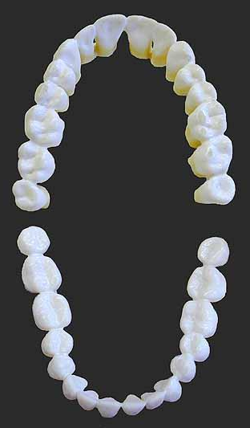
Mandibular left quadrant
Maxillary teeth
Mandibular teeth
Mandibular right quadrant
Maxillary right quadrant
Maxillary left quadrant
Anteriors
Posteriorss
Posteriorss

Figure 2.1 Groups of teeth
2.2. Tooth surfaces
Each tooth will be having five surfaces [30]. Figure 2.2 shows all those surfaces.
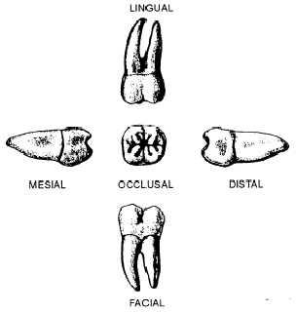
Fig 2.2 Surfaces of tooth [30]
2.2.1. Labial or Bucal Surface. Labial is the surface of the tooth which is towards the lips side in Incisors and Canines. Bucal is the surface of the tooth which is towards the cheek side in premolars and molars.
2.2.2. Lingual Surface. The surface of the tooth towards the tongue in the mouth is called as Lingual.
2.2.3. Mesial Surface. It is the surface of the tooth towards the adjacent tooth and facing the middle of the dental arch.
2.2.4. Distal Surface. It is the surface of the tooth towards the adjacent tooth and facing away from the middle of the dental arch.
2.2.5. Occlusal Surface. It is the biting surface of the tooth. It is the surface that comes in contact with the opposite tooth of the other jaw when biting.
  - Names of Teeth

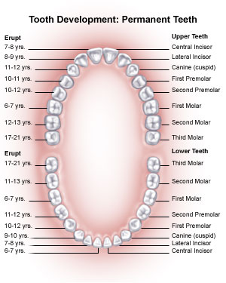
Figure 2.3 Teeth names and their development [34]
A permanent adult teeth consists of 8 types of tooth. All these types of tooth are present in both left and right quadrant in a mirrored fashion when a line is drawn at the center of the teeth arch in Maxillary teeth. This makes 16 tooth in Maxillary jaw. Also these teeth are arranged opposing likewise in the Mandibular jaw. So totally there 4 tooth of each type in a human skull.
To explain the teeth name let us consider Maxillary Left Quadrant.
    - Incisors. Incisors are the tooth which are generally used of cutting and shearing of the food, whose crown looks like a thin blade and situated anteriorly. There are 4 incisors each in Maxillary jaw and Mandibular jaw.
      - Central Incisors. The teeth commonly seen when a person smiles is called as the Central Incisor.
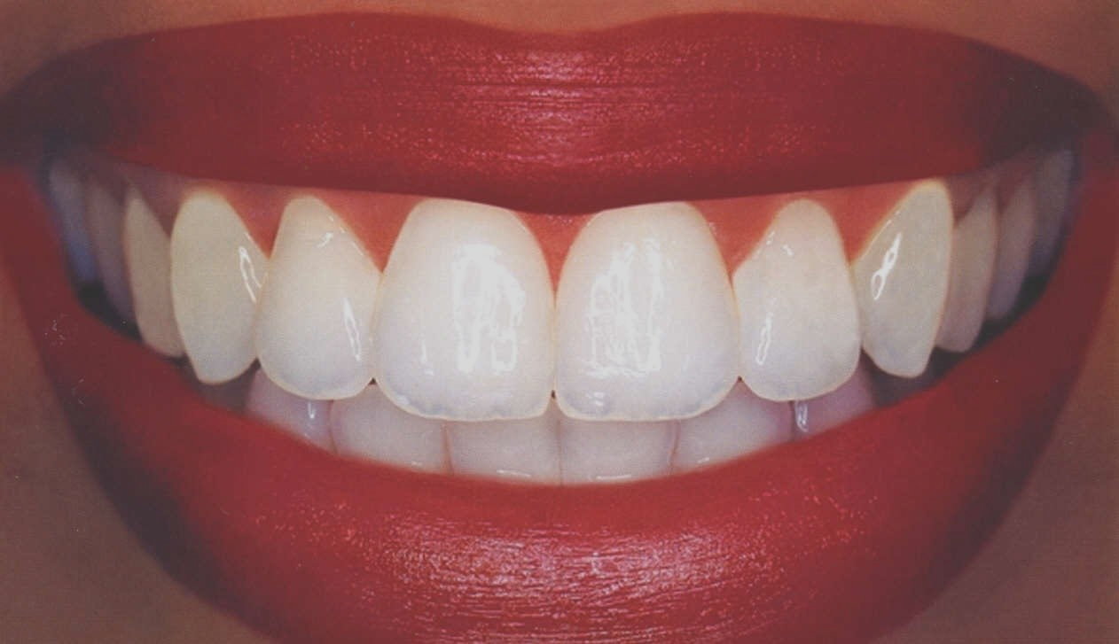
Upper central incisors
Lower central incisors
Figure 2.4 Central Incisors [34]
There are two upper central incisors and two lower central incisors. The right and left upper central incisors are at the extreme anterior region of the dental arch, one on each side of the central line, touching each other at the side surface. The crown has 4 surfaces, 4 angles, and a cutting edge, or incisal surface. They have single root and general shape of the crown represents a wedge, with rounded angles, merging into a thick rounded neck of the tooth. This teeth has concaved surface towards the labial side (towards lips) and convex towards the lingual side (towards tongue). The mesial and distal surfaces each present the outline of the letter V, with its lines curved with the convexity toward the lips, and the acute angle at the cutting edge. Lower central incisors are similar to their upper counterpart but smaller in size and are narrower at the crown.
      - Lateral Incisors. The teeth which are lateral to each central incisor are called as Lateral Incisor. These are similar to the central incisors in their general form but are much smaller in size and are short, narrower and thinner. The labial surface is more rounded in the meiso-distal surface as compared to the central part. There is one lateral incisor in each quadrant. The crown in the Maxillary lateral incisor is wider in mesial-distal surface compared to the facial-lingual surface. It has a single root with a pointed apex and it deviates to the distal surface. Cervical dimension mesial-distally is approximately equal to facial-lingually. Similar to the Maxillary central incisors their lingual surface is convex and the facial surface is concave. But it has the most concave surface of all the incisors. The Mandibular Lateral incisors are tilted on the distal surface along the root and are much broader on labial-lingual surface than mesial-distal surface.
It has a single root and are narrow on mesial-distal surface. Also the surface is concave along mesial-distal surface.
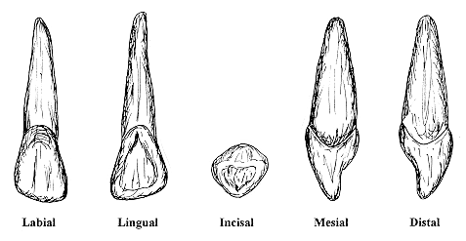
Maxillary Lateral Incisor
Figure 2.5 Maxillary Right Permanent Lateral Incisor [30]
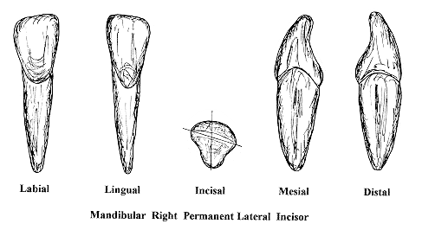
Figure 2.6 Mandibular Right Permanent Lateral Incisor [30]
    - Canines. These are the most stable tooth of all teeth. The canine teeth used for tearing and shredding of food and to assist this activity they have a sharp pointed corner on the crown. Canines are present in each quadrant and are located lateral to each of the Lateral incisors. They are also called as cuspids because their sharp pointed corners are elevated. It can be easily identified as the large conical crown which extends beyond all other teeth. Maxillary canines have large cingulum and are centered mesial –distally. The crown has a wider facial – lingual surface than the mesial distal surface. It has the longest root of all teeth and are also called as eye teeth. It has a shorter mesial cusp ridge compared to distal cusp ridge. Mandibular canines are similar to their opposing teeth but at the crown they slightly narrow meisodistally and are shorter. Even these have single root are almost equal in length than the upper. The cusp tip is displaced lingually and the mesial surface of the tooth is almost parallel to the long axis of the tooth.
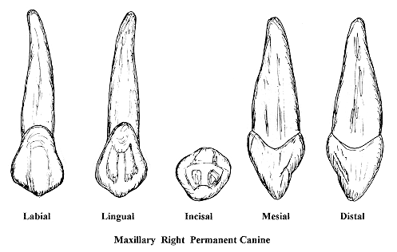
Figure 2.7 Maxillary right Permanent canine [30]
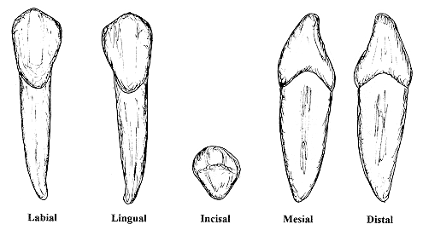
Figure 2.8 Mandibular right Permanent canine [30]

Premolars. These are the teeth which are used for chewing the food. There are totally 8 premolars and 2 each in every quadrant. These premolars have two cusps hence also called as bicuspids. Depending on the type of premolar they have either one or two roots. One premolar is located lateral to the canines and another premolar is located lateral to the first premolar. There are two types of premolars

First Premolar. These are located lateral to the canines. There is one first premolar in each quadrant and 4 in total. Maxillary premolars have the widest crown of all the premolars which have a greater buccal-lingual surface than the mesial-distal surface and a longer occlusal-gingival surface than any other posterior maxillary teeth. These teeth have two roots. These teeth have large buccal cusp than the lingual cusp and is located slightly towards the distal surface. It has a shorter distal buccal cusp ridge than the larger meisal-buccal cusp ridge. The mesial half of the lingual surface has the lingual cusp located towards it. The occlusal surface has a depression on its surface with a central groove without any pits.Mandibular first premolar has a buccal ridge is more prominent than the 2nd premolar and its crown is bell shaped. It has one root with pointed root apex. It does not have any distal curvature but have many concave regions on the mesial and distal surfaces. The buccal cusp is large and pointed and even though it has small lingual cusp it does not have any function. Its buccal pulp horn is bigger than the lingual pulp horn. It has a small occlusal pattern mostly a non functioning one with no central grooves.
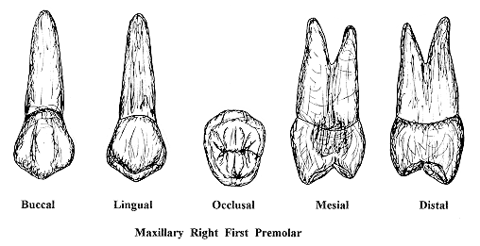
Figure 2.9. Maxillary Right First Premolar [35]
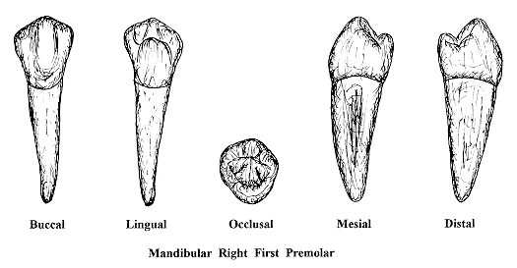
Figure 2.10. Maxillary Right First Premolar [35]

Second Premolar. These are located laterally to the first premolars. There is one premolar in each quadrant and 4 in total. The crown of the maxillary 2nd premolar is slightly smaller than the 1st premolar and has three roots. It has a large mesial lingual cusp and the pit is absent at the buccal groove on the cusp. The mandibular second premolar has three cusps, one cusp towards the buccal surface and two towards the lingual surface. The occlusal surface is square in shape. This is single rooted and is longer and broader than the 1st premolar. It has smaller distal-lingual cusp than the mesial lingual cusp. Its occlusal surface is very large and does not have any mesial-lingual groove

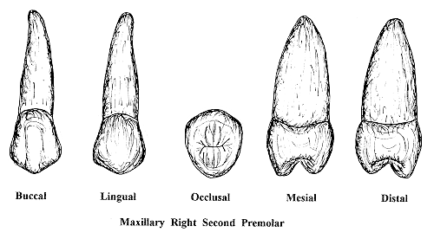
Figure 2.11. Maxillary Right Second Premolar [35]

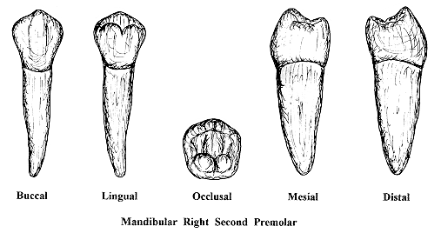
Figure 2.12 Mandibular Right Second Premolar [35]

    - Molars. These are the type of teeth which are used for final chewing and grinding of the food before it is consumed. There are three types of molars which are present in each quadrant and are the final teeth at the back of the dental arch. Molars are the largest of all the permanent teeth with large occlusal surface and often two to four roots.

1st Molar. They are the third last teeth in the dental arch. Maxillary 1st molar has the largest crown of all the permanent teeth and broader along lingual surface than along buccal surface. The crown has four cusps, 2 buccally and 2 lingually. Its mesial-lingual cusp is the largest and highest than any posterior teeth. The distal –buccal cusp is narrower than the mesial-buccal cusp. The occlusal is rhomboidal in shape. Its distal surface has a distinctly concave at the cervical region and has pit in the buccal groove. Mandibular 1st molar has a large mesial-distal region of all tooth. It has two roots with three canals. Ithas 5 cusps three buccally and 2 lingually and a large mesial-buccal cusp and small distal cusp. It has more pointed and higher lingual cusp compared to the buccal cusp.

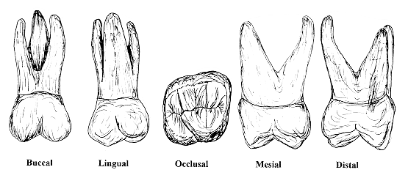
Figure 2.14 Maxillary Right First Permanent Molar [35]

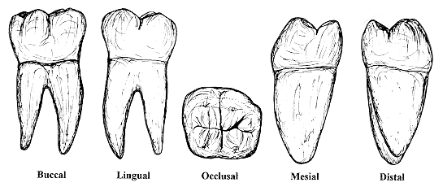
Figure 2.15. Mandibular Right First Permanent Molar [35]

      - 2nd Molar. Maxillary 2nd molar have smaller crown than the 1st molar and it does not have the 5th cusp. It has three roots. The distal-lingual cusp is so small that it can be called as 3 cusp tooth. Pit is absent from the buccal groove. The mandibular 2nd molar occlusal surface in the crown outlines a rectangle. It has two roots very close to each other and straight compared to the mandibular 1st molar. It has a narrower mesial root buccal – lingually and long root trunk than the 1st. It has four cusps making a plus sign at their intersection. It has pit at the buccal groove.
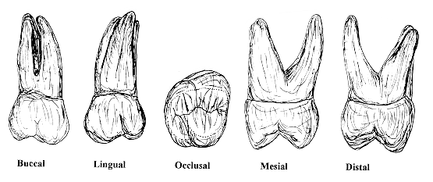
Figure 2.16. Maxillary Right Second Permanent Molar [35]
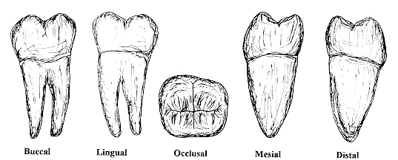
Figure 2.17. Mandibular Right Second Permanent Molar [35]

      - 3rd Molar. These are the teeth popularly known as wisdom teeth and are unpredictable about their growth. Maxillary 3rd molar has a smaller crown both mesiodistally and axially. Their shape varies, mostly round and their distal surface does not have any contact with other teeth. These teeth have 3 roots, one lingually and two buccally, which are mostly fused to each other. Even though these teeth are variable shape they smaller distal-buccal cusp and slightly larger mesial-buccal cusp. Mandibular 3rd molar has mostly shorter crown representing a bulb. They have two short roots, with poor development. Sometimes they even do not erupt in many people.
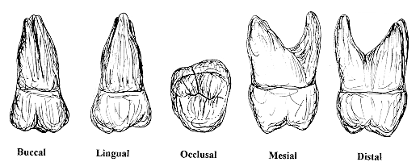
Figure 2.18. Maxillary Right Third Molar [35]
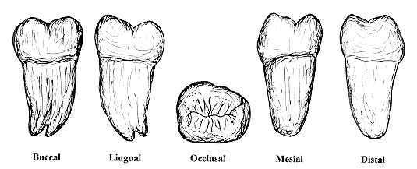
Figure 2.19. Mandibular Right Third Molar [35]

  - Internal Tooth Structure
An adult tooth is mainly divided into two parts, crown and root. Crown is the visible part which is entirely exposed in mouth above the gum line and root is the one which is attached to the alveolar bone and is completely under the gum line.
A typical tooth has four basic tissues, enamel, dentin, cementum and pulp tissues. The crown is made up of enamel, dentin and pulp tissues. The root is made up of cementum and pulp tissues. These tissues are attached as shown in the figure. The outer most part in the crown structure is called the enamel and the one below is called as dentin. The junction between these tissues is called as DEJ (dentin-enamel junction). Cementum covers the root of the tooth over the dentin. The junction between enamel and cementum tissues is called as CEJ (dentin-enamel junction).The cavity inside the dentin is called as the pulp.
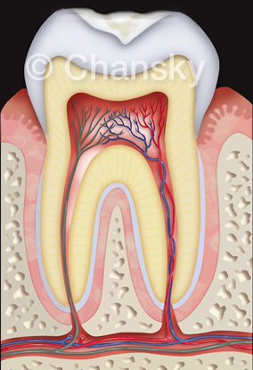
Crown
Root
Enamel
Dentin
Pulp
Cementum
Cementum
DEJ
CEJ
Figure 2.20 Tooth Structure [32]

2.4.1. Enamel. The enamel forms a protective covering of variable thickness over the entire surface of the crown. On the cusps of human molars and premolars the enamel attains a maximum thickness of about 2 to 2.5 mm, thinning down to almost a knife edge at the neck of the tooth. The shape and contour of the cusps receive their final modeling in the enamel. Because of the high content of mineral salts and their crystalline arrangements, enamel is the hardest calcified tissue in the human body. The function of the enamel is to form a resistant covering of the tooth, rendering them suitable for mastication. The structure and hardness of the enamel render it brittle, which is particularly apparent when the enamel loses its foundation of sound dentin, The specific gravity of enamel is 2.8.
Another physical property of enamel is permeability. It has been found that enamel can act like a semi permeable membrane, permitting complete or partial passage of certain molecules.
The color of the enamel covered crown ranges from yellowish white to grayish white. This color difference is because of the translucency. Yellowish teeth have thin translucent enamel through which the yellow color of dentin is visible and grayish teeth have more opaque enamel. The translucency may be because of the variation in the degree of calcification and homogeneity of enamel. Grayish teeth show slightly yellowish color at the cervical regions because of the thin enamel [29].
Enamel consists mainly of inorganic material(96%) and only a small amount of organic substance(4%). The main inorganic material is hydroxilapatite, crystalline calcium phosphate with small amount of Sodium, Chlorine and Magnesium. These substances account not only for its strength but also for its brittleness[29].
      - Enamel Structure. The enamel is composed of enamel rods or prisms, rod sheaths, and in some regions a cementing interprismatic substance[29]. There are around 5 million enamel rods in the Mandibular incisors and around 12 million in the maxillary 1st Molar. Starting from the dentine enamel junction the rod runs towards the outer surface of the tooth. Usually these rods are normal to the surface of the dentin and are almost horizontal at the cervical and the central regions of the tooth. The length of the enamel rod is always longer than the thickness of the enamel because of their sloping direction and curly course of the rods [29]

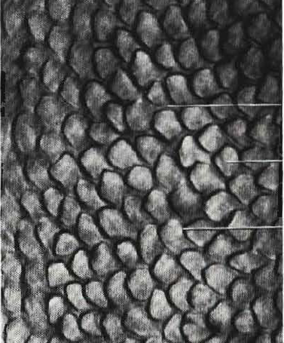
Interrod substance
Enamel Rod
Rod sheath

Figure 2.21 Enamel Structure [29]

    - Dentine. The dentin comprises the bulk of the tooth. This tissue supports the enamel by absorbing the load acted on the enamel while eating by their ability flex. This is the second hardest tissue in the human body which covers up under the enamel and throughout the tooth, making it the largest area of the tooth. In an adult tooth, dentin is normally lightish yellow in color. Unlike enamel which is very hard and brittle , dentin is subject to slight deformation and is highly elastic. It is somewhat harder than bone but is softer than the enamel. The smaller content of mineral salts in dentin makes it more radiolucent than enamel [29].
It resembles the bone in its physical and chemical properties. Dentin is made up of 65% organic material and 35% of organic matter and water [29]. The organic substance consists of collagenous fibrils and a ground substance of mucopoly-saccharides. Similar to enamel, bone and cementum, inorganic material in dentin is hydroxyapatite. Each hydroxyapatite crystal is made of several thousands of unit cells ( Ca₃(PO₄)₂.Ca(OH)₂ ). The crystals are palate shaped and are much smaller than the hydroxyapatite crystals in enamel. Dentin also contain small amount of phosphates carbonates and sulfates. The organic and inorganic substances are separated by decalcification [29]
      - Dentin structure. Since dentin is a living tissue it is made up of special cells , the odontoblasts and bonding those are intercellular substance. The dentinal matrix of collagen fibers is arranged in a random network. As dentin calcifies, the hydroxyapatite crystals mask the individual collagen fibers, which are visible only in electron microscopic level. From the pulp to the cementum or the enamel dentin has microscopic channels called as Dentinal tubules. These tubules radiate between the above two tissues [29].
The whole course of this tubules is S shaped and curved. The ration between the outside surface and the inner surface of dentin is 5:1. Accordingly, the tubules are farther at the outer surface and are closely packed at the inner surface. Also there more tubules per unit area in the crown than in the root.

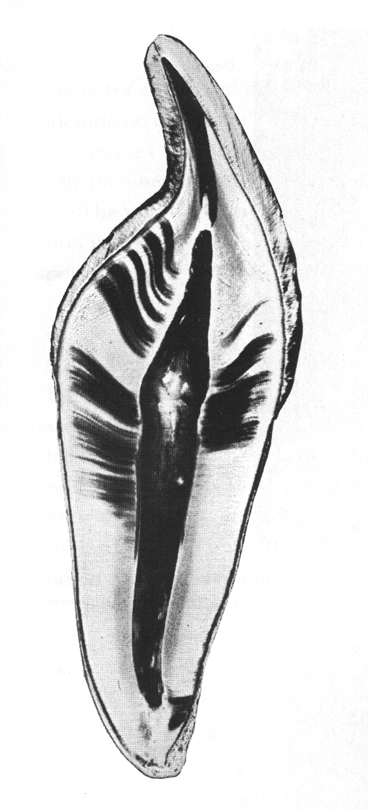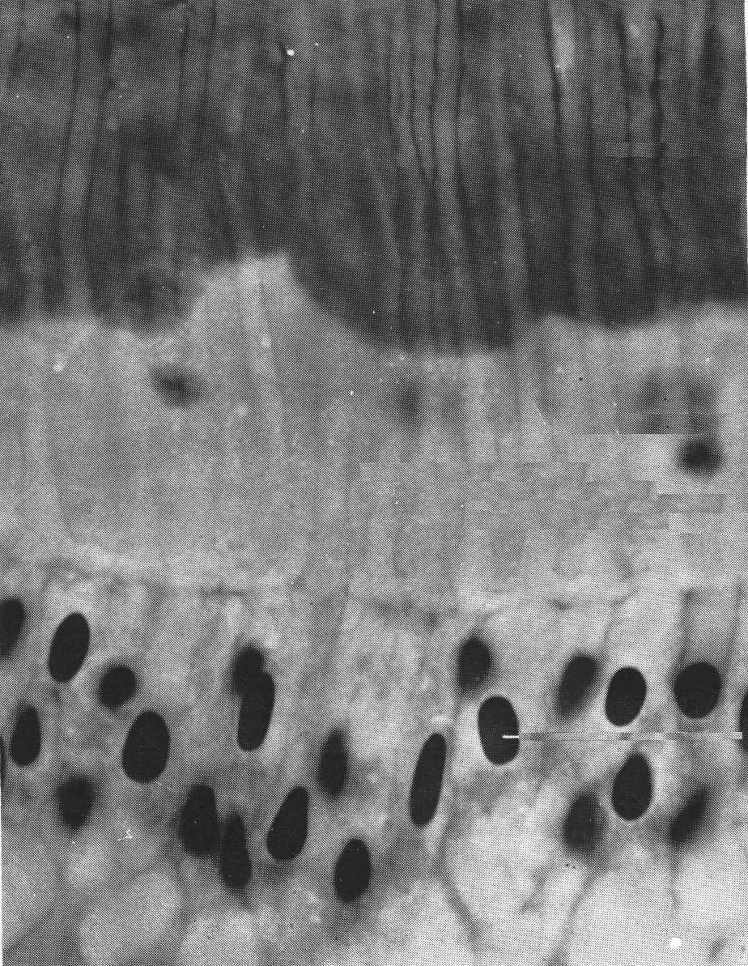
Figure 2.22. Dentine [29] Figure 2.23. Dentine Structure [29]

    - Cementum. This is the mineralized tissue which covers the dentin in the root from the cervical region of the tooth all the way to to the tip of the root. Cementum is little bit softer than enamel and dentine but still a hard tissue of the tooth and is not visible since it is under the gum line. It furnishes a medium for the collagen fibers that bind the tooth to its surroundings. Cementum is slight yellow in color and can be distinguished from enamel by its lack of sheen and its dark shade, which is bit lighter in color than dentin. Since the difference is color is very insignificant, it is difficult to differentiate between cementum and dentin under clinical condition. It can be differentiated under experimental condition since it is permeable to various materials. The primary function of cementum is to bind the tooth to the alveor bone by attaching it to periodontal ligament.
In an adult tooth cementum have about 45%-50% inorganic material and 50%-55% organic substance and water. Even though many trace elements in varying amount are found in cementum, Hydroxyapatite, which contains calcium and phosphate, is the main inorganic substance. Interesting fact is it has the highest fluoride content of all the mineralized tissues. Collagen and protein polysaccharides (proteoglycans) are the main substances in the organic part. . These collagen is similar to the ones in dentin and alveolar bone, but the chemical nature of polysaccharides is virtually unknown [29].
      - Cementum structure. When we closely look at the cementum under the microscope we can see two types of cementum, layers of cementum which do not incorporate cells and the ones which incorporate cells. Acellular cementum is that part in the root which is under the enamel approximately covering 1/3rd of the root. The remaining part until the apex is the cellular cementum. Cementum is the thinnest at the cementoenamel junction about 20 to 50 µm and thickest towards the apex about 150 to 200 µm. Sometimes cementum even extends to the inner surface of the dentin forming the line for root canal.
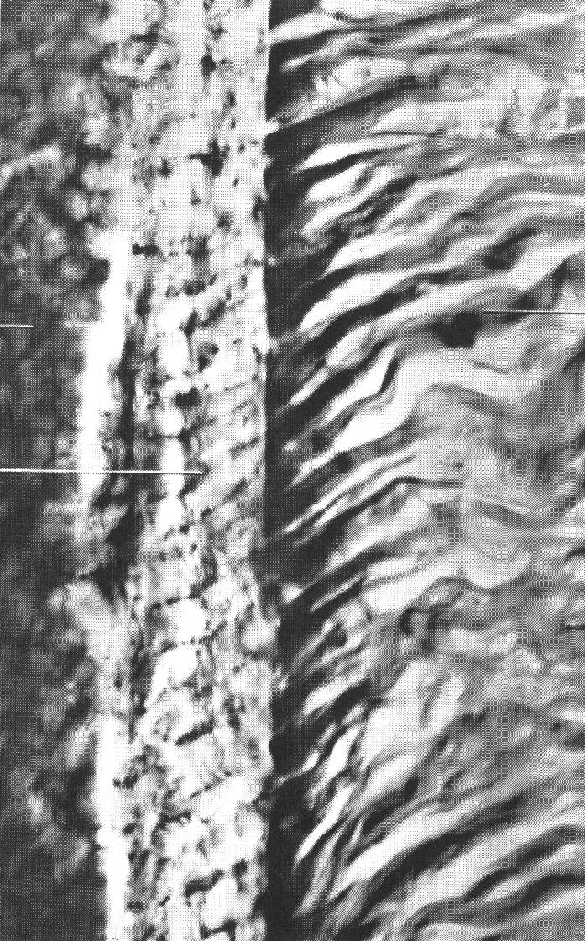
Fibers of periodontal ligament
Dentin
Cementum
Figure 2.24 Cementum Structure [29]

    - Pulp. The Pulp is housed in the pulp cavity, most internal structure, the chamber inside the tooth which is completely surrounded by dentin. Pulp is made up of blood vessels as well as the nerves , lymphites and variety of connective tissues. It nourishes the dentin through the odontoblasts and their process and by means of blood vascular system of the pulp. The size of the pulp depends on the type of teeth. The volume of the pulp in incisors are 3 to 4 times smaller than the molar teeth. The total volume of all the permanent teeth pulp organs is 38cc, and the mean volume of single adult human pulp is 0.02cc. The pulp cavity can be divided into two areas. The area in the crown portion of the tooth which is usually little wider and broader in size is called Pulp Chamber . The area which is generally a narrow canal traversing down to the root of the tooth is called Root canal [29][32].
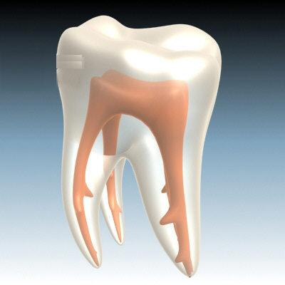
Pulp chamber
Root canal
Figure 2.25 Pulp [36]

  - Periodontal tissues.
Periodontal tissues collectively surround and support the tooth. They help in holding the tooth, nourish and protect the tooth. They mainly consist of gingiva, periodontal ligament and alveolar bone [32].
    - Gingiva. The tough pink-colored tissue that covers the base of the tooth and supports the tooth structure is the gingival sometimes called as gums. It is located over the alveolar bone of the jaw and grasps the tooth very tight at its neck.
    - Alveolar bone. It is the bone present in the jaw that holds the tooth in its place, feeding, supporting and protecting it. It constitutes a cortical bone that has a tooth socket to fit in the root of the tooth, and this bone is supported by trabecular bone.
    - Periodontal ligament. It is the connective tissue which connects the the teeth to alveolar bone of the jaw and continuously supports the teeth during its function
By means of cementum, it is attached to the dentin of the tooth
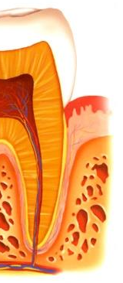
Gingiva
Periodontal ligament
Alveolar bone
Figure 2.26 Periodontal Tissues [36]
- BIOMECHANICS OF ABFRACTION

The study of abfraction is an interesting problem in the field of biomechanics. One section of argument which this research supports is that abfractions are caused by excessive cyclic loading on teeth which flexes the cusp of the teeth leading to stress concentration on the vulnerable cervical areas. When the stresses exceed the failure stress of enamel tissue, it breaks the bond between hydroxyapetite crystals and causes loss of tooth structure, which occurs microstructurally [14]. This loss may cause further propagation of loss of tooth structure by propagation of the abfraction.
3.1. Biomechanical Studies
Various biomechanical studies have been conducted to investigate the effect of parafunctional loading on the occlusal surface of the teeth. Some important studies are
- Theoretical studies
- Photoelastic studies
- Strain Guage studies
- Finite element studies
Theoretical Studies. Usually the lower anterior teeth are at right angle to the horizontal plane and the upper anterior teeth develop forward at around 115⁰ -120⁰ to the horizontal plane [37]. Result of this, when two teeth contact, the maxillary teeth apply non axial load on the mandibular teeth by bending outwards, developing tensile stress at the cervical region. This might contribute to the Abfraction. This is also linked to the familiar concept among engineers known as ‘loading outside middle third.
When an axial load is applied on the structure, load is evenly distributed on it. But when the structure is eccentrically loaded it creates tensile stresses on the base of the structure on the farther end. Consider the figure which has three sections in it. When load is applied outside the middle third portion, it creates tensile stress at the base of the opposite third.

Figure 3.1. Axial loading Figure 3.2. Eccentric loading
The shape of this structure and the loading pattern is similar to a molar and a premolar.
Hence this partly explains the reason for Abfraction.
Photoelastic studies. In a photoelastic technique birefringent plastic model of the structure to be tested is built and is studied under the polarized light once loaded. Multiple concentration rings indicate the regions of high stress concentration [38]. Lukas and Spranger [39] and Klahn [40] have done similar tests on a tooth. They observed stress concentration on the cervical regions once the load was applied outside the middle third . The main disadvantage of this technique was building the model with plastic material, since stress depended on the elastic modulus of the material. The elastic modulus of plastic is less than that of enamel and dentin. However, this study showed stress concentration at the cervical regions when a non axial load was applied on the occlusal surface.
Strain gauge studies. Many studies have been observed on the cervical regions of tooth using strain gauge for occlusal loading [17][41][42]. Strain gauges were attached to the tooth at the cervical region and were tested for occlusal loading, which resulted in higher tensile stresses at CEJ. Even though many factors such as oral environment, support of the tooth by periodontal ligament and alveolar bone were not considered in the study, it supported the theory stated above.
Finite Element studies. Various finite element studies have been carried out on teeth. Initial studies were carried out by Goel [43-44] and Lee [45]. They independently created a two dimensional finite element model of upper premolar. Though these studies were not for Abfraction, results showed higher tensile and shear stress at the cervical regions. Later Rees[8,13] carried out two dimensional finite element studies on maxillary incisors, canines and premolars for Abfraction .The findings from his studies provided information on the magnitude of stress developed in the cervical region and how it differed in various types of tooth. Rees[8,13,14] continued his finite element study on lower second premolar to show that the presence of an occlusal amalgam restoration may increase the stresses in the cervical region of the tooth to a level where breakdown of enamel was possible.
Articulated study model. Spranger[46 ] simulated the loading pattern on the tooth using four piezo electric transducers on the gypsum models. This study showed potentially damaging effects of oblique loading on occlusal surfaces. Since the work was done only on the gypsum model it was criticized.
3.2. Forces on the teeth.
Activity in the oral environment causes various types of loads on the teeth. The effect of forces during static or cyclic activity is unavoidable when the teeth come in contact. It is estimated that the average length of time for teeth to be in contact during the day is 9 minutes for chewing, and 17.5 minutes for swallowing. The act of swallowing takes place 1500 times in a day, resulting in teeth contact each time. The contact area of the opposing teeth is 0.4 – 2.2 mm². A normal chewing force in 10 N, but the maximum biting force of the teeth in the molar teeth is 500N and in the incisors it is 100-200 N, inducing contact stresses of 0.45 to 2.5 GPa. There are other sources of forces on the teeth, including abnormal tongue activity, tongue thrusts, malocclusion and collapsing of the oral activity [47 ]. These include
Harmful habits such as excessive thumb sucking, blanket sucking, etc.
Use of pacifiers.
Using improperly designed baby bottles and nipples for baby feeding.
Stiffened tongues.
Unusual large tongue. ( Macroglossia )
Disgustingly enlarged tonsils/adenoids and obstructed airways.
Abnormalities in the Facial-skeletal growth.
Affect of Central nervous system dysfunction on facial muscles.
Refined sugars and poor nutrition
3.3. Mechanical Properties of teeth structure
Table 3.1. Physical properties of dental tissues [48]
 | Physical Properties
Structure | Density  (g/cm³) | Specific heat  (cal/g.⁰C) | Thermal conductivity
Cementum | 2.03 | 0.4 | 0.5-1.51
Dentine | 2.14 | 0.28-0.38 | 1.36
Enamel | 2.97 | 0.18 | 1.84-2.23
Hydroxyapetite | 3.1 | 0.21 | 3

Table 3.2. Mechanical properties of dental tissues [48]
 | Mechanical Properties
Structure | Elastic Modulus (GPa) | Compression strength (MPa) | Tensile strength (MPa) | Shear strength  (MPa) | Poisson ratio
Dentine | 15 | 297 | 105 | 134 | 0.31
Enamel | 75-90 | 384 | 10-20 | 90 | 0.33
Hydroxyapetite | 110 |  |  |  | 0.28

- Finite element study
The finite element method was used to study and investigate the behavior of the tooth at the cervical region under various loading on the tooth. A 3D finite element model of the tooth was built and was analyzed using ABAQUS finite element code. The 3D tooth model was created by scanning the real tooth from an i-CAT 3-D Imaging System and importing these images to MIMICS software, which was used to build the 3D tooth model.
4.1. 3D Teeth Scanning.
Before investigating the tooth in ABAQUS a 3D tooth model had to be built. Since the tooth is of a very complex shape, it is very difficult to build the 3D tooth model using CAD software.
The first step in creating a 3D model of a human tooth was to scan a real tooth. For this task two bicuspids were chosen, since abfraction is observed to be most likely occurring in the premolars. Two adult teeth, a maxillary bicuspid and a mandibular bicuspid were scanned in an i-CAT 3-D imaging system (Imaging Sciences International Inc), using wax to place the teeth in it. High resolution images at 2.5 voxels were obtained from this machine which showed detailed images of the tooth structure differentiating between enamel, dentin and pulp because of the density difference.
This machine gave a DICOM (Digital Imaging and Communications in Medicine) files, standard file type in medical imaging which is a compatible output file for maximum interoperability with third party applications Figure …… shows the tooth being scanned in an i-CAT 3-D imaging system.
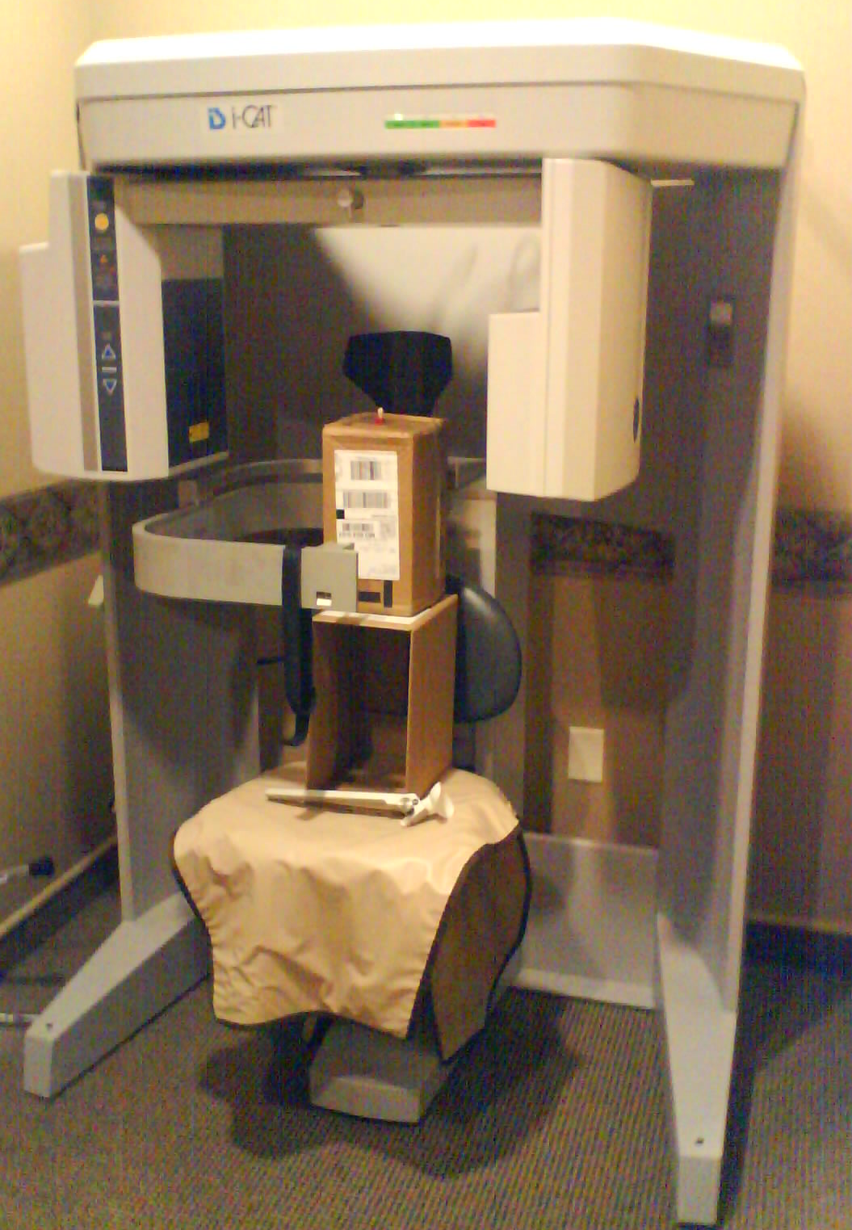
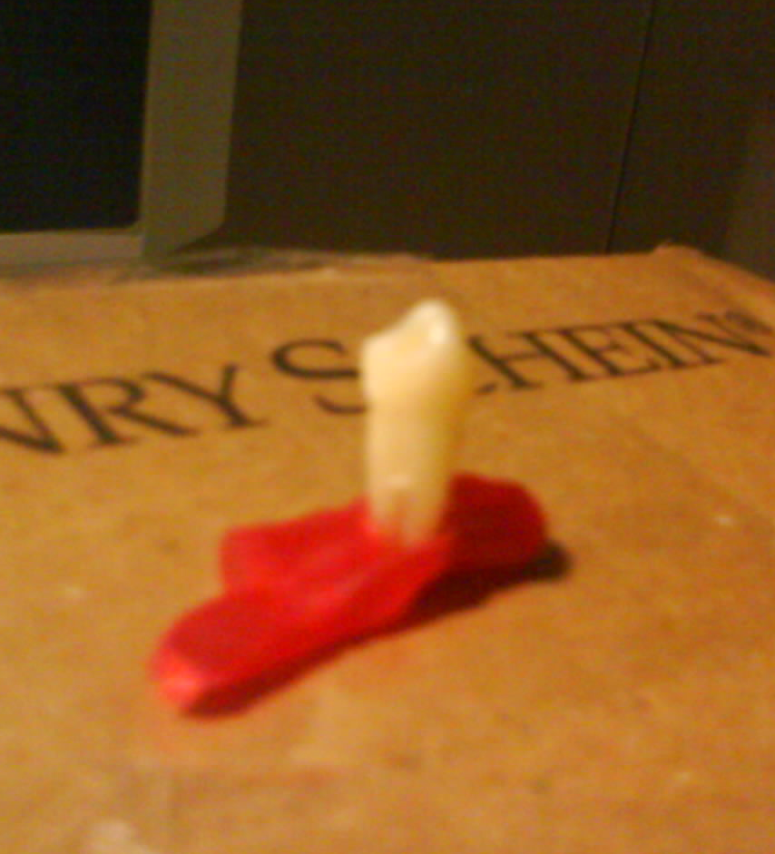
Figure 4.1. Bicuspid tooth scanning in i-CAT 3-D imaging system
4.2. 3D teeth modeling and meshing
The DICOM files which had three views of the tooth were imported to MIMICS (Materialise Co., Ltd/ Belgium) software. MIMICS software allows for processing and editing of scanned data to construct accurate 3D models. Basically it interprets the pixels density of the images from three different views and processes it to give a 3D tooth file. Meshing of the tooth was done in the same software. Tetrahedral meshing was done on both of the 3D teeth models. A coarse 3D meshing was done on the crown and root of the tooth but the cervical region was finely meshed. This allowed us to concentrate on the vital cervical region and keep the output file size smaller. The meshed 3D models were exported as an ABAQUS input file, which can be directly imported into the ABAQUS software with all the details on the 3D model including the meshing on its body. The model could not be created for two different tissues, enamel and dentin because of the limited access to the features in MIMICS.A 3D model with single material was created

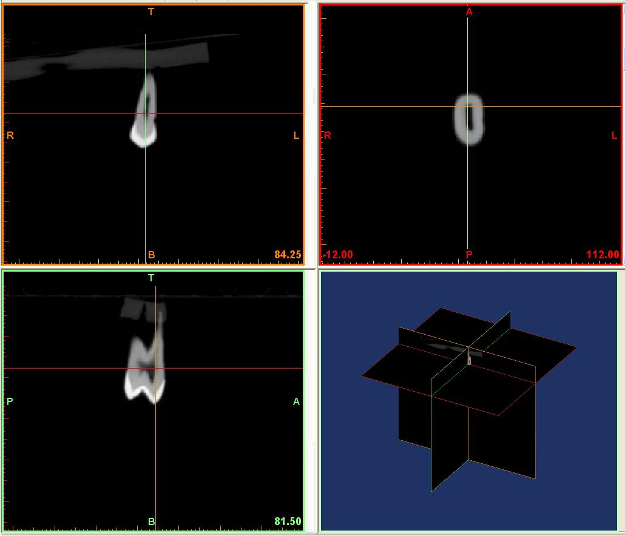
Figure 4.2. Scanned images showing 3 different views
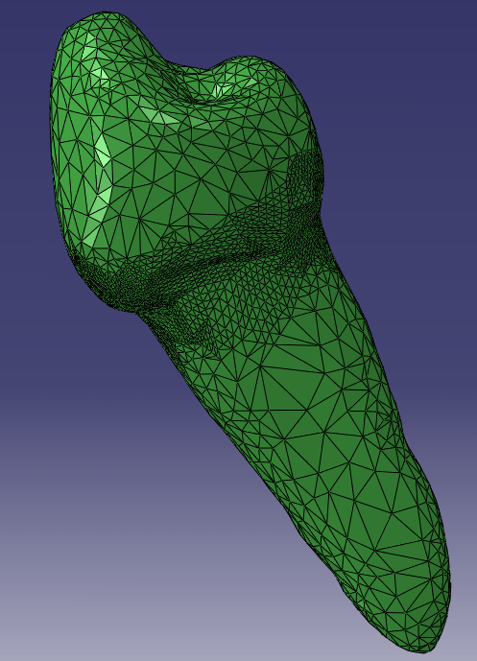
Figure 4.3. Tetrahedral meshing of 3D mandibular tooth model
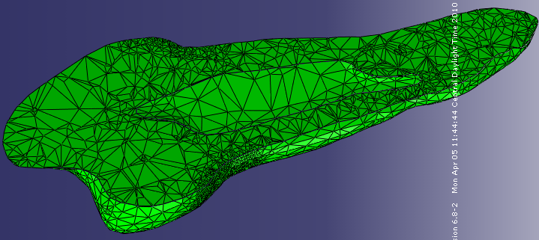
Figure 4.4. Cross section of 3D mandibular tooth model
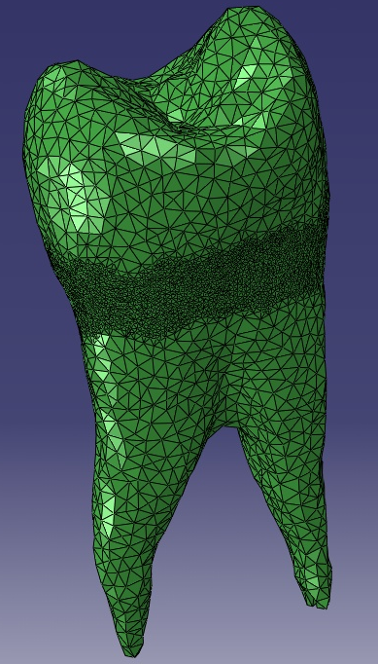
Figure 4.5. Tetrahedral meshing of 3D maaxillary tooth model
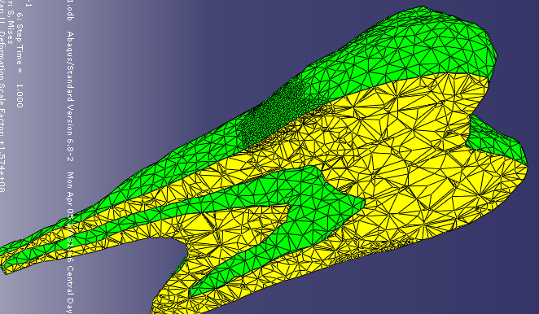
Figure 4.6. Cross section of 3D maxillary tooth model
4.3. Finite element model
The final step was to analyze the 3D teeth model for various static loading conditions. The finite element model was developed using ABAQUS finite element package code to investigate the stresses in the cemento-enamel junction for loads applied on the occlusal surface.
Abaqus input file (*.inp) generated by MIMICS was imported on to the ABAQUS software with all the meshing. These files, once imported in ABAQUS cannot be edited to change their size, physical appearance or meshing. The 3D model was considered as an isotropic material with an elastic modulus of 83 GPa and Poisson ratio of 0.33. These are the properties of enamel and were chosen considering the whole model as that of enamel. The next feature was to give the boundary condition at its roots. The root of the tooth was constrained with all degrees of freedom for no movement in X, Y and Z directions. Constrains surrounded the root starting from the cervical region to the apex of the tooth. This depicts the way actual tooth is been held and supported by the periodontal ligament tissues in the alveolar bone of the jaw.

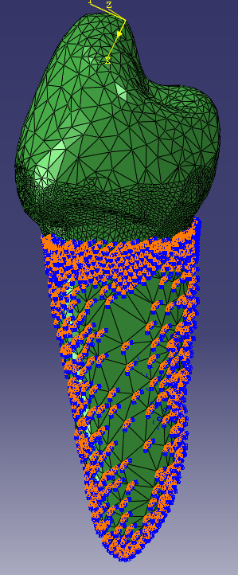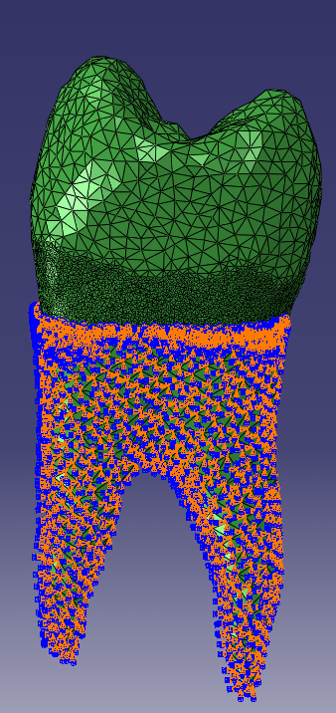
Figure 4.8. All degrees of freedom fixed at the root in a maxillary bicuspid
Figure 4.7. All degrees of freedom fixed at the root in a mandibular bicuspid

Once the teeth were constrained, loads were applied on the occlusal surface of the teeth on the cusps representing the opposing teeth contact. A parafunctional load of 500 N was applied on the cusps of the teeth mainly concentrating on the contact point of the teeth. The point of application of load on the tooth surface was varied at different position on the cusps. Direction of the load was normal to the surface of the crown. Loads representing the parafunctional activity like bruxism and malocclusion were applied to theteeth, which various studies found to be ranging from 100N – 500 N [references].
B
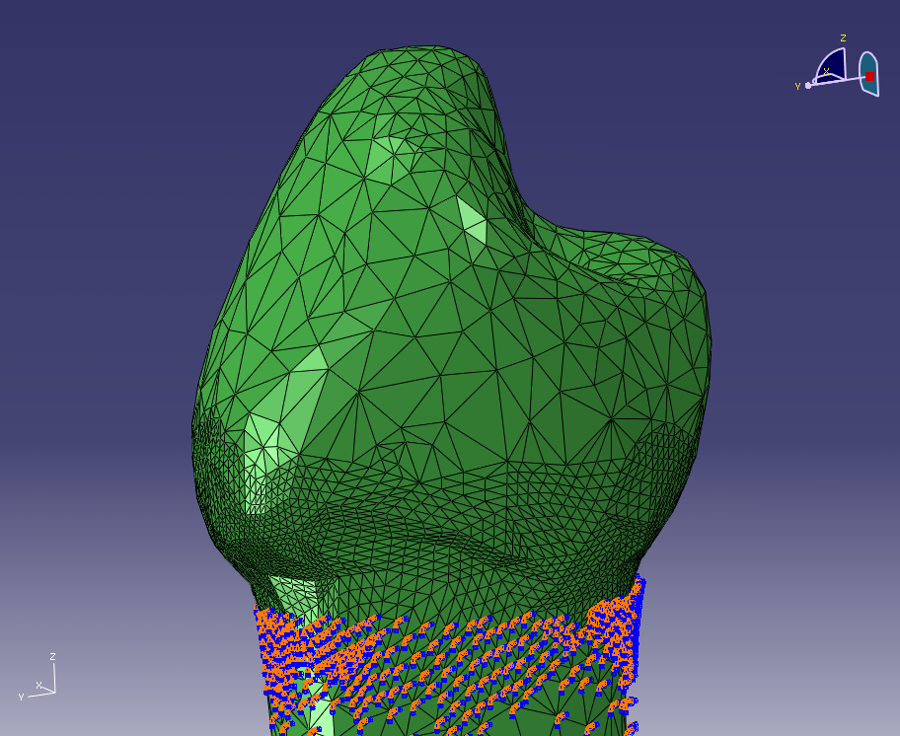
C
D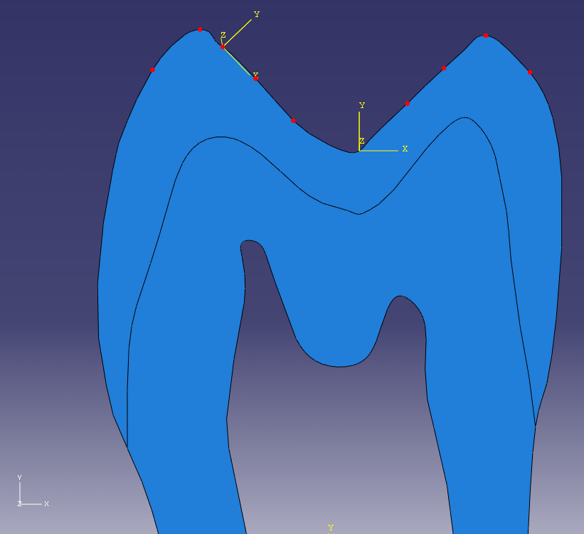
E
F
A
Figure 4.9. Various loading points on a mandibular bicuspid

A
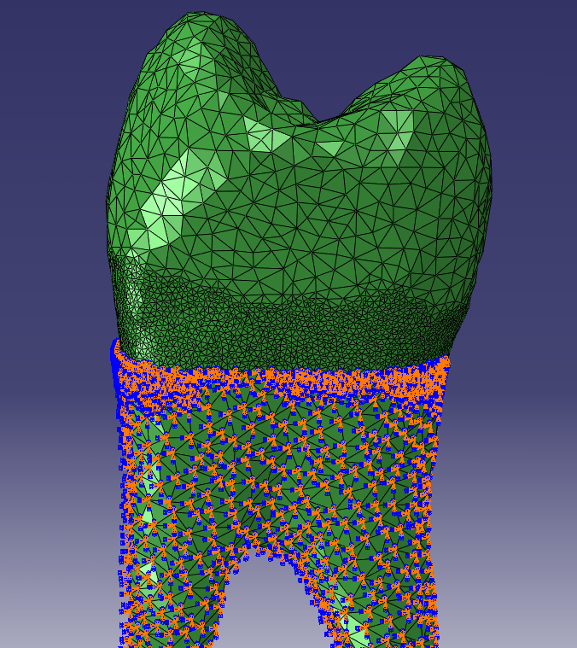
B
C
D
E
F
Figure 4.10. Various loading points on a maxillary bicuspid
- Fatigue test on the teeth

The second section was to develop an experimental design portraying the oral environment found in the human mouth to obtain reliable results. This was very difficult because of the complex physiology and anatomy of the teeth and all of the interactions and relationships. As explained earlier, the tooth is attached to the jaw by means of Periodontal tissues. The type of tooth, oral environment, fixture to setup the tooth and the means of loading had to be considered before starting the experiments.
In this experiment, healthy human tooth extracted from dental patients were set up in the epoxy. Since the epoxy could effectively bond and hold the tooth in the setup, it was selected to represent the bone and periodontal tissues holding the tooth in the socket.
5.1. Fixture Design
To setup the tooth in the epoxy two small fixtures were designed. The design had to fulfill the requirement of holding the teeth in epoxy and also be easy to disassembly after the experiment was done. Figure 5.1 shows the fixture 1 and figure 5.2 shows fixture 2. These fixtures were built in a mechanical workshop with Aluminum plates, block and angles. Fixture 1 has a pocket in the Aluminum plate to accommodate the two aluminum C channels. Slots were created at the end of the C-channels so they would fit tightly together. These assembled channels were then placed in aluminum plate pocket. Since this fixture was leaking epoxy at the bottom, it would reduce the height of the epoxy level from CEJ. The second fixture had an aluminum plate with a square slot at the center. Two aluminum angles of same length were placed inside this slot. Then an aluminum block with a square hole at the center was slid from the top. The second design helped in prevent the leakage of epoxy.

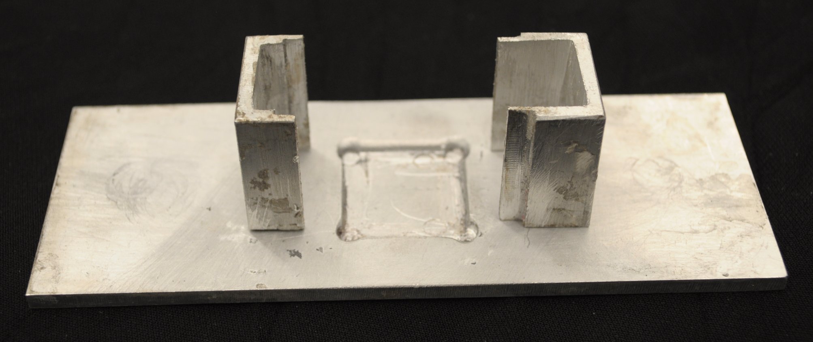
Figure 5.1. Fixture 1 for setup of tooth
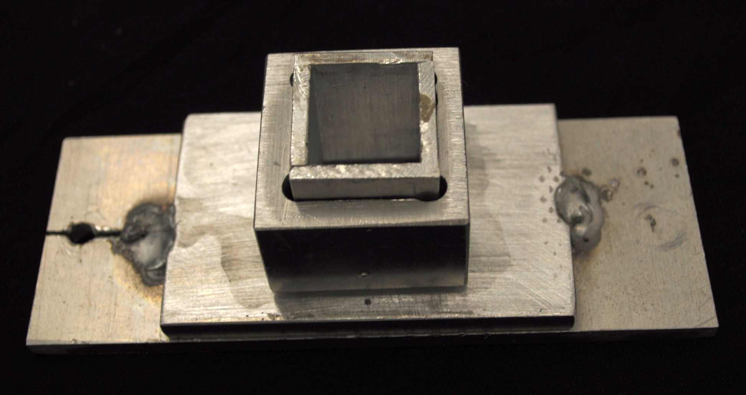
Figure 5.2. Fixture 2 for setup of tooth
  - Maintaining the moisture of Tooth
The next factor to be considered was the moisture content in the oral environment. Because teeth begin to dry out immediately after they are removed from the oral environment, thus potentially affecting the results, the specimens were stored in saline solution until they were placed in the epoxy. The tooth had to be dried out when it was placed in the mixture of resin and hardener. The epoxy mixture took 24 hrs for full curing, and the tooth was not placed in any saline solution during that period. However once the epoxy was cured the saline solution was poured in the pocket of the fixture until the experiment was finished to prevent further drying out of the tooth.
Figure 5.3 shows the crown of the tooth inside the saline solution.

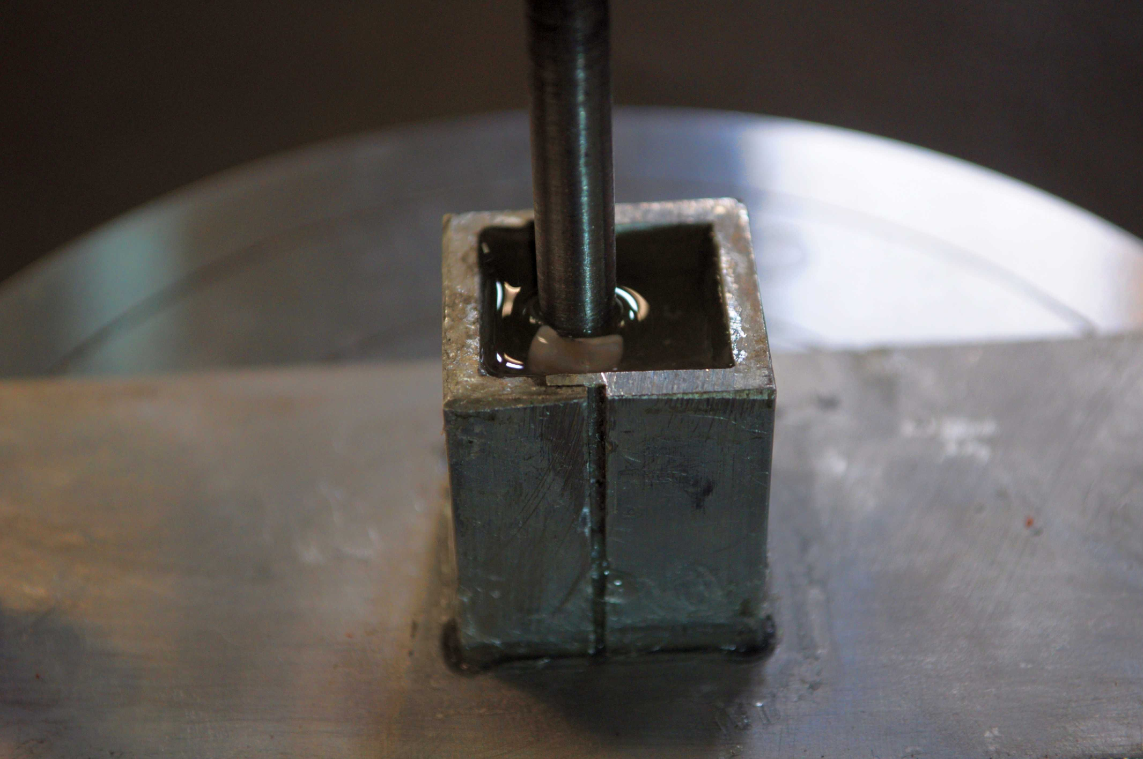
Figure 5.3. Tooth covered by saline solution during experiment
  - Selection of tEEth
Since the type of tooth chosen for the experiment would directly affect the results, it was necessary to choose a healthy adult tooth. Because premolars are more prone to have abfraction, healthy mandibular premolars were chosen for experiments from a collection of many teeth. Fortunately for this research, orthodontic treatment also sometimes requires that healthy premolars be extracted, which provided ideal healthy, young teeth to test.
  - Experimental Procedure
The first tooth sample of mandibular bicuspids were set in West System 105 epoxy resin with 206 slow hardener at 4:1 ratio in the fixture. The tooth was placed inside the fixture at the center and the resin and harder mixture was poured into pocket until the epoxy level reached the CEJ. The teeth were then allowed to set in the epoxy for 24 hours until the epoxy was fully cured. Please see Figure 3: Experimental Tooth Setting and Figure 4: Tooth in Epoxy – Post Experiment
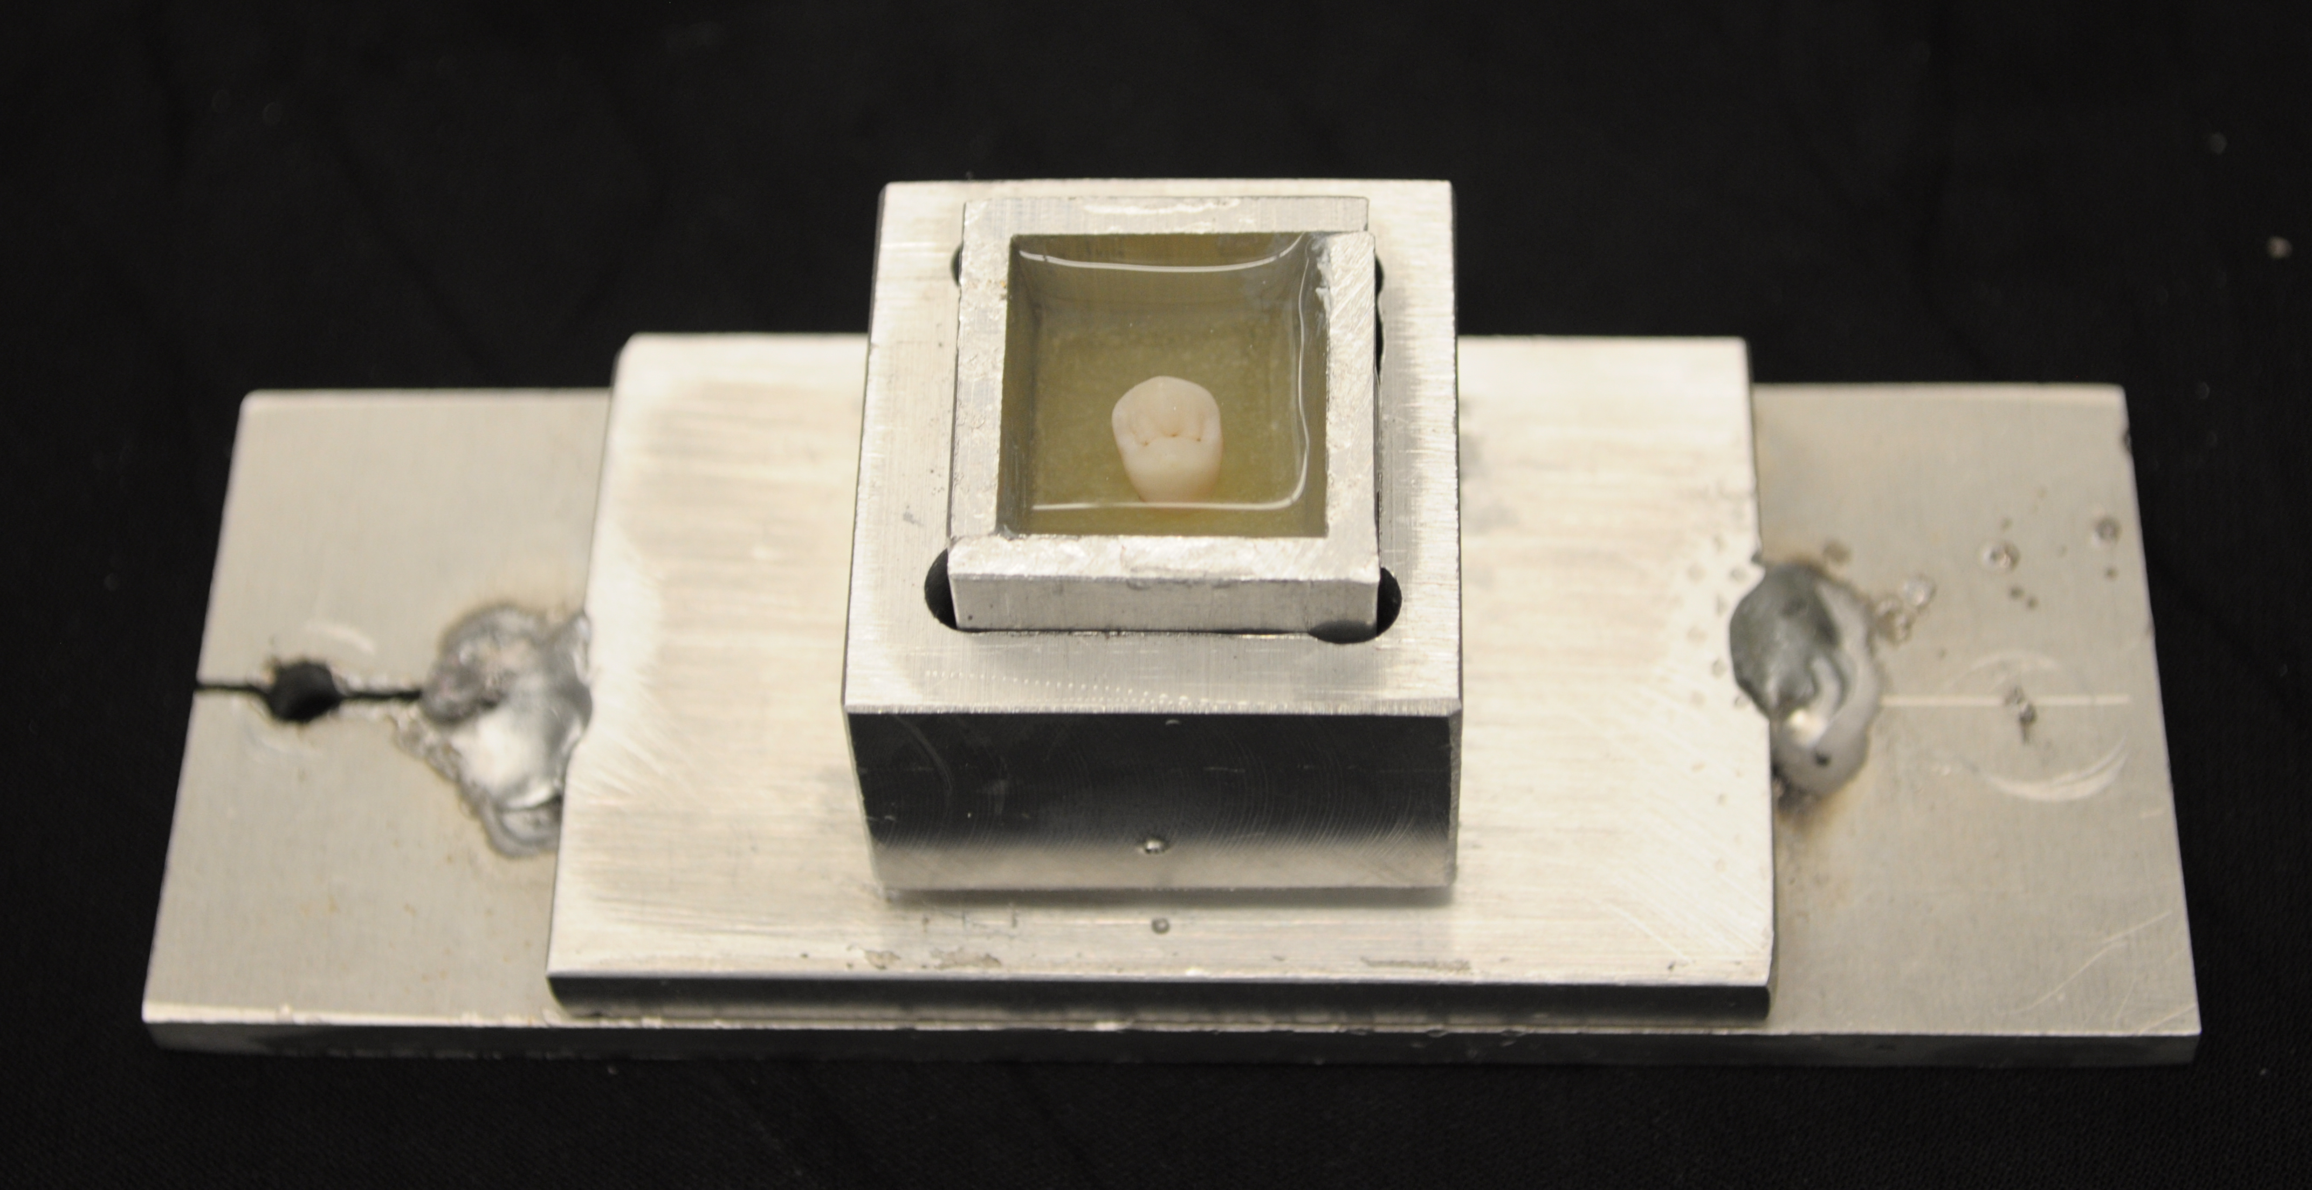
Figure 5.4. Experimental tooth setting
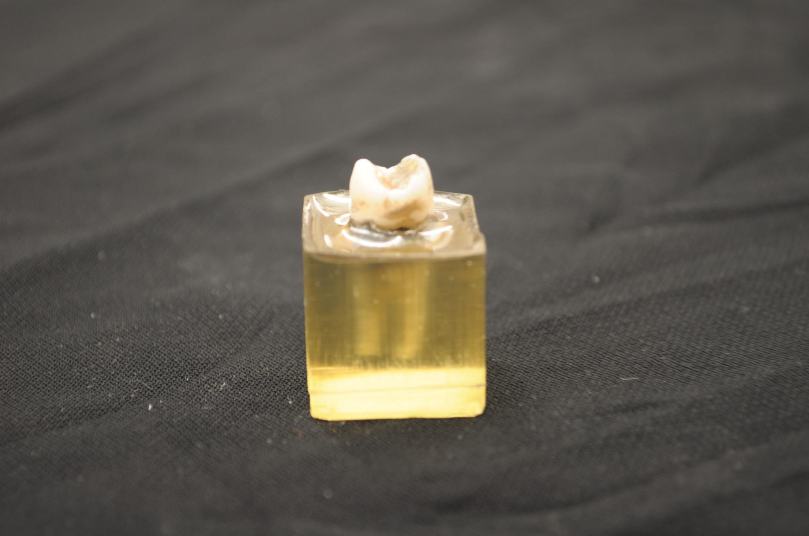

Figure 5.5. Tooth in Epoxy – Post Experiment
Two machines were considered to apply fatigue load on the tooth, MTS and Instron. For the small amount of load that had to be applied on the tooth, a suitable load controller for a smaller load cell on a MTS machine was not available. Therefore MTS machine was ruled out. To apply the cyclic load on the tooth, and Instron 4469 electro-mechanical UTM with a load cell of capacity 2 kN was used. A steel rod 6.35 mm in diameter was used to serve as the opposing tooth to apply the load. The end of the rod was machined to form a conical head that could apply the load along the length of the lingual incline of the buccal cusp. This rod was locked onto the cross head, which was directly connected to the load cell of the Instron. The fixture was firmly clamped on to the Instron’s lower compression platen on each side using small c-clamps. The gap above the epoxy was filled with saline solution to cover the crown of the tooth. Care was taken to align the cusp of the tooth with the opposing tooth, such that it did not generate forces on other portions of the tooth, particularly the central fossa - the crevice between the cusps of the premolar. This was important because the opposing teeth will be having contact and the abnormal forces at the cusp.
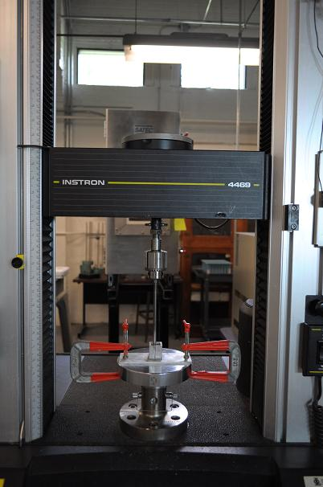
Figure 5.6. Tooth setup for fatigue test in Instron 4469
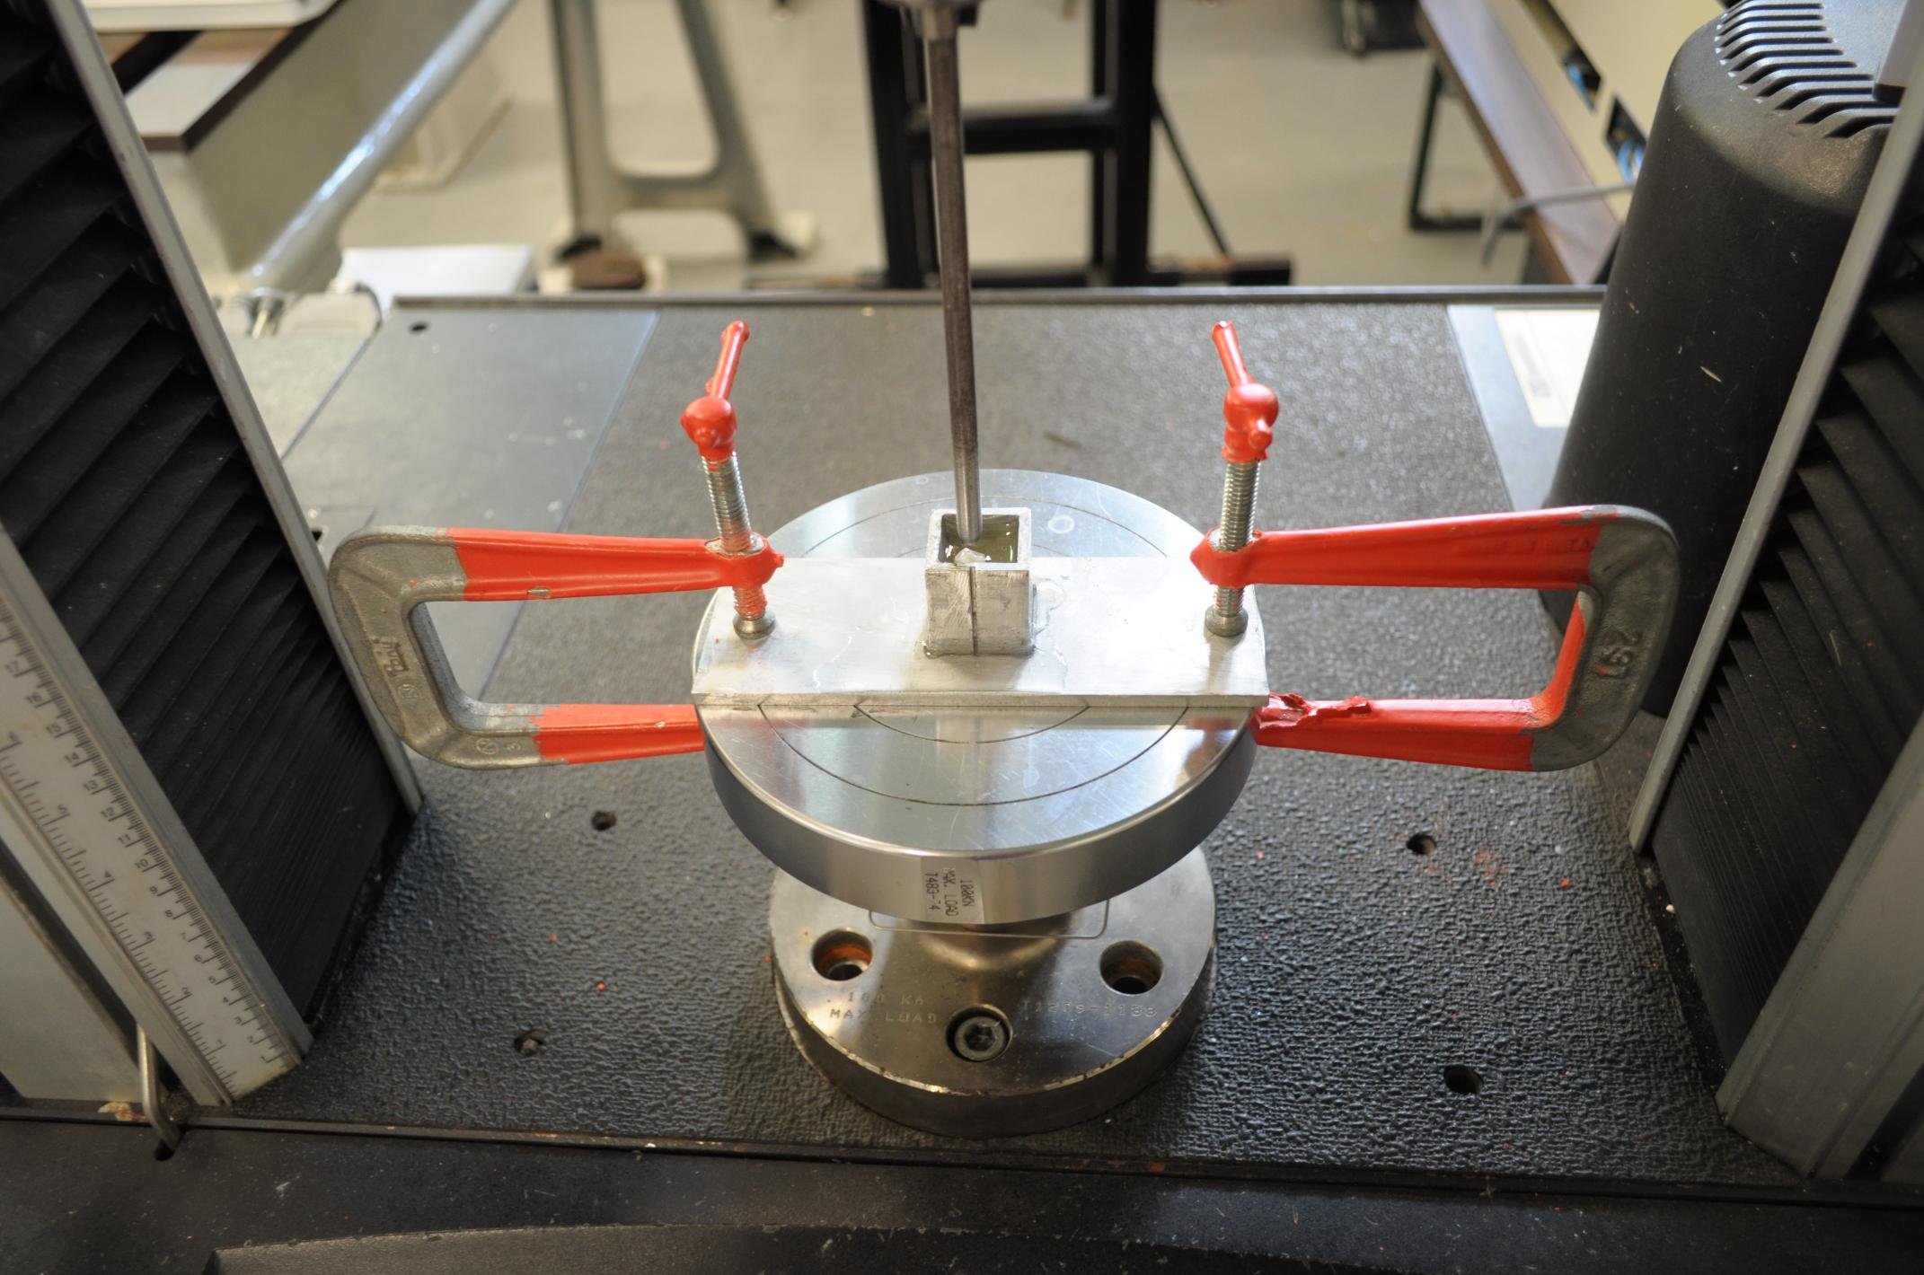
Figure 5.7. Fixture clamped on to the machine table and the tooth is aligned with the steel rod to contact at the cusp

Since the Instron 4469 was a displacement controlled machine, we could only control the distance travelled vertically by the load frame. Because of this a standard fixed load could not be applied. Rather, the loading rod connected to the load cell was first set to the zero position and later was moved manually in small increments to maintain contact with cusp until a load of 110 lbs was reached. The distance travelled by the rod from its zero position was noted and was entered in the machine’s computer software along with the number of cycles to be run the tooth sample. Each of the samples were run for a total of 15000 cycles in three steps. Firstly the experiment was stopped at 3000 cycles and the software setting was reset to bring the machine to initial stage. Next the experiment was continued on the same sample for another 5000 cycles and stopped to reset the software. Finally the experiment was finished by completing the remaining 7000 cycles. This procedure was followed to minimize any error in the machine setting and the load applied.
The above procedure was conducted on healthy tooth samples as well as a tooth which already had cracks, caries, and stains on it. Also the experiment was for conducted for different loads, teeth samples were tested for 25lbs, 50lbs, 75 lbs and 110 lbs. And finally the samples were coated in carbon or gold palladium and the surface of the teeth at the cervical region was studied using the electron microscope.
- RESULTS AND DISCUSSSION
Results were obtained from both the parts of the research. The finite element analysis results showed stresses at the cervical regions for various non axial loading on tooth and the fatigue tests showed the loss of enamel micro-structurally.
6.1. Finite Element Analysis
The peak stresses obtained at the cervical regions are shown in the table 1 which shows that higher stresses are obtained at the cervical regions than compared to other regions. Three-dimensional results showed similar results when compared to the two dimensional results obtained by Rees.
Table 6.1. Magnitude of Maximum principle stress for load positions on mandibular bicuspid and maxillary bicuspid
Load points | Maximum principle stress on Mandibular bicuspid (MPa) | Maximum principle stress on Maxillary bicuspid (MPa)
A | 181 | 100
B | 78 | 126
C | 212 | 80
D | 246 | 55
E | 271 | 120
F | 167 | 90

When a section is taken at the cervical regions the results show that the magnitude of the stresses reduces near the adjacent side along the plane. Similar results are shown in regions away from the cervical regions along the outer surface.. Figure 6.1 shows the plot of maximum principle stress along a plane at the cervical region from outer surface to adjacent surface.
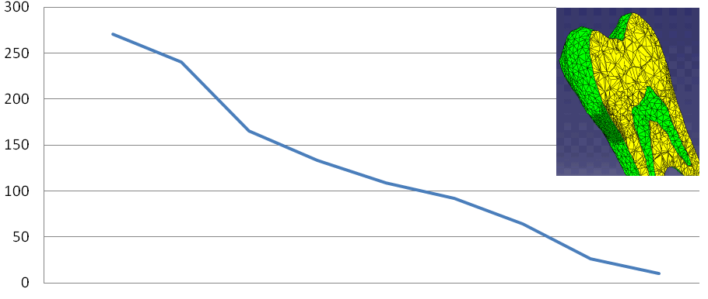
Maximum principle stress
Outer Surface
Adjacent

Outer Surface
Adjacent

Figure 6.1. Plot of cervical maximum principle stress on the section plane
The cervical region shows stresses on both lingual surface and buccal surface. But the magnitude of the stress at the buccal side is much higher than the lingual side which suggests that the tensile stress produced is much higher than the compressive stress and also it follows the one-third rule. The theoretical calculation suggests that the failure stress of materials may vary from E/5 to E/30, where E is elastic modulus of material. For brittle materials fracture strength is almost equal to E/1000 [13]. Enamel is brittle and considering the Elastic modulus of enamel as 83 GPa [8], the failure stress is 83 MPa.

The stresses seen at the cervical regions for all the loading points are higher than the failure stress of the enamel. Therefore the Finite element model gives a resonable biomechanical explaination for the breakdown of enamel at the cervical regions due to parafunctional activity loading on the teeth.

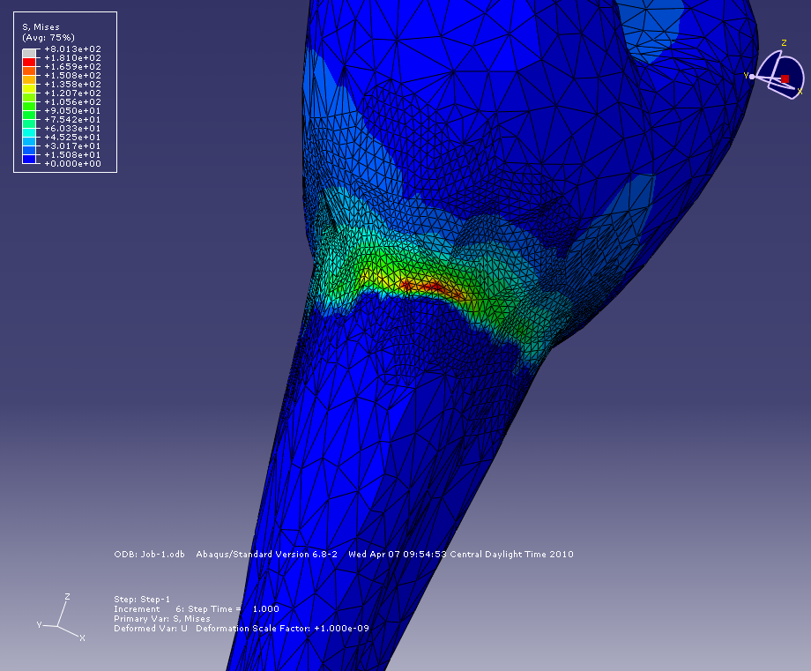
Buccal surface
Lingual surface
Figure 6.2. Stress at cervical regions for load point A on mandibular tooth

Results as given in figure 6.2 show that the Maximum principle stress obtained on the buccal surface for load point A in a Mandibular tooth is 181 MPa . The stress obtained is more than the failure stress of Enamel. Though it shows some stress in the lingual surface, it is well within the failure strength of the material.

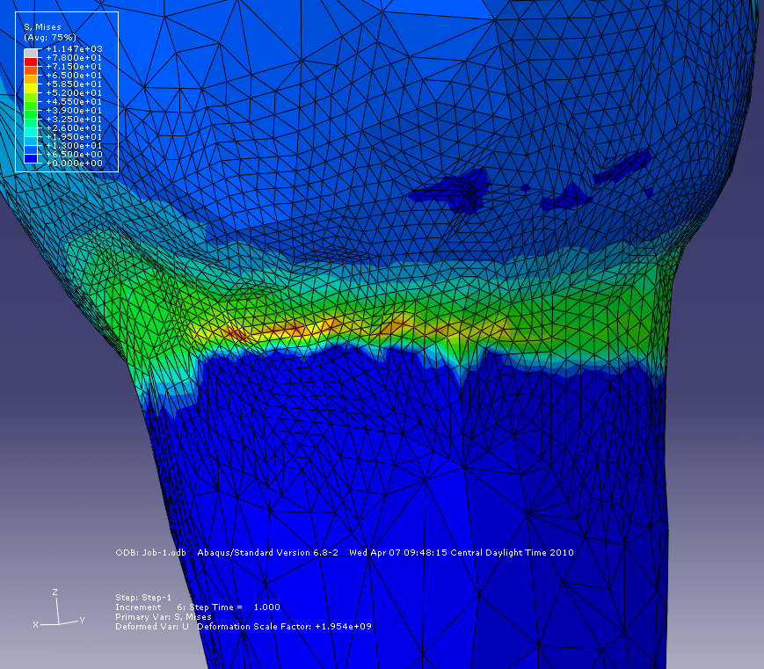
Figure 6.3. Stress at cervical regions for load point B on mandibular tooth

Results shown in figure 6.3 show that the Maximum principle stress obtained on the buccal surface for load point B in a Mandibular tooth is 78 MPa . The stress obtained is almost equal to failure stress of Enamel. The stress in the lingual surface is much lower.

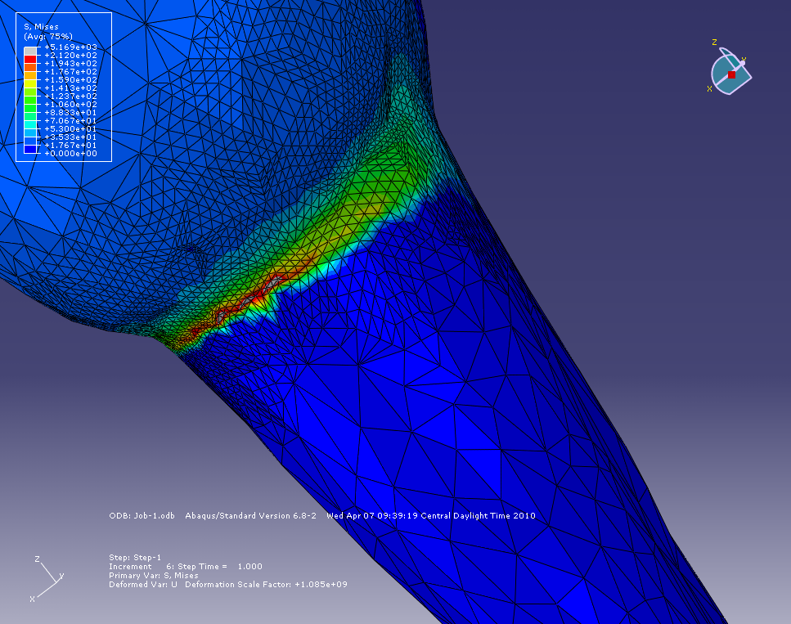

Figure 6.4. Stress at cervical regions for load point C on mandibular tooth

Results shown in figure 6.4 show that the Maximum principle stress obtained on the buccal surface for load point C in a Mandibular tooth is 212 MPa . The stress obtained is more than the failure stress of Enamel. The stress in the lingual surface is much less.

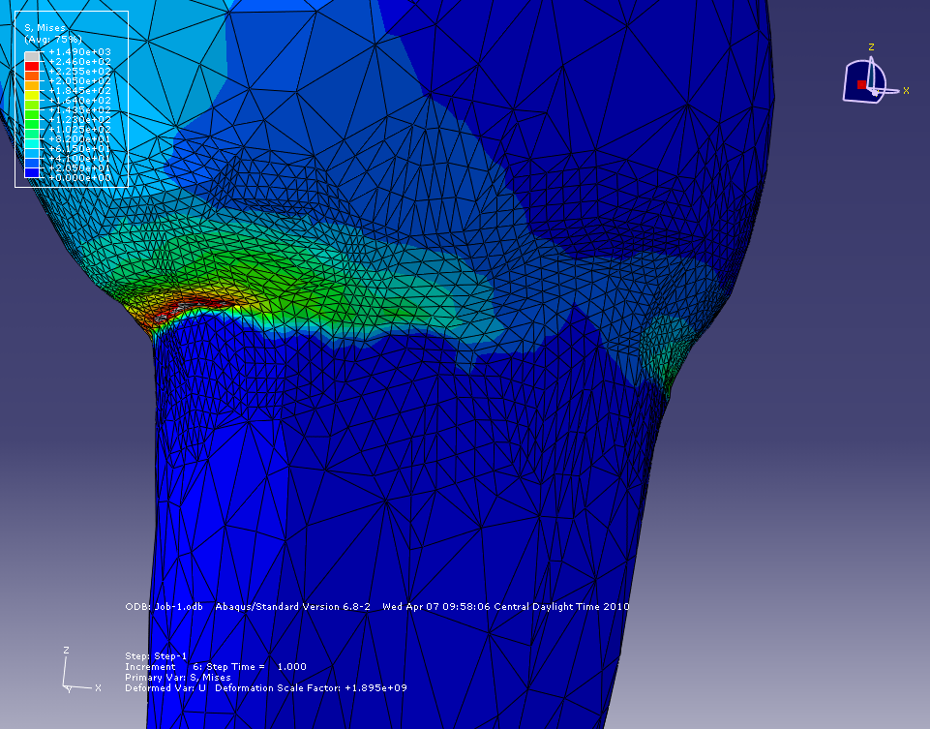

Figure 6.5. Stress at cervical regions for load point D on mandibular tooth

Results shown in figure 6.5 show that the Maximum principle stress obtained on the buccal surface for load point D in a Mandibular tooth is 246MPa . The stress obtained is more than the failure stress of Enamel. The stress in the lingual surface is much less.

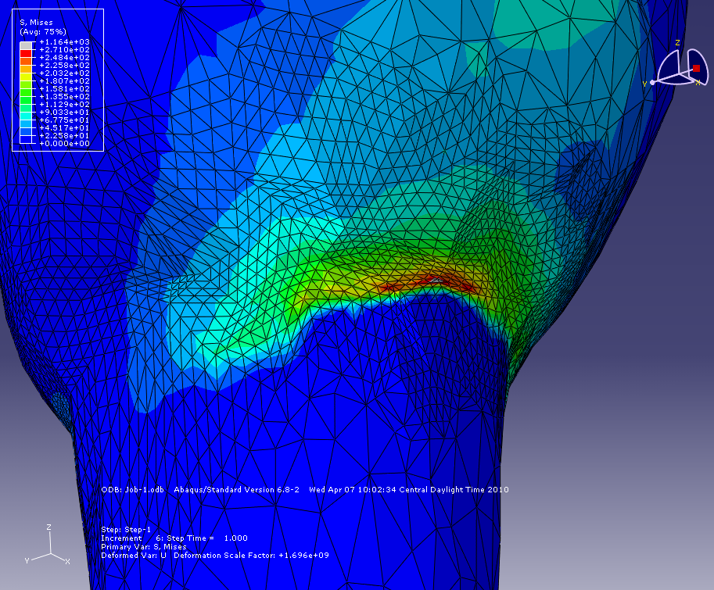

Figure 6.6. Stress at cervical regions for load point E on mandibular tooth

Results shown in figure 6.6 show that the Maximum principle stress obtained on the buccal surface for load point E in a Mandibular tooth is 271MPa . The stress obtained is more than the failure stress of Enamel. The stress in the lingual surface is much less.

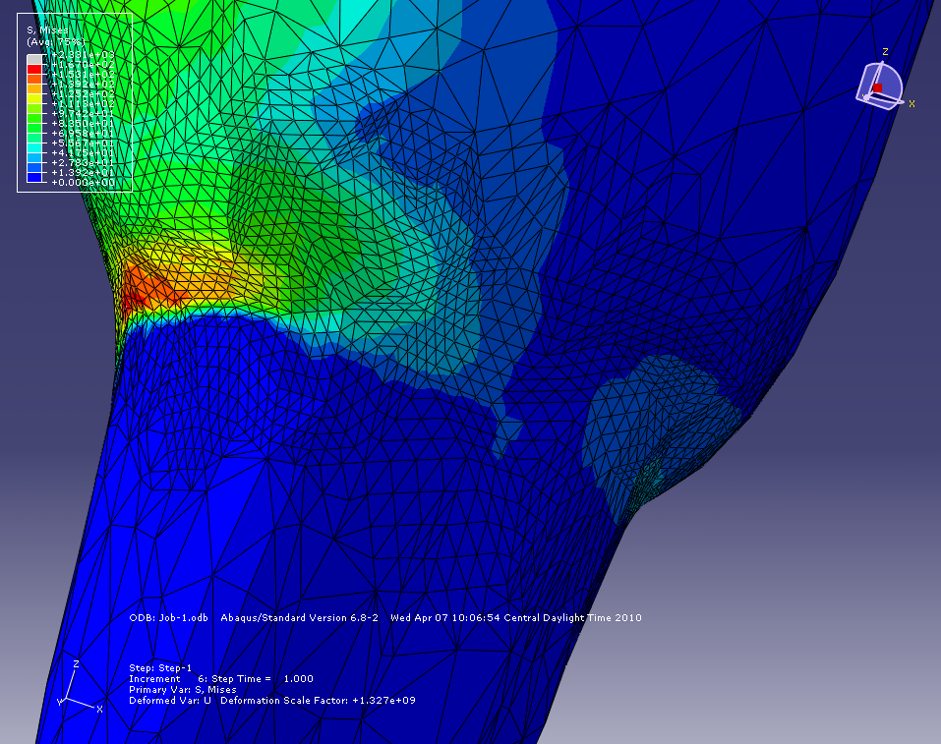

Figure 6.7. Stress at cervical regions for load point F on mandibular tooth

Results shown in figure 6.7 show that the Maximum principle stress obtained on the buccal surface for load point F in a Mandibular tooth is 161MPa . The stress obtained is more than the failure stress of Enamel. The stress in the lingual surface is much less.

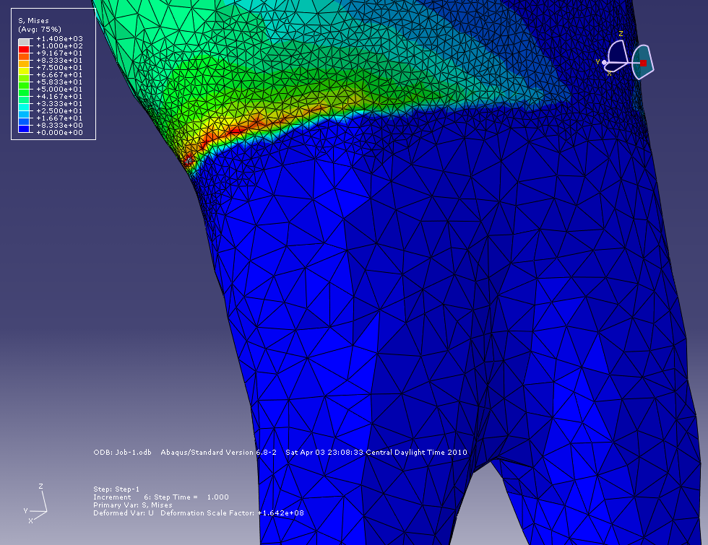

Figure 6.8. Stress at cervical regions for load point A on maxillary tooth

Results as given in figure 6.8 show that the Maximum principle stress obtained on the buccal surface for load point A in a maxillary tooth is 100 MPa . The stress obtained is more than the failure stress of Enamel. Though it shows some stress in the lingual surface, it is much less than the strength of the material.

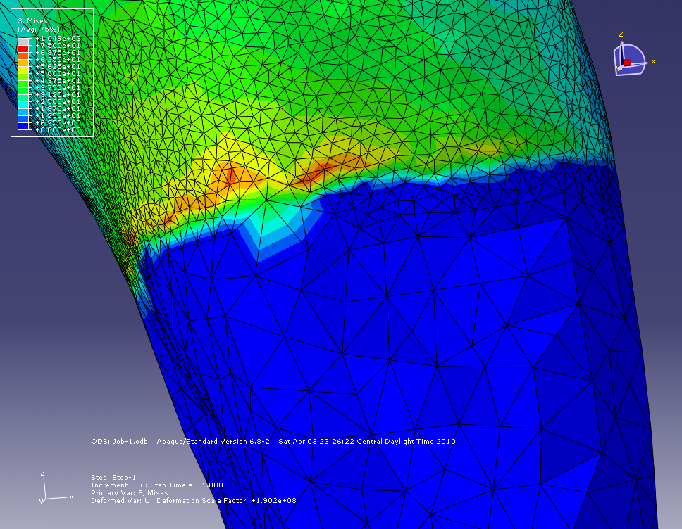

Figure 6.9. Stress at cervical regions for load point B on maxillary tooth

Results as given in figure 6.9 show that the Maximum principle stress obtained on the buccal surface for load point B in a maxillary tooth is 126 MPa . The stress obtained is more than the failure stress of Enamel. Though it shows some stress in the lingual surface, it is much less than the strength of the material.

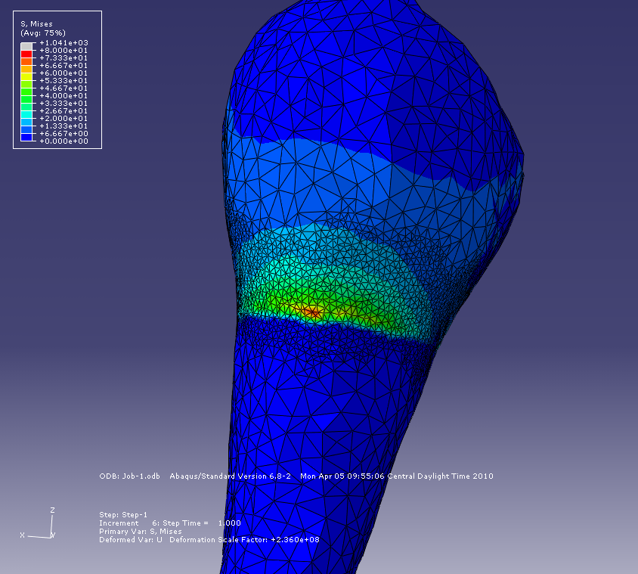

Figure 6.10. Stress at cervical regions for load point C on maxillary tooth

Results as given in figure 6.10 show that the Maximum principle stress obtained on the buccal surface for load point C in a maxillary tooth is 80 MPa . The stress obtained is almost equal to the failure stress of Enamel. Stress shown in the lingual surface, is well within the strength of the material.

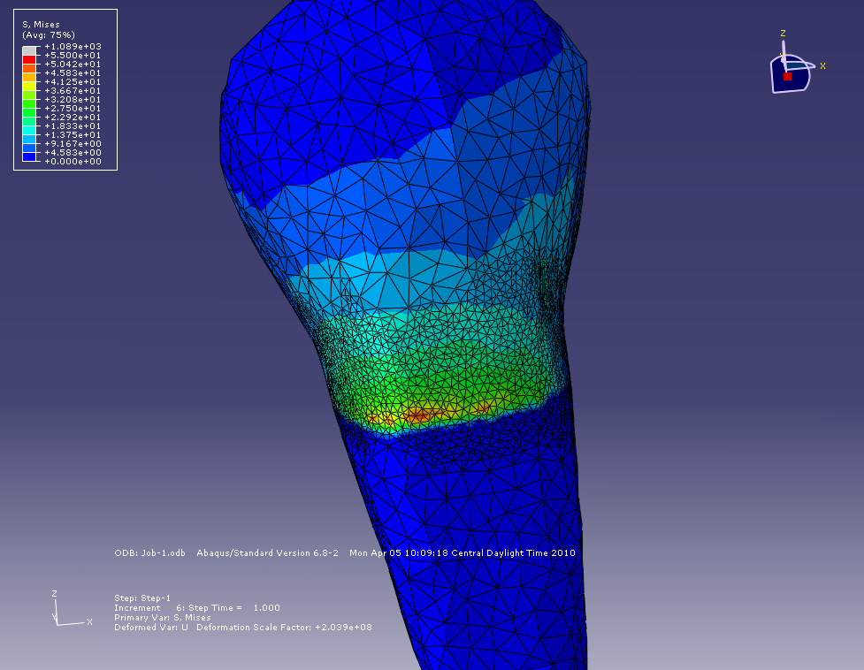

Figure 6.11. Stress at cervical regions for load point D on maxillary tooth

Results as given in figure 6.11 show that the Maximum principle stress obtained on the buccal surface for load point D in a maxillary tooth is 55 MPa . The stress is within the failure stress of enamel.

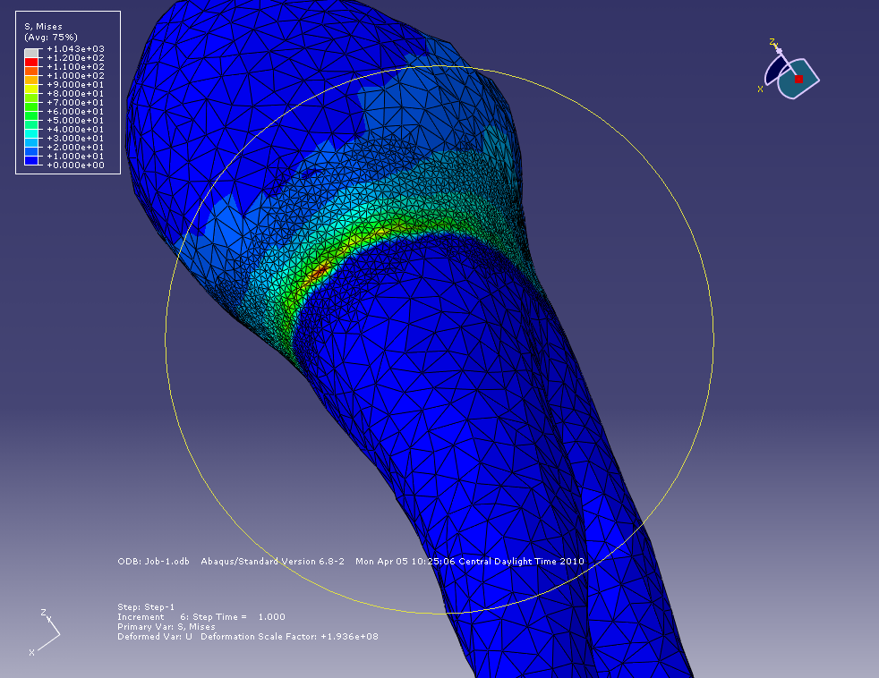

Figure 6.12. Stress at cervical regions for load point E on maxillary tooth

Results as given in figure 6.12 show that the Maximum principle stress obtained on the buccal surface for load point E in a maxillary tooth is 120 MPa . The stress obtained is more than the failure stress of Enamel. Though it shows some stress in the lingual surface, it is well within the failure stress for enamel.

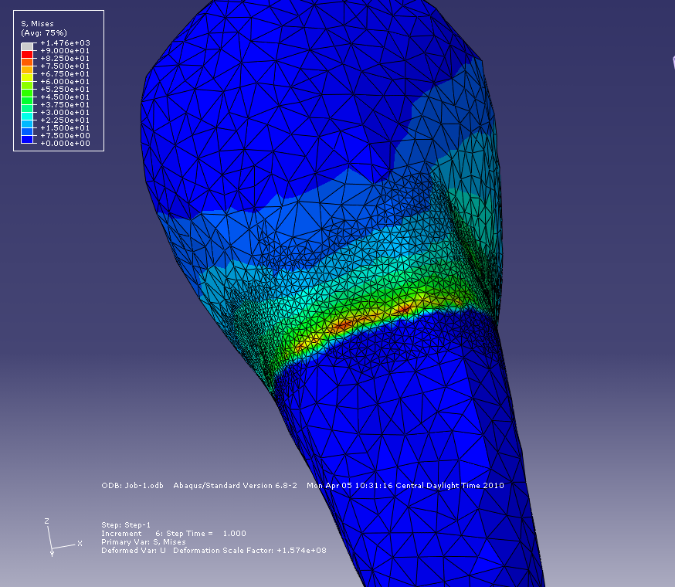

Figure 6.13. Stress at cervical regions for load point F on maxillary tooth

Results as given in figure 6.13 show that the Maximum principle stress obtained on the buccal surface for load point F in a maxillary tooth is 90 MPa . The stress obtained is more than the failure stress of Enamel. Though it shows some stress in the lingual surface, it is well within the failure stress for enamel.
  - Fatigue test on tooth
Fatugue test was conducted on 10 tooth samples. Each of these samples was tested with the same environment as explained in Chapter 5. Most of the samples showed some distortion on the surface at the cervical regions as compared to the surface of the cervical regions which have not undergone cyclic loading.
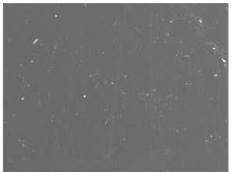
Figure 6.14 SEM image of enamel of healthy tooth (x500, 10μm)
The first tooth sample selected had a weak root. It cracked at the root and broke away during the experiment. Even though the load applied was 10N, a normal biting force, it broke at the surface of the resin after 115 cycles.
The Second sample chosen for fatigue test was a healthy sample without any cracks, caries, and stains. This sample was cyclically loaded at 135 N for 15000 cycles. Figure 6.15 shows the cervical region of the tested sample. The right side of the image divided by the junction shows the enamel and the left side shoes the cementum. However this junction does not shows any signs of cracks at the junction but the region slightly above this junction towards the enamel showed some possible cracks.

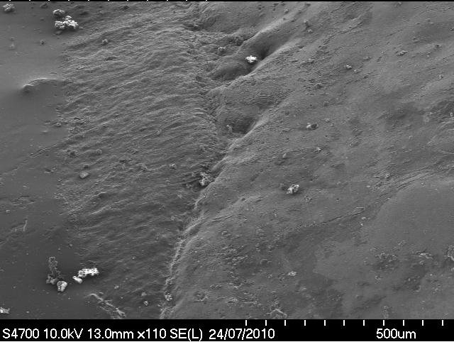
Figure 6.15 CEJ of the tooth

The region slightly above the CEJ shown in figure 6.16, clearly indicates the presence of the surface cracks on cervical regions. The whole of the image shows a slight rough surface on the smooth enamel structure on the buccal surface except for few lines on it. These lines might be micro-structural cracks formed due to the cyclic loading on the tooth or stains present on the surface of the tooth.
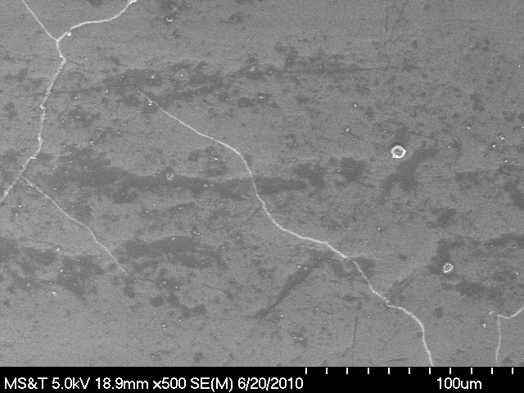
Figure 6.16 SEM image of enamel just above CEJ (x500, 100μm)
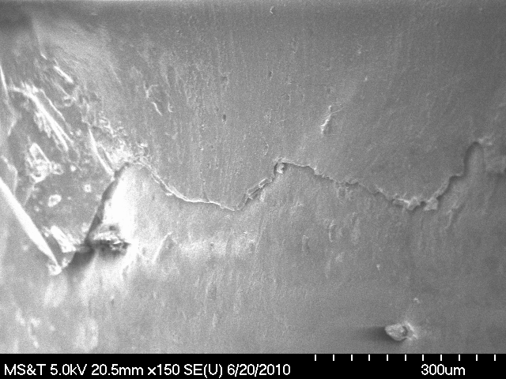
Figure 6.17 Loss of enamel with the formation of cracks.

For more detailed inspection of the surface, cervical regions were further magnified on the visible lines, to x2500 and 300 μm as shown in figure 6.16. From this it can observed that it is not the stains but the loss of enamel material at the cracks. The center of image shows the crack running horizontally on the smooth enamel surface. From the image, one can see the edge of the crack formed due to the chipping of enamel material from the bulk of the tooth. Due to formation of these cracks slightly above the above CEJ it can inferred that the reason for the loss of enamel structure in the cervical region is mainly due to the cyclic loading on the tooth caused by the parafunctional activity in mouth.
The third sample was loaded at 1000 N for 20000 cycles. Because of the large load the steel rod acting as the opposite tooth created a dent on the cusp but did not show any crack at the point of contact. Since the load applied on the tooth depended on the distance travelled by the crosshead, it reduced the amount of load on the tooth. However the test was completed by increasing the crosshead travel distance such that it applied the required load on the tooth. Figure 6.18 shows the surface of the enamel just above the CEJ on the buccal side. This region shows rough texture of the enamel surface and the evidence micro-structural cracks. The image shows the edges formed due to chipping away of enamel from it. This sample shows more extensive cracks along with numerous small cracks in random direction. The formation of cracks and chipping of enamel from the cervical region is more noticeable in this because of high load and more number of cycles.
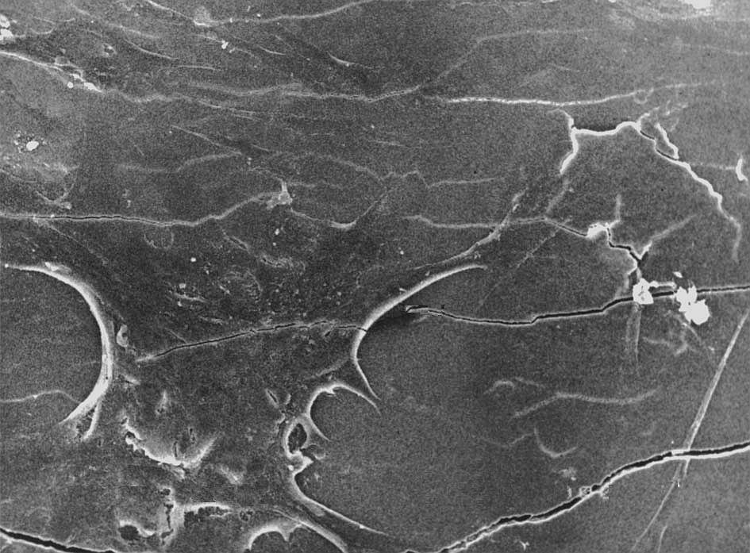
Figure 6.18 Surface of sample 3

Some more healthy samples were tested at 110 N, 250 N, 500 N for 15000 cycles and a sample at 110 N for 1000 cycles Each of them showed similar results as sample 2 and sample 3. The intensity of these cracks depended on the load and number of cycles at which the samples were tested. For high loads and more number of cycles the results showed large cracks and rougher enamel surface just above CEJ on the buccal side. The size and density of these cracks are reduced for lesser load and less number of cycles. This formation of crack shows that the cervical region is affected by the cyclic load applied on the cusp of the tooth
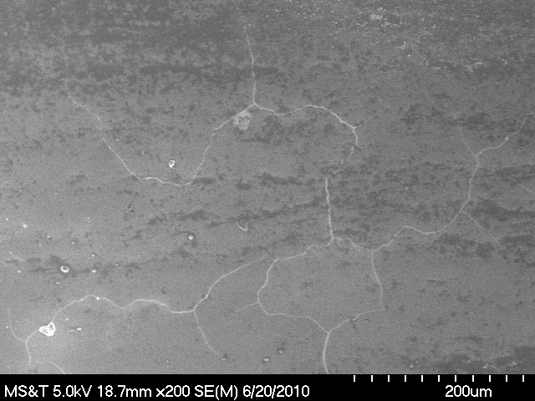
Figure 6.19 Surface of sample 4
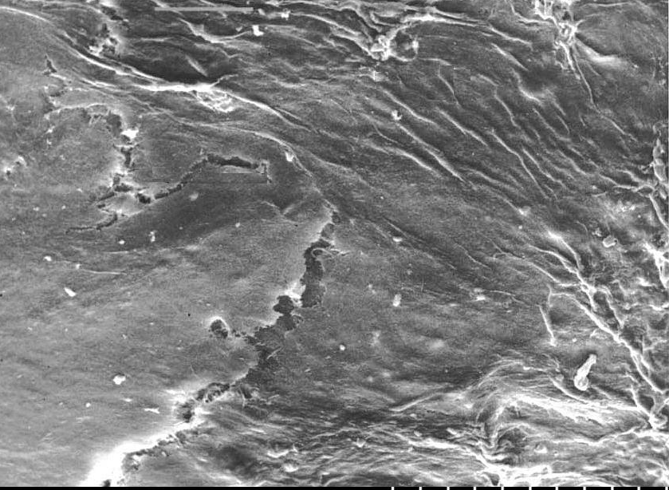
Figure 6.20 Surface of sample 5
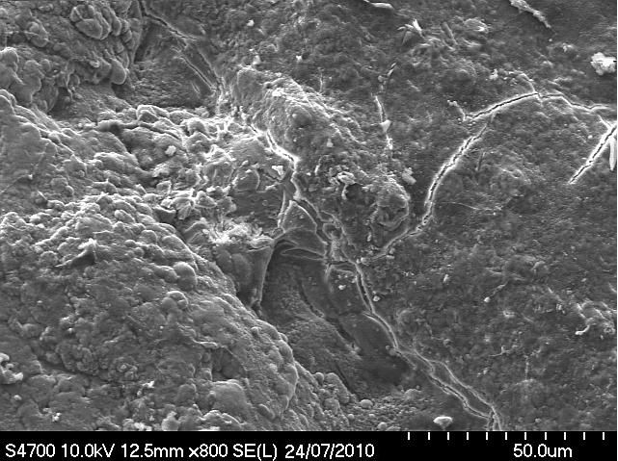
Figure 6.21 Surface of sample 6
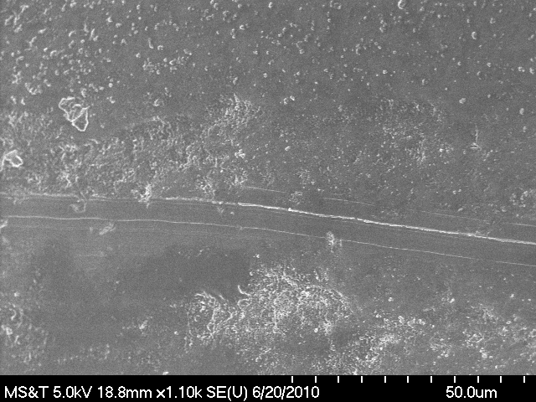
Figure 6.22 Surface of sample 7

Sample 8 was tested at 150 N for 15000 cycles. This sample was setup in the resin such that the root was completely inside the resin and the CEJ just touching the surface of the resin, where as in other samples the level of resin was just below the CEJ. Though cracks were formed on the buccal surface, it was formed on the cementoenamel junction unlike other samples where crack were formed slightly above the CEJ. Figure 6.22 shows the cracks formed on the CEJ of this tooth sample. This indicated that the location of the crack formation depends on upto what level the root is held by the resin. So it essential to study the periodontal ligament and simulate that in the experiment.

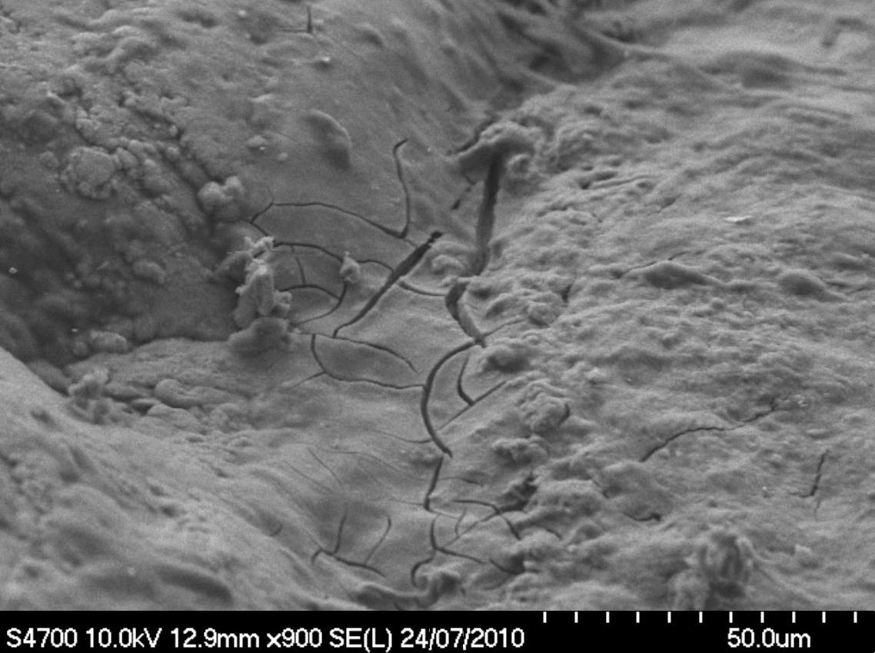
Figure 6.23 Surface of sample 8

Two samples, having caries were tested at 500 N for 15000 cycles. Both the samples vertically cracked, running the crack from the cusp until the CEJ. But the test was continued on them which later chipped of the enamel throughout the crack to show the dentin. Experiments were stopped on them as the dentin was exposed at the loading point.
CONCLUSION
In the present research 3D tooth structure was modeled and studied by simulating the biomechanical forces acting on the teeth using ABAQUS. The results obtained for both Maxillary bicuspid and Mandibular bicuspid show that the stresses generated at the cervical regions due to parafunctional loading on the tooth cusps is more than the calculated failure stress of the enamel in buccal surface.
Fatigue test on many bicuspid tooth samples is done to check the loss of material at microscopic level at the cervical regions. Results showed that the samples which were cyclically loaded developed micro cracks at the surface of enamel slightly above the cement-enamel junction on the buccal surface. Cracks were developed intensely on the samples which were tested at higher loads and higher number of cycles which indicate that the microstructure of the tooth will eventually be broken over time leading to formation of larger notches and cracks at the cervical region known as abfraction
Results obtained in this research by finite element study and fatigue testing on tooth support the argument which postulate mechanical forces acting on the tooth loosens the bond between hydroxyapatite crystals in enamel which eventually leads to crack formation and loss of material in enamel and the adjacent dentine called as abraction.

REFRENCES
[1] http://dentistry.about.com/od/toothmouthconditions/tp/10-Common-Dental-Problems.htm
[2] Seligman DA, Pullinger AG, Solberg WK, “The prevalence of dental attrition and its association with factors of age, gender, occlusion, and TMJ symptomatology”. Journal of Dental Research 1996; 67: 1323-33.
[3] Grippo JO, Simring M, Schreiner S. “Attrition, abrasion, corrosion and abfraction revisited: a new perspective on tooth surface lesions.” JADA 2004;135(8): 1109–18
[4] Ten Cate JM, Imfeld T. “Dental erosion: summary”. Eur J Oral Sci 1996;104(2, part 2):241–4.
[5] Espejo LC, Simionato MR, Barroso LP, et al. “Evaluation of three different adhesive systems using a bacterial method to develop secondary caries in vitro.” Am J Dent 2010 Apr; 23(2):93-7.
[6] Tomislav Badel, Jadranka Keros , Sanja Šegović , Dragutin Komar. “Clinical and Tribological View on Tooth Wear”. Acta stomatologica Croatica, Vol.41 No.4 December 2007.
[7] Lee WC, Eakle WS. “Possible role of tensile stress in the etiology of cervical erosive lesions of teeth.” J Prosthet Dent 1984;52:374–80
[8] Rees JS. “The role of cuspal flexure in the development of abfraction lesions: a finite element study.” Eur J Oral Sci 1998;106:1028–32
[9] Grippo JO. “Abfractions: a new classification of hard tissue lesions of teeth.” J Esthet Dent 1991;3:14–9.
[10] Grippo JO. Noncarious cervical lesions: the decision to ignore or restore. J Esthet Dent 1992;4(supplement):55–64.
[11] Michael, J. A., Townsend, G.C., Greenwood, L.F., and Kaidonis, J.A. “Abfraction: Separating Fact from Fiction.” Australian Dental Journal 54 (2009): 2-8.
[12] Takahashi N, Kitagami T, Komori T. “Behaviour of teeth under various loading conditions with finite element method.” J Oral Rehabil 1980;7:453–61
[13] Rees JS, Hammadeh M, Jagger DC. “Abfraction lesion formation in maxillary incisors, canines and premolars: a finite element study.” Eur J Oral Sci. 2003 Apr;111(2):149-54.
[14] J S Rees “The biomechanics of abfraction” Proceedings of the Institution of Mechanical Engineers, Part H: Journal of Engineering in Medicine ,Volume 220, Number 1 / 2006, 69-80
[15] Langlais, Robert P., and Miller, Craig S. Color Atlas of Common Oral Diseases, 3rd ed.United States: Lippincott Williams & Wilkins, 2002.
[16] Waters, N. E. “Some mechanical and physical properties of teeth.” In Mechanical Properties of Biological Material (Eds J. F. V. Vincent and D. Currey), 1980, pp. 99-135 (Cambridge University Press, Cambridge).
[17] Palamara, D., Palamara, J. E. A., Tyas, M. J., and Messer, H. H. “Strain patterns in cervical enamel of teeth subjected to occlusal loading”. Dent. Mater., 2000, 16, 412-419.
[18] Thresher RW, Saito GE. :The stress analysis of human teeth.” J Biomech 1973;6:443–9.
[19] Miller WD. Experiments and observations on the wasting of tooth tissue variously designated as erosion, abrasion, chemical abrasion, denudation, etc. Dental Cosmos 1907;XLIX:1-23.
[20] Black GV. Operative dentistry: the pathology of the hard tissues of the teeth. London. Medico-Dental Publ Co; 1914:39-59,157
[21] Fritz Mannerberg, Appearance of tooth surface as observed in shadowed replicas.CWK Gleerup, Lund, 1960.(Odontologisk Revy, Vol. 11, Suppl. 6, 1960)
[22] Sognnaes R, Wolcott R, Xhonga F. Dental erosion: erosion-like patterns occurring in association with other dental conditions. J Am Dent Assoc 1972;84:571-82
[23] Yettram A, Wright K, Pickard H. Finite element stress analysis of the crowns of normal and restored teeth. J Dent Res 1976;55:1004-11
[24] Radentz WH, Barnes GP, Cutright DE. A survey of factors possibly associated with cervical abrasion of tooth surfaces. J Periodontol 1976;47:148-54.
[25] D. Palamara, J. E. A. Palamara, M. J. Tyas, M. Pintado and H. H. Messer, “Effect of stress on acid dissolution of enamel” Dental Materials, Volume 17, Issue 2, March 2001, Pages 109-115
[26] Hassan R, Caputo AA, Bunshah RF.”Fracture toughness of human enamel”. J Dent Res 1981;60:820–827.
[27] Staninec M, Nalla RK, Hilton JF, et al. “Dentin erosion simulation by cantilever beam fatigue and pH change.” J Dent Res 2005; 84:371–375.
[28] G. V. Black, “Oral Histology and Embryology”, University of Michigan Library (January 1, 1902)

[29] S.N. Bhaskar, “Orban’s Oral histology and embryology” 9th Edition, The C V Mosby Company
[30] www.tpub.com “Dental Anatomy and Physiology” subcourse MD0501 Edition 200, U.S. Army medical department center and school fort Sam Houston, Texas 78234-6100

[31] www.simplyteeth.com “The Anatomy of Teeth and Jaws”

[32] http://en.wikipedia.org/wiki/Dental_anatomy

[33] www.homesteadschools.com/dental/courses/Anatomy/Chapter2.htm

[34] www.colgate.co.in, “Tooth Anatomy”

[35] www.uic.edu

[36] Google images

[37] Houston, W J. B. Walther's Orthodontic Notes, 4th edition, 1983 (Wright, Bristol).

[38] Darbar, U., Huggett, R., and Harrison, A. Stress analysis techniques in complete dentures. J. Dentistry, 1994, 22, 259-264.

[39] Lukas, D. and Spranger, H. Untersuchungen über die auswirkungemn unterschieldlich gemessener gelenkbahn und bennetwinkel auf die horizontalbelastung des zahnesdes zahnes bei definierten unterkieferlateralbewegungen. Dt. Zahnärztliche Z., 1973, 28, 755-758.

[40] Klähn, K. H., Köhler, K. U., Kreter, F., and Motsch, A. Spannungsoptische untersuchungen zur entsehung der sogenannten keilförmigen defekte am organum dentale. Dt. Zahnärztliche Z., 1974, 29, 923-927.

[41] Nohl, F. S., McCabe, J. F., and Walls, A. W. G. “The effect of load angle on strains induced in maxillary premolars in vitro.” British Society of Dental Research Meeting, University of Leeds, 12-15 April 1999, Abstract 200.

[42] Chen, K. K., Miyake, K., and Terashita, M. “Cervical strains induced by occlusal loading.” J. Dent. Res., 1999, 78, 474, Abstract 2947.

[43] Goel, V. K., Khera, S. C., Ralston, J. L., and Chang, K. H. “Stresses at the dentoenamel junction of human teeth - a finite element investigation.” J. Prosthetic Dentistry, 1991, 66, 451-459.

[44] Goel, V. K., Khera, S. C., and Singh, K. “Clinical implications of the response of enamel and dentine to masticatory loads.” J. Prosthetic Dentistry, 1990, 64, 446-454.

[45] Lee, H. E., Lin, C. L., Wang, C. H., Cheng, C. H., and Chang, C. H. “Stresses at the cervical lesion of maxillary premolar - a finite element investigation.” J. Dentistry, 2002, 30, 283-290.

[46] Spranger, H. “Investigation into the genesis of angular lesions at the cervical margin of teeth.” Quintessence Int., 1995, 26, 149-154.

[47] Brian Palmer, “The significance of lateral forces to the development of dental abfractions” ww.brianpalmerdds.com

[48] Roberto De Santis, Luigi Ambrosio and Luigi Nicolais “Integrated Biomaterials Science “Springer US, 2002

VITA

Madhuchandra Mahadevaswamy was born on May 16, 1982 in Mysore, India. He completed his Bachelor of Engineering in Mechanical Engineering from Malnad College of Engineering, Hassan which is affiliated to Visveswaraiah Technological University, Belgaum, India. After his bachelor’s he worked as CAD Engineer at John Crane Sealing Systems India Pvt Ltd, Bangalore, India for 18 months. He also worked for General Electric Transportation, JFWTC, Bangalore, India for as an Engineer for 23 months. He enrolled in the Master of Science Program in Mechanical Engineering at Missouri University of Science Technology (formerly known as University of Missouri-Rolla) in August 2008. Since then he has held positions of Graduate Research Assistant and Graduate Teaching Assistant in the Department of Mechanical and Aerospace Engineering. He graduated with a Master of Science degree in Mechanical Engineering from Missouri University of Science Technology in August 2010.

