CE 120 – BEAM OF TWO MATERIALS

Section (circle): | A B C D E F G H I J K | Date:
Group (circle): | 1 2 3 4 5 6 7 8 9 10 11 12 13 14 15
Data Recorder:

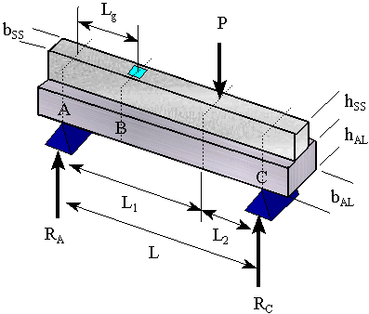
b_{ss}:
h_{ss}:
b_{al}: |  | L_{g}:
h_{al}: |  | L:
E_{ss}: | 28 x 106 psi | L₁:
E_{al}: | 10.6 x 106 psi | L₂:

Load  (lb) |  | Steel Strain  (micro-strain) |  | Aluminum Strain  (micro-strain)

