CE 120 – TENSION TESTING FOR ELASTIC CONSTANTS

Section (circle): | A B C D E F G H I J K | Date:
Group (circle): | 1 2 3 4 5 6 7 8 9 10 11 12 13 14 15
Data Recorder:

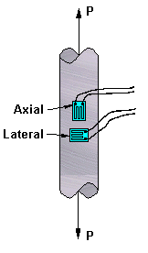

diameter:
material:

Load  (lb) |  | Axial Strain  (micro-strain) |  | Transverse Strain  (micro-strain)

