CE 120 – PRESSURE VESSELS

Section (circle): | A B C D E F G H I J K | Date:
Group (circle): | 1 2 3 4 5 6 7 8 9 10 11 12 13 14 15
Data Recorder:

Thin-Wall Vessel
a: | 1.8705"
b: | 2.0025"
t: | 0.132"
E: | 30 Msi
ν: | 0.27
φ:

Pressure  (psi) |  | Strain A  (micro-strain) |  | Strain B  (micro-strain) |  | Strain C  (micro-strain)
Do not exceed 2000 psi.

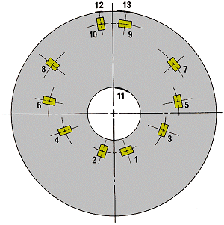
Thick-Wall Vessel

a: | 0.7285"
b: | 2.953"
r: | 1.102" | (for gages 1 and 2)
E: | 10 Msi
ν: | 0.33

Pressure  (psi) |  | Strain 1 – Hoop  (micro-strain) |  | Strain 2 – Radial  (micro-strain)
0

Do not exceed 1000 psi.

