- Why is the concept of Eccentric Loading important?
  - In most real world situations you will not find a single stress state
    - One of the most common situations found is an eccentric axial
    - Important to recognize all the types of stress present
    - Important to be able to know how to combine the different stresses to ensure a safe design
- Example
  - Show them cases of the combined loading situation on loader beam pictured on Combined Loading lesson page
- Lab Procedure
  - We will be applying an offset load to an aluminum beam to create a combined load
    - Each group only needs to test one of the available beams
  - Begin by measuring all the dimensions required by the data sheet
  - Draw on board
  - Do not assume gage #3 is centered on the beam
    - Make sure you measure the location of all gages
  - Use a square and level to align the beam
    - You will be shown how to align the beam in the lab
  - Apply a pre-load of 100-200 lb to hold the beam in place
  - Connect all 5 strain gages to the switch and balance unit
    - Zero the amp and set the gage factor on the indicator
    - Balance the load for each strain gage on the switch and balance unit
  - Zero the load reading
  - Apply an additional 8,000-10,000 lb and then read and record the strains on your data sheet
    - You will only take one set of readings from the strain gages
- Calculations
- Theoretical Calculations
  - Draw FBD of top part of beam on board
  - Cut the beam horizontally at the location of the strain gages
    - Need to find equivalent load condition at the centroid of our cut
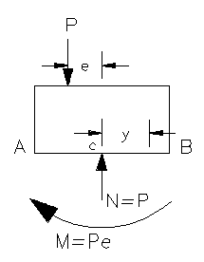
  - Offset load creates both axial and bending stresses in the beam when we transfer the applied load to the cross section of interest
    - Apply superposition to combine the axial and bending stress distributions
    - We have effectively found the distribution of strain across the cross section with the strain gages
  - Find the theoretical stress vs. position line
    - Axial Stress
    - Bending Stress
        - Moment of inertia is found about the centroidal axis at the cross section of interest
    - Combined Stress
  - Calculate the theoretical neutral axis location by setting
  - Also calculate the max. tensile and compressive stresses using your equation for
    - Max. tensile →
  - Max. compressive →
- Experimental Calculations
  - Start calculations by inputting your data to Excel
    - Calculate the experimental stresses present in the beam
      - Uniaxial Hooke’s Law
    - Create a plot of stress vs. distance from the centroid
      - Refer to data sheet for the positive and negative directions for your distance measurements
      - Plot your theoretical stress vs. position equation on the same graph with your experimental regression line

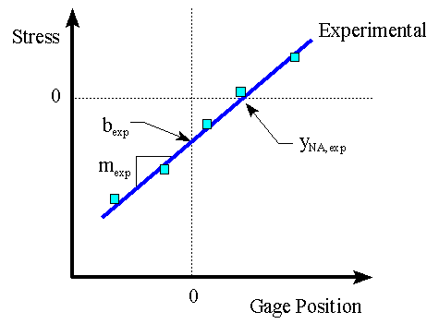
Theoretical
    - Use linear regression to find the equation of the regression line for your experimental data
      - Result will be in the form
    - Find the location of the experimental neutral axis
      - Set in your regression equation from the definition of neutral axis as the point with 0 stress
    - Calculate the maximum tensile and compressive stresses in the beam using your regression equation
      - Max. tensile stress is on the outside of the cross section at
      - Max. compressive stress is on outside of cross section at
- Lab Report
  - The report for this lab should be a memo written by your group worth 100 points
  - Attach your initialed data sheet and a set of hand calculations
  - Experimental Results
    - Include the graph of your data
      - Show both the linear regression line for your data and the theoretical stress vs. position line
    - Show the calculated values for the following
      - Experimental regression line equation
      - Theoretical stress vs. position equation
      - Experimental and theoretical neutral axis location
      - Experimental and theoretical max. tensile and compressive stresses
  - Discussion of Results
    - Compare your experimental values to the theoretical ones using percent difference
      - Should have 3 percent differences total
    - Discuss how well the theory matched your experimental results
    - Give reasons for any major differences in your results

- Presentation
  - Each group will come to the board and fill in your experimental values for the following: neutral axis location, max. tensile stress, and max. compressive stress.
  - Then two random groups will be asked questions about the lab

