Joe Miner

**Getting-Started Problem A**

Model + Loads + Ground Reactions

* vertical pin reaction = 19.13 kips
* vertical roller reaction = 33.37 kips

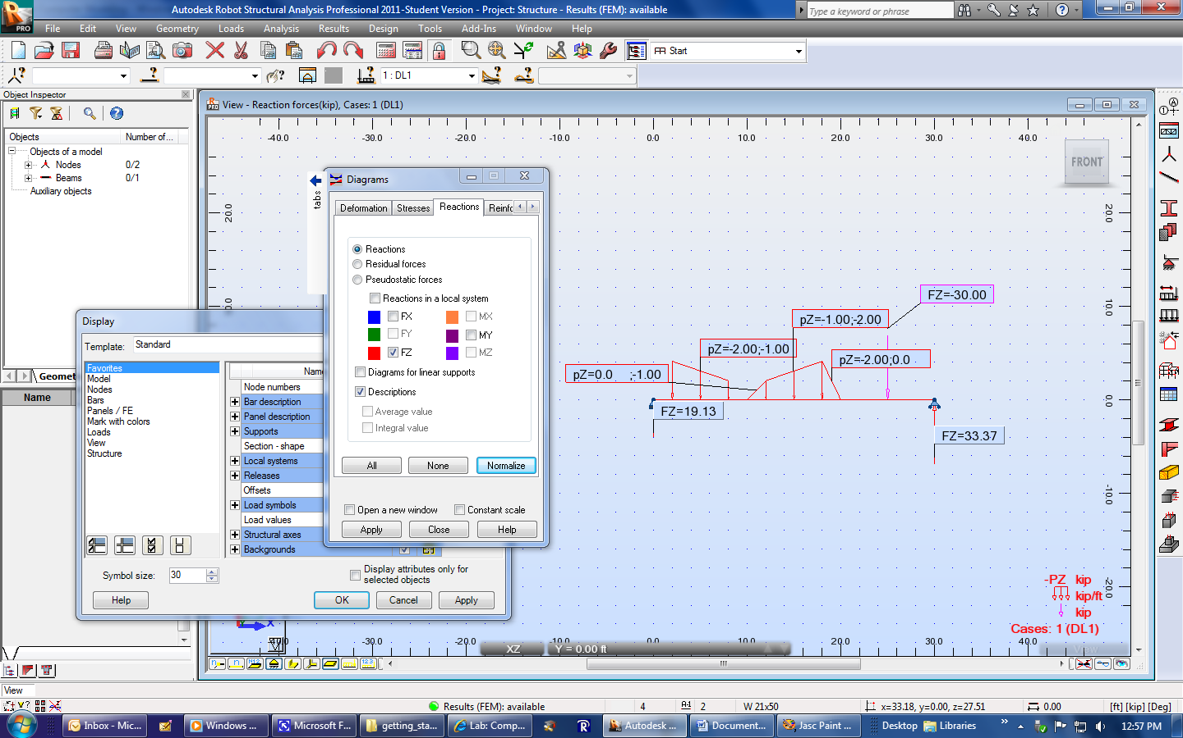

Shear Force + Bending Moment + Bending Stress + Shear Stress Diagrams

* shear force = -33.37 to 19.13 kips
* bending moment = 0 to 185.67 ft-kip
* bending stress = 0 to 23.58 ksi
* shear stress = -4.82 to 2.76 ksi

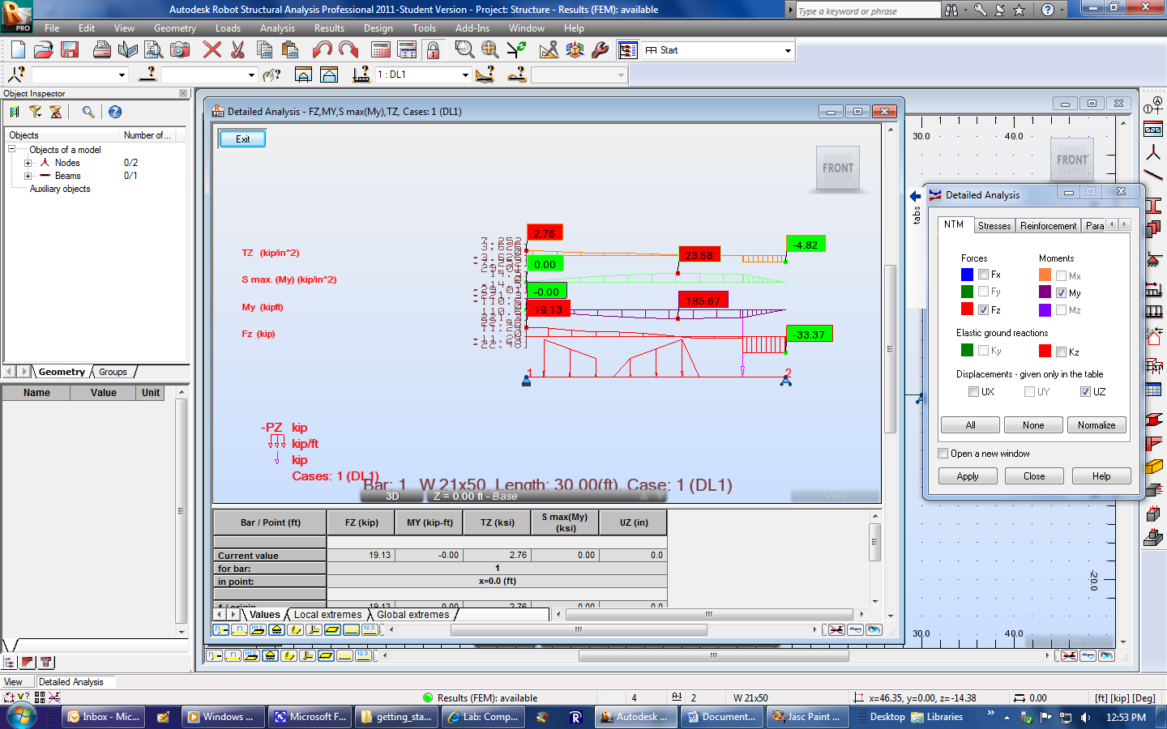

Deflection Diagram

* maximum deflection = 1.0579 in.

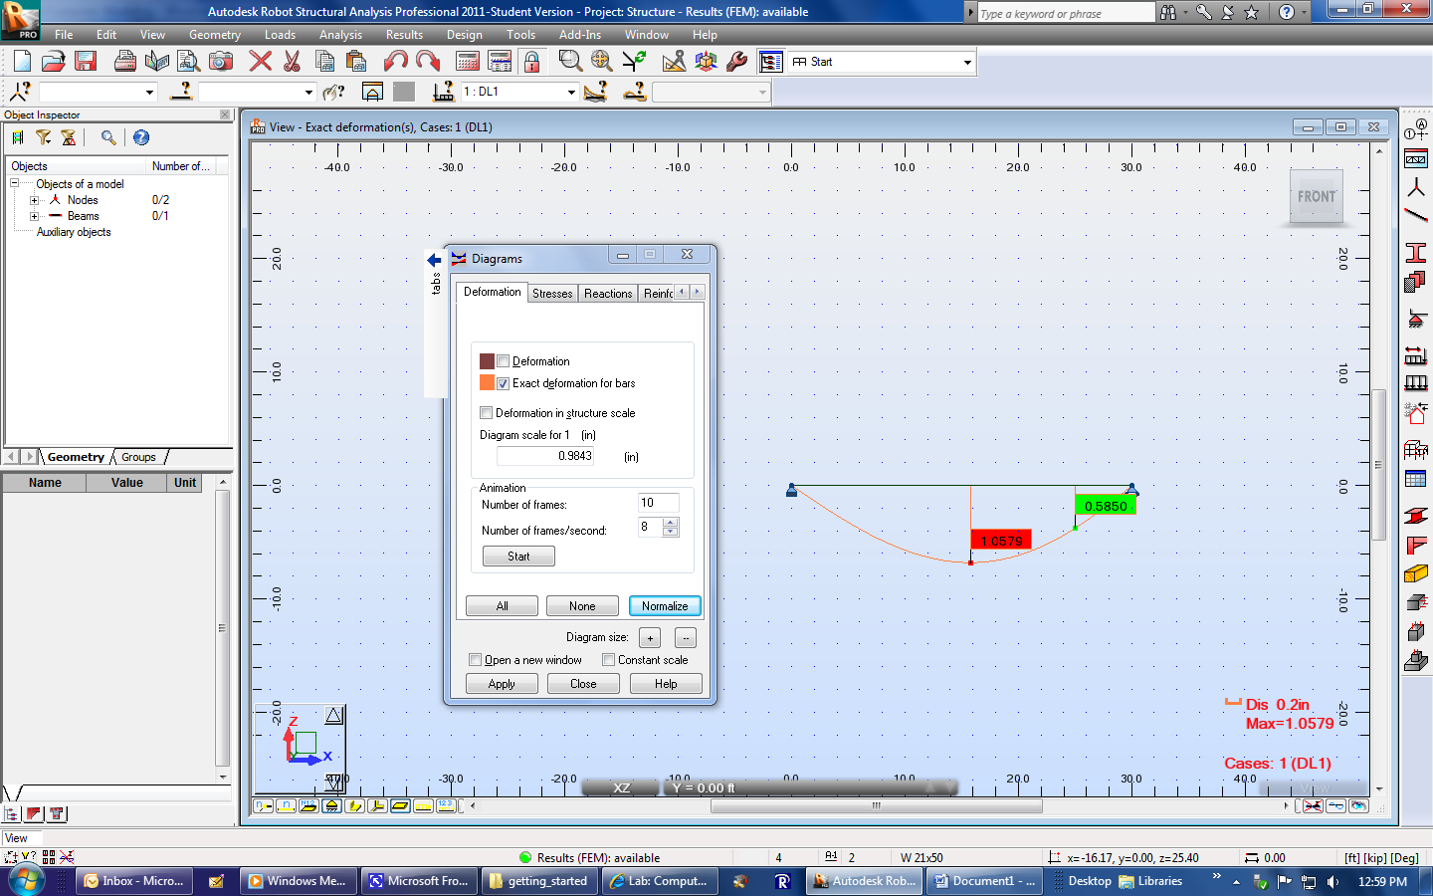

**Getting-Started Problem B**

Model + Loads + Ground Reactions

* vertical pin reaction = 6.39 kips
* vertical roller reaction = 6.39 kips

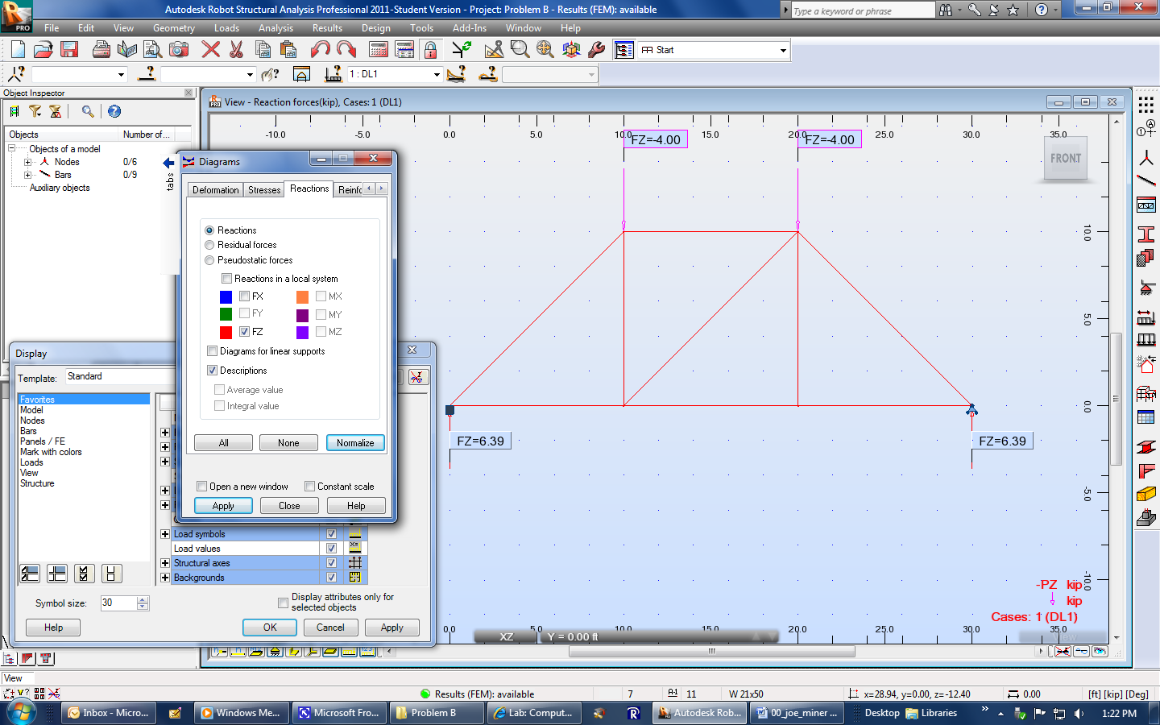

Axial Force

* maximum tension force = 8.19 kips
* maximum compression force = 5.79 kips
* one zero-force member

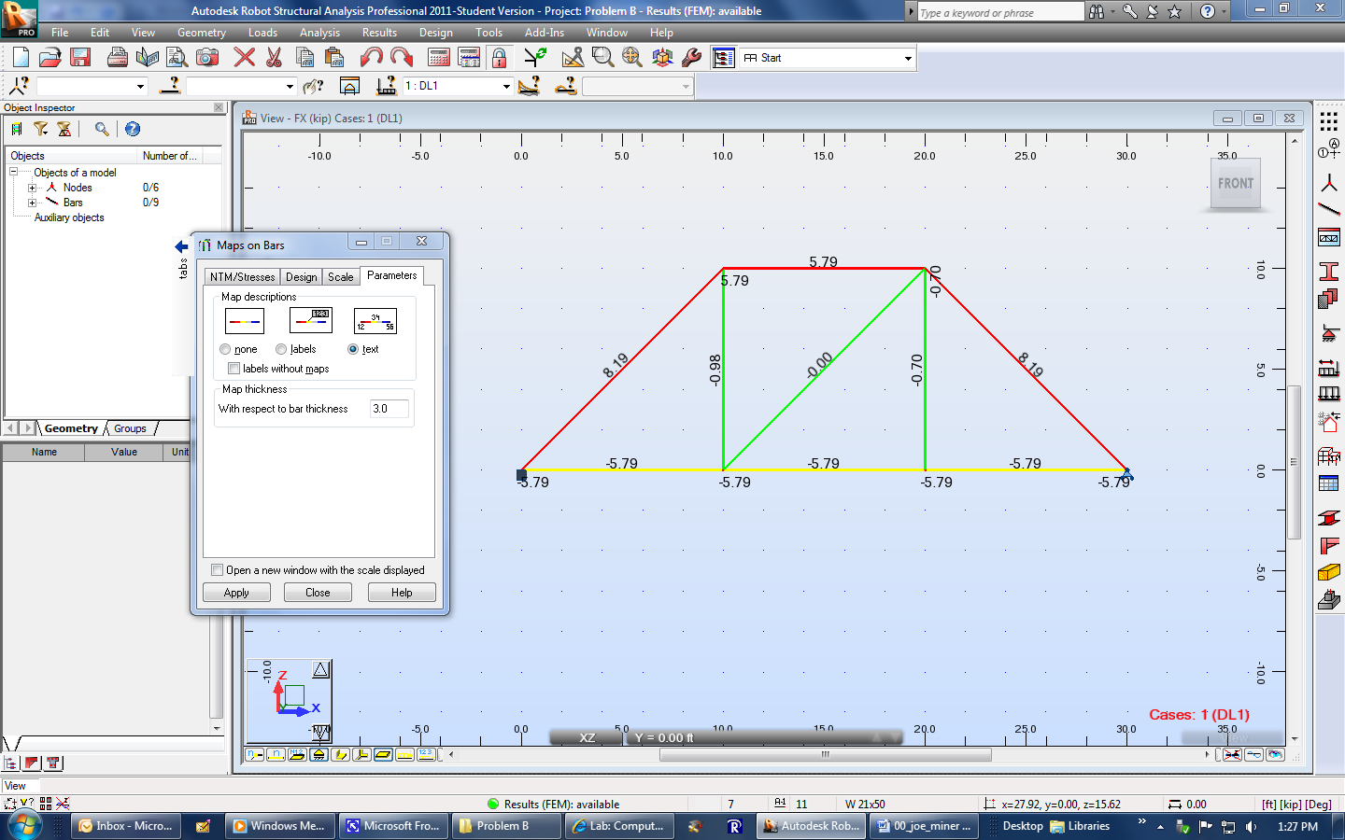

Stress

* maximum tension stress = 0.56 ksi
* maximum compression stress = 0.39 ksi

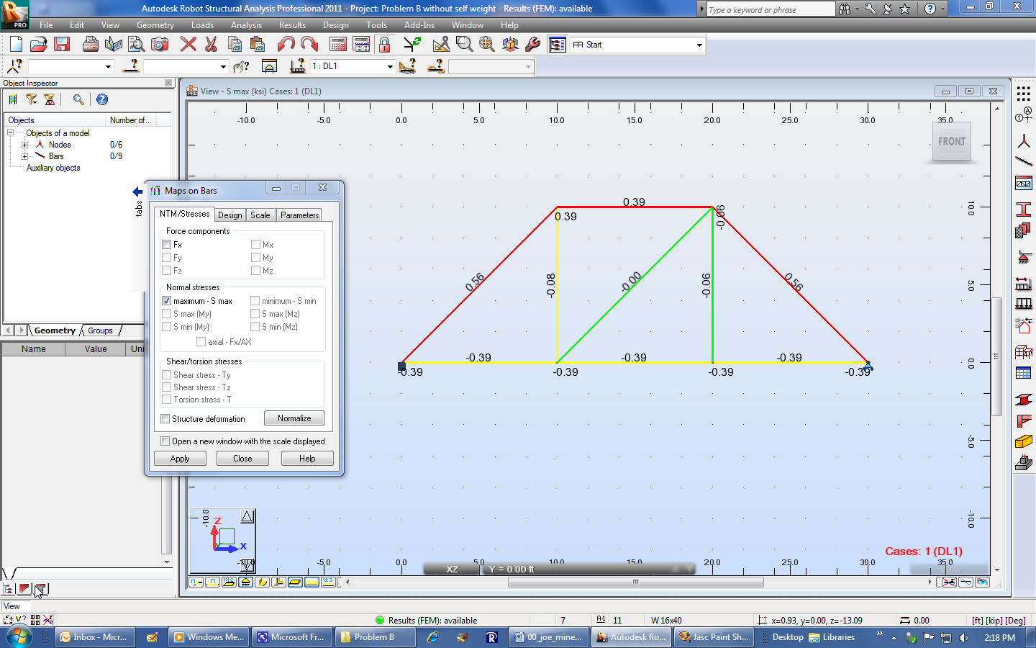

Deflection

* vertical deflection at C = 0.0082 in.
* horizontal deflection at C = 0.0033 in.

