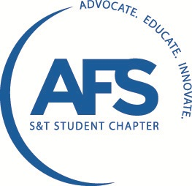
AFS Meeting Agenda
McNutt 212 February 19, 2013

- Call to Order
- Attendance Sheet & Snacks
- Advisor’s report
  - Jobs & Scholarships - Dr. Richards
  - These can be found in a stack in Nicole’s office this week
- Old Business
  - Cast Expo Updates We’re staying at the Ramada by the America’s Center. There is an app for the event called “CastExpo ’13.”There will be a special info meeting to get rides and hotel roommates situated at a later date.
  - St. Pat’s AFS Sweatshirts Updates They have been ordered and will be in before St. Pat’s.
  - Pewter Updates Boots is in charge.
    - Next Pour Date: Friday. Molding on Thursday. Time TBD.
  - Olin Brass Field Trip Sign up in Nicole’s office
    - Alton, IL
    - Thursday February 28th
    - Leave early (~6-7am), arrive back 4pm at the latest
    - Driving our own cars, AFS will reimburse for gas
  - Speaker – Shelly from Magma
    - March 5th at 5pm *next meeting
  - Bradken Field Trip, Kansas City
    - April 16th
- New Business
  - Open Foundry – went well last time. Keep ME 153 there to volunteer. Keep the numbering system and the time 9am-1pm. Pizza at noon.
    - Next Open Foundry: April 13th
  - Bronze Key Pour March 9th More info later
  - Reimbursement for Repair Days Trip $225 + $80 has been approved
  - Elections Nominations are now open for all positions! Email lmkb79@mst.edu or nominate at the next meeting.
    - March 19th election meeting
  - Derek Denlinger
    - Speaking about his experiences at Mercury Marine
    - Awesome presentation! Really cool metal lego dudes!
- Announcements & Questions
There will be pizza at the March 5th meeting!!!

