70 years of schemes to improve and enlarge the Panama Canal

J. David Rogers, P.E., P.G., M.ASCE¹
¹ K.F. Hasselmann Chair in Geological Engineering, Missouri University of Science and Technology, Rolla, MO 65409, rogersda@mst.edu

ABSTRACT

By 1939 plans for capital ships began exceeding the capacity of the canal’s 110 foot wide locks, and Congress approved funding of a Third Locks Project, which began that year. It was prematurely shut down in March 1942 because of America’s entry into the Second World War. In 1946 Congress approved a new round of studies examining the feasibility of excavating a sea-level canal because of the threat posed to the existing locks by nuclear weapons. These plans were approved, but never funded by Congress because the Korean War broke out in mid-1950. A third generation of sea-level canal studies were undertaken throughout the 1960s, as part of the Atomic Energy Commission’s Project Plowshare. Plowshare proposed to employ strings of thermonuclear warheads set at various depths to excavate a new canal across the Panamanian Isthmus. These studies fell victim to increasing concerns about environmental impacts, and were quietly cast aside in the early 1970s, during the Vietnam Conflict. A few years later (1977) the Carter Administration signed a treaty with Panama that provided for a 20-year transition of the canal’s ownership and operations, between 1979-99. In 1999 the Panama Canal Authority (ACP) assumed charge of all aspects of the waterway. In 2006 Panamanian voters approved a $5.2 billion expansion of the Panama Canal known as the Third Set of Locks Project, proposed by the ACP. This measure was funded by the National Assembly in July 2007. The additions will double the capacity of the Panama Canal by 2014 by allowing more and larger ships to transit the Canal. The canal presently generates about half of Panama’s revenue.

THE FIRST THIRD LOCKS PROJECT

The first Third Locks Project was authorized by Congress with an appropriation of $277 million in the spring of 1939. It proposed to enlarge the canal’s locks; from 1050 to 1200 ft long, from 110 to 140 ft wide, and from 31 to 45 ft deep. Excavations for the Third Locks at either end of the canal were essentially completed between mid 1939 and early 1942, but the project was shut down shortly after the attack on Pearl Harbor in December 1941, and never completed. The massive excavations for the Third Locks Project are usually mistaken for the old French excavations at either end of the canal (Figure 1).

During the Second World War all of the Essex Class carriers passed through the Panama Canal on their way to the Pacific Theater, lead by the USS Essex, which passed through the canal on June 3, 1943. These 40,000 ton vessels were the last fleet carriers capable of passing through the canal’s original locks. Post-war carriers have been obliged to circle Cape Horn to get to the Pacific, or take the longer path, around Africa and through the Indian Ocean. One of the most unusual canal transits was Navy Floating Dry-dock YFD-6, to which the Seabees tied 1000 Type 6 steel pontoons to the edges of the structure and turned it sideways to transit the Canal in May 1945. For security reasons, photography of transiting ships was strictly forbidden during the Second World War.

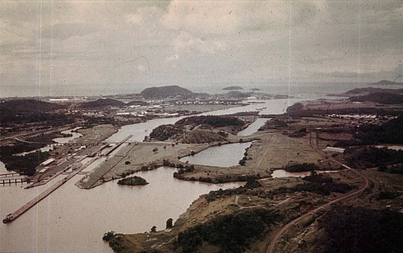
Figure 1. The massive excavations for the Third Locks Project. Until the new Third Locks Project got underway in 2008 these excavations were usually mistaken for the old French excavations at either end of the canal (National Archives).

POST WAR STUDIES

The bombing of Hiroshima and Nagasaki with nuclear weapons in August 1945 shattered conventional concepts of protecting critical engineering facilities, like the Panama Canal locks. This led to the Comprehensive Engineering Studies of 1945-48. On December 28, 1945 Congress passed Public Law 280, setting aside $5 million to prepare a comprehensive engineering study to determine whether the Panama Canal could be made safe for merchant or naval fleets during wartime, and ascertain its adequacy to meet the growing demands of peacetime shipping. The key aspects that were evaluated revolved around modern assessments of the canal’s future capacity and providing for its security. Figures 2 and 3 present two charts that summarized the issue of providing for the canal’s future capacity in 1947. The 1947 study estimated that the original canal would be adequate until at least 1964. This turned out to be a bit low, as 12,000 transits were recorded in 1963, about 9% above the 1947 estimate. The 1947 study estimated that the original canal would be adequate until 1964 (Stratton, 1948), so the decision was made to do nothing further.

During the high operational tempo of the Second World War hull clearance tolerances were noted by the canal’s pilots, which proved useful in postwar assessments. Maintenance issues loomed large because of their potential impact on wartime operations. The massive steel lock gates of the Panama Canal had to be removed and overhauled to battle corrosion. This maintenance necessitated the loss of one lock for 4 months every two years, hindering ship transits. This was another factor supporting the option to develop a more reliable and defendable sea level canal.

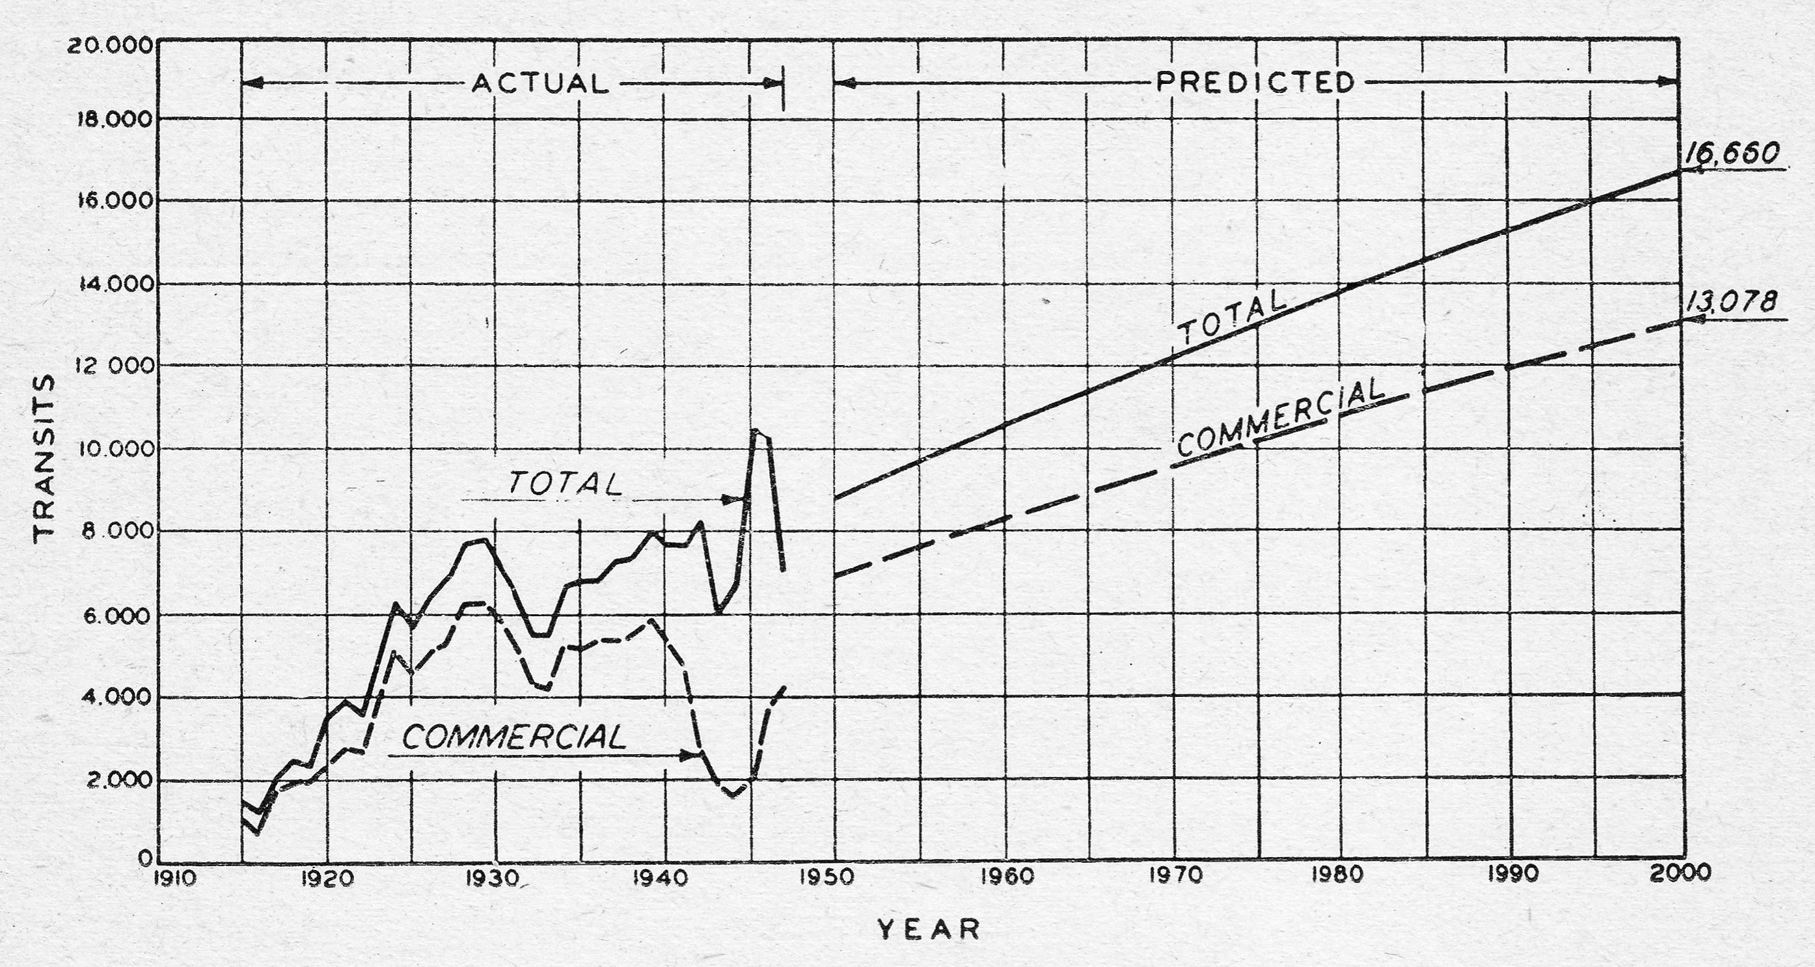
Figure 2. Total and commercial vessel transits through the Panama Canal between 1915 and 1947, with estimates of both categories projected through the year 2000 (from Stratton, 1948).

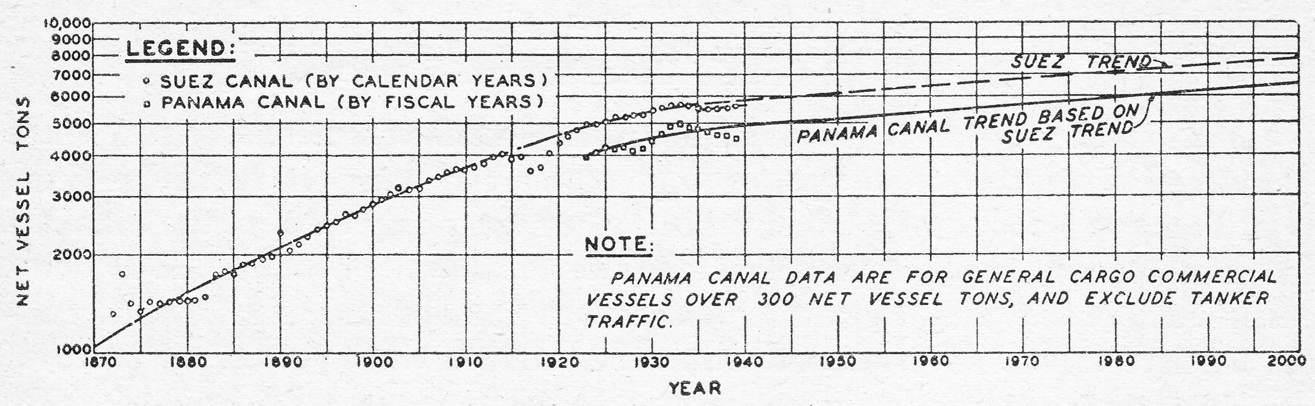
Figure 3. Average net vessel tonnages recorded in the Suez and Panama Canals, between 1870-1947 (from Stratton, 1948).

Sea level canal schemes of 1945-48.

During the immediate post-war era (1945-48) 22 canal routes were examined in detail by the Army Corps of Engineers, with four of these being selected for detailed examination as possible candidates for a new sea level canal, capable of passing the largest vessels then anticipated over the next 75 years. As in the past, the Tehauntepec Canal across Mexico enjoyed considerable political support because of its geographic position. The Corps of Engineers estimated that this route would require a staggering 6.5 billion cubic yards of excavation and 15 lock lifts (as opposed to the six in Panama).

In 1946 there was considerable interest in establishing a sea level canal, because it would be much easier to defend from enemy airborne bombing (due to the perceived vulnerability of lock gates) and it would allow two-way traffic without costly delays at either end, such as those required to pass through locks. And there was the new dilemma of protecting critical elements, such as the locks and, especially, their swinging gates, from attack using nuclear weapons.

In 1885 a vessel hit and damaged one of the gates of the old Soo Locks in Sault Sainte Marie, between Michigan and Ontario, preventing it from being closed. These locks had been completed in 1855 and transferred to the Corps of Engineers in 1881. This accident allowed uncontrolled flow to pass through the lock, which made repairs lengthy, difficult, and expensive. For these reasons the Corps paid a great deal of attention to contingency planning for each lock gate, which resulted in a general aversion to having any more gates than were absolutely necessary, because each set of gates represented more risk to operations.

After several years of feasibility studies, the Panama Sea Level Canal Plan was adopted in 1948, shown in Figure 4. The sea level canal would have been 600 ft wide and 60 ft deep, requiring excavations up to 60 ft deep on the Atlantic side and up to 70 ft deep on the Pacific side. These post-war feasibility studies by the Army Corps of Engineers recognized the enormous influence of geology on construction and excavation costs. Corps planners developed techniques of drilling exploratory borings in up to 135 feet of water from barges, which was unprecedented at the time (Thompson, 1947; Binger, 1948).

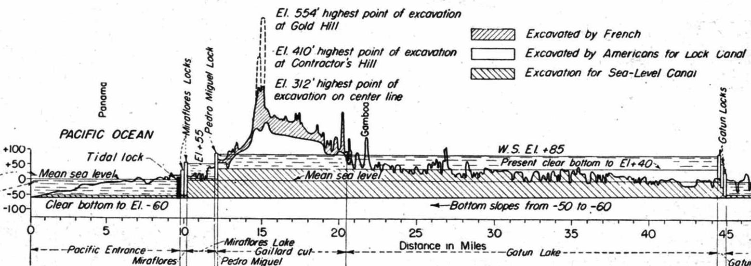
Figure 4: Profile of the Panama Canal illustrating the excavations made by the French, by the Americans, and what would be required in 1948 to excavate a sea level canal (from Stratton, 1948).

The biggest challenge of the sea level schemes was the requirement to excavate between depths of -85 ft (across most of Gatun Lake) to as much as -135 feet below the existing water surface in the Culebra Cut. Temporary conversion locks could be discarded if dredges capable of excavating to depths of -135 feet could be developed, so Dredge Development Contracts were let to four different firms. The dipper dredge would have required a bucket capacity of 20 to 30 yds³. The spuds on this machine would have been 150 ft long, with telescoping legs 80 ft long, and a 165 ton counter-weight. The estimated cost was $5 million apiece. The hydraulic dredges would require 46 inch diameter suction and 40-inch discharge lines, with booster pumps set 65 ft below water level, on a 185 ft long boom. The bucket ladder dredges would have employed 2 yd³ buckets capable of excavating to depths of -135 ft. The Yuba Manufacturing Co. had built 2/3 yd³ bucket dredges capable of excavating to -124 ft.

Colonel James H. Stratton constructed a half-mile long hydraulic model of the Canal Zone to examine the various facets of tidal influx and flood control on a sea level canal. The US Navy favored the Pacific Terminal Lake Plan, which relocated the Pedro Miguel Lock to Miraflores, creating an enlarged Miraflores Lake at the same level as Gatun Lake (+85 ft). This idea had originally been conceived by Navy Captain Miles P. Duval during the first Third Locks Project, between 1939-42.

The navigable pass plan of 1948

The Corps of Engineers model studies suggested that tidal control structures could be operated to accommodate shipping. In this schemes ebb tides would flow out of the canal into the ocean through control gates, and during flood tides, the flow would be into the canal. During these periods ships could transit the tidal passes.

The vexing problem was the differential in tidal levels between the Atlantic (2 feet) and Pacific (20 feet) ends of the canal. One way to handle this would have been to construct tidal regulation structures. Another engineering challenge of the sea level canal was how to handle the 4.2 knot currents triggered by the 20-ft tides on the Pacific side of the Canal, felt too high for safe ship transits.

The Panama sea level canal scheme of 1948 envisioned about 1.07 billion cubic yards of excavation, of which 750 million cubic yards would have been excavated in the dry, with dredging removing the remaining 320 million cubic yards.

CANAL IMPROVEMENTS

In 1954 much concern was aroused when a series of tension cracks developed behind Contractor’s Hill, along the southwestern side of the Gaillard Cut, which rises 330 ft above the canal. Careful monitoring by the Corps of Engineers revealed that a block consisting of more than one million cubic yards of material was slowly moving towards the canal, each time the groundwater levels exceed a certain threshold level.

Professors Arthur Casagrande (Harvard) and Ralph Peck (Illinois) advised the Panama Canal Company on how to resolve the problems with Contractor’s Hill moving into the canal in the mid-1950s. This led to an increased understanding of the role of strain softening in the degradation of slope stability with time. The recommendation was made to cut the face back in a series of massive steps to an average inclination of 45 degrees.

By the early 1960s the Canal was averaging 12,000 transits per year (Figure 2). In 1962 the $20 Million Thatcher Ferry Bridge for the Pan American Highway linked the two Americas across the Balboa Estuary on the Pacific shore. Dredging was carried out to maintain the approach channels on either end of the canal.

Between 1962-70 the Gaillard Cut was widened from 300 to 500 feet, by excavating 22 million cubic yards of material, using conventional earth moving equipment and bucket dredges. Lights and navigation aids (radar reflectors) were also installed in the cuts, locks, and approaches to allow nighttime transits and two way traffic in the widest portions of the canal and 24-hr per day transit, under favorable weather (no fog).

In October 1968 tension cracks 5 ft wide and 82 ft deep were discovered behind Hodges Hill, adjacent to the old West Culebra Landslide. The PCC assembled a Geotechnical Advisory Board, chaired by Professor Casagrande. The troubled slope was stabilized by improving surface drainage and installing horizontal drains.

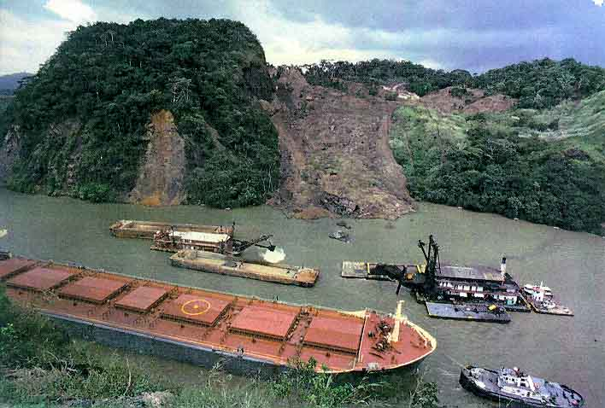
Figure 5. Ground view of the October 1986 Cucaracha Slide, which temporarily closed the canal and led to the appointment of a new Geotechnical Advisory Board (USGS image).

The Advisory Board also established a Landslide Control Program. More than 60 landslides, with volumes as great as 23 million cubic yards, occurred between 1912 and 1979. These slides required additional excavations of > 59 million cubic yards to construct and maintain the Canal before it was turned over to the Panamanian government in 1979.

On October 13, 1986 the eastern side of the Cucaracha Slide reactivated (Figure 5), spilling 526,000 cubic yards of debris into the canal, narrowing the opening to just 115 ft! The slope had crept 13 feet towards the canal during the previous four years before rupturing. The Canal’s experienced pilots were able to keep ships moving at a reduced speed and the debris was removed using dredges.

In late October 1986 a new Geotechnical Advisory Board was formed, comprised of Professors J. Michael Duncan, Norbert R. Morganstern, Robert L. Schuster, and George F. Sowers. This was in response to the East Cucaracha Slide. They meet in Panama about once per year. Research revealed that the Tertiary volcanic sedimentary rocks, mostly shales, siltstones, and agglomerates were responsible for all of the landslippage. The Cucaracha, Culebra, and LaBoca Formations were all found to contain smectite clays, which are subject to significant strength loss upon shearing (Lutton, 1975).

That board dealt with a number of vexing issues, including a decade-long study of Gold Hill and Contractor’s Hill along the Continental Divide. These slopes were carefully instrumented and were found to be slowly slipping into the canal along the faults bordering their margins. It was retrofitted with a series of drilled post-tensioned rock anchor tendons during the late 1990s to tie it together and retard its creep movement towards the canal.

PAN-ATOMIC CANAL SCHEMES

Operation Plowshare 1961-77

Operation Plowshare was a 16-year project by the U.S. Atomic Energy Commission (AEC), as part of their “Atoms for Peace” initiative, launched in the early 1960s. The Plowshare program conducted six underground nuclear explosions intended to evaluate the feasibility of using nuclear cratering to excavate a new sea level canal across Mexico, Nicaragua, Panama, or Columbia. These proposed “Pan-Atomic Canal” routes are shown in Figure 6.

Projects Gnome and Sedan were a series of underground detonations carried out at Nevada Test Site between 1961-64, which that succeeded in excavating craters of up to 2.4 million cubic yards volume. The first Sedan test in July 1962 used a 100 kiloton warhead detonated from depth of 635 feet, creating a crater 320 feet deep (Figure 7). Over the next 11 years 26 more nuclear explosion tests were conducted under the U.S. Peaceful Use of Nuclear Explosions program. The Plowshare scheme envisioned a string of 2, 5, and 15 megaton devices detonated at varying depths, to “throw” the spoils aside.

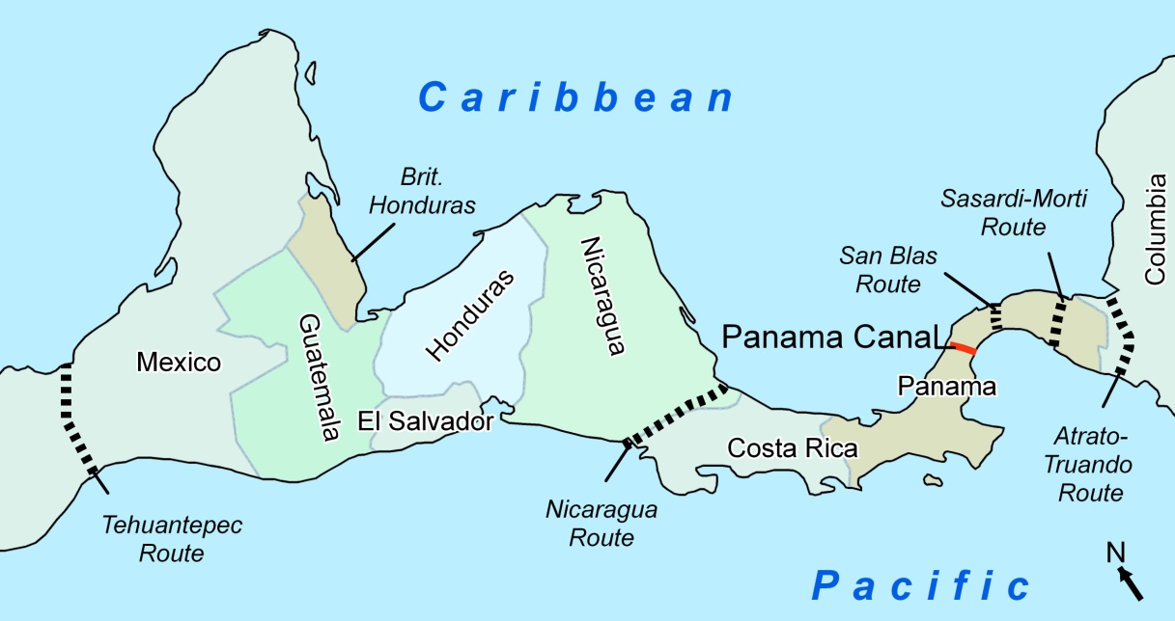
Figure 6. Map of Central America showing the six possible routes for a “pan-atomic” sea level canal that were evaluated as part of Project Plowshare in the 1960s. The Atrato-Truando Route through Columbia was selected as the most viable because it was the most remote.

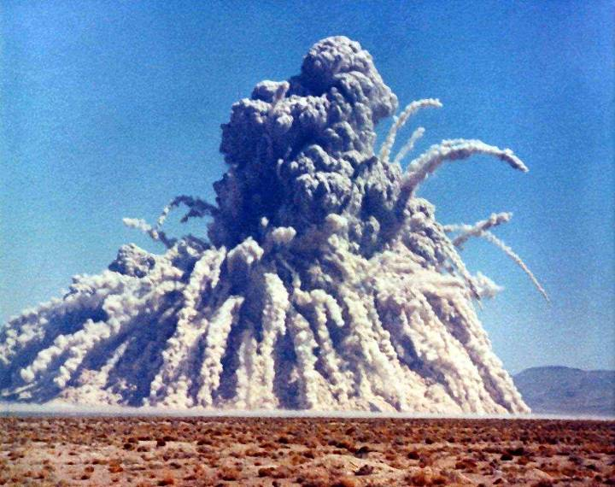
Figure 7. In July 1962 a 100 kiloton warhead buried 635 feet deep was detonated at the Nevada Test Site, shown here. It excavated a circular crater 320 feet deep (from U.S. Department of Energy).

Atlantic-Pacific Interoceanic Canal Study Commission 1965-70

During 1964 Congressional hearings experts from the Army Corps of Engineers and Atomic Energy Commission testified that the cost of excavating a new sea-level canal could range anywhere from $620 million for a canal through San Blas, Panama, excavated by nuclear methods, to as much as $13 billion for one at Tehuantepec, Mexico, using conventional excavation procedures. According to the Atomic Energy Commission, the nuclear approach probably could not be used under the recently approved nuclear test ban treaty limitations.

As a consequence of these conflicting estimates, Congress passed Public Law 88-609 on September 22, 1964, forming a non-partisan Atlantic-Pacific Interoceanic Canal Study Commission. Commissioners were appointed by President Lyndon Johnson in April 1965 “to make a full and complete investigation and study…. For the purposes of determining the feasibility of, and most suitable site for, the construction of a sea-level canal connecting the Atlantic and Pacific Oceans; the best means of constructing such a canal, whether by conventional or nuclear excavation, and the estimated cost thereof.”

In 1967-68 the Army Corps of Engineers employed 50 geologists to assess potential routes. They selected Route 8 (nuclear) in Nicaragua, Routes 10 and 14 in Panama, Route 17 (nuclear) in Panama, and Route 25 (nuclear) in Columbia for more detailed study. They ended up concluding that a sea level canal would require between 1.5 and 2.0 billion cubic yards of excavation.

In March 1968 the AEC oversaw the Project Buggy test, the first nuclear row charge experiment. The explosion, which involved the simultaneous detonation of five explosives (each detonation yielded 1.08 kilotons) placed 150 feet apart at a depth of 135 feet created a ditch 855 feet long, 254 feet wide, and 65 feet deep. Evaluation of the nuclear aspects of the study were aided by the Atomic Energy Commission's successful detonation of the 30 to 35-kiloton Schooner shot in December 1968 at the Nevada Test Site, which produced a crater approximately 850 feet in diameter and 200 feet deep. This was the last Plowshare canal test.

Conclusion of the Plowshare Program

The feasibility of nuclear excavation was never verified because nuclear cratering tests in the megaton range had been fraught with too many uncertainties. The nuclear excavation schemes were about $500 million less expensive than conventional excavation schemes, but the all-nuclear routes were not considered feasible because of safety concerns or unsuitable geologic conditions.

Route 25 in northwestern Colombia (Figure 6) had an estimated cost of $2 billion, and would have been the preferred route. Most of this expense would have been expended for the conventionally excavated portions of that route. The AEC believed that it could resolve the major technical uncertainties relating to Route 25, but the Sturtevant and Yawl shots, intended to complete the Plowshare canal studies, were never conducted, because of increasing concerns about public reaction to the radiation that would have been released. Field operations were terminated in July 1969 and engineering feasibility and environmental impact studies were concluded between June and November 1970.

The Interoceanic Canal Study Commission chaired by Corps of Engineers BGEN Charles C. Noble submitted their report in November 1970. It recommended against employing nuclear excavation technology because of concerns about relocating indigenous populations and possible damage to the environment from radioactivity. They also concluded that a sea-level canal was not economically justifiable.

Smaller scale Plowshare tests continued, examining other peaceful uses of nuclear weapons. Funding quietly ended in 1977. Costs for the program have been estimated at more than $770 million.

PANAMA ASSUMES CONTROL

The Canal Zone operated as an unincorporated Territory of the United States from 1903 to 1979, operated by the Panama Canal Company. The Canal Company operated like a colonial enclave, where all goods were brought in and sold by stores run by the company, such as a commissary, and so forth, similar to a military base. The U.S. Government provided its own police force (Canal Zone Police), courts, and judicial system (the United States District Court for the Canal Zone).

A Canal Zone Governor was appointed by the American President, who served as the company head as well as the Governor of the Panama Canal Zone. This was usually a Corps of Engineers officer, or his immediate assistant was a senior Corps officer. Residents did not own their homes, but rented the houses that were assigned to them, based on seniority in the zone. The utility companies were also managed by the company.

In 1979 a new treaty was negotiated between American President Jimmy Carter and Panamanian President General Omar Torrijos. This treaty eliminated the old Canal Zone on October 1, 1979, and provided for an orderly transfer of all government owned facilities and property to Panama by December 31, 1999. During that 30-year transition, the Canal was operated by the Panama Canal Commission.

During the transition Panamanian nationals took over responsibility for all the normal operations, maintenance, and upkeep of the Canal facilities. Panamanian engineers assumed responsibility for making all the necessary repairs and designing various schemes to mitigate the many challenging problems that the U.S. Army Corps of Engineers had assumed for almost 75 years. On June 11, 1997 Panamanian legislation established the organization and operation of the new Panama Canal Authority (ACP), creating inalienable patrimony of the Republic of Panama. ACP is governed by a parent board of 11 directors with overlapping terms.

In 2005 the Panama Canal Authority (ACP) proposed a massive expansion of the Panama Canal they termed the Third Set of Locks Project. This proposal was approved by 77% of Panamanian voters in 2006, and funded by the National Assembly in July 2007. The new project will double the capacity of the Panama Canal by 2014 by allowing more and larger ships to transit the Canal. The canal currently generates about half of Panama’s revenue.

The existing locks will be augmented by larger locks with water-saving basins, capable of transiting much enlarged container ships. The total cost will be about $5.2 billion, requiring seven years to complete. The new “bypass” locks will be about 300% larger than those constructed 100 years ago; from 1050 to 1400 feet long; from 110 to 180 ft wide, and from 42 to 60 feet deep. The larger locks will also employ water saving basins.

The new Panamax vessels will be about 160 feet wide with a fully loaded draft of 50 ft, requiring navigation channels to be deepened to at least -55 feet. The next generation of Panamax vessels will carry 240% greater payloads than the existing Panamax ships.

Thus closes this summary of the first 100 years of the Panama Canal, which is presently on the brink of being reborn, setting new standards for maritime navigation that, like its predecessor, are sure to have world-wide impact.

ACKNOWLEDGEMENTS

The author was fortunate to be stationed at Rodman Naval Base and Howard Air Force Base near Balboa, where he was shown generous hospitality by engineers of the Panama Canal Commission, including George Berman, Luis Alfredo, Carlos Reyes, Maximillian DePuy, and Pastroa Franceschi. The writer is also indebted to the staff of the old Panama Canal Commission Library and Technical Resources Center, in particular, librarian Nan S. Chong, who supplied access to thousands of photos. Subsequent interviews and many documentary materials were provided by Ralph B. Peck and Robert L. Schuster, who were associated with consultations on the numerous slope stability problems for many decades.

REFERENCES

Binger, W.V. (1948). Analytical studies of the Panama Canal slides. Proceedings 2nd International Conference on Soil Mechanics and Foundation Engineering, Rotterdam, v. 2:54-60.
Lutton, R.J. (1975). Study of Clay Shale Slopes along the Panama Canal. U.S. Army Corps of Engineers Waterways Experiment Station, Vicksburg, Technical Report S-70-9.
Stratton, J. H. (1948). The Future and the Panama Canal. ASCE Proceedings 74:4, pp. 444-468.
Thompson, T.F. (1947). Origin, nature, and reengineering significance of the slickensides in the Cucaracha clay shales. Isthmian Canal Studies, Memorandum 245.

