Struggles to make the Panama Canal viable, 1914-39

J. David Rogers, P.E., P.G., M.ASCE¹
¹ K.F. Hasselmann Chair in Geological Engineering, Missouri University of Science and Technology, Rolla, MO 65409, rogersda@mst.edu

ABSTRACT

The Panama Canal opened just as the First World War erupted in August 1914. The newly completed canal was underutilized and plagued with closures by massive landslides throughout its first quarter century of operation. In 1916 President Woodrow Wilson empowered the National Academy of Sciences to undertake a scientific study of the landslides and report on how they might be mitigated. During the interwar years the canal became a naval bastion almost without peer in the western world, but plans for capital ships began exceeding the width of the canal’s locks by the late 1930s.

THE CANAL OPENS FOR BUSINESS

On August 3, 1914 the S.S. Cristobal, a 9,300 ton steamer built for the Boston Steamship Line in 1902 and purchased by the Isthmian Canal Commission (ICC) in 1910 to haul cement, made the first coast-to-coast transit of the new canal (Figure 1). It was the same day that the Archduke Ferdinand was assassinated in Sarajevo, Serbia, touching off the First World War. All of the pomp and circumstance expected with the canal’s official opening in mid August more or less vanished, as the Western Europe became embroiled in the largest war in history, up to that time.

The canal’s official christening occurred 12 days later, on August 15th, when the Cristobal’s sister ship, the steamer S.S. Ancon (ex S.S. Shawmut), made the first official ocean-to-ocean transit, carry media and dignitaries from the Atlantic to the Pacific (Figure 2). On October 10th the USS Jupiter, a Navy collier of 19,300 tons, built at Mare Island on the West Coast, made the first west-to-east transit of the Canal. She was the Navy's first surface vessel to employ turbo-electric propulsion, and became the Navy’s first aircraft carrier, the USS Langley, in 1922.

Unlike the French, the Americans never intended for the project to be a commercial investment, paying dividends to individual investors. For them, it was the first federally-funded mega project, intended first and foremost, that firmly established the United States as the premier power of the Western Hemisphere. The Canal was a miserable commercial failure during its first five years of operation because the expected shipping traffic did not materialize, because of Europe’s preoccupation with the First World War.

America’s entry into the First World War in 1917-18, and the capital ship contracts that resulted, firmly established the United States Navy as a premier naval power, on parity with only Great Britain by 1922. America’s emerging role as a great maritime power continued over the next three decades, as a consequence of increased exports of foodstuffs and raw materials, gradually bolstered by the import of foreign oil which American companies began to exploit in other parts of the world, beginning in the late 1930s.

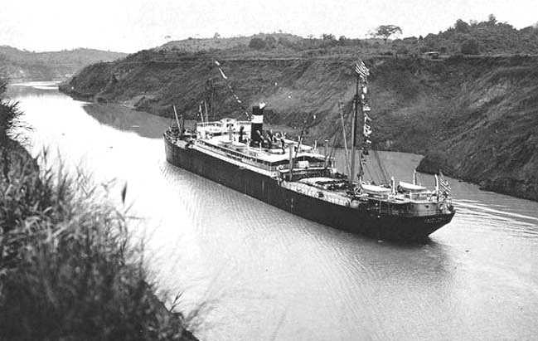
Figure 1. The S.S. Cristobal making the first coast-to-coast transit of the Panama Canal through the Culebra Cut on August 3, 1914, carrying a load of cement (National Archives).

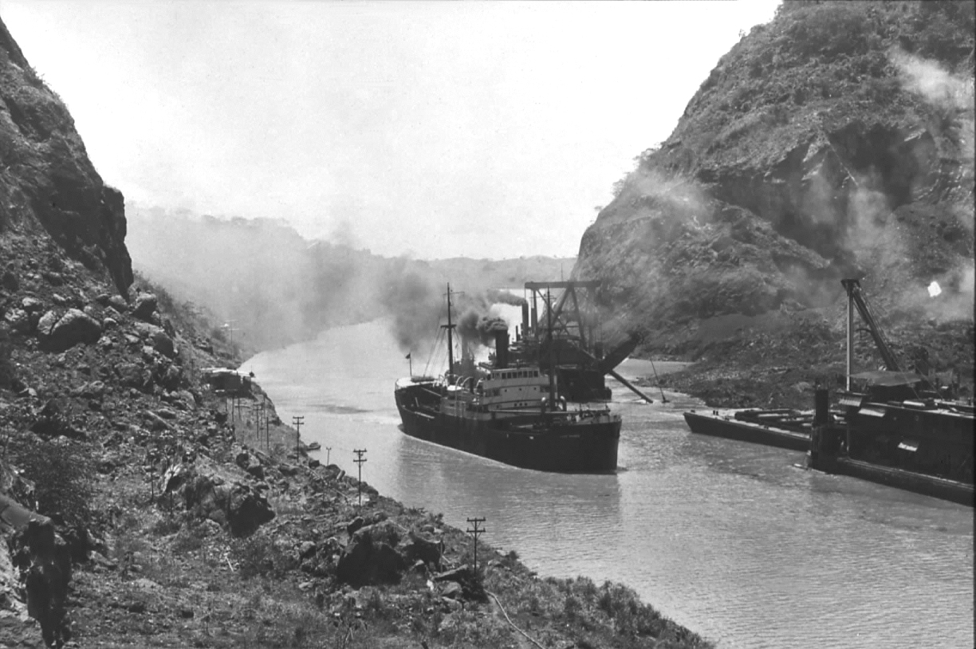
Figure 2. The Cristobal’s’ sister ship S.S. Ancon making the first official transit of the newly completed Panama Canal on August 15, 1914, carrying dignitaries and media representatives. Few outside the United States noticed (National Archives).

CANAL OPERATIONS AND PLANNED EXPANSIONS

Landslides plague the canal

The canal’s opening in August 1914 did not bring an end to the landslides, which continued to occur with seeming regularity. Landslides shut down the canal on 26 occasions between 1914 and 1986. On September 18, 1915 massive landslippage impacted a half-mile section of the canal, hastening its untimely closure. The East and West Culebra Slides had reactivated, as well as the toe of the Cucaracha Slide. Goethals was still overseeing operations and maintenance activities as the new Canal Zone Governor.

Much of the sliding took the shape of basal heave, where the bottom of the canal lurched upward, occasional breaking surface, as shown in Figure 3. Goethals dispatched every floating dredge he could squeeze into the gap, from the Atlantic and Pacific sides, and ordered them to start digging. The dipper and suction dredges worked the toe of the East Culebra Slide, excavating 10 million cubic yards over the next nine months, just to re-open the canal. The canal was eventually re-opened, but with many restrictions that would become all too familiar, such as innumerable delays and employment of one-way transits, as shown in Figure 4.

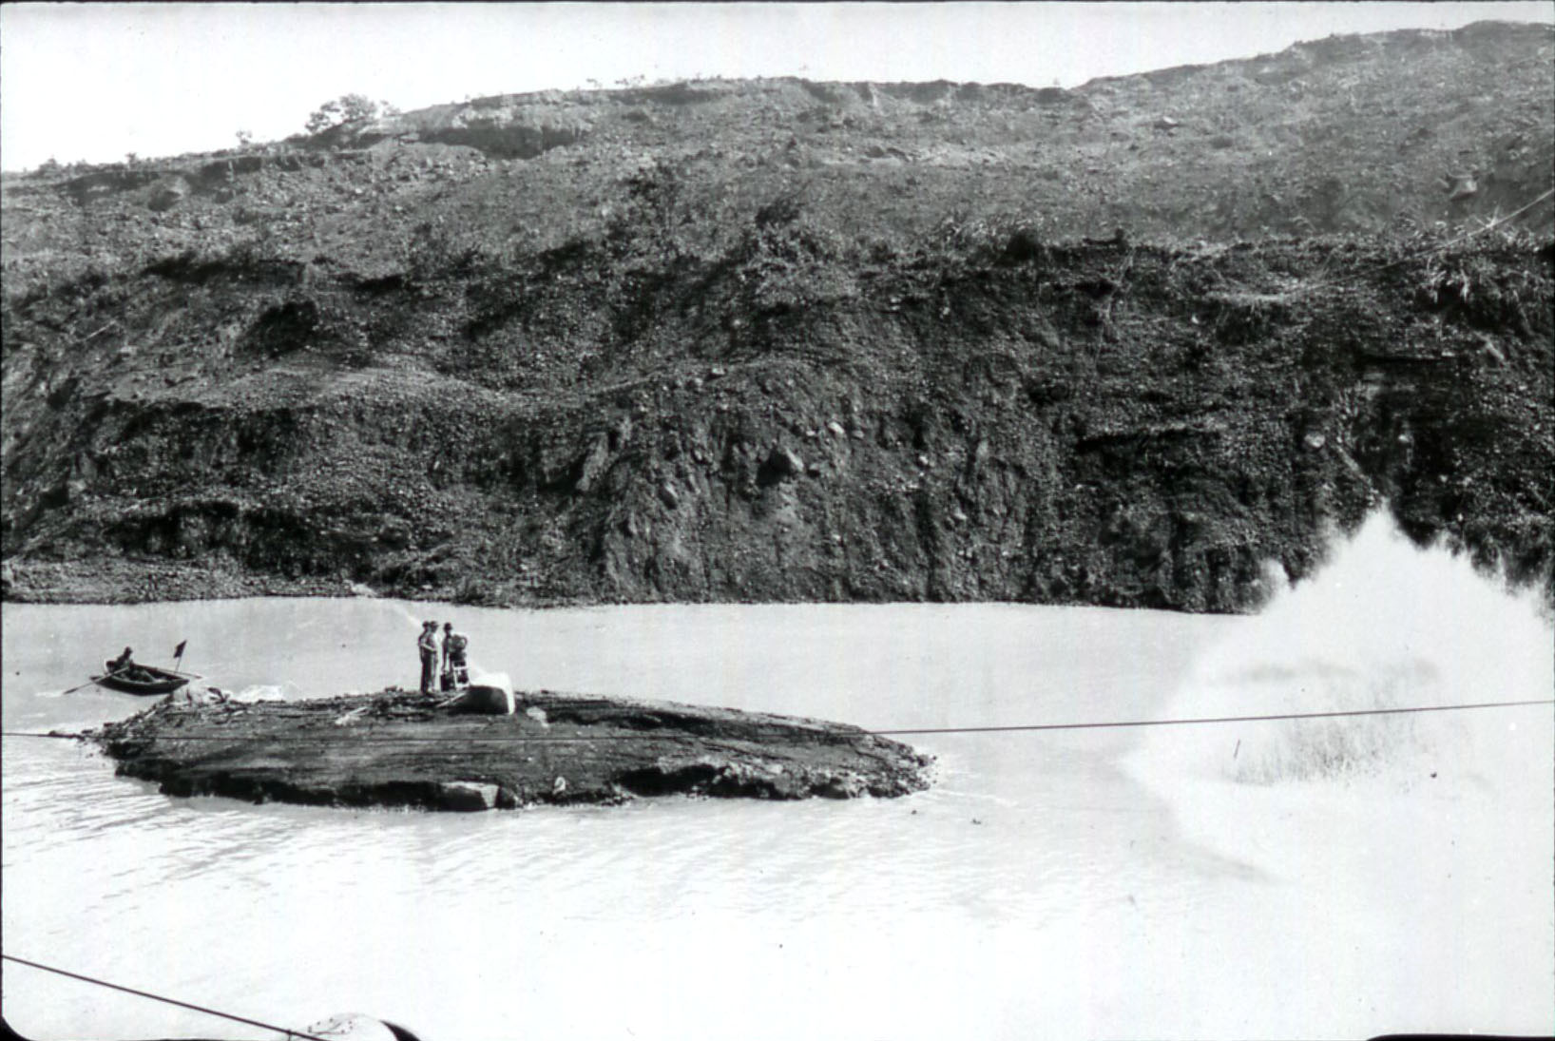
Figure 3. The floor of the canal heaved more than 30 feet upward, rising out of the water in this view taken on September 15, 1915, 13 months after the canal opened. This basal heaving restricted the dredges to working each end, towards one another, and closing the canal for nine months (National Archives).

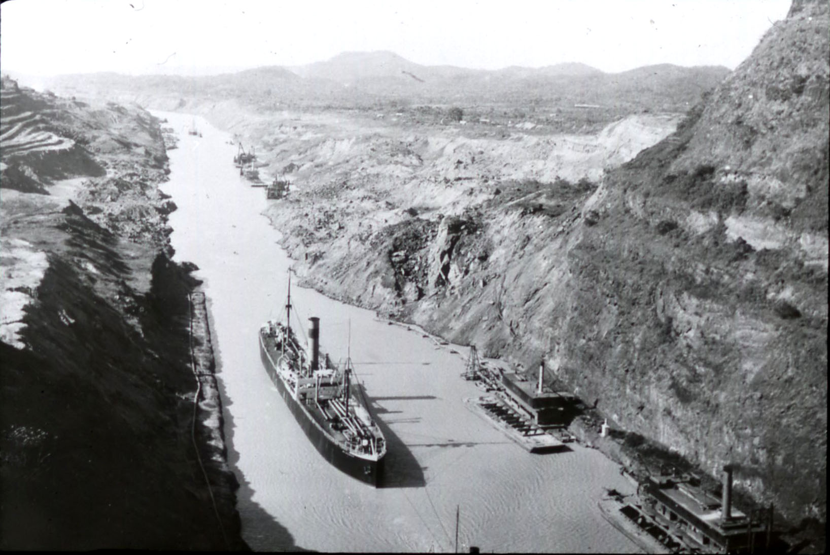
Figure 4. When landslides partially blocked the channel, ships were queued up on either side of the construction and escorted through the gap. This one-way traffic pattern continued through the Culebra Cut until 2002, following a 10-year widening project (National Archives).

National Academies report

The 1915 closures triggered the appointment of a commission drawn from the National Academy of Sciences, which reported to President Woodrow Wilson. This panel was the first august body ever charged with examining large scale slope stability problems. The panel was comprised of: University of Wisconsin President and Geology Professor Charles R. Van Hise, Chairman, BGEN Henry L. Abbot, Stanford University President and Geology Professor John C. Branner, USGS geologist Whitman Cross, Cornell University Civil Engineering Professor Rolla C. Carpenter, U.S. Reclamation Service Director Arthur P. Davis, renowned waterworks engineer and MIT Trustee John R. Freeman, Northwestern University Civil Engineering Professor John F. Hayford, and Johns Hopkins Geology Professor H. Fielding Reed.

Half or these men were eminent geologists, the other half engineers. Davis, Freeman, and Abbot all had prior experience with the problems in Panama, as members of the ICC before it was disbanded in August 1914. USGS geologist George F. Becker also contributed what he had learned while examining the canal’s landslides in 1913. Van Hise died in 1918, and geologists Whitman Cross of the USGS and H. Fielding Reid of Johns Hopkins University prepared the final report, released by the National Academy of Sciences (NAS) in 1924. It included an extensive appendix on the Geology of the Canal Zone prepared by USGS geologist Donald F. MacDonald, who served as the project’s geological expert during the canal’s construction, between January 1911 and December 1913 (MacDonald, 1913; 1915).

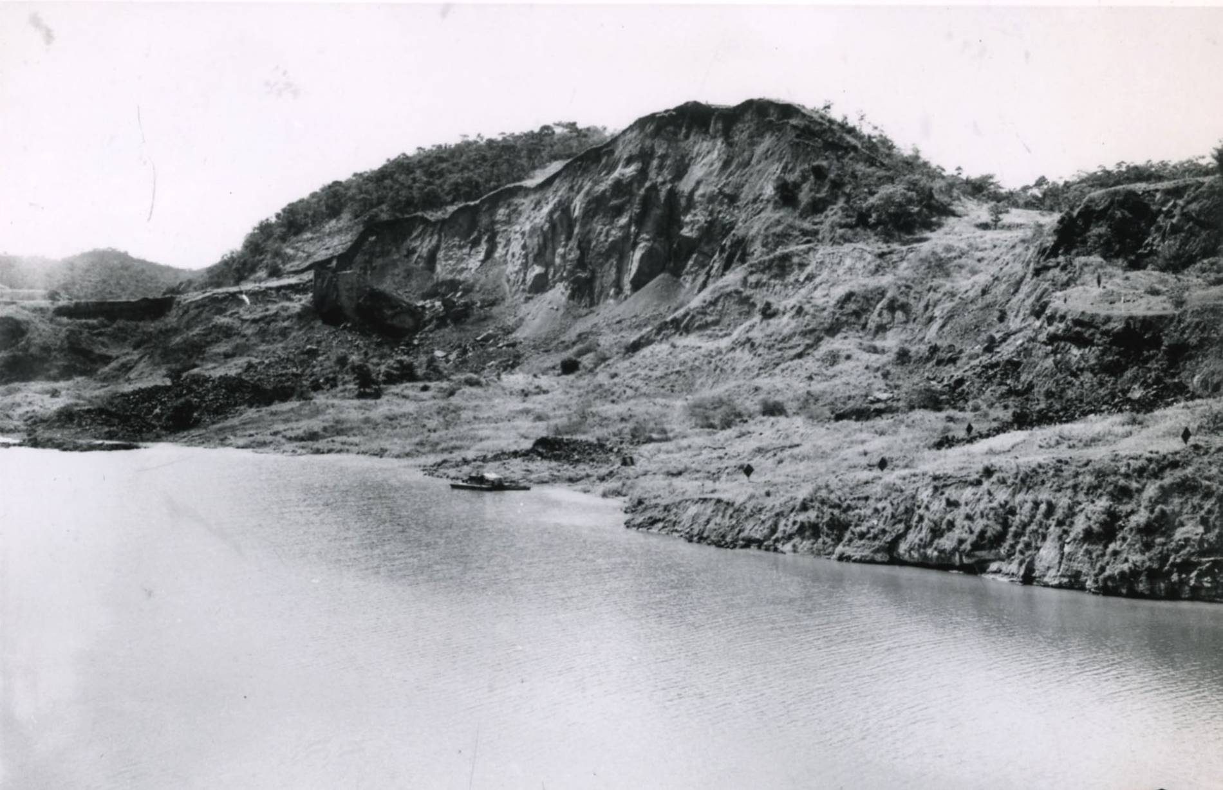
Figure 5. Massive head scarp of the West Culebra Slide at Zion Hill, towering 300 feet above the canal, as seen on January 26, 1937 (National Archives).

Despite all efforts to stem the advance of the existing slides, the East Culebra Slide continued to enlarge itself throughout the 1920s. In June 1923 it reactivated, forming a scarp nearly 300 feet high, shown in Figure 5. Corrective action was limited to simple dredging of the submerged toe and hoping that the mass would somehow stabilize itself. Dredges continue to work the zone between Obispo and East Culebra throughout 1923 and 1924, ten years after the canal opened. It was obvious to everyone now the shear strength of the landslide slip surfaces, in particular, the Cucaracha Shale, had been transformed to a much lower value.

Residual shear strength

The Army Corps of Engineers spent decades unraveling the reasons for the acute loss of shear strength in the Cucaracha Shale, which was actually an volcanic agglomerate (volcanic mudflow) deposit, not a sedimentary unit. The fragments of volcanic ash weather to highly expansive smectite clays, including montmorillonite. These materials were then complexly folded, faulted, and compressed by the crustal tectonic forces that form Central America.

As a consequence of the tectonic pressures, the clays became overconsolidated, appearing quite stiff and capable of sustaining great loads (Figure 6). When these materials are sheared, they lose noticeably shear strength. The concept of residual strength came out of tests on the Cucaracha Shale in the late 1940s for the Corps of Engineers (Canal Zone, 1947; Lutton, Banks and Strohm, 1979). Shear tests on the Cucaracha Shale showed that it lost 80% of its peak strength with continuing strain. It is now known and appreciated that overconsolidated shales tend to exhibit strain softening behavior, leading to low residual strengths (Canal Zone, 1947; Lamb and Whitman, 1968; Trollope, 1973; Mesri and Shahien, 2003).

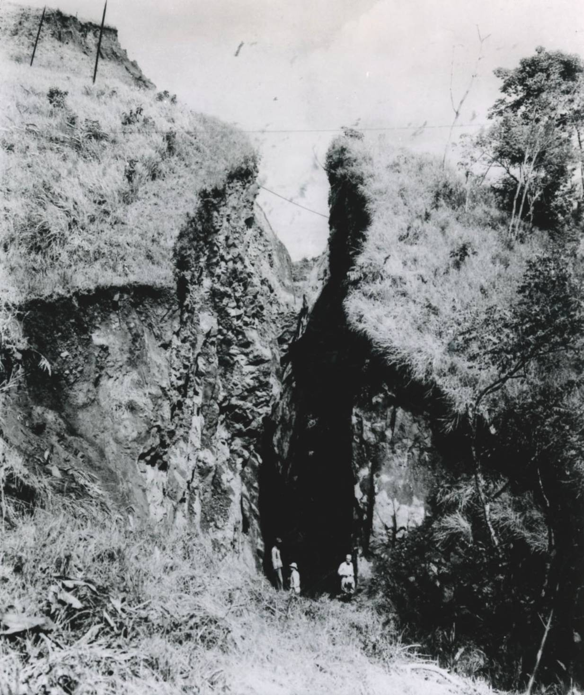
Figure 6. Massive tension crack opening above the West Culebra Landslide, as seen on October 22, 1936. Note men for scale (National Archives).

AMERICAN NAVAL BASTION

During the First World War the American Congress authorized construction of the most ambitious program of capital ship construction the world had ever witnessed. Building on the wartime experiences of both allies and adversaries, the new American battleships would be larger, faster, and carry much larger caliber naval rifles than any then in existence, anywhere. Only one of these ships was being built on the west coast, the battleship USS California at Mare Island (commissioned in 1921). The design of America’s capital ships was limited by the size of the Panama Canal Locks, which were 110 feet wide and 1200 feet long.

During the Inter-war years (1919-39) the Panama Canal emerged as a prime element in shaping American maritime strategy and foreign policy in the Pacific. Soon after the Armistice in November 1918, the Navy converted all of their capital ships from coal to oil fired boilers, which were much easier to operate and more efficient. The emerging importance of oil was showing itself in virtually every fleet problem that was played out.

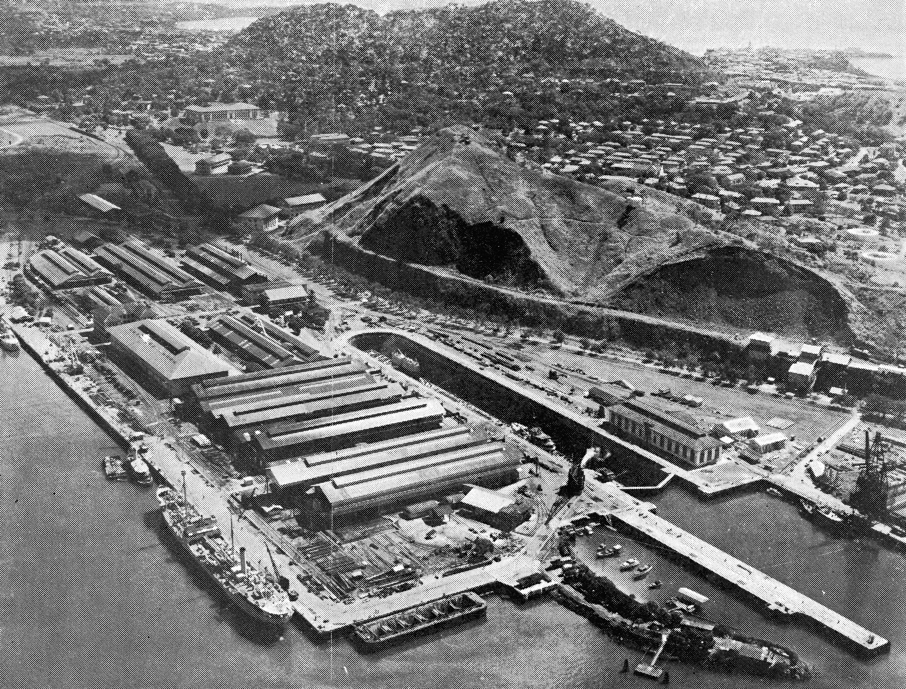
Figure 7. Aerial oblique view of the Canal’s Mechanical Division Shops and the massive dry dock constructed at Balboa during the First World War, as viewed in 1938 (National Archives).

The canal was the most obvious choke point in America’s Pacific strategy, as almost every warship in the Pacific had to pass through it. Its defense, therefore, became imperative, and this was reflected in annual navy exercises, which centered on the defense of the canal every other year from 1925 thru 1939. Panama had also been shaped into a great naval base, hosting the largest dry dock in the world (Figure 7), and the Canal’s Mechanical Division Shops were tasked to perform double duty on the warships that passed through the canal. Balboa’s outer harbor also supported a sizable reserve fleet of recently built, but decommissioned warships, which could quickly be brought into service, should the need arise. The pivotal role of aircraft carriers was proven out repeatedly in the annual exercises off Panama in the 1930s, and two Army air bases were constructed on either side of the canal to provide shore-based aircraft capable of defending the canal from attack by naval aircraft.

The naval arms race of the late 1930s

Early on the Japanese were viewed as the most likely potential adversary, because of their ambitious ship building program between the wars. In 1936 the Japanese refused to be part of the London Naval Treaty and embarked on a secretive building program, which worried American naval planners.

Worried about the intelligence reports coming from Japan, the American Naval Act of 1936 authorized the construction of the first American battleships in 17 years. Plans were soon in the works for battleships of 45,000 tons displacement capable of making 28 knots, considerably faster than those constructed previously. The first two units of the Iowa Class were ordered on July 1, 1935 in anticipation of the amendments. The Iowa Class battleships utilized much longer cruiser shaped hulls, with more length and shaft horsepower than had ever been applied to any previous warships (Figure 8). Their maximum dimensions were a beam of 108-1/8 feet to barely slide through the Panama Canal, with a waterline length of 860 feet. Capable of flank speeds in excess of 34 knots; they became the fastest battleships ever built.

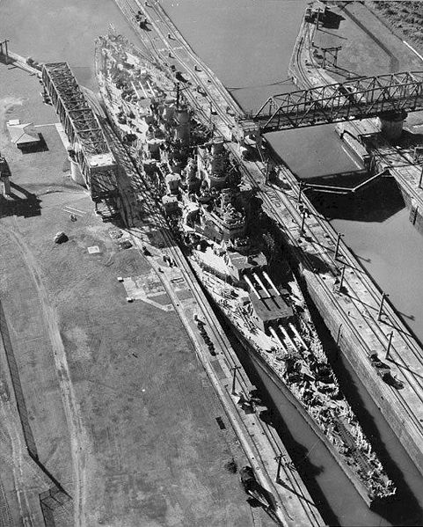
Figure 8. The battleship USS New Jersey passing through the Pedro Miguel Locks in 1944. With less than a foot of clearance on either side, the Iowa Class battleships and Essex Class aircraft carriers vessels were the last capital ships able to transit the Panama Canal (National Archives).

As these new revolutionary designs were being developed, an even more ambitious program of constructing larger and faster aircraft carriers suddenly came of age, in the wake of the Second World War, which began on September 1, 1939. These were the Essex Class fleet carriers: 860 feet long, 108-1/8 feet wide, and displacing 40,000 tons. Like the North Carolina, South Dakota, Iowa, and Montana Class battleships, their hull widths were fixed by the 110 foot width of the Panama Canal locks. By 1939 the Navy realized that the Iowa and Essex Class would be the last capital ships capable of transiting the canal unless larger locks could be built to accommodate the super carriers (the Midway Class) already being evaluated at the David Taylor Ship Model Basin near Washington, DC. These developments soon led to the first “Third Locks Project,” funded by Congress in 1939, but interrupted by the Second World War in 1942.
CONCLUSIONS

The landslide investigations carried out by the National Academy of Sciences between 1916-24 were the first of their kind carried out by American engineers and geologists. The problem of strain softening experienced by the Cucaracha shale continued to vex engineers for many decades thereafter, because the material lost about 80% of its initial peak shear strength. This is what led to most of the cost overruns experienced during the canal’s initial construction, and the high maintenance costs expended during the first 25 years of operations. During this period, the canal never operated two-way ship traffic, because of the slides.

The canal was in integral piece of the United States Navy’s expanded role as a major two-ocean navy, because all the nation’s capital ships were built on the eastern seaboard. American control of the Panama Canal exerting an enlarged American presence in the Pacific Basin after the First World War, gradually supplanting Great Britain as the world’s premier naval power. Maintenance and repair facilities in Panama were among the best equipped in the world, and military personnel were stationed on both sides of the canal to provide defense against attack.

Despite excellent and well-thought planning, the canal’s locks were perceived to be out-dated within 25 years of completion, in 1939. This was because capital ship design and marine powerplants had grown at a rapid pace after the conversion from coal to oil as the principal fuel source, and the abandonment of naval arms limitations treaties in the late 1930s.

ACKNOWLEDGEMENTS

The writer was fortunate to be stationed at Rodman Naval Base as a naval intelligence officer, where he was shown generous hospitality by engineers and geologists of the Panama Canal Commission. The writer is also indebted to the staff of the old Panama Canal Commission Library and Technical Resources Center, who supplied access to thousands of photos.

REFERENCES

Canal Zone, Governor (1947). Report of the Governor of the Panama Canal, Isthmian Canal Studies, and Appendix 12: Slopes & Foundations.
Lutton, R.J., Banks, D.C., and Strohm, W.E. (1979). Slides in Gaillard Cut, Panama Canal Zone. Ch. 4 in B. Voight ed., Rockslides and Avalanches, 2. Elsevier, New York, pp. 151-224.
MacDonald, D.F. (1913). Excavation Deformations. International Geological Congress, Canada, pp. 779-792.
MacDonald, D.F. (1915). Some engineering problems of the Panama Canal in their relation to geology and topography. U.S. Bureau of Mines Bulletin 86.
Mesri, G., and Shahien, M. (2003). Residual Shear Strength Mobilized in First-Time Slope Failures. Journal of Geotechnical & Geoenvironmental Engineering 129:1, pp. 12-31.
National Academy of Sciences. (1924) Report of the Committee of the National Academy of Sciences on Panama Canal Slides. NAS Volume XVIII, Wash, DC, 84 p, 51 pl.
Trollope, D. H. (1973). Sequential Failure in Strain-Softening Soils. Proceedings of the Eighth International Conference on Soil Mechanics and Foundation Engineering, Moscow, v. 2, pt. 2, pp. 227-232.

