Spatial Geologic Hazard Analysis in Practice

J. David Rogers, Member, ASCE

Abstract

This article seeks to focus on applications of Geographic Information Systems (GIS) to geologic hazard assessment, as developed in actual consultations in the San Francisco East Bay over the past decade. The applications examined include acquisition of published geologic data onto GIS, fabrication of new products using GIS technologies, combining political concerns and legal restrictions with geohazards into new composite GIS products, and preparation of detailed geohazard maps for earth movement potential. The last areas evaluated are three dimensional storage and retrieval of subsurface geologic information, with emphasis on providing a means to assess ground water resources and expected seismic site response. A number of problems inherent to GIS representations of voluminous geologic data are then discussed in the conclusions; forewarning readers of the many limitations not commonly appreciated by end users of GIS products.

Introduction

Most GIS products build upon the familiar format of spatial maps, commonly presented in the form of recognizable cadastral base maps, such as highway, parcel or topographic maps. Today most land survey products are produced on orthophoto bases, in a digitized format easily applied to any range of GIS software. An orthophoto base map greatly enhances accuracy in field-locating, and the recent emergence of inexpensive Global Positioning System (GPS) receivers has greatly aided accurate field locating.

For those practicing in the applied earth sciences, the GIS product portends some recognizable liabilities, in that a two-dimensional (planar map) representation may fail to convey an accurate picture of geologic risk, particularly since such risks often lie beneath the ground surface, while maps only portray what outcrops. GIS also affords the fabrication of politically-fashioned map products, a new application whose ramifications have not yet been fully appreciated, and within which end users could be unduly influenced to draw erroneous or incomplete conclusions. Today, most GIS products are presented in an attractive format, with beautifully orchestrated computer graphics. The use of aesthetic graphics emanating from authoritative sources, such as government agencies and research institutions, are willingly accepted by end users as a “last word”, seemingly without fault or blemish.

The balance of this article seeks to explore some of methods employed and focuses on unintentional problems associated with GIS products in educating end users, such as engineers, scientists, educators, politicians and the public. GIS is here to stay, but as a profession we need to develop a cognizance of its limitations and liabilities. Four GIS geohazard products released in the San Francisco Bay area are briefly profiled, exploring their strengths and weaknesses.

Moraga Development Capability Map (1988-89)

This study was undertaken as a joint project with the Spatial Information Systems Laboratory at U.C. Berkeley’s Center for Environmental Design Research in 1988 (Rogers/Pacific, 1989). The GIS database used was the GRASS (Geographic Resources Analysis Support System) software developed by the Army Corps of Engineers’ Construction Engineering Research Laboratory. The project commenced by tabulating 21 physical attributes within the Town of Moraga, an area of approximately 24.6 km², taken mostly from existing sources of data. Some of the basic data attributes included: elevation, slope, slope aspect, land use categories, parcels, bedrock geology, faults and folds, landslides, FEMA flood hazard, streams and swales, soils, soil shrink-swell potential (from SCS), Storie Index (from SCS), ridge lines, distribution of colluvium and vegetation.

The GRASS GIS program was used to superpose a grid over the polygon map data and reconfigure the data so that each map overlay consisted of grid squares. A grid size of 15 meters square was used, the smallest resolution felt appropriate to a General Plan level of analysis (a finer grid could have been used). The strength of the grid method of storing data maps is its capability for analysis using varying combinations of overlays. Map layers could then be multiplied, divided, added to one another, or otherwise manipulated in order to create the desired map product. The simplest operation was reclassification, in which two existing map categories are assigned some specified attribute. For example, a soil erosion potential map was created by specifying Soil Conservation Service (SCS) erosion hazard ratings for each soil type on the standard County-wide SCS maps. In addition, distance buffers could be provided around recognized hazards, such as along scenic ridge lines, the toes of swales prone to debris flows, or along the crest of steep creek banks, in order to conform to existing planning and safety restrictions.

The Town contracted for the GIS system in order to facilitate the creation of a planning document, called a “Development Capabilities Map”. The purpose of this map was to provide a spatial update to their General Plan, necessitated by the recent creation of a controversial open space ordinance approved by the voters in 1986. Five other maps showing open space ordinance restrictions and two displaying development prohibitions were also prepared for review by the Town Council. The council selected six physical attributes felt most important: Ridge lines, Landslide Susceptibility, Slope, Flood Hazard, Vegetation and Soil Erosion. For each of the selected factors a 10-point scale was developed, 10 being most restrictive and 1 being least. For example, being on an active landslide or atop a restricted ridge line would equate to a “10,”, while simply being within 100 feet of an active landslide would only be a “6.” In this way, both geologic hazards, graded by scientists, and legal/political concerns, such as ridge line development, could be weighted according to concern and combined to form a composite map product.

The end product was a “Development Capabilities Map” (Fig. 1), essentially a politically-fashioned document, based upon physical geologic input (including topography). The map utilized warm and cool colors, arranged upon the 15m² grids. Warm colors (red-yellow-green) denoted areas most suitable for development, while cooler colors (blue-purple-magenta) denoted areas least suitable for development. In this way, citizens were afforded the opportunity to voice their concerns about various geohazards, politicians could incorporate public opinion, and the Town’s legal counsel outlined the legal restrictions imposed by the open space ordinance. These factors were combined with the geologic input to fabricate a planning document in a map form. In order for the map to be legally binding it had to apply equally to all portions of the Town and survive rigorous public review and commentary. The plan has now been in force a little over eight years and development applications continue to be promulgated through the Town using the Development Capabilities Map as a controlling document.

1993 Orinda Landslide Mapping Program

This project sought to map landslides and erosion hazards in Orinda, California, an area of 33.15 km². Like nearby Moraga, Orinda lies within the steeply carved East Bay hills of the San Francisco East Bay area. Mostly developed between 1946-66, it is an area that has long been recognized for spawning numerous landslides, many within a few years of hillside grading for development (Kachadoorian, 1956; Kirsch, 1960; Radbruch and Weiler, 1963; Nilsen and Turner, 1975; Duncan, 1971). A detailed report was prepared for the city to accompany the landslides and surficial deposits hazard maps (Rogers/Pacific, 1994).

In the late 1970s the USGS had pioneered the use of computerized mapping of landslides hazards in San Mateo County (Newman, Paradis and Brabb, 1978). However, this study was the first opportunity to prepare a slope stability hazard product at a large enough scale (1:3,600) to be property-specific; in other words, large enough to allow individual parcel owners to easily assess the aerial limits of mapped hazards with respect to their dwellings and property lines. An essential part of the study was the clients’ desire to create a GIS product which would incorporate the County’s tax assessor parcel maps as the base layer, insofar as citizens and government personnel desired an off-the-shelf product that would delineate upon whose properties various hazards were supposed to exist.
From past experience we had found cadastral maps unsuited for geohazards mapping because of the lack of any meaningful ground references, such as dwellings, paved areas, vegetation patterns and topography easily discerned on aerial photo imagery. The decision was made to map landslides and colluvium on orthophoto topographic sheets, then input these line contacts onto a GIS layer using AutoCad 12, because topographic data is normally delivered on AutoCad. The assessor’s parcel map on ArcInfo was brought aboard via a DXF file transfer and subsequently replaced the orthophoto topographic map as the reference base map most commonly desired by end users (although other base map products, such as orthophotos and topography can be made available, upon request).

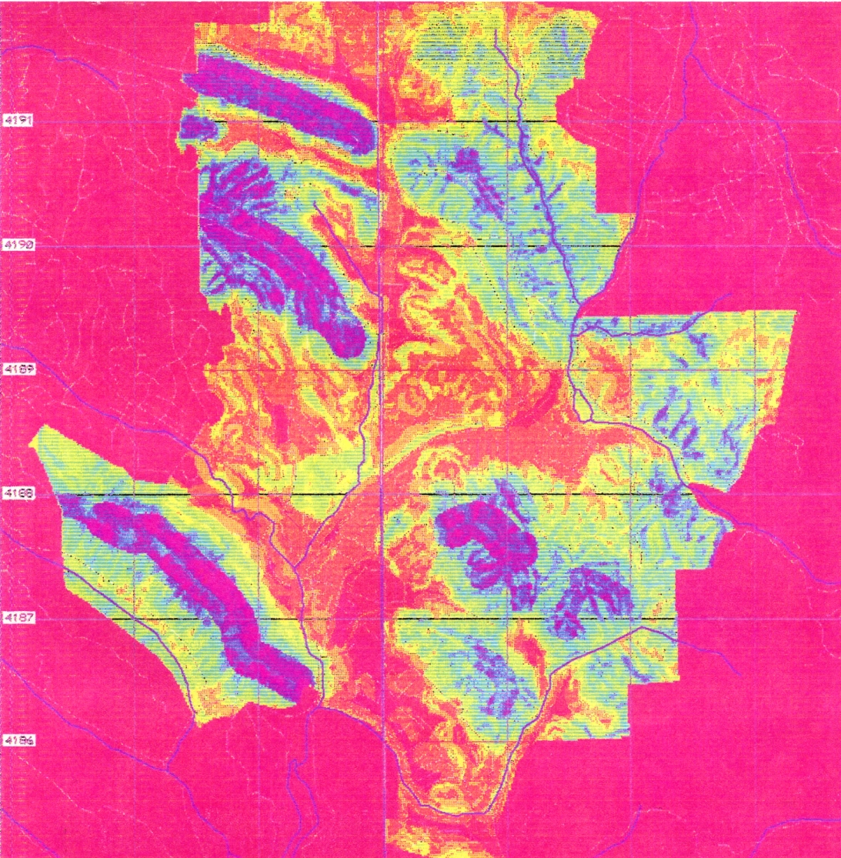

Fig. 1 - GIS generated Development Capabilities Map prepared for Town of Moraga, California in 1989. The map was based upon the addition of six factors, all weighed equally: ridgelines, landslide susceptibility, flood hazard, slope, vegetation and soil erosion.

The contour interval chosen for the topographic base map was 1.52 m (5 feet). At this scale slides as small as 8 to 10 meters of total vertical height could be reliably identified on the basis of anomalous topographic keys. Our experience has shown that contour interval is the most important factor in delineating landslide features, even more reliably than stereopair aerial photos. By focusing on those slope areas with anomalous topographic expression, “target areas” for further examination were identified.

The size of discernable landslides features is intimately tied to resolution and contour interval of the base orthophoto topographic map. Only the largest slides can be discerned on standard USGS 1:24,000 (7.5-minute) topographic quadrangles. This is because one needs at least 5 contour intervals across the slide to recognize topographic indicators of land slippage. The most common topographic intervals on USGS products are 6.10 m (20 feet) and 12.19 m (40 feet), meaning slides would need to be 30+ to 60+ meters in vertical relief to be recognized on the basis of just topographic anomalies.

After areas of anomalous topography are identified, the next step is to make careful evaluation of these same areas with sets of stereopair aerial photos. For this study eight sets of stereopair aerial photos covering the study area were examined, dating from 1928 to 1990. Despite the fact that aerial photos have long been recognized as the preeminent method to make reconnaissance-level evaluation of landslide hazards (Liang and Belcher, 1958; Ritchie, 1958), there are also a great number of problems associated with delineating landslides on aerial photos, including tree canopy and slope aspect, parallax distortion, scale resolution, sun angle and soil moisture.

Because it was a reconnaissance-level product covering over 33 km² , direct filed observations were not made as part of the study (normally, the third step in the identification process). Intended limitations of the map’s accuracy were indicated in a disclosure statement on each sheet, directing users to retain their own consultants to perform site-specific studies if desiring to seek confirmation or denial of mapped units. The last step normally taken in evaluating landslides is site-specific subsurface investigation. Subsurface exploration techniques involved with dormant, ancient or inactive bedrock landslides are often tedious. Common methods of field evaluation include deep trenches across suspected head scarp grabens and large diameter bucket auger excavations in various parts of the suspected mass which can be down hole logged by a geologist.

Unlike the Moraga study discussed previously, this effort sought to summarize the surficial hazards into seven basic map categories. The types of surficial deposits included: 1) alluvium; 2) stream terrace deposits; and 3) colluvium, or slope wash, deposited within old bedrock ravines. Landslides were divided into four major categories, those being: 1) debris flows (including source and run out areas); 2) Earthflows; 3) Translational-Rotational bedrock landslides; and 4) Ancient or Indistinct Landslide deposits. An example of the end product is shown in Fig. 2. Boundaries of mapped units were shown in conventional nomenclature, with solid lines denoting the aerial limits of recently active slide deposits; dashed lines delineating inferred limits; and dashed with query where contacts were concealed.

1991 Study of the Geology Underlying the Oakland-Alameda Area

Following the October 1989 Loma Prieta earthquake, geoscientists were desperate to access geologic data regarding the late Quaternary-age stratigraphy and geologic structure beneath the central San Francisco East Bay plain. Most existing data was unpublished and scattered in a wide range of formats, difficult to track down and correlate. Of greatest interest was information from deep wells, sometimes penetrating 400m or more of late quaternary age sediments into the underlying Jurassic-Cretaceous age basement rocks of the Franciscan assemblage (Rogers and Figuers, 1991).

We managed to collect the logs of over 200 borings between 37 and 316 meters deep within the study area, ranging in age back over 100 years. For older wells, location references can be extremely difficult to verify, as most of the referenced land features no longer exist. Reliable maps from the era in question were then accessed in order to verify the described positions. It soon became apparent that water well drillers had been notoriously careless in stating precise locations of their wells, and some well heads were found upwards of a kilometer from their described positions.

One of the problems inherent in compiling subsurface geologic data from a wide range of sources is to accurately account for variances in interpretation and historical evolution of the stratigraphic nomenclature. Two steps are needed before meaningful correlations can begin: an accurate idea of the bedrock basement geometry, which controls overall sediment thickness; and a coherent representation of the sediment stratigraphy, or the vertical sequence of units previously identified by all sources.

The San Francisco Bay bedrock depression turned out to be structurally controlled, by the existence of right-lateral strike-slip faults (the San Andreas and Hayward) bounding the Bay, but a pull-apart basin beneath the central portion of the East Bay plain was hypothesized to explain the gravity anomalies and much deeper accumulation of late quaternary age sediments occupying this area southeast of Oakland (Fig. 3). Further spatial analysis revealed that less than 5% extension was necessary to explain the pull-apart basin, and that a maximum depth to Franciscan basement of something less than 500 m could be expected (Fig.3).

Once the overall structural geologic setting was firmly established, a conceptual model of the stratigraphy was formulated. Geotechnical well logs generally utilize descriptions of physical attributes, without any serious consideration of stratigraphic unit assignment and faunal age, which is usually derived from detailed evaluation of micro fossils (Sloan, 1992). We were left with logs that repeatedly described “bay mud,” “blue marine clay,” or “estuarine mud,” without any reference to relative age and

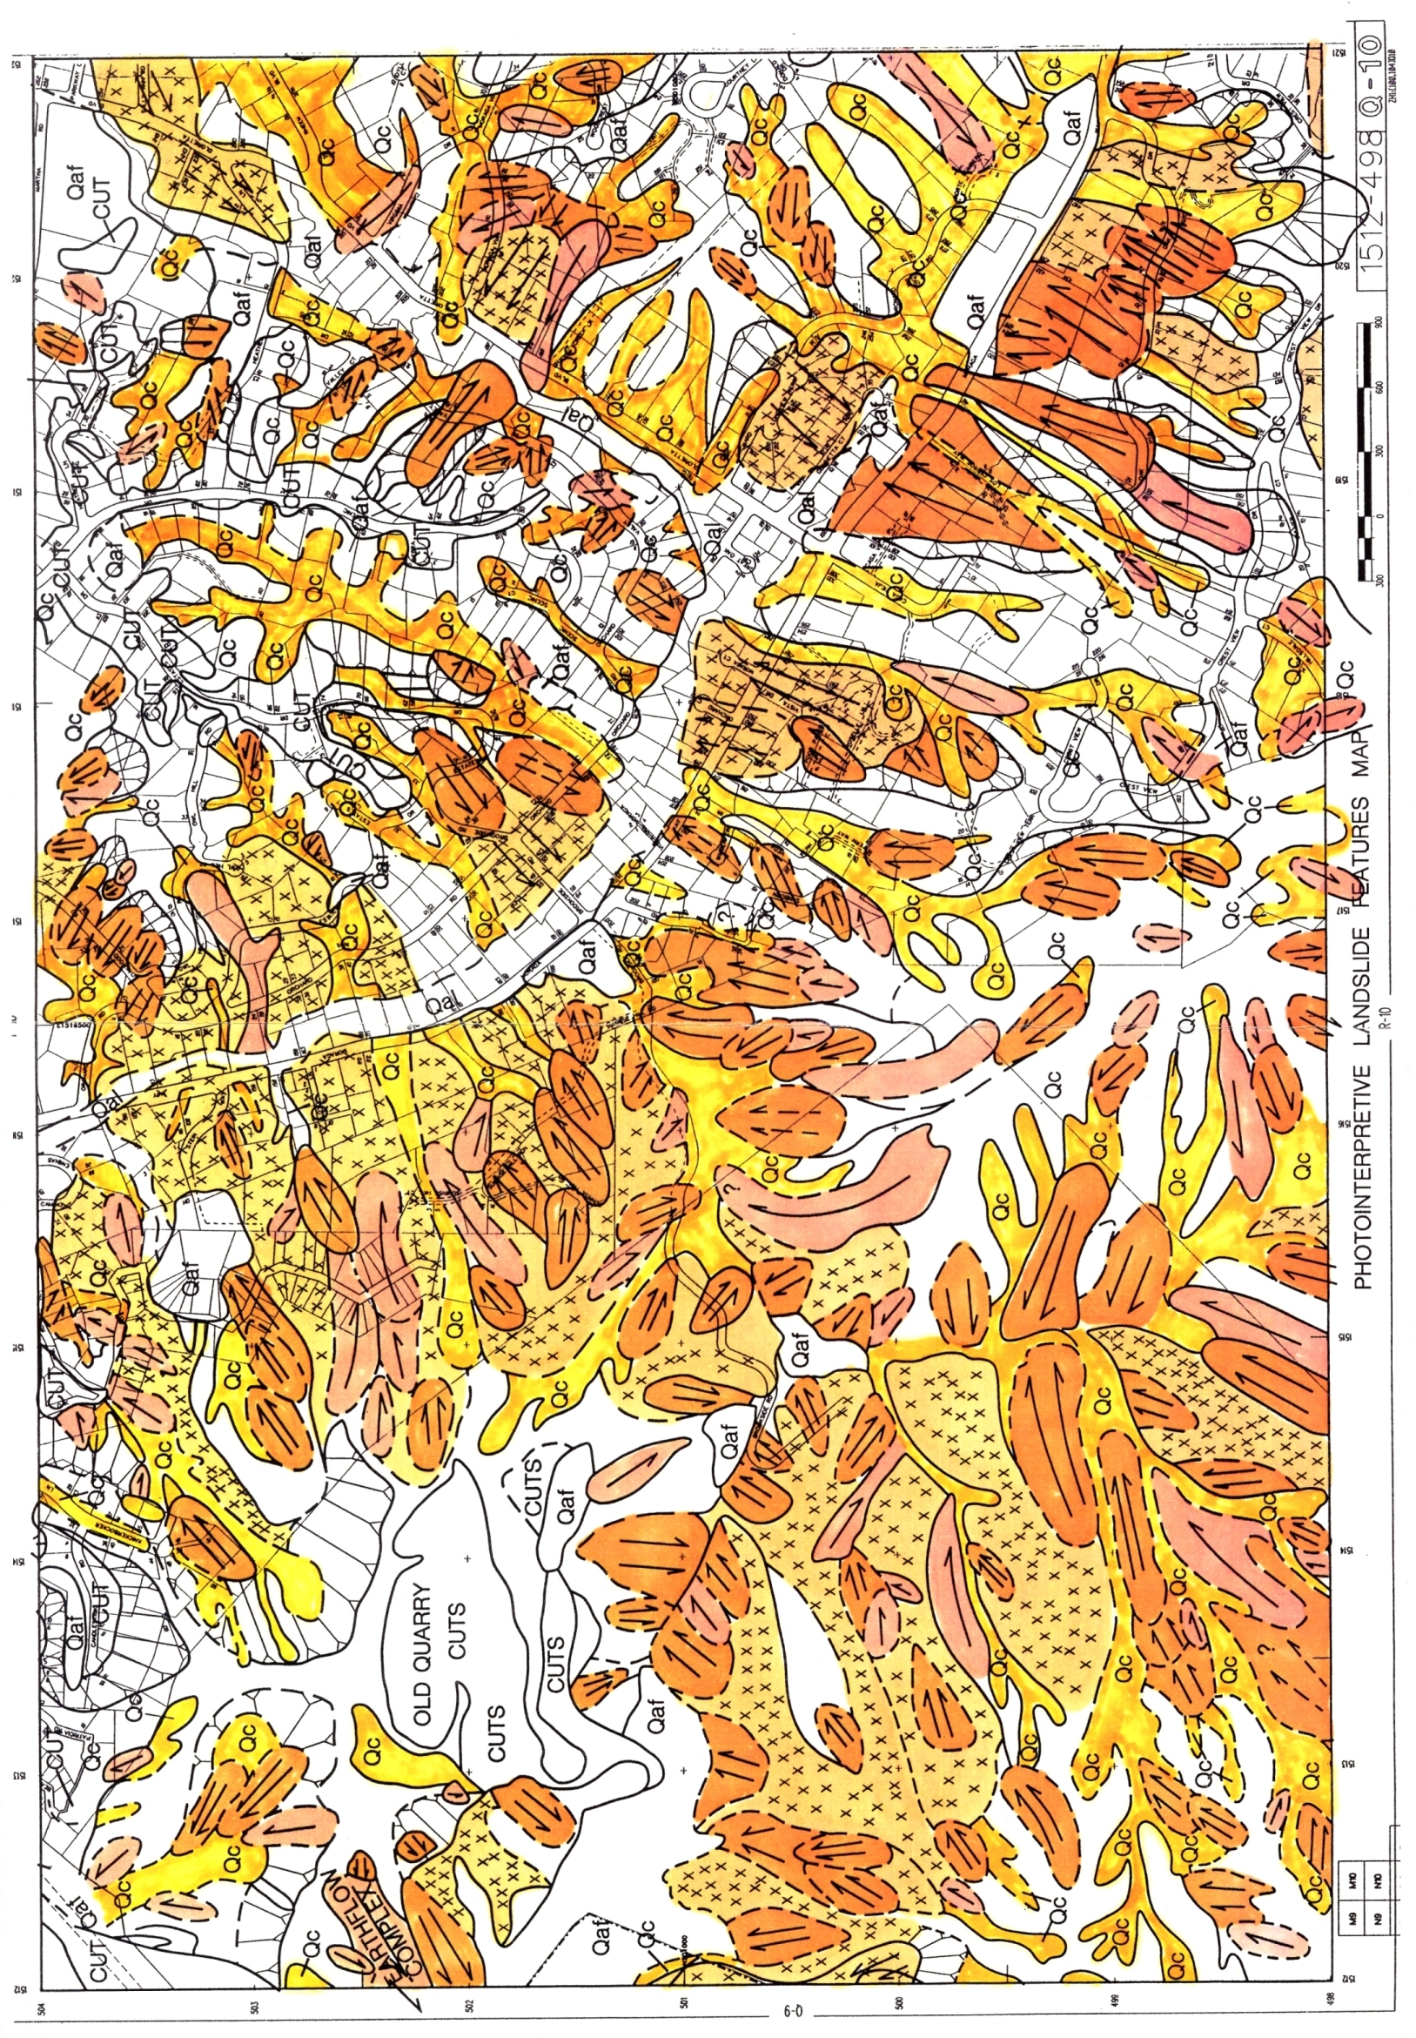
Fig. 2 - Interpretive landslide features overlain on assessor’s parcel map, showing a portion of Orinda, California, originally produced at a scale of 1:3,600. Arrows indicate direction of supposed movement, while check-marked areas are those supposed to be underlain by old bedrock landslides.
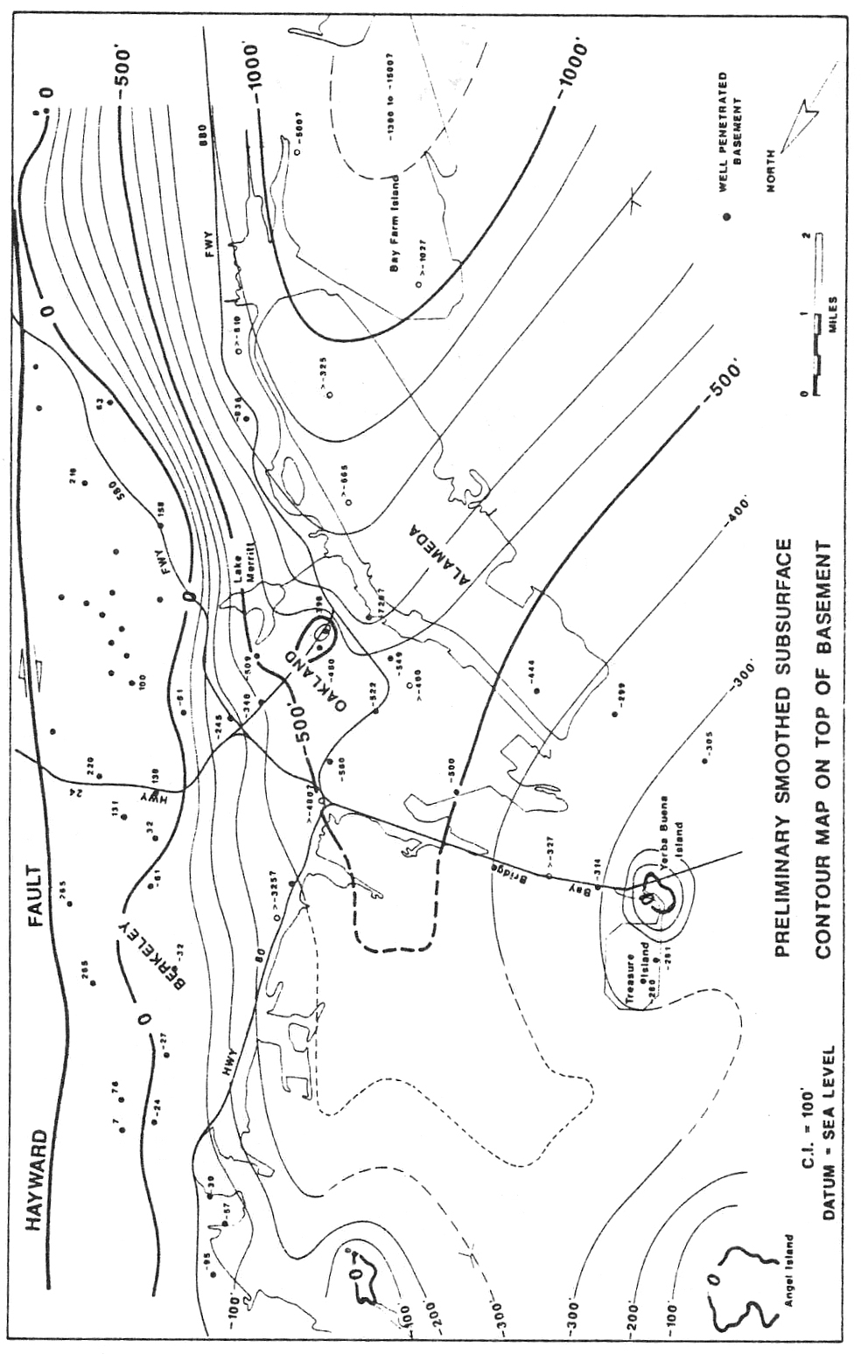
Fig. 3 - Preliminary smoothed subsurface contour map on top of Jurassic-Cretaceous age Franciscan assemblage basement in east central San Francisco Bay. Those wells which penetrated the basement are shown as solid dots. Estimates of expectable site response could be generated from such data, provided shear wave velocity profiles of the overlying quaternary-age fill were available.
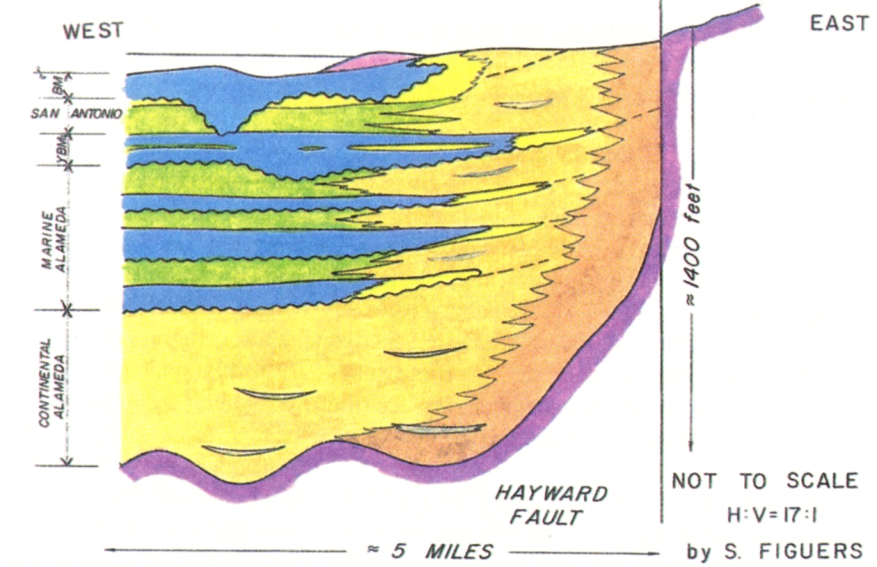
Figure 4 - Schematic section view (with 17:1 vertical exaggeration) of typical stratigraphic relationships across the eastern shoreline of central San Francisco Bay. At least three, and possibly four, landward transgressions of late Pleistocene seas are recorded in the upper Alameda formation. Appreciating the sequence of depositional events was key to making correlations between well logs of dissimilar age and origin.

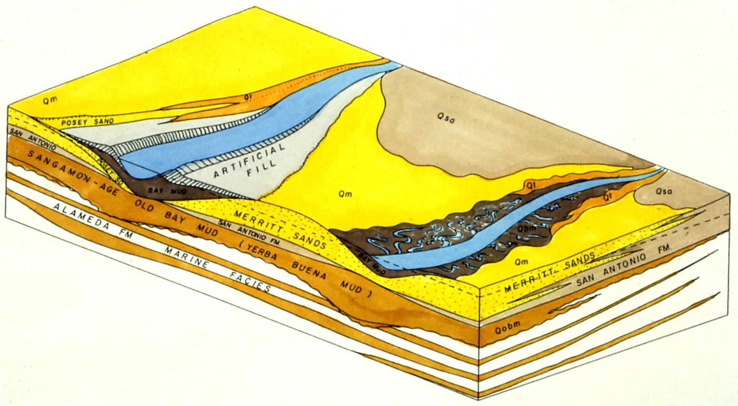
Fig. 5 - Schematic block diagram view looking north across the present East Bay shoreline in vicinity of Oakland and Alameda. Along the Bay margins, bay mud has been deposited in Wisconsin-age channels, cut into the San Antonio formation when sea level was 107m lower than today. It is important to appreciate the lateral restriction of channel deposits when attempting to correlate well logs. Note how succeeding channels are not always situated one atop another, but may be offset.
position. By carefully compiling the best information from the deepest and most complete well logs, we eventually developed what we believed to be an accurate model of the underlying stratigraphy, shown in Fig. 4.

A reliable model of the stratigraphy is critical to understanding what sequences of sediments we could expect to see at any given locale. We were then able to use “sequence models” in lieu of micro fossils from actual cores to unravel likely unit assignments and relative ages. A sequence model is something akin to a fingerprint at any given locale. Major weather pattern and base level changes are faithfully recorded in the Bay’s sediments (Sloan, 1992), and it is the sequence, or vertical order of the various sediments, that attests to sea level encroachment or regression during interglacial periods. By evaluating the entire late quaternary stratigraphic column, an experienced stratigrapher could usually discern accurate age and unit assignments for the various sediment sequences described in the old well logs.

One of the most useful products from the study was a better understanding of the three-dimensional aspect of superposed units, a factor often ignored by many geotechnical professionals, because they usually work on relatively small parcels. As shown in Fig. 5, channel deposits were found to be laterally restricted, seldom extending far in a direction transverse to the old channel axis. Most of these channels support paleo flood plains, within which lie overbank silts. Though commonly referred to as estuarine muds, in 75% of the cases analyzed, these materials turned out to be overbank silt, deposited at flood stage. The block diagram in Fig. 5 shows how individual units interfinger and can be locally missing, causing many an incorrect interpretation. The complexities of working in low gradient, fresh water-salt water mixing environments cannot be understated.

1993-95 USGS Well Repository Project

This project, funded by the U.S. Geological Survey, sought to follow up on the well database begun in the 1991 NSF study, but expanded to the entirety of Alameda and Contra Costa Counties, a land area of 3,806 km². The goal of the project was to establish a computerized database methodology by which meaningful data could easily be retrieved from voluminous quantities of existing well data, mostly in the form of water wells. Some 4,700 well logs were evaluated and tabulated into the database, using the program Paradox 4, which had previously been exploited by petroleum firms to categorize their well data. An example of a graphic print out is presented in Fig. 6.

In California the State Department of Water Resources has collected the logs of all water wells for over 100 years. Though not accessible to the public at large, these logs are available to researchers working with government agencies. Approximately 3,200 well logs were provided from this depository for inclusion in this study. A common problem with using water wells is their poor well log descriptions, which can be almost uselessly vague. As a consequence, a major goal of this study was to create a means by which quality data could be sifted from large volumes of low quality data. Though the goal of most any GIS study, this is easier said than done.

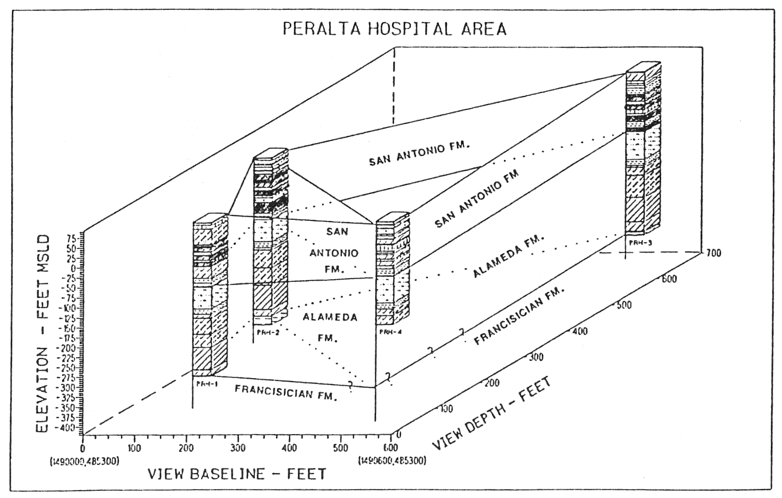
Fig. 6 - An example of GIS geologic data base manipulations made with the program GTGS, using data taken from the USGS well repository, stored on Paradox 4. The example presented is a stratigraphic fence diagram that allows detailed cross-hole correlations of subsurface data.

On a GIS map users will ASSUME that all the input data is of like kind and quality. In this project we were dealing with well data that extended over 100 years from hundreds of independent sources. During the time interval covered, there were innumerable variances in stratigraphic nomenclature, not to mention natural variations in interpretation. Just how great these variables were was appreciated when comparing the logs of adjacent wells drilled and logged by different agencies and methods dozens of years apart.

As the GIS product provider, we were then faced with the dilemma of not only how to store all the available data, but to provide a means by which end users could evaluate the comparative quality of the various logs. Most end users favor data generated within their respective professions, i.e. geotechnical engineers favored geotechnical boring logs, while petroleum industry users favor logs generated within their industry. We eventually decided that we could not “grade” the various entries in the database, we had to trust users to make reliable interpretations, seeing raw well logs for what they really are, limited information, oftentimes little better than nothing.

The final product (Rogers, Figuers and Mero, 1994) contained 43 registers of information, including a battery of location identifiers, such as latitude, longitude, California Well Coordinate System, etc. Other registers included information on well depth, and all manner of log annotations, such as: lithologies encountered, geophysical data, water table information, casings, penetration resistance, sampling, testing, and even the type of well seals applied. Because of the great number of information registers, end users could query the database for data of particular interest, such as: which wells penetrate the Franciscan basement and have electric logs? The data base would then scan for those wells which met each of the requested criteria and answer.

A GIS well database is not difficult to set up with raw data, provided such data can be retrieved. However, it is a time consuming and tedious process to estimate well collar locations, which need to be verified or the spatial nature of the database would be erroneous. As a consequence, data input can involve substantive labor. Computerized well databases are the only available method by which useful information can be skimmed from large volumes of data. The GIS representation of such data, spatially arrayed is essential to formulating any meaningful conclusions about underlying geologic structure.

Conclusions

Existing GIS databases can store enormous quantities of geotechnical data, allowing for unprecedented libraries of information available for manipulation that was impossible to contemplate just a decade ago. The spatial representation of data on map-style layers is invaluable as a tool of communication with the end users of such information, but such products are also fraught with limitations we should not lose sight of. These include:

1. An inherent problem with this form of spatial representation is the inability to inform users of what might lie immediately beneath the ground surface. End users evaluating two-dimensional GIS-derived map products without sufficient training in geology may draw erroneous conclusions from such maps, by assuming that the depicted surface deposits extend to some unknown depth. In the interpretation of landslide features, this problem is particularly acute, insofar as only the most recent generation of slippage is evident to most interpreters. Previous sequences of movement tend to become increasingly masked with time, as one manner of land slippage rests upon another, making detection of superposed events extremely difficult.

2. Another problem is the variable quality and sources of data represented on various layers of GIS products. Whenever we present a set of data with equal line weights or colors, end users will intuitively assume all the data is of like reliability, when in fact it seldom is. An example of this problem was the uncertainty associated with collar locations of old wells, discussed earlier. Some parts of the maps are going to have better data than others. How do we let our users know the degrees of reliability? This facet of GIS products needs further development.

3. Like any geologic product, GIS databases will require periodic updating, as new information and interpretative models become available. The publication of GIS-derived documents by credible sources tends to be seen by end users with a stamp of approval unchanging with time. More often than not, earth science professionals in the private sector will continue to use outdated maps, long after they have been superseded by newer products. By posting future GIS products on the Internet, much of this laziness and familiarity with hard copy products will be avoided, as users will tend to pull down information off the net when they need it, and the requirement for hard copy storage will diminish. However, will we see the funds made available to periodically maintain the GIS database products we produce? We must assume that despite our best efforts, our products will likely become dated, and we should consider the inclusion of disclaimers on all of our work to inform naive end users of the product’s limitations, especially in regards to timeliness.

References

Duncan, J.M., 1971, Prevention and Correction of Landslides: 6th Annual Nevada Street and Highway Conference, Section II, April 7, pp. 1-42.

Kachadoorian, R., 1956, Engineering Geology of the Warford Mesa Subdivision, Orinda, California: U.S. Geological Survey Open File Report, 13 p., 1 plate.

Kiersch, G.A., 1969, Pfeiffer vs General Insurance Corporation-Landslide Damage to Insured Dwelling, Orinda, California, and Relevant Cases: in Kiersch, G.A. and Cleaves, A.B., eds., Engineering Geology Case Histories Number 7: Geological Society of America, pp. 81-94.

Liang, T., and Belcher, D.J., 1958, Airphoto Interpretation, in Landslides and Engineering Practice: National Research Council, Highway Research Board Special Report No. 29, pp. 69-92.

Newman, E.B., Paradis, a. R., and Brabb, E.E., 1978, Feasibility and Cost of Using a Computer to Prepare Landslide Susceptibility Maps of the San Francisco Bay Region, California: U.S. Geological Survey Bulletin 1443, 27 p., 1 plate.

Nilsen, T.H., and Turner, B.L., 1975, Influence of Rainfall and Ancient landslide Deposits on Recent Landslides (1950-71) in Urban Areas of Contra Costa County, California: U.S. Geological Survey Bulletin 1388, 18 p, 2 plates, map scale 1:62,500.

Radbruch, D.H, and Weiler, L.M., 1963, Preliminary Report on Landslides in a part of the Orinda Formation, Contra Costa County, CA: U.S. Geological Survey Open File Report, 35 p.

Ritchie, A.M., 1958, Recognition and Identification of Landslides, in landslides and Engineering Practice: National Research Council, Highway Research Board Special Report 29, pp. 48-68.

Rogers, J.D., Figuers, S.H., and Mero, W.B., 1994, Development of a Computer Well Data Base for Alameda and Contra Costa Counties: final report to U.S. Geological Survey, Contract 1434-92-C-50023, 61 p., 1 plate.

Rogers, J.D., Figuers, S.H., 1991, Engineering Geologic Site Characterization of the Greater Oakland-Alameda Area, Alameda and San Francisco Counties, California: final report to National Science Foundation, Grant No. BCS-9003785, 52 p., 2 plates.

Rogers/Pacific, 1989, Summary Report, Moraga Development Capability Map, Moraga, California: unpublished consultant’s report for Town of Moraga, CA, job number PEO477T, 57 p.

Rogers/Pacific, 1994, Report Accompanying Map of Landslides and Surficial Deposits of the City of Orinda, California for City of Orinda, Department of Public Works: unpublished consultant’s report, February 18, 161 p.

Sloan, D., 1992, The Yerba Buena Mud: Record of the last-interglacial predecessor of San Francisco Bay, California: Bulletin of the Geological Society of America, v. 104, n. 6, pp. 716-727.

UM-Rolla Dept. of Geological Engineering, 129 McNutt Hall, Rolla, MO 65409

