THE OPPOSING PLANS
From: Guadalcanal 1942 – The Marines Strike Back
Author: Joseph N. Mueller

The Japanese Plan

From 7 December 1941 to 7 May 1942, the Japanese advanced with seeming precision, sweeping through east Asia, the Indies and a large portion of Melanesia. They overran the Philippines, Wake Island, Guam and Singapore. As their seemingly unstoppable advance continued, they seized Rabaul on the island of New Britain on 23 January 1943. They thereby acquired a key objective. Rabaul was just 1,200 nautical miles from their bases in the Palau Islands and 640 nautical miles from their base at Truk. It could easily be defended and converted to a bastion from which future offensive operations could be launched. It also had the best harbour in the region and excellent terrain for the construction of airfields.

From Rabaul the Japanese could dominate New Guinea and the Solomon Islands. Once these two areas could be controlled, the Japanese could sever the communications lifeline between Hawaii and Australia.

In March 1942, the Japanese seized Bougainville in the Northern Solomons. From there they proceeded down the Solomons to the centre of British Government, Tulagi. After seizing operational bases on the northern coast of New Guinea and in the Solomon Islands, they attacked Tulagi on 1 May 1942. Unable to defend Tulagi adequately, the British withdrew from the area. Then, on 3 May 1942, the 2nd and 3rd Companies of the Kure Special Landing Force, supported by a small naval force, made an unopposed landing on Tulagi and Gavutu.

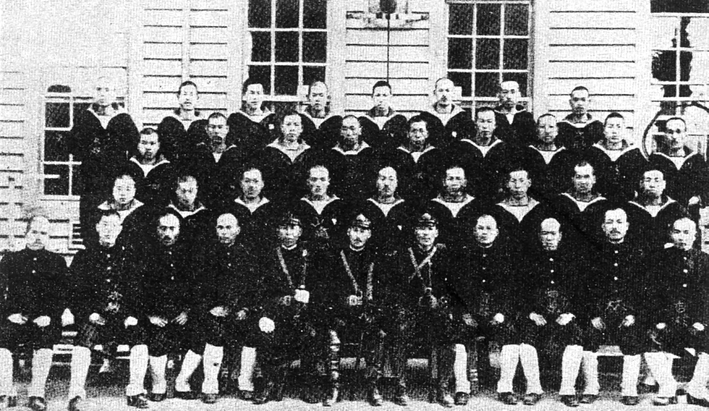
The operation did not go unhindered. The next day, dive-bombers and torpedo planes from the American aircraft carriers Enterprise and Yorktown raided Tulagi sinking the destroyer Kikutsuki and damaging other ships. This attack was the opening phase of the Battle of the Coral Sea. In that battle, the Americans turned back a large Japanese task force that was advancing on Port Moresby, New Guinea. After the Battle of the Coral Sea, the Japanese commander at Rabaul advised his subordinates that the battle had depleted Japanese naval forces in the area. He further advised that supply lines to Lae and Tulagi were in great danger. His greatest concern was for the New Guinea area.

Left: Officers and petty officer of the 3rd Kure Special Landing Force who seized Tulagi and Gavutu on 3 May. This picture was taken prior to the invasion, at their base in Japan. The majority of the men in this picture were killed between 7 and 9August in action against the Marines. (USMC)

Tulagi did not receive much attention. After landing, the small 380 man Japanese force began improving existing facilities by building seaplane bases on Tulagi and Gavutu. Once this was accomplished, they began generally exploring their new conquests. For about a month, no immediate steps were taken to develop bases in the area. Then, in late June 1942, survey parties went ashore at Lunga Point on the north coast of the
big island of Guadalcanal. There they explored the possibility of building an airfield. By mid July construction had started, with completion estimated by mid-August.

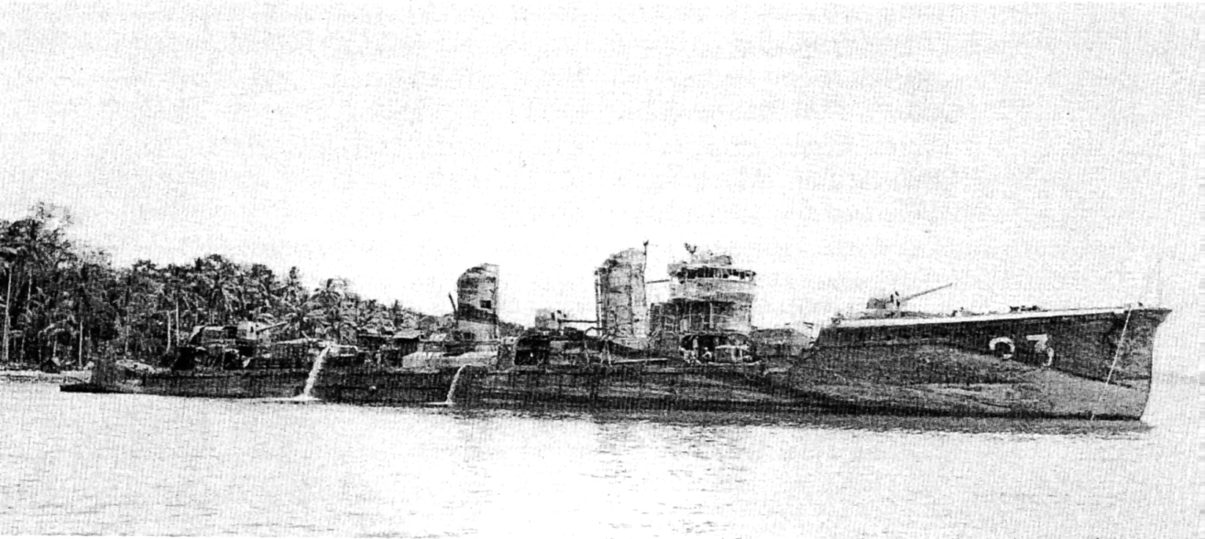
Above: TheJapanese destroyer Kikutsuki participated in the Japanese invasion of Tulagi on 3 May 1942. She gave fire support to the Kure Special Landing Force that made an unopposed landing. On the following day she was sunk in an air raid by pilots from the American aircraft carrier Yorktown. In October 1943 she was raised and used as a floating repair ship by the 34th Construction Battalion. (National Archives 80-G-89212)

According to Japanese documents captured later, the objective of capturing Tulagi and building an airfield on Guadalcanal was to protect their flank while carrying out their main attack on Port Moresby, New Guinea. The secondary objective was to secure a favourable base of operations to move south through New Caledonia to attack Australia. This attack was to take place after the capture of New Guinea.

The American Plan

The American plan for the invasion of Guadalcanal began with inter-service rivalries. After the Battle of the Coral Sea, in early May 1942, General Douglas MacArthur, Commander of the Southwest Pacific Forces (CINCSWPA), realized that the Japanese would eventually attempt to sever the lines of communication between Hawaii and Australia. He felt that a Japanese attack on New Guinea was inevitable. To prevent such an attack he wanted to take the offensive against the Japanese in the New Britain-New Ireland areas. An attack of this nature would force the Japanese out of the region and back to Truk. MacArthur's plan found favour with General George C. Marshall, US Army Chief of Staff. However, MacArthur did not have the resources available to launch such an offensive. Further, he had no troops under his command that had any experience of amphibious warfare.

Simultaneously, Admiral Chester W. Nimitz, Commander in Chief Pacific- Fleet (CINCPAC) and Pacific Ocean Area (CINCPOA), was contemplating a strike on Tulagi, a plan that found favour with Admiral Ernest J. King, Chief of Naval Operations, Joint Chiefs of Staff. Originally, Nimitz had advocated the taking of Tulagi with a Marine Raider Battalion, but the concept was rejected by King, who felt the force was not suitable. However, King felt that the immediate objectives should be in the Solomon and Santa Cruz Islands, with the ultimate objective in the New Guinea and New Britain area.

The Operations Division of the War Department (OPD), did not favour the Navy plan to attack and occupy Tulagi and move progressively against Rabaul: they felt that the quick strike at Rabaul had the most merit. Once Rabaul was taken the Japanese would be driven from the area and other positions could be isolated.

To complicate the issue further, neither side in the debate could agree on an operational commander. The Navy felt that MacArthur might unnecessarily expose its carriers to land based aircraft while they would be operating in restricted waters with limited aircraft carrier capability. They also felt Tulagi should be taken first to lessen the Japanese danger, at the same time establishing a base in the Solomons for future operations. This would allow a build-up of naval power for future operations. The Navy concluded that command should be through Nimitz, to his subordinate, Vice Admiral Robert L. Ghormley, Commander South Pacific Area and South Pacific Force (COMSOPAC). MacArthur objected strenuously. He felt he was the logical choice for command since the amphibious objectives were in his area. However he lacked the ground troops to initiate an amphibious mission.

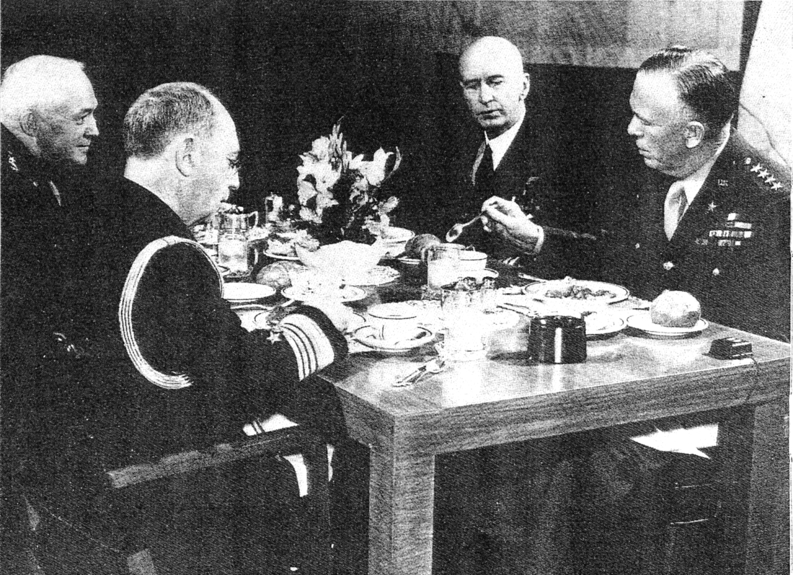
Above: Joint Chiefs of Staff during the Guadalcanal campaign. From left to right: Lieutenant General Henry H. Arnold, Admiral William D. Leahy, Admiral Ernest) King and the Chairman, General George C. Marshall. It was interservice rivalries between King and Marshall that caused some friction during the planning stages of the campaign. (National Archives)

Between 29 June and 2 July 1942, the Joint Chiefs of Staff met and came up with a compromise plan. It called for Admiral Ghormley to command the Tulagi portion of the upcoming offensive; thereafter General MacArthur would command the advance to Rabaul. The American Navy with the Marine Corps would attack, seize and defend Tulagi, Guadalcanal and the surrounding area, while MacArthur made a parallel advance on New Guinea. Both drives would aim at Rabaul. The boundary between Southwest Pacific Area and the South Pacific Area was moved to reflect this, and South Pacific Forces were given the go-ahead to initiate planning. Admiral King had not waited for the final approval: on 25 June 1942 he notified Nimitz to alert Ghormley to start planning. Ghormley in turn contacted Major General Alexander A. Vandegrift, the Commanding General, 1st Marine Division (reinforced), that his division would spearhead the amphibious assault, scheduled to take place on 1 August 1942.

For General Vandegrift the problems were just beginning. He had not expected to go into combat until after January 1943. Only a third of his division was at Wellington; a third was still at sea; and the other third had been detached to garrison Samoa. In little less than a month Vandegrift would have to prepare operational and logistical plans, unload part of his ships, reload for combat, sail from Wellington to the Fiji Islands for an amphibious rehearsal, and then sail to the Solomon Islands to drive out the Japanese.

To make the amphibious assault, the cargo that had been loaded in America would have to be reconfigured into a combat load. This in itself would pose a difficult set of problems and take place in New Zealand at Aotea Quay, a confined area that could only berth five ships at a time. To make bad matters worse, two other events compounded the misery. First, the dock workers went on strike so that the Marines had do all the stevedore work themselves. Next came the rains, which were steady for almost the entire period and were driven by a cold, persistent wind. The Marines worked around the clock in three eighthour shifts, and the docks offered no protection from the weather. Space was adequate for stacking cargo, but it was left unprotected. The net result was the loss of food and clothing, which had been packaged in cardboard cartons that virtually dissolved. Morale of the Marines also suffered while working in such conditions - and, to make matters even worse, an influenza epidemic broke out. Once the combat loading task was completed, it was discovered that there was not enough room for all the motor transport to go back aboard: nearly all one-ton vehicles and below were put aboard, but 75 per cent of the heavier prime movers had to be left behind.

In addition to all this, Vandegrift would have to gather intelligence on an amphibious objective that most people had never heard of nor been to. Information on Guadalcanal in the summer of 1942 ranged from sketchy to completely unreliable. There were two main sources of information available to the Division's intelligence officer, Lieutenant Colonel Frank B. Goettge. The first source was obtainable from former residents of the area, who were now scattered throughout New Zealand and Australia. Goettge set up an extensive interview programme to gain as much information as possible. The second source of intelligence was from maps and hydrographic charts of the region. Unfortunately, these proved to be virtually nonexistent.

The most useful source of information came from aerial photos taken by Lieutenant Colonel Merril B. Twining and Major William B. Kean on 17 July 1942. The flight was made in an Army B-17 bomber based at Port Moresby, New Guinea, but it was cut short when three Japanese float planes were observed taking off from the Tulagi area to attack the B-17. The aerial photographs did not clearly identify the Japanese airfield, but they did give an excellent view of the north coast of Guadalcanal and the Tulagi area. It would be maps made from these photographs of the northern coast that the Marines would use for the majority of the campaign.

Realizing the enormity of the task ahead. Vandegrift asked for an extension of the invasion date. He was given one week: the amphibious assault would take place on 7 August 1942. There would be no further postponements, for the Japanese had most of the airfield completed.

With logistical preparations completed so far as time permitted, General Vandegrift issued the tactical orders. The grouping of the Marines for the operation was based on intelligence estimates of Japanese forces in the area. It was estimated that of the 8,400 Japanese believed in the area, 1,400 were on Tulagi and its

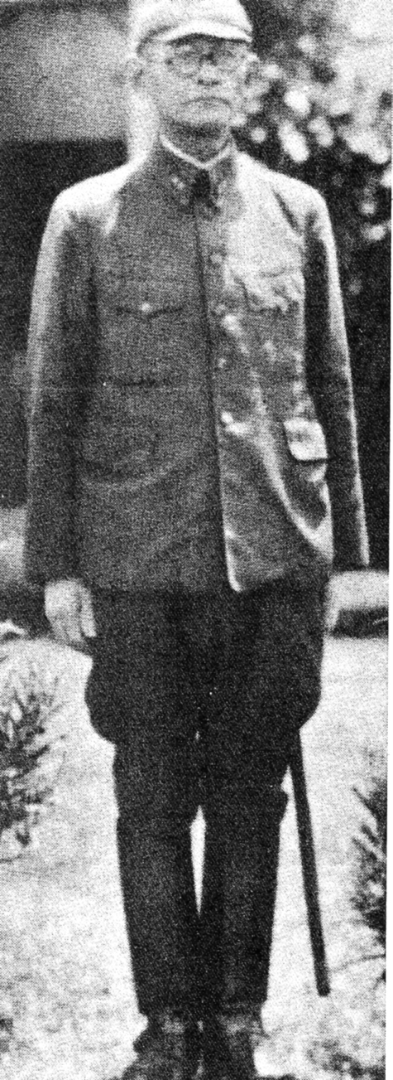
neighbouring islands. The remaining 7,000 were thought to be on Guadalcanal, but this later turned out to be an erroneous estimate; only about half that number were there.

It was anticipated that Tulagi would be the more difficult of the two amphibious objectives. The Marines going ashore there would have to make a direct assault against a small, defended island. To protect the flanks of the Marines landing on Tulagi, it was decided first to seize key points overlooking Tulagi on nearby Florida Island. Later in the day, Gavutu, Tanambogo and the other smaller islands would be taken. With their seizure, the Tulagi portion of the operation would be completed.

Right: Lieutenant General Harukichi Hyakutake, Commanding General ofthe Japanese Seventeenth Army, was assigned the mission of recapturing Guadalcanal. Preoccupied with the capture of New Guinea, he did not grasp the seriousness of the Guadalcanal battle until it was too late, and his piecemeal attacks were defeated by the Americans in detail. (National Archives)

THE OPPOSING COMMANDERS

The Japanese Commanders

Japanese troops in the Solomon Islands in the summer of 1942 constituted a force to be concerned with, but were not numerically superior, while the Japanese command structure was disjointed and plagued with a lack of cooperation between the Army and Navy.

Army forces in the area centred around the Japanese Seventeenth Army under the command of Lieutenant General. Harukichi Hayakutake, who was preoccupied with the conquest of New Guinea.

The naval commander tasked with defence of the area was Vice Admiral Gunichi Mikawa, a seasoned officer who had commanded the escort for Admiral Nagumo's carrier force from Pearl Harbor to the Indian Ocean. Mikawa was in command of the 4th Fleet (Inner South Seas Force), not a large force and composed of either middle-aged or older ships.

Although Mikawa was tasked with defence of the area, he did not have control over the air units at Rabaul. They were controlled by Vice Admiral Nishizo Tuskahara, Commander of the 11th Air Fleet. Mikawa was justifiably concerned with the command and control measures

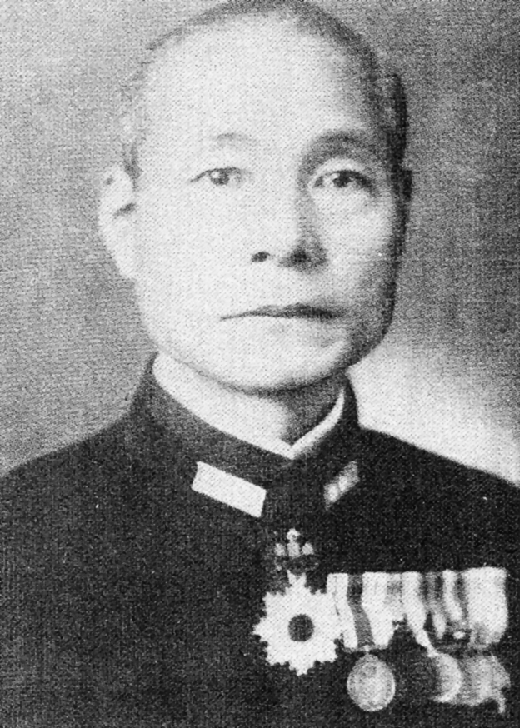
Left: Vice Admiral Gunichi Mikawa, Imperial Japanese Navy, was the architect of the Battle of Savo Island. This battle was the worst defeat suffered by the American Navy since Pearl Harbor. Mikawa was appalled by the lack ofa cohesive command in the Solomon Islands area. B_v his staff he was considered an alarmist. (Naval Historical Center)

utilized by the Japanese forces in the area. He was also disturbed by the lack of preparedness on the part of forces in the Solomons. The members of his staff thought he was an alarmist.

The American Commanders

For the Guadalcanal campaign the American command was set up under Admiral Nimitz, with Admiral Ghormley as Commander of the South Pacific Area (COMSOPAC) and the South Pacific Force. Ghormley would be in overall command of the operation, code named `Watchtower'. Ghorm
ley, in turn, would appoint Vice Admiral Frank J. Fletcher as commander of the entire task force. This naval task force, designated an Expeditionary Force, was made up of two groups: the aircraft carriers constituted the Air Support Force, under Rear Admiral Leigh Noyes; other warships and the transports were organized as the Amphibious Force, under Rear Admiral Richmond K. Turner. Major General Alexander A. Vandegrift would command the Marines as part of the Landing Force.

This command set up, which placed Vandegrift's Marines under the Amphibious Force commander, stemmed back to an earlier era. The Navy felt the Marines were an extension of the forces afloat and still connected to the Navy. The Navy would therefore not only designate the Landing Force Objective, but the manner in which the land campaign would be prosecuted. The Marines, knowing the intricacies of an amphibious assault, were not overjoyed with this relationship. They believed that, once they were ashore and firmly established, command should be transferred from the Navy: the Marine commander ashore could then best control the battlefield.
Rear Admiral V. A. C. Crutchley, Royal Australian Navy, would provide the anti-aircraft protection and the naval gunfire support for the operation. His forces were detached from MacArthur to assist in the operation.
To assist Admiral Ghormley in any dealings with the US Army, Major General Millard F. Harmon, Commanding General US Army Forces South Pacific Area (COMGENSOPAC), was assigned to his command. Further, General Harmon would also be responsible for the administration and supply of Army units in the South Pacific Area. This, then, was the command that propelled the American forces towards the amphibious objective area.

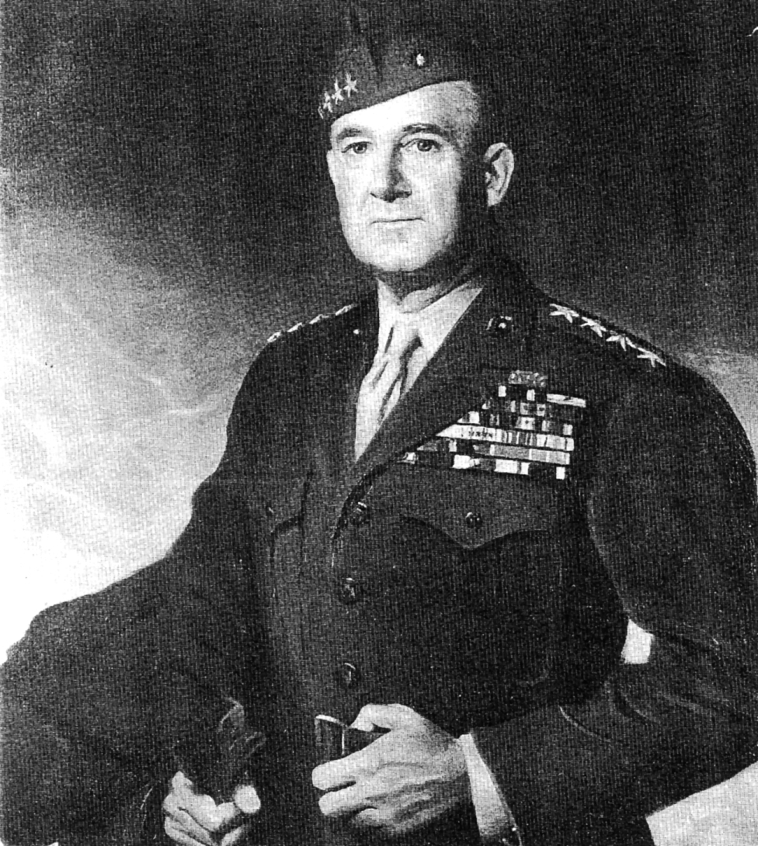
Left: General Vandegrift, Commanding General, 1st Marine Division, Guadalcanal. This portrait depicts him some time after Guadalcanal when he became Commandant of the Marine Corps. The senior, or topmost, ribbon on his uniform, is the Congressional Medal of Honor, America's highest award for valour; it was presented to him for his skills as commanding general on Guadalcanal. (USYIC A413197)

Below: Vice Admiral Robert L. Ghormley, Commander of the South Pacific area and South Pacific Force (COMSOPAC) was in command of the Guadalcanal phase of the Joint Chiefs of Staff plan. Ghormley was a competent leader and planner; however, he never left his command centre at Noumea, New Caledonia, to get a firsthand account of the fighting. (Naval Historical Center)
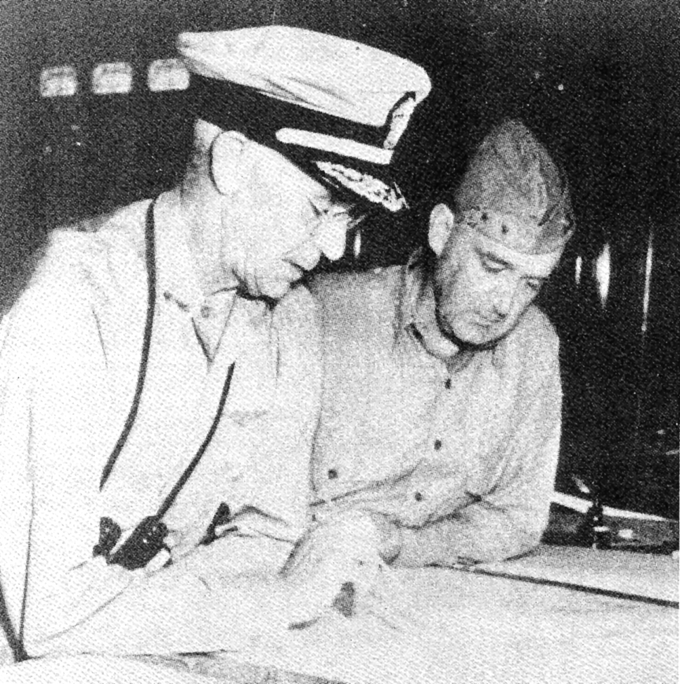
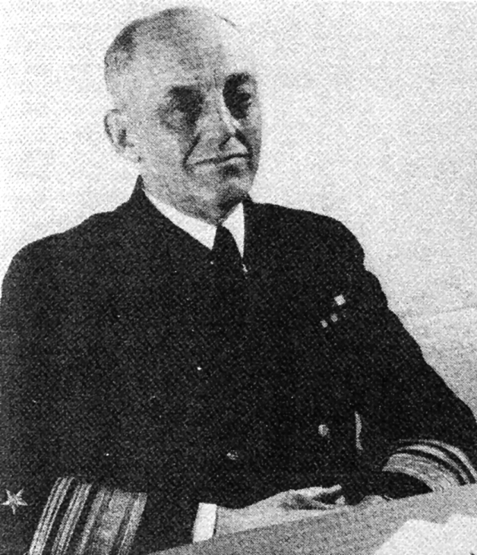 Left: En route to Guadalcanal, Rear Admiral Richmond K. Turner goes over the movement to objective area with Major General Vandegrift. Turner was a brilliant amphibious planner; however, his relationship with Vandegrift was sometimes strained by philosophical differences. Turner was the commander of the amphibious task force and was senior to Vandegrift, who was commander of the landing force. (Naval Historical Center)

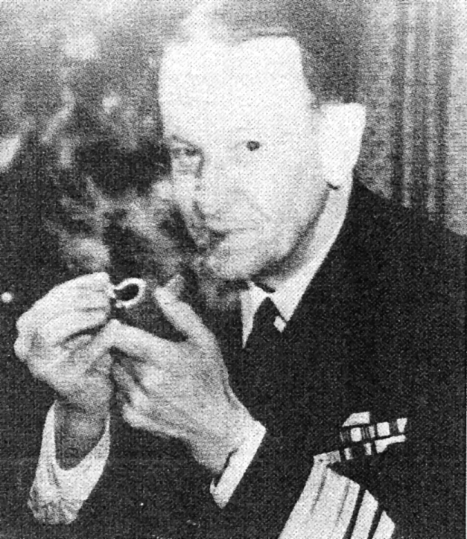
Left: Vice Admiral Frank J. Fletcher was the commander of the naval task force at the invasion of Guadalcanal. His decision to withdraw the aircraft carriers on 9 August caused disastrous consequences in the early stages of the campaign, for it left the Marines ashore virtually unsupported and without adequate supplies. (National Archives)

THE OPPOSING FORCES

Guadalcanal would set the tone for the future campaigns of the war in the Pacific - not just one battle of quick duration, but a series of land, air and sea battles `slugged out' along a narrow coastal belt, in restricted waterways and in the air space over Guadalcanal.

he reason why the campaign was to be so prolonged was that neither side would be able to mass its forces at a critical juncture to obtain a decisive victory. The Japanese and the Americans were operating at the farthest points of their supply lines. The Americans were hampered further by the fact that the bulk of their Pacific Fleet (with the exception of their aircraft carriers) had been sunk at Pearl Harbor, and that they were fighting a two-ocean war. The eventual outcome would be decided by the dogged determination of the American forces committed to the campaign and the release of critically needed supplies and equipment - coupled with luck.

The Japanese Forces

Initially, the Japanese were successful in the early naval battles. With the Battle of Savo Island (8-9 August) they achieved a great naval victory that severely crippled the American Navy's ability to support the operations ashore and in the waters surrounding Guadalcanal. And initially, with their land based fighters they also were able to control the air space overhead. Their ground forces were seasoned fighters and had achieved notable military successes up to Guadalcanal.

Japanese soldiers were masters of camouflage and reputably masters of jungle warfare. Their artillery was accurate, but not mobile enough for the type of jungle warfare engaged in. The tanks they used were also inadequate. The tactics the Japanese used, or were forced to use, were not conducive to success. For the most part, they attempted to conceal the movement of their forces in the jungle of Guadalcanal. This of course restricted their movements considerably. Much of the terrain they traversed was rain forest with few footpaths to travel on. Communications in the jungle were poor, and supplies were limited to what could be manpacked. Couple all of these disadvantages with a tropical disease factor second to none and you have a formula for disaster. Of the 21,500 casualties suffered by the Japanese in the campaign, 9,000 were to die of tropical diseases. By the end of the campaign the Japanese would be reduced to scavenging their food from the jungle.
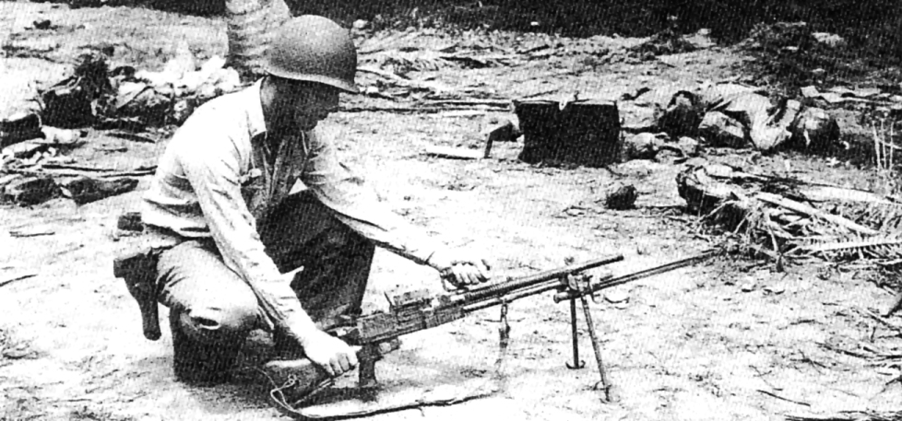
Left: In the aftermath of the Tenaru battle, many Japanese weapons were captured. This particular weapon, a Japanese Nambu light machinegun, is examined by 1st Lieutenant Soule. The Nambu was a gun based on the British Bren-gun system, and had an accurate, high rate office. This picture was taken on the east or Japanese side of the river. The Nambu's gunner lies dead in the background. (USMC 50491)

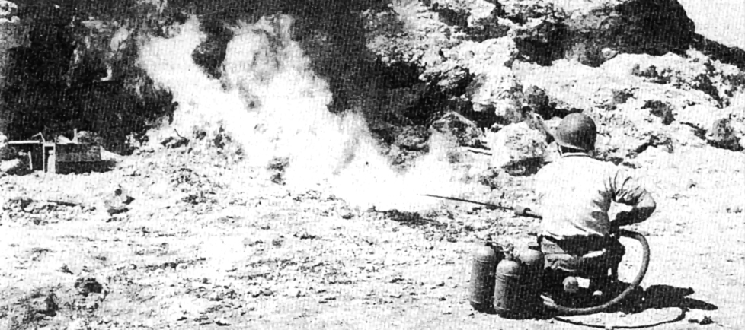
Right: A Marine tests a captured Japanese flamethrower on Guadalcanal. Neither side used this type of weapon in the campaign, but it was to be used quite effectively by the Marines against the Japanese in the later Pacific campaigns. (USMC 50046)

Below: Captured Japanese weapons. The Marine in this picture is holding a Japanese Arisaka Model 38 bolt-action rifle. The rifle fired a 6.5mm (25cal) bullet which was inferior to the .30/06 Springfield rifle used by the Marines. The machine-gun mounted on the tripod is a Model 92 heavy machine-gun, which fired a 7.7mm bullet. It was serviced by a crew who could carry it into battle assembled with the pole carrying handles seen attached to the tripod legs. The weapons in the foreground are Model 99 Nambu light machineguns; they fired a 7.7mm bullet and were extremely effective weapons. (USMC 108575)
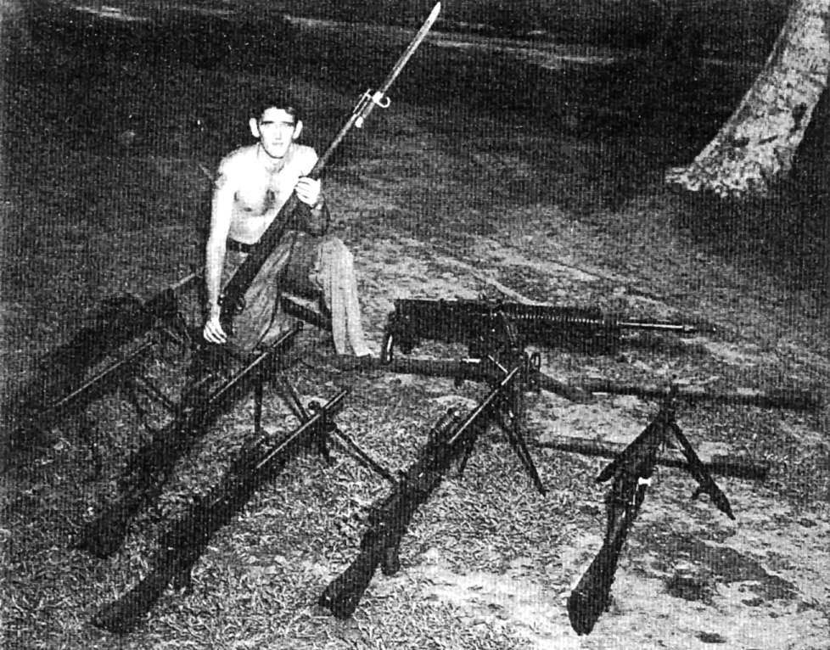
As for the Japanese soldier, he was hardy and more than likely had some prior combat experience. He was tenacious, and subscribed to the code of 'bushido', or warrior, preferring death to capture. As he was subject to privations and stern discipline, those who became his prisoners were shown little mercy.

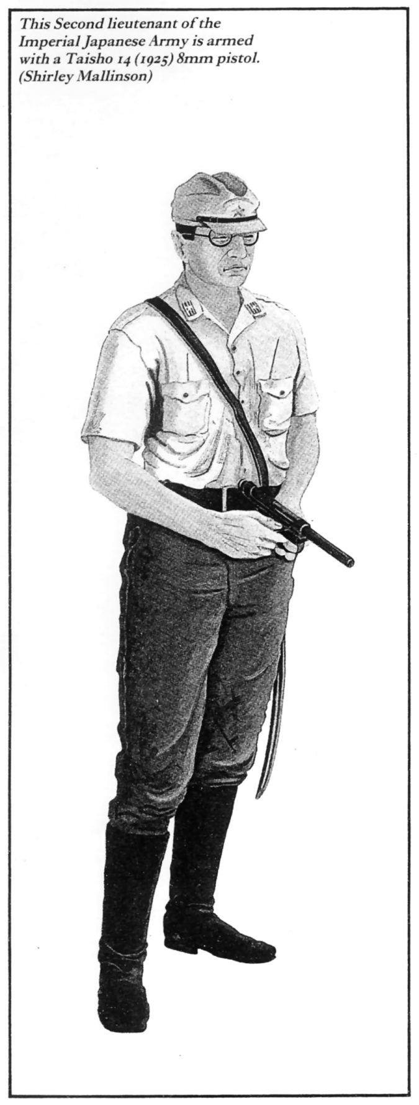
The Japanese Army was fairly well organized at the regimental level and below, but rarely did it operate at a divisional level. It consistently underestimated the capabilities of its enemies, a course of action that would prove disastrous on Guadalcanal. It also lacked security consciousness, and many of its soldiers carried detailed diaries into combat. Small unit leadership was not stressed: the running of the command and its employment was centred around the officers and senior sergeants.

The Japanese Navy on the other hand was an efficient organization. Tactically it could operate by day as well as by night. It was a disciplined aggressive force that carried out its assigned tasks without hesitation, using its weapons systems with deadly efficiency. Most notable was the infamous `Long Lance' 24-inch diameter torpedo, which was used in conjunction with naval gunfire toinflict maximum damage upon American warships.

The most serious failing of the Japanese Navy was its inability to exploit its successes. Time and time again throughout the naval campaign the Japanese achieved a tactical victory and then departed. By exploiting their successes they could have achieved a strategic victory.

In the air, the Japanese had clearly achieved a technological masterpiece with the zero fighter. This aircraft, with its lightweight construction and high rate of climb, could outmanoeuvre any American plane on Guadalcanal, but its diving capability was poor and it was not well suited to absorb punishment inflicted on it in aerial combat. Another disadvantage the Japanese had in the air was the amount of time they could spend over Guadalcanal: their time of flight and fuel consumption meant that their air missions were extremely restricted.

The American Forces

The American troops who invaded Guadalcanal were for the most part untried volunteers. The bulk of the initial combat forces were from the newly formed Ist Marine Division, of which only the advance elements were in Wellington at the time the decision was made for the amphibious assault on Guadalcanal. The remainder were to arrive just prior to embarkation.

The majority of the equipment that the Marines had was First World War vintage. Although it was time tested, in many cases it was either antiquated or worn out; either way, it was generally not suited for conditions on Guadalcanal.

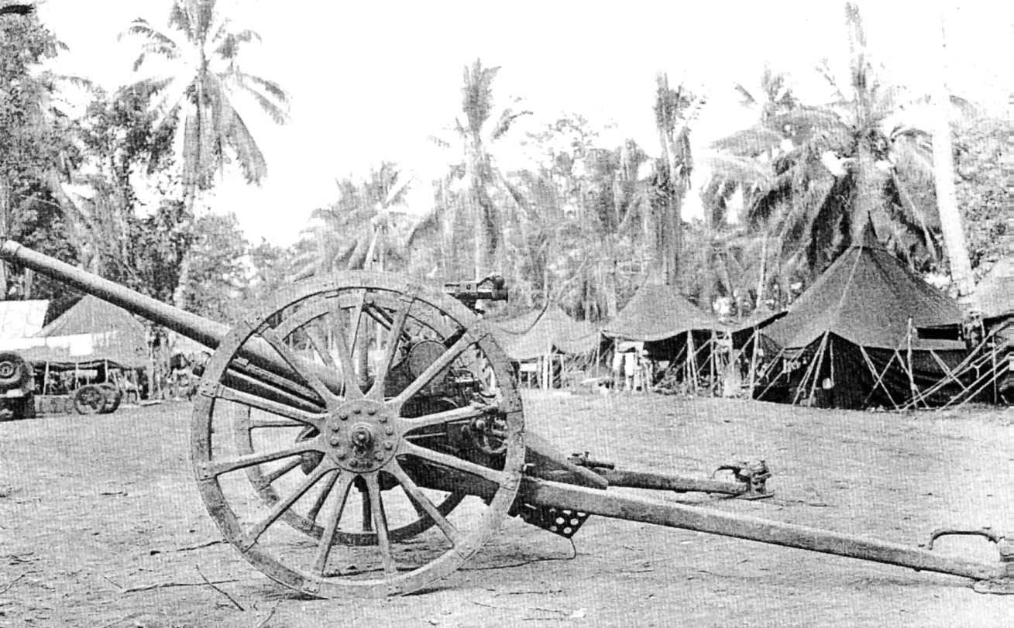
Left: This 37mm Model 97 anti-tank gun was one of the few Japanese weapons that had an equivalent American counterpart. Although not a heavy weapon, it was not easily transportable in the jungle. (USMC53480)

Medical technology, although better than the Japanese, was inadequate in coping with the jungle diseases, primarily malaria. Communications were a problem, but since the Marines had mostly internal lines, these were not as severe as the problems experienced by the Japanese.

The tactics used by the Marines to encounter the Japanese were basic. Preparing to seize and then defend the airfield, they held the key terrain features that were encompassed by the Lunga Perimeter. On these they created strongpoints, forcing the Japanese to attack at a disadvantage. The Marines also discovered that in the jungle flanking attacks on dug-in positions worked much better than frontal assaults.
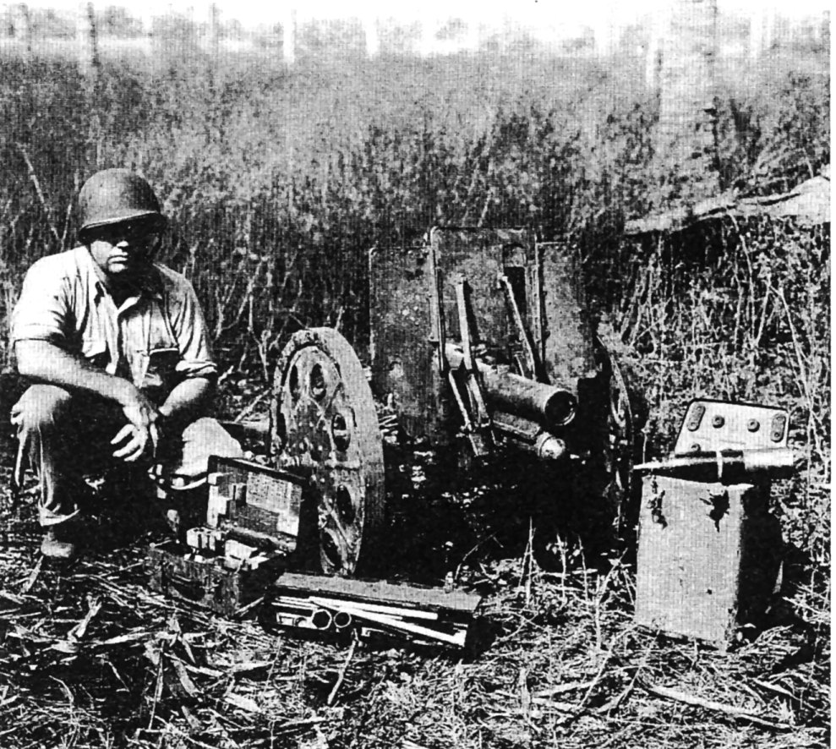
Right: A captured Japanese Model 92 mountain gun. This 70mm light field piece was used throughout the campaign by Japanese troops. It was one of the few pieces of artillery that could be broken down and manpacked. However, even when broken down it proved too much for the Japanese to carry over the terrain of Guadalcanal. The square box with leather handle contains the sight optics for the gun. The oblong metal box contains the tools and cleaning kit, and the upright metal box is the fixed ammunition container. (USMC 51015)

American artillery was accurate and could deliver a high volume of high-angle fire either in the attack or on the defensive. The Japanese on the other hand launched most of their attacks unsupported, taking appalling losses. The M3A1 light tanks (Stuarts) brought ashore by the Marines were utilized effectively. They were light enough to be employed in the jungle clearings and superior to their Japanese counterparts.

Later, when the Army was brought in to reinforce and eventually to relieve the Marines, they also learned valuable lessons in jungle warfare. The fighting endured by the soldiers did not differ greatly from that of the Marines, but in most cases the equipment they carried and used was
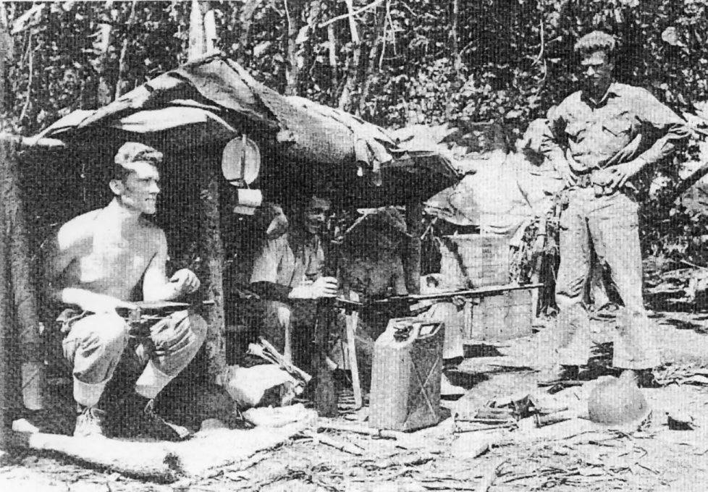
Left: On Guadalcanal, Marines used a variety of weapons. In this picture, two types of the Reising .45-calibre submachinegun are visible. The Marine in the left of the picture is holding the folding stock variant, while the Marine in the centre has the fixed stock. The Reising was not a preferred weapon and was prone to malfunctioning. The third Marine is cleaning a.30-calibre Browning Automatic Rifle (BAR), which was used as the squad automatic rifle and was a reliable, proven weapon. (USMC 51366)

Below: Once ashore on Tulagi the Marines took over abandoned Japanese positions. Here a Marine 75mm Pak howitzer crew occupies a camouflaged Japanese gun position. The 75mm Pak was a light-weight infantry support weapon capable of being emplaced in confined spaces. (USMC 50515)

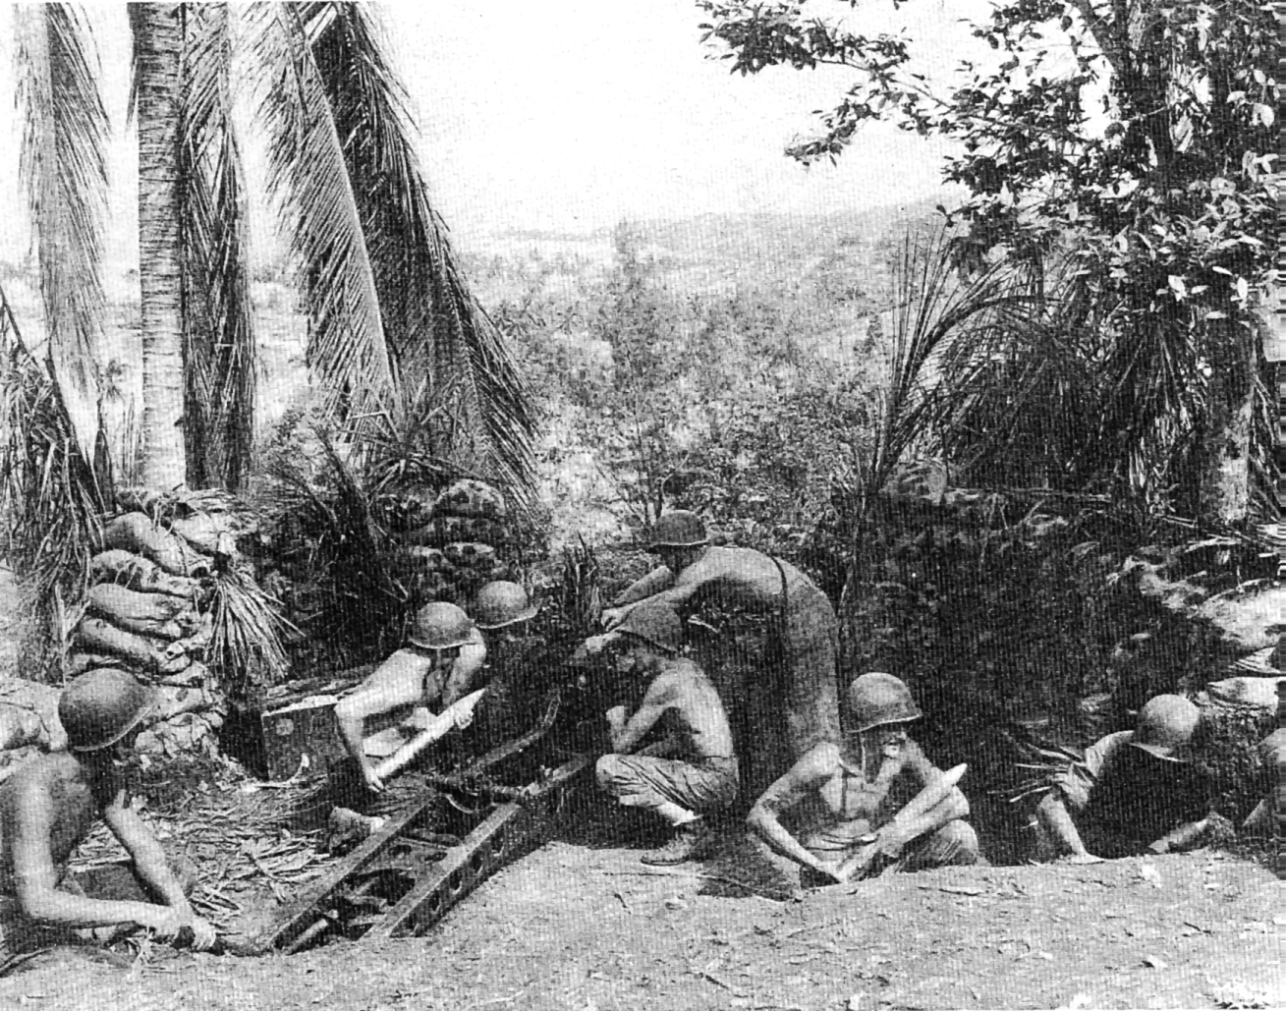
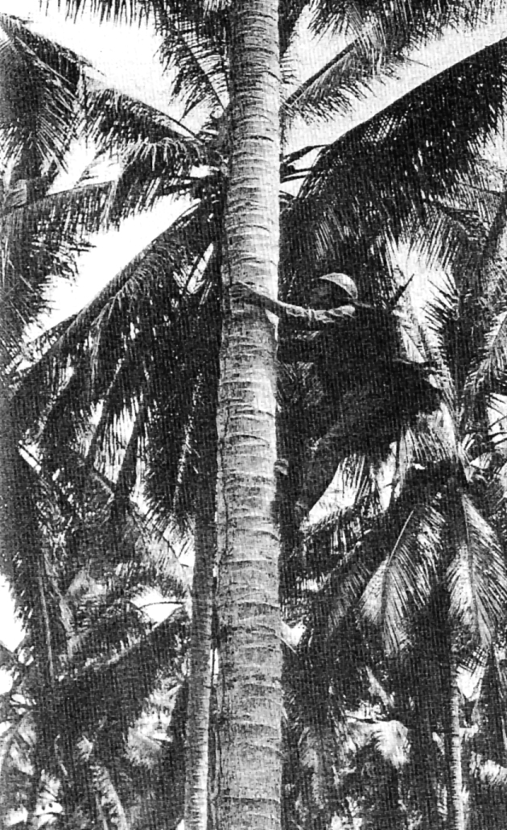
Left: Sergeant Charles C. 'Monk' Arndt dressed in the garb of a Japanese sniper, demonstrates how a sniper would ascend a palm tree on Guadalcanal. To assist his climb, Arndt uses Japanese climbing spikes which tie on to his field shoes and ease the climb. He is also wearing a woven fabric vest designed to blend the wearer into the tree top. Arndt was one of the three survivors of the ill-fated Goettge Patrol of 12-13 August. (USMC-50988)

Below: M3A1 Stuart tanks of the 1st Tank Battalion on patrol, at Kukum Beach. These tanks operated primarily along the coastal plain and performed reconnaissance, screening and defensive roles. The Kukum area was the initial western boundary of the Marine perimeter. In the background are supply ships offloading at Lunga Point. (USMC 53256)

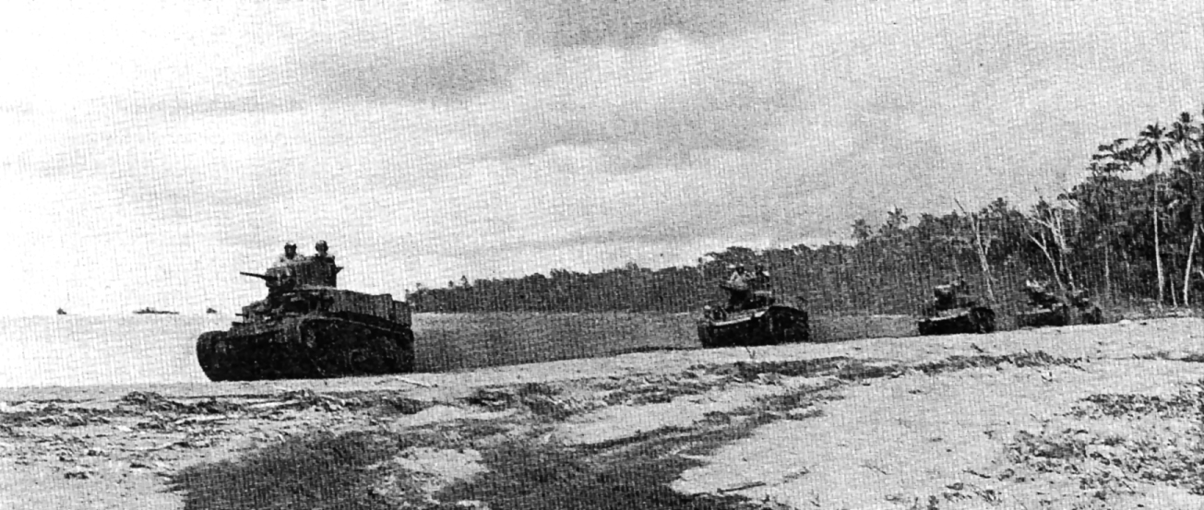
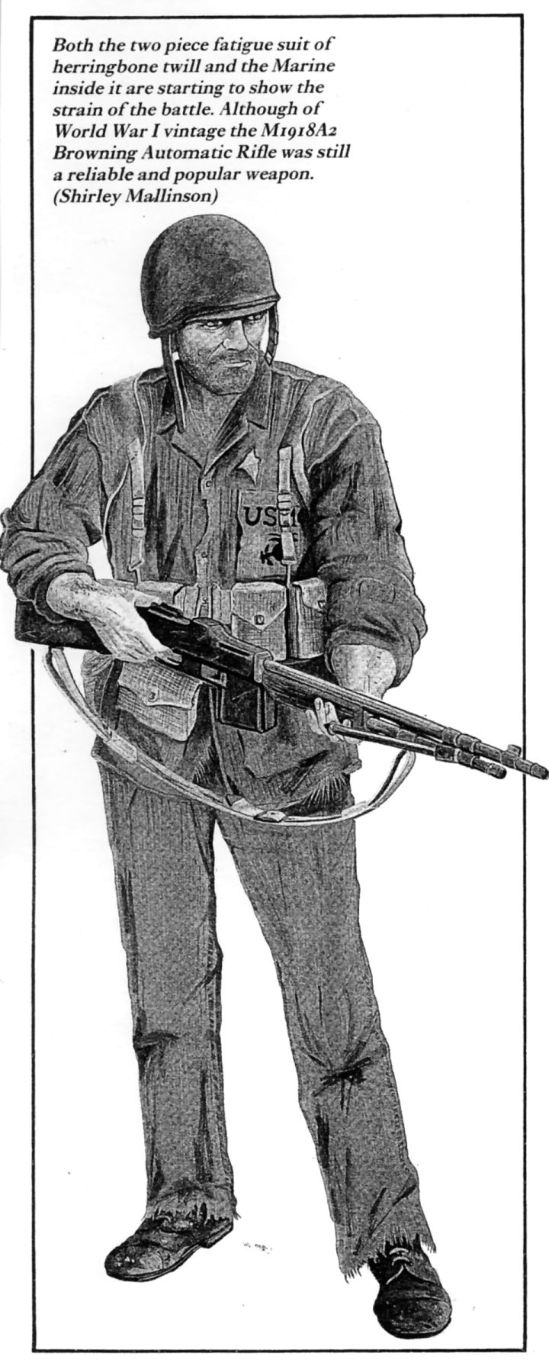
newer and better. And when the Army arrived it came in force. Supply and communications problems were being solved, and the campaign was passing from a defensive into an offensive phase. By this time, the Americans had taken control of both sea and air lanes to the island.

(For purposes of clarifying Marine and Army unit regimental designators for the remainder of the text, Marine regiments are referred to as `Marines' and Army regiments are referred to by branch. Thus the 1st Battalion, 5th Marine Regiment, is listed as the 1st Battalion, 5th Marines. The 1st Battalion, 164th Infantry Regiment, is listed as the 1st Battalion, 164th Infantry.)

The American Navy's entry to the campaign did not start off on a good note. The Battle of Savo Island was the worst naval disaster since Pearl Harbor. Most of the equipment on board the ships was First World War vintage. Radar was virtually new technology and was not effectively exploited.

The Navy learned its lessons in battle, and once an error was made it was seldom repeated. The naval battles fought for control of the waters surrounding Guadalcanal were violent in nature and occurred mostly during the hours of darkness. They were fought by ships ranging in size from PT boats up to battleships. The aircraft carrier, a mainstay for both sides, also played a decisive role in the campaign.

Damage control was another key aspect of the naval war. If a Japanese ship was damaged in a naval engagement it would have to be out of range of American aircraft from Guadalcanal by daylight - if not, it would be sunk by those planes. On the other hand, damaged American ships could be repaired at a series of `local advanced naval bases' and be returned to fight again.

In the air the Americans had an advantage. Aircraft taking off from Guadalcanal could quickly engage the enemy and not use up tremendous quantities of fuel. Damaged aircraft could make emergency landings, and pilots could easily be rescued. The Grumman Wildcat fighter (F4F-4), was the mainstay Navy-Marine fighter for the campaign; although not as agile as the Zero it could out-dive it and absorb more punishment. And what the American pilots lacked in technology they made up for in skill and daring.

THE LANDINGS

Prior to the amphibious assault, very few people in the outside world had ever heard of Guadalcanal. Up to that point in time probably the only person who had mentioned it was Jack London in a turn of the century novel. The only information available was from planters and missionaries who had lived there in the past. Due to time constraints and fear that operational security would be compromised, there was no opportunity for intelligence patrols to conduct a reconnaissance. So, with somewhat sketchy information, the American forces departed for the objective area.

The Solomon Islands are a chain that extend from 163° E 12° S and run in a north-westerly direction to 153° E 5° S. They lie just below New Britain and New Ireland and are directly north and east of the tail of New Guinea. The larger islands of the group form two parallel chains separated by a long enclosed stretch of water that was later nicknamed the `Slot'. Each of the longer islands, of which Guadalcanal is one, has a long axis that lies parallel to the chain as a whole. Several smaller islands and islets abound in the region: Florida, Tulagi, Gavutu and Tanambogo fall into these categories.

Because of their remoteness, there was not a great deal known about the Solomon Islands prior to the amphibious assault. What was known was not encouraging. Guadalcanal seemed a beautiful island from the air, but from the ground it would be difficult to conduct military operations. It is covered by a dense tropical rain forest that carpets the bulk of the island. Not far from the coastal area there are mountains, deep rivers, swamps, heat, humidity, rains and mud - all of which, when combined with the jungle, makes movement difficult. Here too was a breeding ground for various tropical diseases and fungi that would plague the soldiers of both sides.

The island itself is shaped like a rather large kidney bean, roughly sixty miles long by thirty miles wide. It has a large northern coastal plain, on which the Japanese had started their airfield. The coastal plain is covered by stretches of high, tough, razor-sharp kunai grass and is cut by many rivers that had no names or bridges across them. They generally ran from south to north stopping at the coast where their mouths were usually blocked by sand, forming stagnant pools. It was in this tropical wilderness, with its strange smells and animal sounds, that one of the major battles of the Pacific would take place.

It was still dark (0400) on 7 August 1942 when the amphibious task force silently separated into two groups as it approached Savo Island. The Transport Division (TRANSDIV) was divided into two groups, X-RAY Guadalcanal and Y-OKE (Tulagi). The regiments of the 1st Marine Division consisted of two groups:

• The 5th Marines (Reinforced) less its 2nd Battalion, under the command of Colonel Leroy P. Hunt, was designated Combat Group A.
• Combat Group B was made up of the 1st Marines (Reinforced) under Colonel Clifton B. Cates.

These two combat groups, under Major General Alexander A. Vandegrift, the Division Commander, were to land on Guadalcanal, while smaller, more specialized groups of Y-OKE were organized to assault Florida, Tulagi, Gavutu and Tanambogo:

• The 1st Battalion, Second Marines, under Major Robert E. Hill, made up the Florida group.
• The Tulagi group was under Colonel Merritt A. Edson of the 1st Raider Battalion and included the 2nd Battalion, Fifth Marines, under Lieutenant Colonel Harold E. Rosecrans, and the 3rd Defense
Battalion under Colonel Robert Pepper.
• The Gavutu and Tanambogo group were under Major Robert H. Williams of the lst Parachute
Battalion.

These smaller groups were under the command of Brigadier General William H. Rupertus, the Assistant Division Commander.

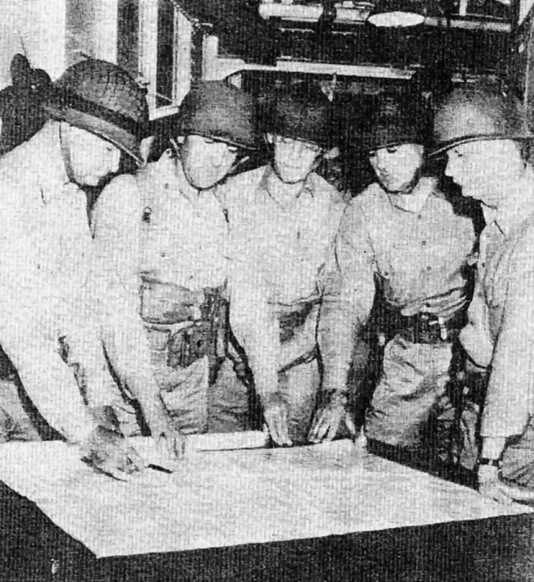
Left: A posed picture taken on 7 August showing. General Vandegrift discussing invasion plans with his staff Clockwise from the left arc General Vandegrift, Commanding General; Lieutenant Colonel Thomas, Operations Officer; Lieutenant Colonel Pate, Logistics Officer; Lieutenant Colonel Goettge, Intelligence Officer; and Colonel James, Chief of Staff (National Archives)

Both groups were task organized for the invasion: that is to say the 1st Marine Division had been reduced to a two-regiment division. The third regiment (7th Marines) had been detached for duty in British Samoa. (In reality, this was not the case and the division was actually far stronger than implied.) The 2nd Marines, who were normally part of the 2nd Marine Division, were added as were specialized units such as the 3rd Defense Battalion, the 1st Raider Battalion and the 1st Parachute Battalion. The division support group under Colonel Pedro A. Del Valle of the 11th Marines completed 'the force. A total of 1,959 officers and 18,146 enlisted Marines and Navy Corpsmen comprised- the amphibious landing force on 7 August 1942.

Prior to their arrival in the area, the task force had conducted an amphibious rehearsal at Koro, in a remote portion of the Fiji Islands. The rehearsal, conducted in high surf conditions on beaches obstructed by coral reefs, was a disaster and was aborted to avoid injury to the personnel and damage to the precious landing craft. The planners who observed the rehearsal hoped that it would not be indicative of the upcoming landing!

The American amphibious forces were embarked on nineteen transports and four destroyer/ transports. There were five cargo ships, eight cruisers, fourteen destroyers and five minesweepers. The accompanying carrier support group consisted of three carrier battle groups, Saratoga, Enterprise and Wasp. One battleship, North Carolina, and a force of cruisers and destroyers screened the battle groups. This force stayed to the south of Guadalcanal while the amphibious force sailed north, dividing in two when they approached Savo Island.

The movement to the amphibious objective area was shielded from the Japanese on Guadalcanal by one of the many tropical rain storms that frequent the region. Once the two groups separated they proceeded to their assigned beaches. After arriving on station, naval gunfire and carrier aircraft began to bombard their respective targets in accordance with the landing plan. The pattern of future campaigns in the Pacific was about to be demonstrated on the beaches of Tulagi and Guadalcanal.

Tulagi

The plan for the conquest of Tulagi was somewhat complicated. The Marine planners felt that in before Tulagi could be taken, certain key terrain features on nearby Florida Island would have to be captured.

At 0740 on 7 August 1942, 20 minutes before H-Hour, the first amphibious landing operation in the Solomon Islands was undertaken. It was made near the village of Haleta on Florida Island to secure a promontory that overlooked Beach Blue, the Tulagi invasion beach. The unit selected for the landing was reinforced Company B of the 1st Battalion, 2nd Marines, 2nd Marine Division, commanded by Captain Edgar J. Crane. The landing was unopposed and the western flank was secured quickly. An unopposed landing was also made by the remainder of the Ist Battalion, 2nd Marines, which landed at 0845 at Halavo on Florida Island to secure the eastern flank of the Gavutu landing.

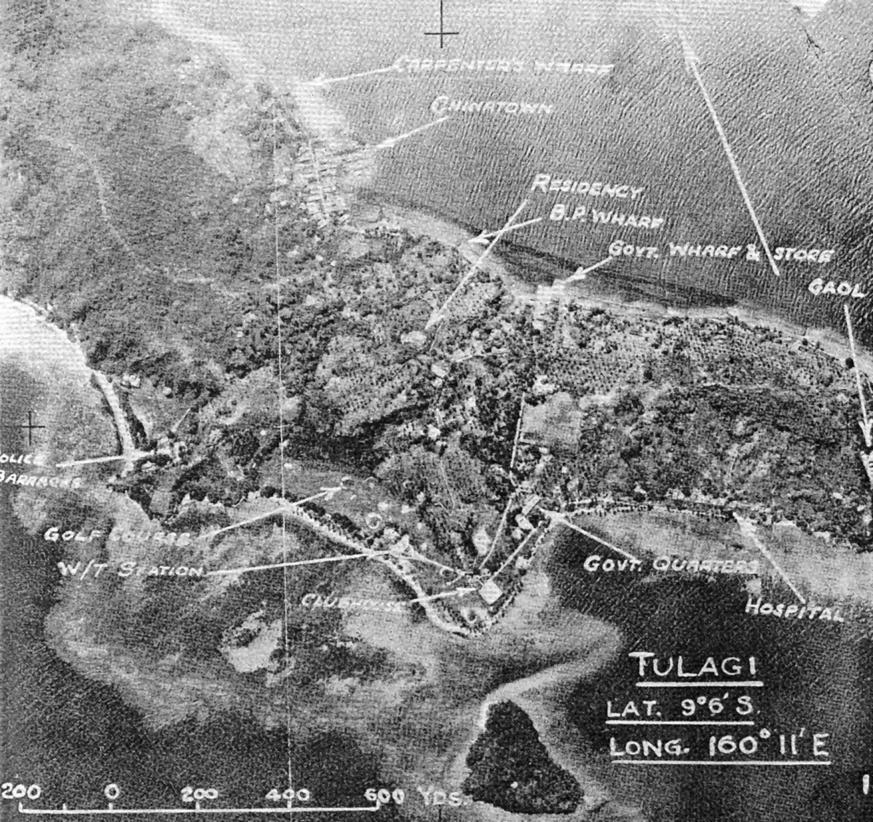
Tulagi was attacked at 0800, according to schedule. The first to see action were the Marines of the 1st Raider Battalion, commanded by Colonel Merrit A. Edson, and they were followed by the 2nd Battalion, 5th Marines. As the landing craft approached Beach Blue, they ground to a halt on coral formations ranging from 30 to 100 yards out from the beach. The assault waves then began to make their way into the beach through water ranging from waist to armpit level. Upon reaching the shore, the Raiders and the 2nd Battalion, 5th Marines, began to make their way inland, the

Left: The landing on Tulagi was made on the beach just south of the golf course by Marines of the 1st Raider Battalion, followed by the 2nd Battalion, 5th Marines. The Raiders then moved west and the 5th Marines moved east to capture the island. The date of the photograph (17.5.42) indicates iris an early intelligence photo and was undoubtedly one used to plan the assault. (USMC)

Raiders moving east and the 2nd Battalion, 5th Marines, moving north-west. Japanese resistance was encountered almost immediately by the Raiders but was systematically overcome. The advance continued slowly until dusk, when they consolidated and dug in for the night. This first night on Tulagi was to be indicative of many future nights in the Pacific: four separate attacks were launched by the Japanese to dislodge the Raiders from their positions; each attack was beaten back.
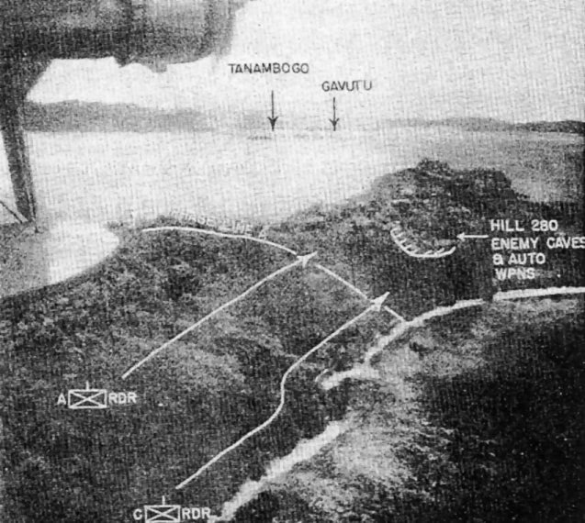
Above: The advance west along Japanese from the island. Tulagi was made during The fighting around Hill the morning of 7 August 280 with its cave complex by the Raiders. By 1120 was the most intense in they had advanced as far the entire battle. (USMC)

The next day, the Marines resumed the offensive and encountered a stiff pocket of resistance in a deep man-made cut that ran northsouth in the north-eastern portion of the island. The Japanese, taking advantage of the cut, 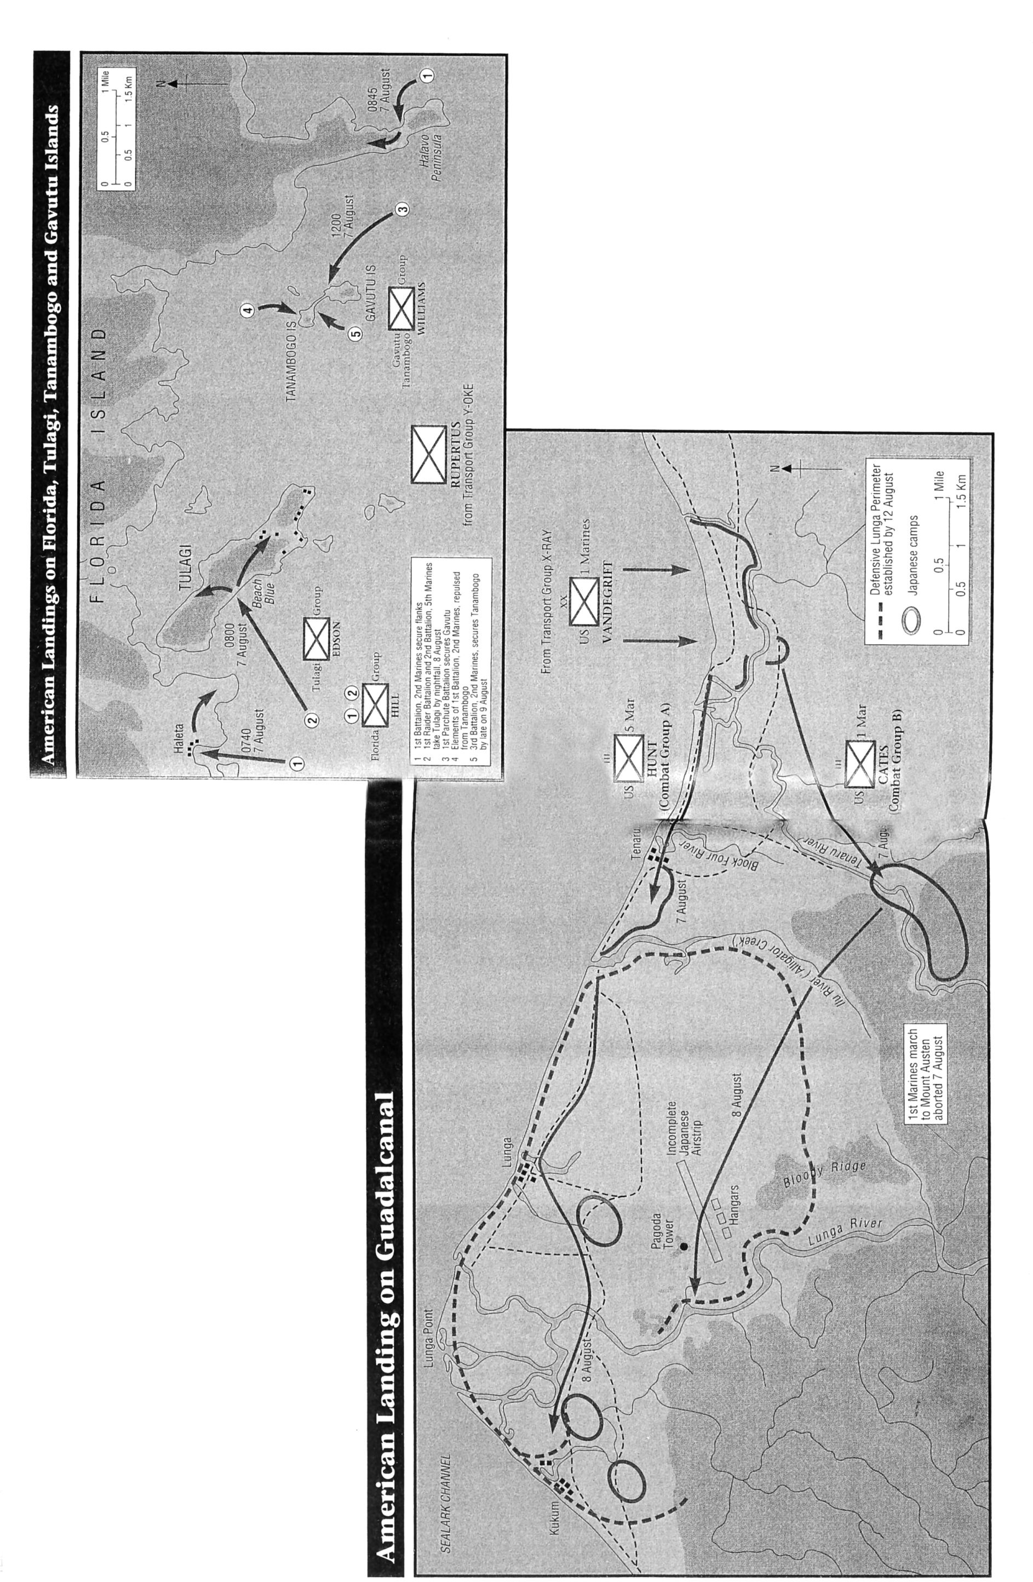
dug positions into its base, from where they could bring fire to bear on the Raiders. Bringing up reinforcements, the Raiders isolated the enemy position on three sides; then, using improvised TNT-gasoline explosives, they systematically cleared this troublesome terrain feature and by the evening of the second day had eliminated effective Japanese resistance. For several days afterwards, isolated individuals and groups of Japanese continued to resist, but by nightfall on 8 August 1942, Tulagi was in Marine hands.

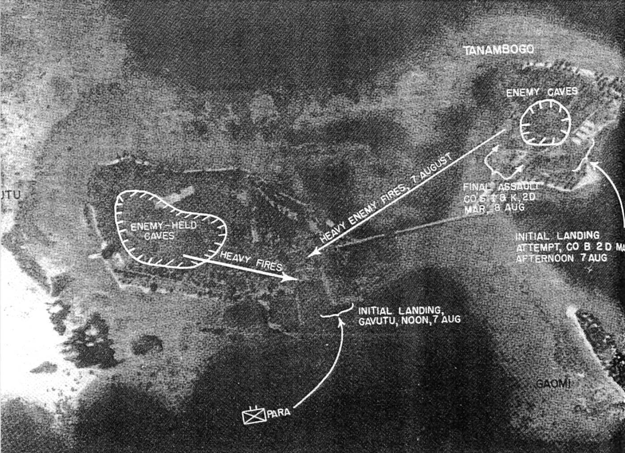
Above: The fighting on Gavum and Tanambogo was fierce. This photograph shows the landing site of the Parachute Battalion and the locations from which they received heavy Japanese fire. Also shown are the landing sites of the companies from the 2nd Marine Division who attacked Tanambogo. (USMC)

Gavutu and Tanambogo

These two small islets, each with prominent hills and connected by a causeway, were to be seized by two companies of the 1st Parachute Battalion led by Major Robert H. Williams. A third company would be held in reserve support for the assault companies. Gavutu, the higher in elevation of the two islands, was to be taken first.

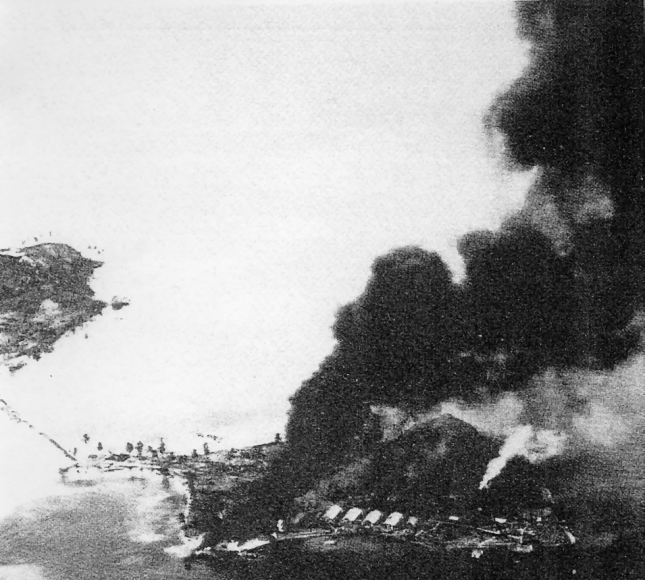
Left: Smoke rises from the gasoline supply dump on Tanambogo. It was struck by a shell from a naval gunfire ship supporting the landing on the night of 7August. The photograph was taken the next day and shows the initial landing beach just to the right of the base of the column of smoke, and the final assault position located to the left and rear of the column. (USMC)

The amphibious assault was to take place at H-Hour + 4 (1200) on 7 August. The plan called for a landing on the north-east coast. The naval gunfire support for the Gavutu amphibious assault was so effective, however, that it actually began to work against the Marines: so complete was the destruction that the original landing site, a concrete seaplane ramp, was reduced to rubble. The landing craft were forced to divert farther north to land the Parachutists and in so doing were exposed to flanking fire from Tanambogo. Despite heavy casualties, the Parachutists took the north-eastern portion of the island and its dominating hill, but to secure Gavutu, Tanambogo would have to be taken to stop its flanking fire, which was delaying the operation. Reinforcements were requested to undertake this phase of the operation.

Not being informed as to the number of reinforcements needed for Tanambogo, and with the bulk of his forces tied up on Tulagi, General Rupertus attached Company B, 1st Battalion, 2nd Marines, to the Parachutists. The Company reported to the Parachutists at 1800 and was informed that only a small Japanese force was on Tanambogo. It was felt that a night landing could be made and the Japanese quickly routed. The night amphibious assault was undertaken by Company B, minus one platoon, which did not take part as its landing craft had become stuck on the coral coming to Gavutu. The first boat came ashore without incident. As the second boat ground to a halt on the landing beach, a shell from a naval gunfire ship struck a nearby Japanese gasoline storage area, the explosion and resulting glare exposing the assaulting Marines. The ensuing battle was a nightmare. Unable to be reinforced, the attacking Marines were forced to withdraw under the most haphazardous conditions, the last making it back to Gavutu by 2200. Throughout the night, groups of Japanese counterattacked on Gavutu but were quickly repulsed.

On 8 August, the 3rd Battalion, 2nd Marines, was ordered to - reinforce the parachutists on
Gavutu and then attack Tanambogo. Supported by tanks from the 2nd Tank Battalion and with air and naval gunfire support, the 3rd Battalion, 2nd Marines made an amphibious landing at 1620 on 8 August 1942 on Tanambogo. Once a beachhead was established, reinforcements crossed the causeway, and by 2300, two-thirds of the island was secured. After a lot of fighting during the night, the island was completely secured by late on 9th.

Once Tanambogo fell, organized resistance in the Tulagi, Gavutu, Tanambogo and Florida Islands ceased. In all, the operation had taken three days. American losses overall were light, and the Japanese lost 1,500 troops. Only a handful of prisoners were taken.

Guadalcanal

On Guadalcanal an unopposed landing was made at Beach Red, about 6,000 yards east of Lunga Point. It was spearheaded by the 5th Marines, followed by the 1st Marines, and by 0930 the assault forces were ashore and moving inland. Their plan was simple: the 5th Marines would proceed along the coast, securing that flank, while the 1st Marines would move inland through the jungle and secure Mount Austen, described as a grassy knoll and reportedly only a short distance away. Now came the realization that intelligence concerning the terrain on Guadalcanal was faulty - Mount Austen was by no means a short way off, nor was it the grassy knoll as described. It was in fact the most prominent terrain feature in the area, more than four miles away and well outside the planned perimeter. It was not be captured until months later.

The remainder of the first day was spent consolidating positions and attempting to disperse the supplies that were stockpiling on the beach. Meanwhile the strongest Japanese countermeasure came at 1400 in the form of an air raid by eighteen twin-engined 'Type 97 bombers, two of which were shot down. A second wave of Type 99 Aichi bombers that came later was also repulsed with the loss of two aircraft; the cost to the Americans was a bomb hit on the destroyer Mugford.

At 2200, General Vandegrift issued the attack order for the next day. With Mount Austen out of
reach and only 10,000 Marines ashore, he ordered the airfield to be taken and a defensive perimeter set up. The beachhead would be held temporarily to protect the off-loaded supplies until they could be moved into the perimeter. The next day, 8 August, therefore began with a westward advance by all Marine forces on Guadalcanal. The original objectives out of necessity had been changed, but the airfield remained the primary objective.

Contact with small groups of Japanese began to occur as the Marines closed on the airfield. In the Lunga region, just south of the airfield, defensive positions consisting of trenches and antiaircraft emplacements, well built and equipped, were discovered deserted. The airfield, nearly 3,600 feet long and in its last stages of construction, was defended by a small group of Japanese who were attacked and killed. The hangers,
revetments and machine shops were all captured intact. Two large camps each with radio stations and other technical equipment were also captured.

By the end of the day, the airfield had been taken and a defensive perimeter established. As the Marines took over the Japanese camps in the area they came across large quantities of food, ammunition, weapons, trucks and other equipment(some of which, unfortunately, was destroyed by improperly indoctrinated Marines). Except for some token resistance by Japanese stragglers, air action constituted the only major threat.

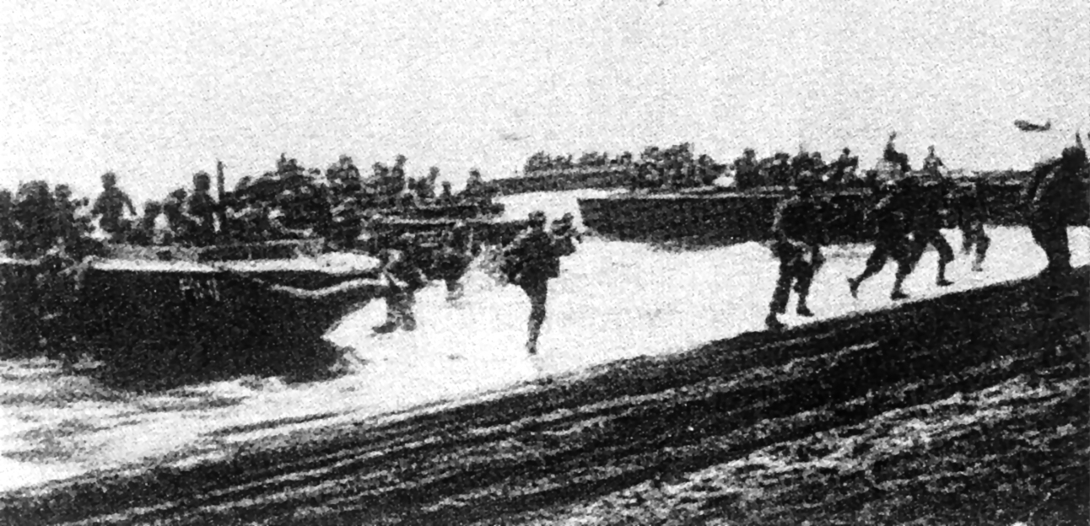Above: Beach Red, which was about 6,000 yards east of Lunga Point, was the selected landing beach for Guadalcanal. Expecting to land under heavy fire, the Marines were relieved that the landing was unopposed. These Marines coming ashore are part of the initial waves. After crossing the beach, they moved inland to establish a beachhead. (National Achieves)

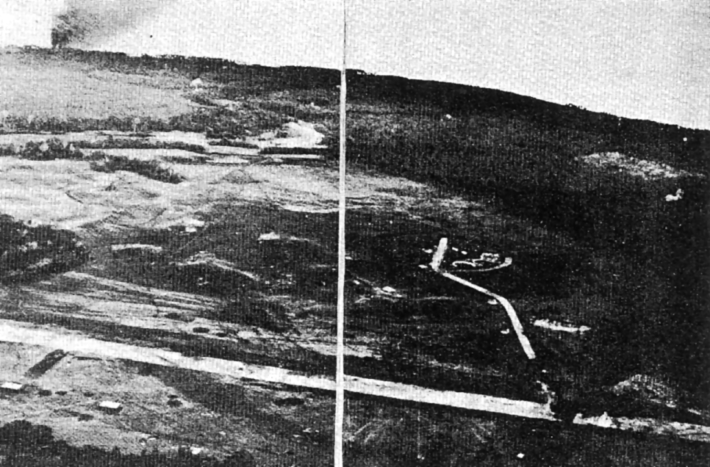
Left: The Japanese airfield on the morning of 7 August shows clearly how close the airfield was to completion. Hangers are seen in the left foreground, and the taxi way is clearly depicted. Smoke is billowing from a gasoline blaze set by off by Fire from an American destroyer, seen to left of the column of smoke.
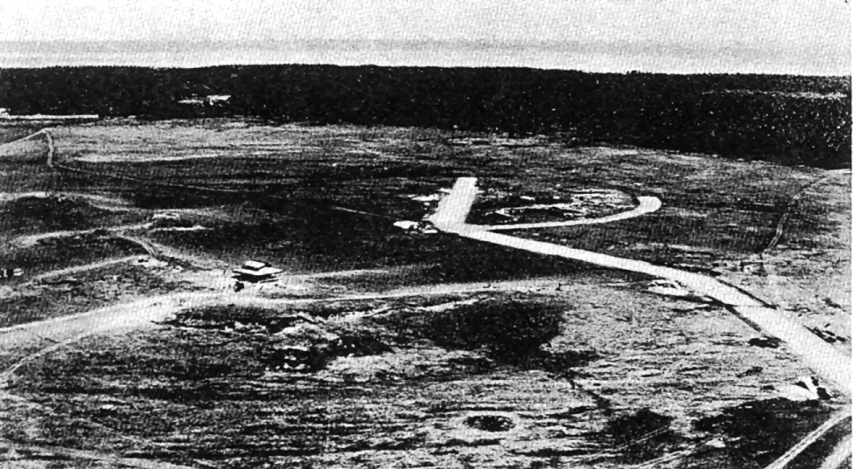Above: Taxi-way to main runway is clearly defined, as are circular plane revetments. The structure to left is the pagoda type control tower that was set up by the Japanese to control airfield operations. The preparations made on the ground are clearly indicative of how far the Japanese had progressed to complete the airfield. (USMC)

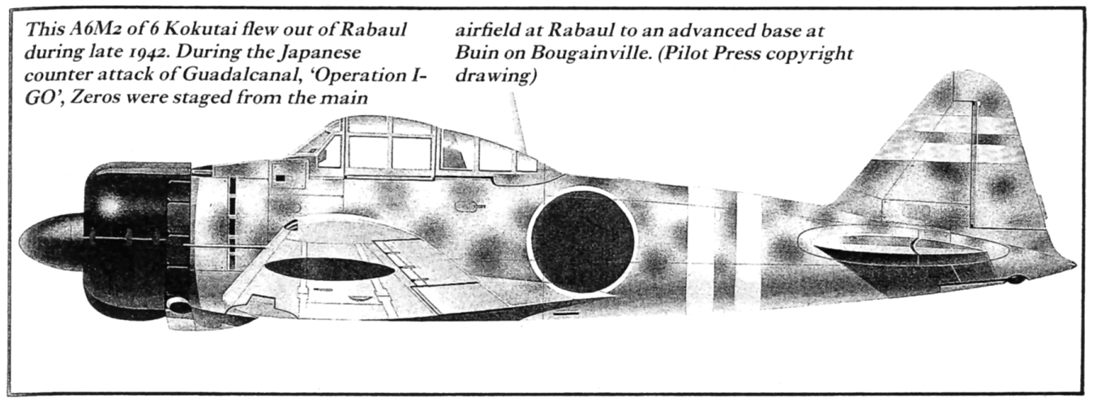

Originally it was thought that the Japanese were taken by surprise. Intelligence sources later revealed that the Japanese had been aware of the impending American assault but had thought it was only to be a raid. The Japanese higher command therefore had instructed the Japanese troops in the area to withdraw into the hills until the Americans departed.

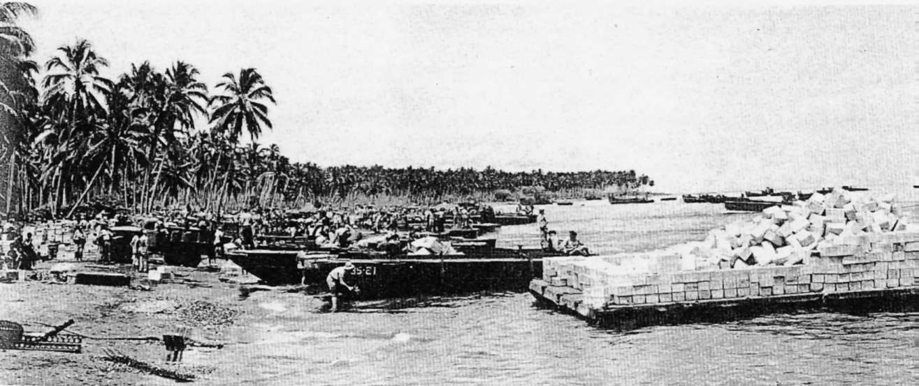Above: After the assault troops had moved inland, Beach Red became somewhat chaotic. Not enough manpower was allocated to move the masses of supplies from the landing craft to the beach, and there was not enough motor transport to move supplies from the beach to the dumps. By the end of the First day the unloading of supplies had to be suspended, as there was no place on the beach to put them. The congestion depicted here is indicative of the problems experienced. (USMC 52193B)

A report from a Coastwatcher, Cecil J. Mason, on Bougainville, warned of a large group of Japanese aircraft heading toward Guadalcanal. This early warning message and many others that would follow from other Coastwatcher stations throughout the Solomon Islands would save many American lives throughout the campaign. (The Coastwatcher organization was started by Commander Eric Feldt of the Royal Australian Navy, the purpose being to report on Japanese activities in the Solomon Islands. The group was carefully recruited from local inhabitants of the area. The intelligence gathered by these individuals was passed back to the Coastwatcher HQ in Townesville, Australia, for processing and dissemination.) About an hour after Mason's message was received, forty twin-engined Japanese torpedo planes appeared, to find the amphibious task force alerted and manoeuvring at high speed.

So far the Japanese resistance had been less than effective. In the air, attacks were repulsed with minimum damage to the Americans. However, the Japanese had no intention of giving up the Solomon Islands without a fight.

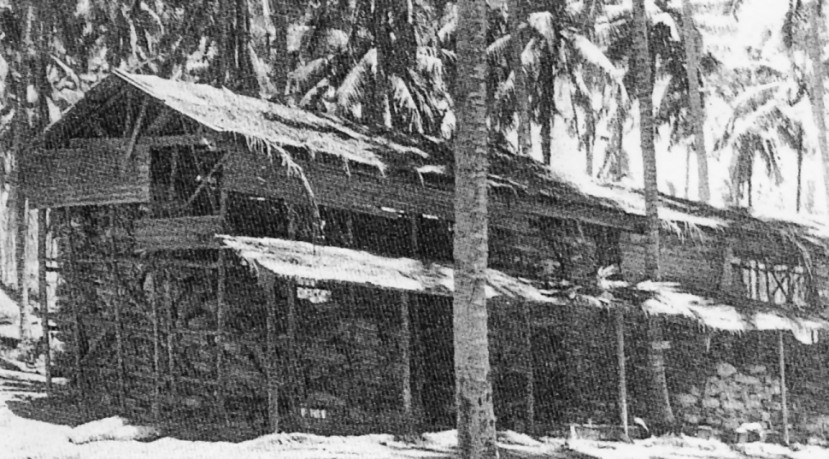
Left: As the Marines moved through the Lunga area south of the airfield they captured vast stocks of Japanese equipment and foodstuffs. This particular building, which housed a vast quantity of rice, was captured in the first few days. Note the palm frond camouflage hastily applied to the roof by the Japanese. (USMC 53436)

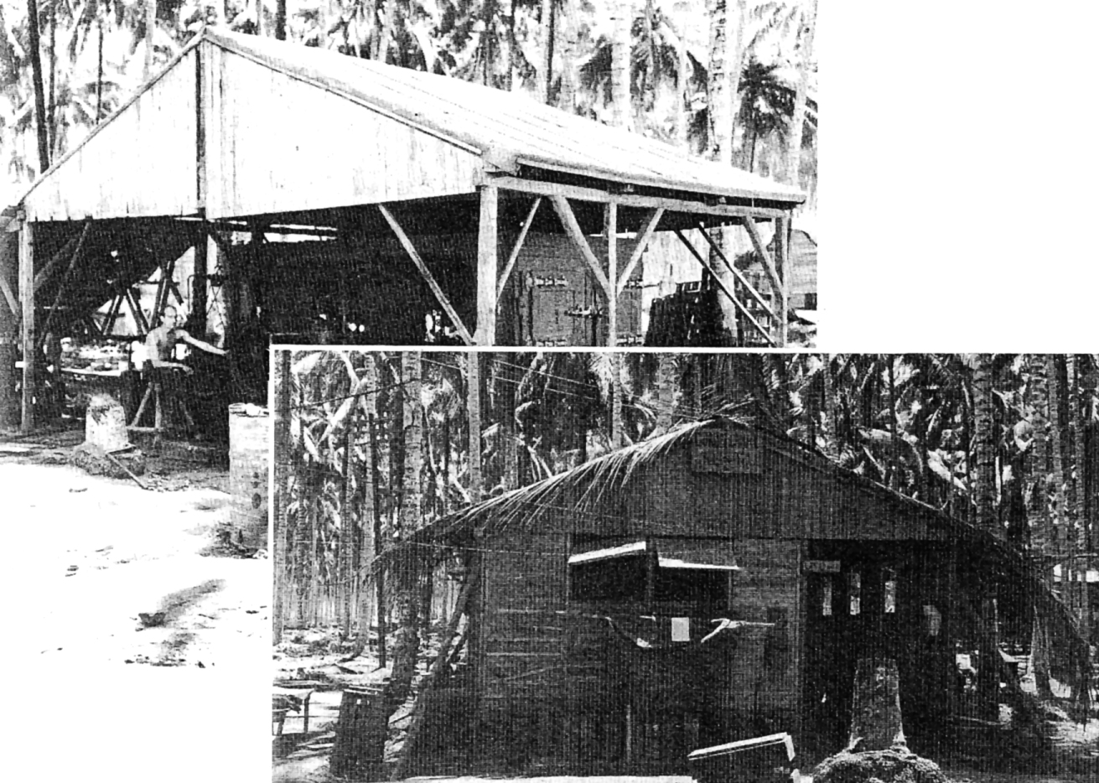Top Left: Some captured buildings were immediately converted for effective use. This particular one houses the 1st Marine Division switchboard and has been named the Guadalcanal Telephone and Telegraph. The smaller sign over the door says USO Club and was typical of Marine humour throughout the campaign. (USMC 61556)

Bottom Right: TheJapanese ice plant, which was initially vandalized by Marines and later repaired. The plant was the only steady source of ice for the Marines throughout the campaign. Luxuries such as this were few and far between on Guadalcanal and demonstrated the primitive conditions encountered. (USMC 50493)

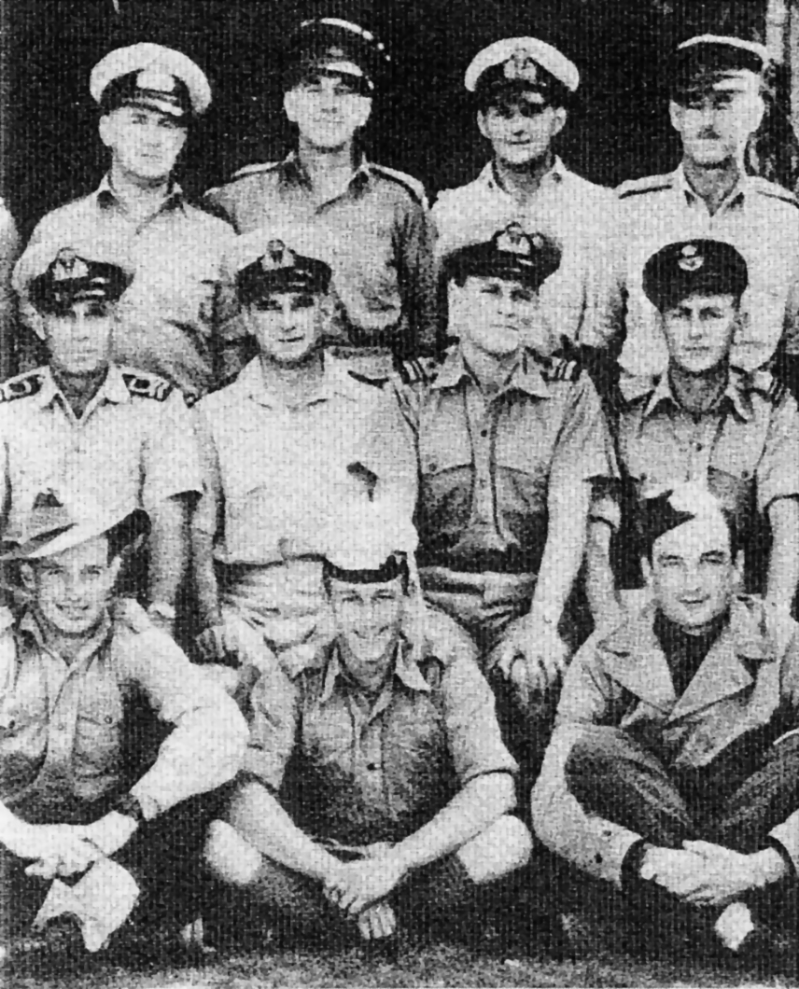
Left: The Coastwatchers were an organization set up by Lieutenant Commander Eric Feld t (middle row, second from left). Their mission was to gather intelligence in the Solomon Islands and forward it on via radio communications to the Townesville, Australia, headquarters.

Below: Japanese captured on Guadalcanal were a valuable source of information for the Marines. Once captured, prisoners were usually cooperative. In this picture, a daily roll call is taken. The Japanese soldier to the right of the Marine in the picture is the translator. (USMC51430)



