http://linz.orf.at/orf/gusen/dok/B8/B8001x.htm

KZ GUSEN MEMORIAL COMMITTEE

within ARBEITSKREIS FUER HEIMAT-, DENKMAL- UND GESCHICHTSPFLEGE
and Local-International Platform ST. GEORGEN/GUSEN, Austria

KZ Mauthausen-GUSEN Info-Pages

B8 BERGKRISTALL - ESCHE II
Underground Plant

Introduction

Location: A-4222 Sankt Georgen an der Gusen, Austria
Production Area: 50.000 m2 (bomb-proof & gas-tight)
Slave-Workers: 10.000 Production "Bergkristall-Fertigung" (code-name: ESCHE 2)
6.500 Construction "Bergkristall-Bau"
Purpose: Me 262 jet propelled plane (fuselage- and final assembly)
Construction start: 9 March 1944 (foundation of KL Gusen II concentration camp)
Concentration-Camp: KL Gusen II of Mauthausen-Gusen complex
(most evil satellite)
Number of Victims: 8.000 to 20.000 prisoners of Mauthausen-Gusen complex
Related Monument: Memorial Crematorium KZ Gusen (40.000 victims)
Liberation: May 1945 (S/Sgt. Al Kosiek & 23 men of 1st Platoon Troop D,
41st Cav Recon Sqdrn, 11th ArdDiv, 3rd US-Army

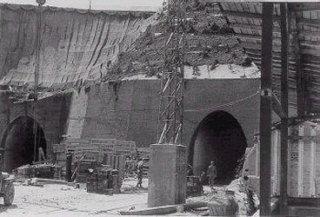
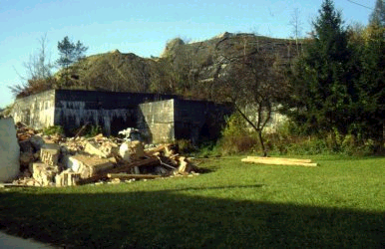

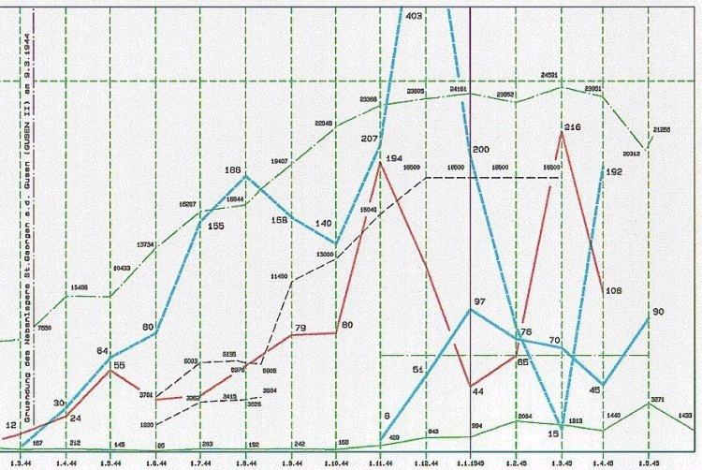
With more than 50.000 m2 (some 10 km tunnnel length) one of the biggest german underground installations that reached production status in late 1944. According to Allied intelligence reports, it was "one of the most modern and most complete underground plants in Germany".
Constructed within 13 months by prisoners of the KL Gusen II concentration camp within the Mauthausen-Gusen complex due to its high mortality (up to 98%), it became one of the most horrible concentration camp sites in European history (average survival period 4 months).
Main deportations came form KL Auschwitz B and western Europe (France, Italy, Belgium, Luxembourg) when Nazi-troops had to move out this countries due to military pressure of the Allied Forces
A vast number of the Jewish man were exterminated by hardest labor at the tunnel construction site.
With Winter 1944/45 more deportations came in than lives were consumed, by construction and production. So, many died in unopend railway cars at the local station, froze to death or were killed by the many other cruelties of the KL Gusen II "extermination" camp.
One of the many unknown victims of the KL Gusen II - BERGKRISTALL plant had been the young french youth activist Marcel Callo. He became beatified by Pope John Paul II. in 1987.
According to Allied Intelligence, some 987 jet propelled planes left serial production lines. Construction of tunnel-system was nearly finished and installations operational for some 85%.

Production started in parallel to construction of the tunnel-system in Summer 1944 and reached maximum in April 1945 (some 90 jet-plane fuselages, fully equipped per month).
Original planned production capacity should have been 1.250 jet-planes per month until the year 1955.
Fuselages and wings were brought by railway cars during the night from BERGKRISTALL to several locations in southern Germany and Bohemia where the turbines had been fixed and the jets became operational.
Secrecy was extremely high: The test-pilots didn't know where the planes came from. German civilians being employed at BERGKRISTALL were not allowed to give the name of town where they did work to any third persons.
With the end of the war plans and preparations were made to blast-off this top secret installation along with the slave-workers, the local population and the other eye-witnesses to prevent knowhow-transfer to allied forces and to kill potential prosecutors for later Mauthausen-Gusen trials.
This plan was not carried out due to the unclear situation in early May 1945. Vice-major Aschenbrenner of St. Georgen/Gusen and the Swiss Red-Cross delegate Louis Haefliger played key roles in an attempt to prevent this tragedy. The installations of strategic importance were later on investigated and partly dismantled by US troops.
With August 1945 BERGKRISTALL was handed over to the Soviets. The Soviets dismantled all of the residual installations and finally destroyed the key-parts of this strategic tunnel-system in November 1947.
After this, BERGKRISTALL and KL Gusen complex became totally forgotten and never appeared in any scientific- or research thesis.

In the vicinity of BERGKRISTALL there still exist the ruins of one further, but smaller underground installation with the code-name KELLERBAU (just 12.000 m2). KELLERBAU was used to house some key production facilities for the production of machine guns for Steyr-Daimler-Puch.
That means; in addition to the 16.000 prisoners of BERGKRISTALL, some further 8.500 prisoners and some 4.000 prisoners had to work and die in Gusen for this small-arms plant and the stone-quarries owned by the "Deutsche Erd- und Steinwerke GmbH (DEST)", a company of the SS that had its "Austrian" office at St. Georgen/Gusen.
Back to KZ Gusen II
Back to Index
For additional information, comments or suggestions, please contact:
ARBEITSKREIS FUER HEIMAT DENKMAL- UND GESCHICHTSPFLEGE

Most recent updates of this page were made on
2002-01-18 by Rudolf A. HAUNSCHMIED,
Martha Gammer, Siegi Witzany-Durda and
Jan-Ruth Mills with her students in US-Alabama

