Retreat Faculty Input for ChE Department Goals
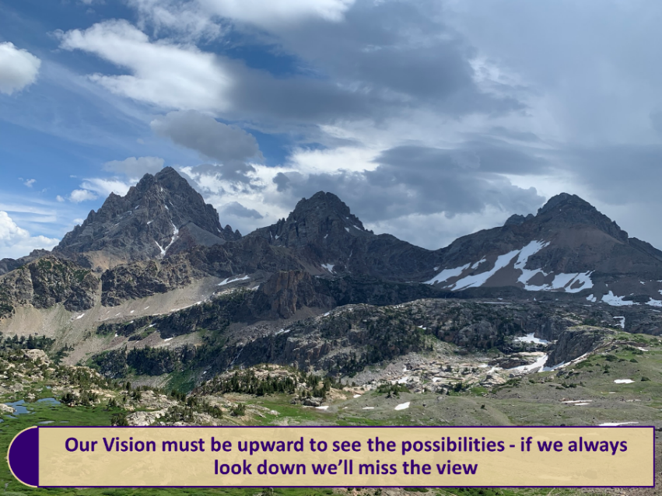
Joseph D. Smith, 18 Aug 19

Climbing the Mountain- where is our department going?
To get to the summit, a hiker needs a clear map showing the path to take to the top. I asked the faculty the following question: “What actions can we take over the next year that will put us on a trajectory leading to the summit? The faculty was split into two groups and discussed our vision of “where we will be in a year from now”. Results from each group are listed below. We will use this information to form our department goals.
Group 1:
- Successful department chair search will be completed!
Each faculty will proactively nominate potential candidates. Each faculty will participate by presenting optimistic, positive view of department and will follow-up with candidates as appropriate.
- Increase our research expenditures by 25%
The college goal is $200,000 per faculty per year which is the “summit” so 25% increase by next year is on this path.
- Increase faculty presence and recognition
Faculty will Increase proposal submissions, form collaborative proposals, form industrial partnerships, attend key workshops, identify and pursue new hot topics.
- Increase outreach to multiple audiences
Need to expand this…which audiences, how to reach, what activities can we do?
- Successfully prepare for and complete our ABET accreditation
Gather/submit required course data to department/college ABET lead.
Group 2:
- Enhance quality of undergraduate education
Increase presentations by faculty to undergrads about their research activities and by undergrads to faculty about their undergrad research experience and use these in UG courses
- Establish a UO laboratory committee
Review all UO lab experiments and develop a realistic upgrade plan for each.
- Expand quality of undergrad experiments
Identify and work with company sponsor for each experiment
- Expand online course offerings
Follow Dr. Luks’ example with her courses and put more on YouTube for student’s use
- Establish BioChemE program at UMSL
Follow-up with UMSL and execute plan
- Actively participate in NIMBL and RAPID research centers to expand and nurture industry contacts
Join Rapid, attend workshops at annual meeting, submit collaborative proposals
- Find new chair
Faculty identify candidates to selective approach and actively participate in recruitment process

