CE 120 – BEAM DEFLECTION

Section (circle): | A B C D E F G H I J K | Date:
Group (circle): | 1 2 3 4 5 6 7 8 9 10 11 12 13 14 15
Data Recorder:

Simply Supported Beam

L: | 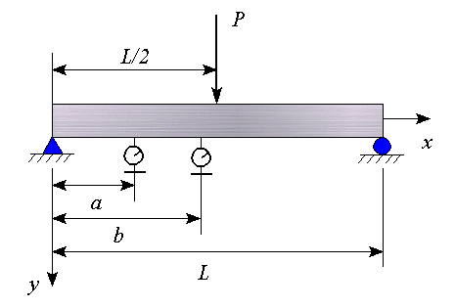
a:
b:
width:
thickness:

material: | aluminum
E: | 10.6 Msi

Load  (lb) |  | Deflection at “a”  (in) |  | Deflection at “b”  (in)

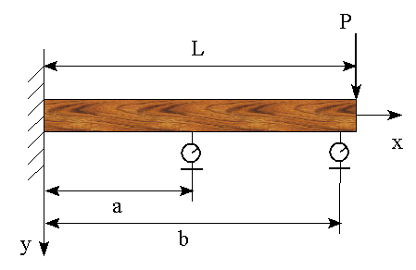
Cantilever Beam

L:
a:
b:
width:
thickness:

material:

material | modulus of  elasticity (Msi)
cedar | 1.1
pine | 1.5
oak | 1.5
poplar | 1.6
red oak | 1.8
douglas fir | 1.8
if not specified | 0.9 to 1.8

Load  (lb) |  | Deflection at “a”  (in) |  | Deflection at “b”  (in)

