Mechanical Failure Mode Taxonomy
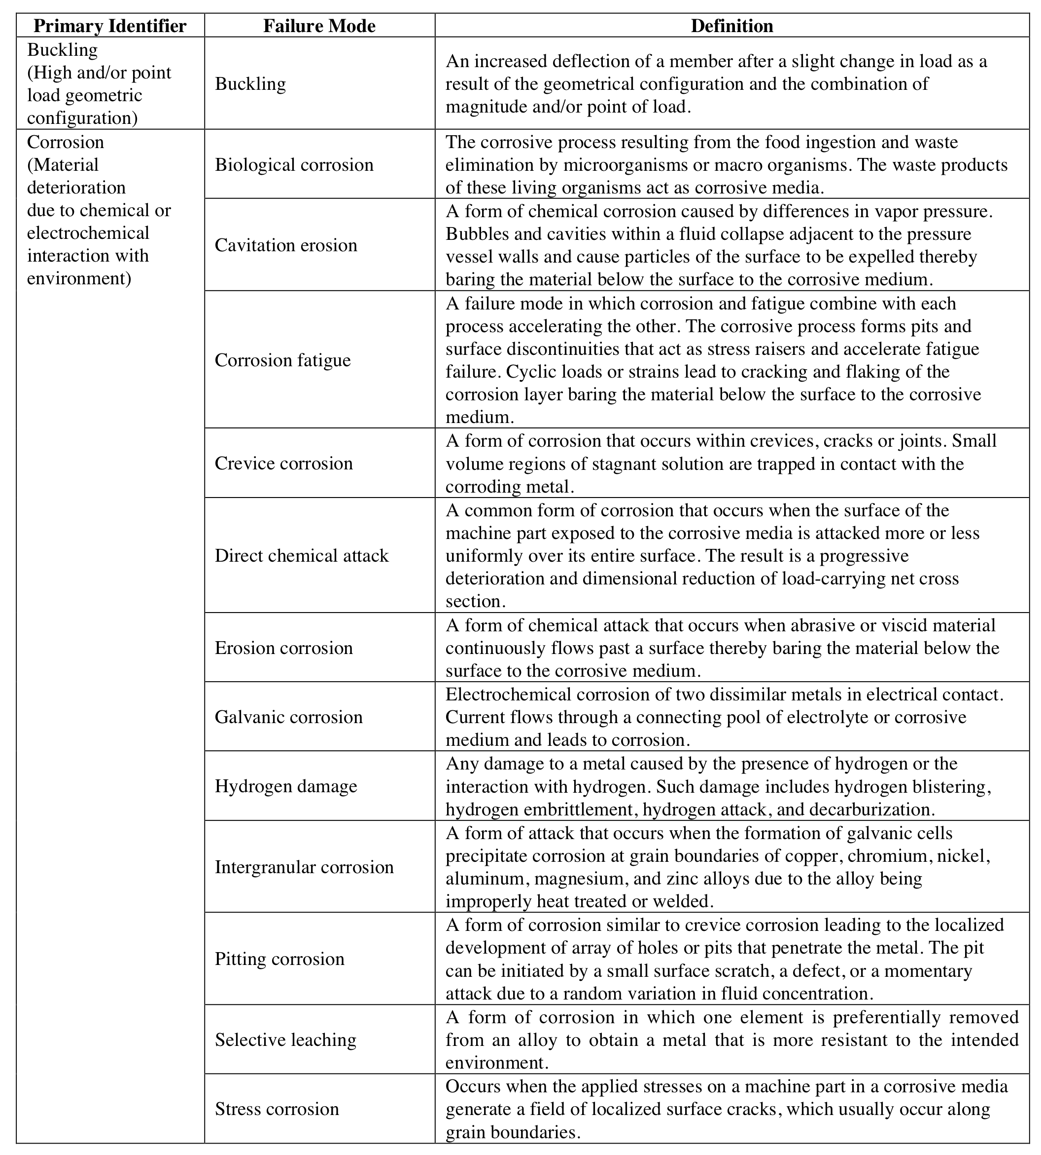

Mechanical Failure Mode Taxonomy (continued)
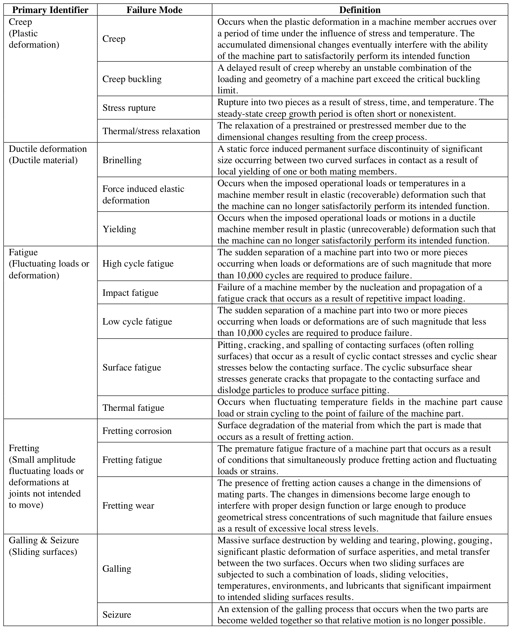
Mechanical Failure Mode Taxonomy (continued)
