CE 120 – DIRECT SHEAR and TORSION

Section (circle): | A B C D E F G H I J K | Date:
Group (circle): | 1 2 3 4 5 6 7 8 9 10 11 12 13 14 15
Data Recorder:

Direct Shear

specimen material: | A36 steel
test speed: | 0.1 in/min
specimen diameter:
0.2% yield load:
ultimate load:

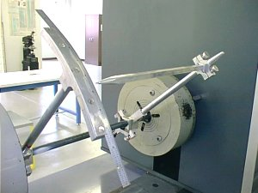
Torsion

specimen material: | A36 steel
specimen diameter:
troptometer gage length: | 12”
troptometer radius:

T_{FP}:
T_{E}:

T_{max}:

Torque  (in-lb) |  | Arc Length  (in) |  | Torque  (in-lb) |  | Arc Length  (in)

