- What is a composite?
  - A composite is anything made using more than one type of material
  - Structure of a composite
    - Usually a continuous phase and a discontinuous phase are present
Composite Beams→Introduction to Composite Materials
    - Discontinuous phase is usually harder, stronger, and more expensive
      - Called the reinforcing material
    - Continuous phase is usually weaker than discontinuous if used alone
      - Called the matrix of the composite
    - Based on this, who can name a common composite and identify the matrix and the reinforcing material?
      - Most common is steel reinforced concrete where the concrete is the matrix and steel is the reinforcing material
      - Fiberglass
  - Reasons for using composites
    - Allows you to create a material with properties that are superior to those of the individual materials
    - Can exploit the good points of the individual materials and make up for any shortcomings by using the other materials appropriately
- Examples of Composites and Their Use
  - Carbon fiber reinforced polymer wrap on concrete
Examples of Composite Materials →Fiber-Wrapped Concrete Column
    - Concrete column alone would fail at 600,000 lb
    - With CFRP wrap, the column withstood 3,000,000 lb which was the capacity of the testing machine
    - Can be used to repair concrete columns that have been damaged
  - UMR Smart Composite Bridge
Examples of Composite Materials→UMR Smart Composite Bridge
    - Used bonded tubes in construction
      - Built up layer-by-layer
- Lab Procedure
  - We will be working with composite beams made from aluminum and stainless steel sections bolted together
    - Make sure you set up the beam with the stainless steel side up
  - You will need to take several measurements and record them on your data sheet
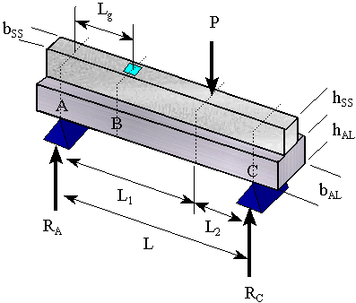
    - Draw on board

  - There are two strain gages attached to the composite beam
    - One is on the top surface and the other is on the bottom surface
    - Both measure axial strain
  - Place the weight hanger on the beam if using the lathe bed
    - You can select any arbitrary location to place the load
  - Connect the strain gages to the indicators and follow the steps from our previous lab
    - Zero the amp
    - Set the gage factor
    - Balance the load
  - Load the beam in 10 lb increments from 0 to 100 lb
    - Record the axial strains at each 10 lb increment of load
- Calculations
  - Start your calculations by converting your strain values to stresses using
    - These formulas are from Hooke’s law for uniaxial loading
  - Next, use Excel to plot normal stress vs. load for both strain gages on the same graph
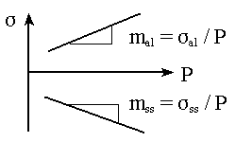
    - From linear regression find the slopes of the two lines
  - Use your slopes to find the experimental location of the neutral axis
    - Convert your slopes back into strains per unit load
    - Use the following formula to find the location of the experimental neutral axis
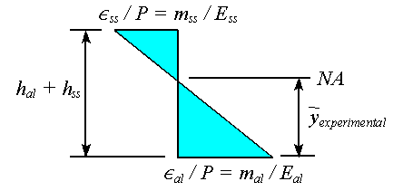
      - This follows from the fact that strain increases linearly with distance from the neutral axis
        - Allows the use of similar triangles
- Composite Beam Theory
  - We will use composite beam theory to calculate theoretical values to compare the experimental values against
    - Can’t directly apply beam theory to a composite beam
      - What assumption of beam theory do we violate if we apply it directly to a composite beam?
      - Due to the fact that the beam is made of more than one material
      - Beam isn’t homogeneous
    - We get around this by transforming the beam cross section into an equivalent cross section made from one material
      - Creates a homogeneous beam that allows use of the usual beam formulas
  - Cross Section Transformation
    - Transform the cross section to being made of only one of the two materials
    - Easiest if you convert the material with the higher E into an equivalent amount of the other material
      - Find the ratio of the modulus of elasticities of the two materials
      - Multiply the width of the stainless steel by n to find the transformed width
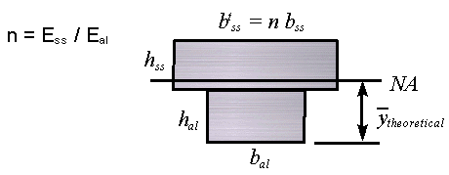
      - Creates an equivalent cross section composed entirely of aluminum
      - The height of the stainless steel section does NOT change
        - This ensures the strain and radius of curvature are continuous from one section to the other
  - Theoretical Neutral Axis Location
    - Solve for this using the transformed cross section and the usual method of finding the centroid by applying
      - Make sure all the dimensions you use in this equation come from the transformed cross section
      - The location found for the transformed cross section is the same location of the NA as for the actual composite beam
  - Moment of Inertia About Neutral Axis
    - This should also be calculated using the transformed cross section dimensions
  - Theoretical Stresses per unit Load
    - These are found by looking at a FBD of the beam at the section where the strain gages are located
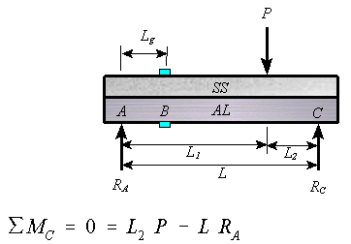

$R_{A}=\frac{L_{2}P}{L}$
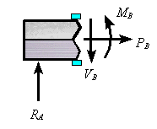
L_{g}

      - $${ΣM}_{g}=M_{B}−R_{A}L_{g}=0$$
      - $$M_{B}=R_{A}L_{g}=\frac{{\text{PL}}_{g}L_{2}}{L}$$
- Lab Report
  - The report for this lab should be a memo worth 100 points
  - Make sure you attach your initialed data sheet and sample hand calculations
  - Experimental Results
    - Include a table showing the original data collected in lab
    - Include the graph created in Excel and show the linear regression lines along with their equations
    - Calculate the following experimental values
      - Location of neutral axis ()
      - Stress per unit load for each material
    - Calculate the following theoretical values
      - Location of neutral axis
      - Stress per unit load for each material

    - Create a table with the following information
Experimental
Theoretical
% Difference

  - Discussion of Results
    - Compare your experimental and theoretical values using % error
    - Discuss how well the composite beam theory predicted your experimental values
    - Describe any reasons for why your results don’t exactly match the theory
    - Research and discuss two different composites
      - Tell what materials are used to create the composite
      - Describe how the materials are joined together and the benefits gained by using them as a composite
- Presentation
  - Each group will write their experimental values for, , and on the board.

