- Importance of Compression Testing
  - Compression testing gives properties similar to those found from our tension tests
  - Material behavior
    - Some materials behave nearly the same in compression as they do in tension
      - Ductile metals are a good example
    - Other materials behave much differently when subjected to compressive loads rather than tension loads
      - Brittle materials such as concrete or most ceramics
      - Very strong in compression when compared to tension
    - Complete Stress-Strain Diagram
      - Shows a material’s reaction to both tensile and compressive loads on one diagram
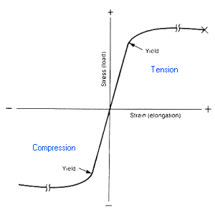
- Failure Methods for Compression Testing
  - During tension testing there was only one way for the material to fail
    - Necking and then pulled in to two halves
  - Compression tested material can fail in one of two ways
    - Excessive stress above the compressive yield strength or the compressive ultimate strength
      - Leads to yielding or the material cracking or breaking into two or more pieces
    - Buckling
      - Mainly happens for long narrow columns loaded in compression
      - Caused by the column deflecting away from being straight and becoming curved
      - Examples
Compression→Introduction
        - Railroad tracks rigidly fixed together expanding on a hot day
        - Alaskan pipeline was laid out to avoid long straight sections that could buckle
      - Euler Buckling Formulas
        - Whether a column will fail due to buckling depends on whether the amount of load or stress applied is above a critical level
        - Critical load
        - Critical stress
        - Critical load and stress formulas are derived for a column with pin connections on both ends
        - If a different end connection is used then the effective length (L_{e}) will be different
Compression→Euler Buckling
          - More rigidly the ends are held the harder it is to buckle the column
- Lab Procedure
  - Each group will perform one compression test on a wood block
    - You can either perform a compression test parallel to the grain or perpendicular to the grain
    - For a parallel to the grain test you will need to select a 2”x3”x8” block
    - For perpendicular to the grain testing you will need a 2”x3”x6” block
  - Parallel-to-grain test
    - Put marks 6” apart on your specimen that are centered from end to end
    - Attach a 6” mechanical extensometer to your specimen at the marks
    - Insert your specimen to the Instron 4485 testing machine
    - Set the cross-head speed to 0.024 in/min
    - Apply a compressive load to your block and record the deformation at each 1000 lb increment of load
    - Stop the test once a maximum load has been reached
  - Perpendicular-to-grain test
    - Insert your specimen to the Instron 4469 machine
    - You will use a dial gage to measure the deformation during the test
    - Set the cross-head speed to 0.012 in/min and record the load every 0.0025 in
    - Stop the test when a maximum load has been reached or the deformation is 0.1 inches, whichever occurs first
- Lab Report
  - Memo written by your group worth 100 points
  - Remember to attach your initialed data sheet
  - Create a stress-strain diagram using your data
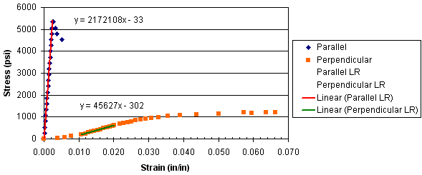
  - Find the compressive modulus of elasticity by applying linear regression to a portion of the stress-strain curve that appears linear
    - Justify your selected area for regression
    - The slope of your regression line will be the compressive modulus of elasticity
  - Also find the compressive strength of your block by applying the following:
  - If you perform the parallel-to-grain test then you will also need to find the load at which your block would begin to buckle
    - Our end conditions would be considered fixed-free
    - The moment of inertia you should use is the minimum I for the cross-section
    - Use your experimentally determined E in your calculation
  - Comparisons to reference values
    - Compare your experimental compressive modulus of elasticity and compressive strength of your block to the reference values given on the data sheet
      - Use % error
      - Give reasons to justify your differences
  - Discuss in your memo a situation where it would be useful to know the compressive modulus of elasticity
  - Also discuss another real world application where it would be helpful to know the compressive strength of your block
- Presentation
  - Each group will come to the board and fill in the following information
Load Direction | Comp. E (psi) | S_{UC} (psi) | P_{cr} (lb)
  - Then two groups will be selected answer questions about the lab

