- Beam Deflection
  - Importance
    - As we’ll talk about later in the semester one of the types of engineering failures is excessive elastic deformation
      - So the stresses in the material do not have to reach the yield point for a material to fail
    - We would like to be able predict the amount of deflection for a given loading situation
      - This is where understanding beam deflection becomes a useful tool
  - Assumptions
    - Linear elastic material
      - Same as before
      - We haven’t yielded the material and there is a linear relationship between stress and strain
    - Homogeneous, isotropic material
      - Same throughout
      - Properties the same in all directions
    - Small deformations
      - Allows use of the small angle approximation
    - Pure bending
      - Neglect the shear stresses that are almost always going to be present
      - If the length of the beam is at least 10 times the thickness of the beam then this results in at worst 3% error
- Beam Tables
  - Apply the assumptions of beam deflection theory to common beam loading situations
  - Easy to use
    - Find your given loading situation and read from the table the equation for deflection at a given point on the beam
- Lab Procedure
  - Each group will perform beam deflection tests on two beams
  - One beam is a cantilevered wood beam
  - Other beam will be a simply supported aluminum beam
  - We will use dial indicators to measure the deflection of each beam at two different points
  - Cantilevered Wood Beam
    - Take all measurements required on your data sheet
    - Use a length of roughly 36 inches
    - Set one indicator approximately ½ of the beam length from the cantilevered support
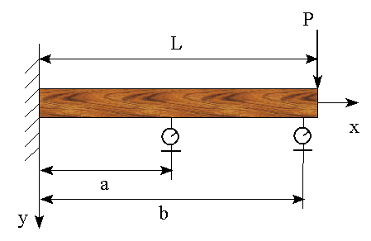
    - Place the other indicator near the end of the beam

    - Zero the indicators with the weight hanger on the beam
    - Apply load in 1 lb increments from 0 to 10 lbs
  - Simply Supported Aluminum Beam
    - Take all measurements required on the data sheet
    - Place the weight hanger on the beam exactly half way between the supports
    - Set one indicator about ¼ of the beam length from the support
    - Set the other indicator about ½ of the beam length from the support
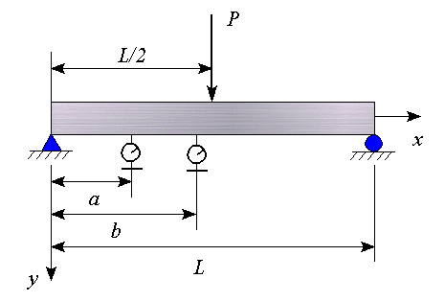

    - Zero the indicators with the weight hanger on the beam
    - Apply load in 5 lb increments from 0 to 50 lbs
- Calculations
  - Start your calculations for both beams by entering your data in Excel
    - Create one graph for each beam
      - Plot deflection vs. load for the two indicators
      - Use linear regression to find the slope ${\left(\frac{y_{i}}{P}\right)}_{\text{exp}}$ of the regression line through the points
  - Beam Theory
    - We will use beam deflection theory to evaluate our experimental results
      - We will compare our deflection per unit load values found for the aluminum beam to the theoretical values
      - We will use the beam theory to calculate the modulus of elasticity of the wood beam using our experimental deflection per unit load values
    - Aluminum beam
      - Calculate theoretical values for $\left(\frac{y_{i}}{P}\right)$using the following formula from the beam table
        - $${\left(\frac{y_{i}}{P}\right)}_{\text{th}}=\frac{x\left(3L^{2}−4x^{2}\right)}{\text{48}E_{\text{al}}I_{\text{NA}}}$$
      - Use $E_{\text{al}}=\text{10}\text{.}6×{\text{10}}^{6}\text{psi}$
      - Compare the deflection per unit load value from beam theory to the experimental value using percent difference
        - Will have two comparisons to make
          - One for each indicator
    - Wood Beam
      - The modulus of elasticity of wood is usually not very well known so we will solve for it
      - Calculate the experimental value for the modulus of elasticity of the beam using
        - $$E_{\text{wood}}=\frac{x^{2}\left(3L−x\right)}{6I_{\text{NA}}{\left(\frac{y_{i}}{P}\right)}_{\text{exp}}}$$
      - Compare your experimental E to the appropriate reference value on the data sheet
        - Again you will have two % difference comparisons to make
- Lab Report
  - The report for this lab should be a memo written by your group worth 100 points
  - Include the original, initialed data sheet and a set of hand calculations
  - Experimental Results
    - Include a table showing your original data
    - Show the graphs created in Excel for linear regression
      - Make sure you show the regression lines and their equations on the graphs
    - Calculate the theoretical value of deflection per unit load for the aluminum beam
    - Calculate the experimental modulus of elasticity for wood
    - Create a table summarizing your experimental and theoretical values

  - Discussion of Results
    - Compare your experimental and theoretical or reference values using percent errors
    - Give reasons for any major differences
    - Explain whether the assumptions of the beam deflection theory were well met or not
    - Compare your results for the aluminum and wood beams and tell which material worked better for the beam theory
- Presentation
  - Each group will come to the board and write your experimental values of ${\left(\frac{y_{i}}{P}\right)}_{\text{exp}}$for the aluminum and E_{wood} from the wood beam test
  - Two groups will be randomly selected to answer questions about the lab

