- Strain Gages
- What is a strain gage?
  - A piece of thin metal foil etched with parallel lines of foil left to measure strain
Elastic→Options
  - Attached to the part on which you wish to measure the strain
- Pros and Cons of Strain Gages
  - Pros
    - Very versatile and inexpensive
      - Many different sizes available
      - Many different materials for specific applications
    - Can be used on a curved surface
    - Very accurate if selected and used correctly
    - Can measure both static and dynamic loads
  - Cons
    - Once they are applied to a part, they cannot be removed without ruining the gage
    - Installation requires attention to detail to be performed correctly
    - Need a special instrument to measure the strain
- How a strain gage works
  - Strain is measured by measuring the change in the resistance of the foil “wires”
    - When the wires stretch or contract the length and cross-sectional areas change
    - A Wheatstone bridge circuit is used to measure the change in resistance for the strain gage
  - Gage Factor
    - Supplied by the manufacturer
    - GF=2.0 for most typical strain gages
    - R is the gage resistance and is typically 120 Ω
- Orientations of Strain Gages
Elastic→Options
  - Uniaxial Gages
    - Used when the principal direction is known or only interested in strain in a certain direction
    - Can only measure strain in the direction the wires are oriented
  - Biaxial Gage Rosettes
    - Two strain gages oriented perpendicular to one another
    - Used to measure both principal strains when the direction is known
  - Three Element Rosettes
    - Three gages oriented in a certain way
      - Example is 0, 45, and 90º
    - Allows you to measure the principal strains and determine the principal direction
- Real World Applications of Strain Gages
Elastic→Applications
- Monitoring Structures
  - Used in bridges to measure the strains and stresses
  - Monitoring strain around a hole drilled to stop crack propagation
  - Why would you drill a hole at the tip of a crack?
- Design
  - Can be used to determine the stresses and strains in a complex geometry
- Three elastic constants studied in this lab
  - Called elastic constants because they only apply when the stress in the material is below the proportional limit where the material yields and becomes plastic
  - Modulus of Elasticity
    - Measures the stiffness of a material
    - Defined as the ratio of normal stress to the corresponding normal strain when below the proportional limit
  - Poisson’s Ratio
    - Defined as the ratio of transverse strain to axial strain caused by a uniform axial stress below the proportional limit
  - Modulus of Rigidity
    - Ratio of shear stress to the corresponding shear strain when below the proportional limit
- Reasons why elastic constants are important
  - These constants allow us to relate the stress and strain found in a part
    - Only have to measure either stress or strain and then can calculate the other

- Hooke’s Law
Elastic→Hooke’s Law
  - Mathematical relationship between stress and strain
    - Uses elastic constants that we will determine today
  - Form of equations depends on the type of material and the type of loading applied
    - In its most general form Hooke’s law requires the determination of 81 elastic constants
    - Also must solve 9 equations in 9 unknowns
  - Assumptions about materials for this lab
    - Linear
      - Linear relationship between load and deformation
    - Elastic
      - Stay in range where deformation is not permanent
      - Material returns to original shape and size if load is removed
    - Homogeneous
      - Material composition is the same throughout
    - Isotropic
      - Material properties are the same in all directions
      - Can anyone name a common material that would not be isotropic?
        - Wood and fiber reinforced materials

- Lab Procedure
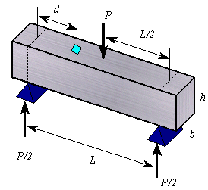
  - Flexure Test
    - Draw picture of setup on the board

    - Make all necessary measurements
      - Length between supports
      - Cross-sectional dimensions of beam
      - Distance to the strain gages from the support
    - There are two strain gages on the beam
      - One measures strain in the axial direction
      - The other measures strain in the transverse direction
    - Put the weight hanger on the beam making sure it is centered between the supports and the hanger doesn’t touch anything other than the beam
    - Set up the strain indicators
      - Connect the wires from the strain gages
      - Zero the amp
      - Set the gage factor
      - Balance the strain
    - For the larger aluminum bar
      - Add weights in 5 lb increments until the total weight is 50 lb
      - Take readings of strain at every 5 lb increment and record on your data sheet
    - For the smaller aluminum bar or the magnesium bar
      - Add weights in 1 lb increments until the total weight is 10 lb
      - Take readings of strain at each 1 lb increment
    - Your group can decide which type of beam to test
      - Need to test two beams per group
  - Tension Test
    - The back of the data sheet is for tension test data
    - We will not be performing tension tests since we will use flexure tests instead
- Calculations
  - Flexure Test
    - Input your data to Excel and create two plots
      - Load vs. axial strain
      - Transverse strain vs. axial strain
    - Use linear regression to find the slope of a regression line for both plots
      - Plot your linear regression lines on the graphs and show the equations
    - Poisson’s Ratio
      - Slope from your transverse strain vs. axial strain graph
    - Modulus of Elasticity
      - (Go through derivation)
      - 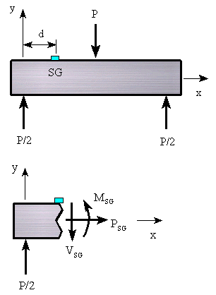

    - Modulus of Rigidity
      - Find this using values from flexure test by applying the following
- Assignment
  - Memo written by your group worth 100 points
    - Attach your group’s initialed data sheet
    - Include the graphs you need to create from your data
    - Show sample calculations
    - Summarize your calculated values in a table
  - Written part
    - Look up reference values for E, G, and Poisson’s ratio
    - Compare your calculated values to the reference values using percent difference
- Presentation
  - Each group will come to the board and write their experimental values for the following
Material | E | G

