Velocities on Wheels Rolling Without Slip

Because many real world dynamics problems involve rolling wheels, we devote a separate section to describing the velocities on such wheels. The figure below uses an absolute analysis approach to describing the displacement, velocity and acceleration of the center of a wheel rolling without slip. Because the wheel is not slipping, there is a direct relationship between the velocity of the center and the angular velocity, ω, so if one is known, the other can be determined. If, on the other hand, the wheel was slipping, no simple equation can be written to relate the rotation and translation. In short, both angular velocity and velocity of the center must be specified in order to describe the motion of a slipping wheel.

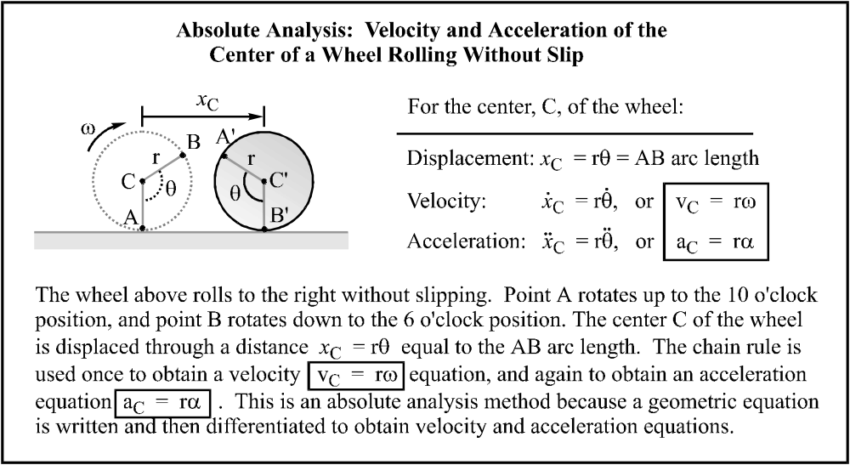

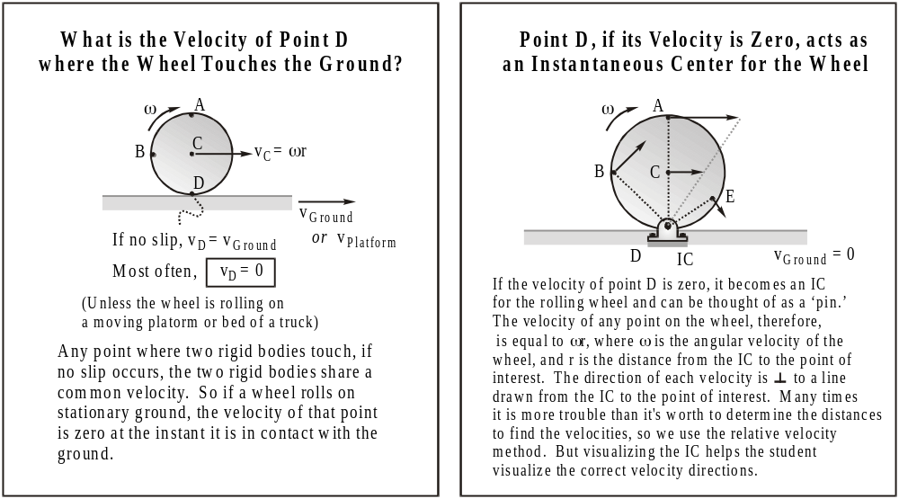

Example Problem _______: Velocities on a Rolling Wheel
The 10 inch radius wheel at right is rolling to the right without slipping. If the velocity of the center C of the wheel is known to be 10 inches/sec, determine:  (a) ω ; (b) 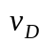; (c) 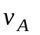; (d) 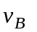 ; (e) 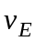. | 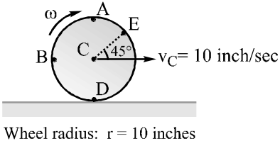
(a) ω: We know that v_{C} = rω; therefore 10 inch/sec = (10 inches)(ω); so ω = 1 rad/sec
(b) : Write a relative velocity equation, and we determine that v_{D} = 0, as expected.
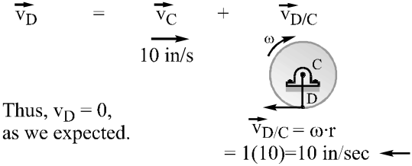
(c) 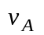: Write a relative velocity equation, and we determine that v_{A} = 20 in/sec .
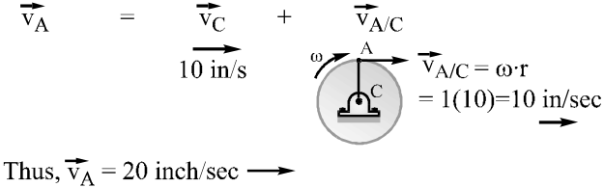
(d) 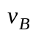: Write a relative velocity equation to determine that 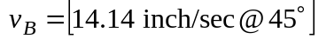
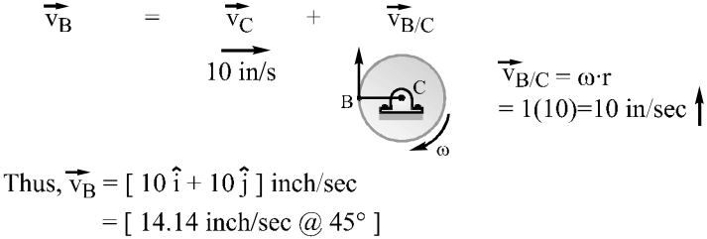
(e) : Write a relative velocity equation to determine that 

